NIIT UNIVERSITY, NEEMRANA

Car Dealership Database

**Group Members-**

* **Nishchay Grover**  (U101115FCS203) S5
* **Payanshi Jain** (U101115FCS205) S5
* **Javin Juneja**  (U101115FCS233) S4
* **Moksh Talreja**  (U101115FCS115) S5

The project is about a car dealership database of a firm which manufactures car. Overview of database is getting spares from vendor to assembling and then selling it to customer through dealer. The company also have a service center for the maintenance of cars. It contains all the information about the car’s make and model, Customer’s basic info, the allotted service Centre (we assume that the customer goes to the same allotted service center). Also it contains the information about the spare part used and the details about the vendor who sold the part and the information about manufacturer of the spare part.

It has 10 entities which further have various attributes that are briefly explained below:

* **Customers**: this entity contains all the information about the customers, i.e. name, address, contact, etc.
* **Dealer**: this entity contains the information about the location and name of the dealer.
* **Inventory**: this entity contains the information about name and location of the warehouses where the cars are stored.
* **Manufacturer**: this entity contains the information about the name and location of the manufacturer.
* **Service Centre**: this entity contains the information of the service ticket, receiving and delivery date, mechanics’ ID who serviced the vehicle and the payment.
* **Car Model**: this entity contains the year in which the model was released, body type and the model name of the car.
* **Spare part**: this entity contains the information about date of supply, the date of manufacture, and the part type or description.
* **Spare part Vendor**: It contains the information about the name and location of the spare part vendor.
* **Vehicle**: It contains the information of the vehicle for example the VIN or Vehicle Identification Number ,model name of the vehicle , color, transmission, fuel type and engine.
* **Service Details** – Is contains the information of the service details of the vehicles a particular service center has performed , it has details like , mech_id , service_center ID, date received , date delivered and amount.

**ER DIAGRAM**

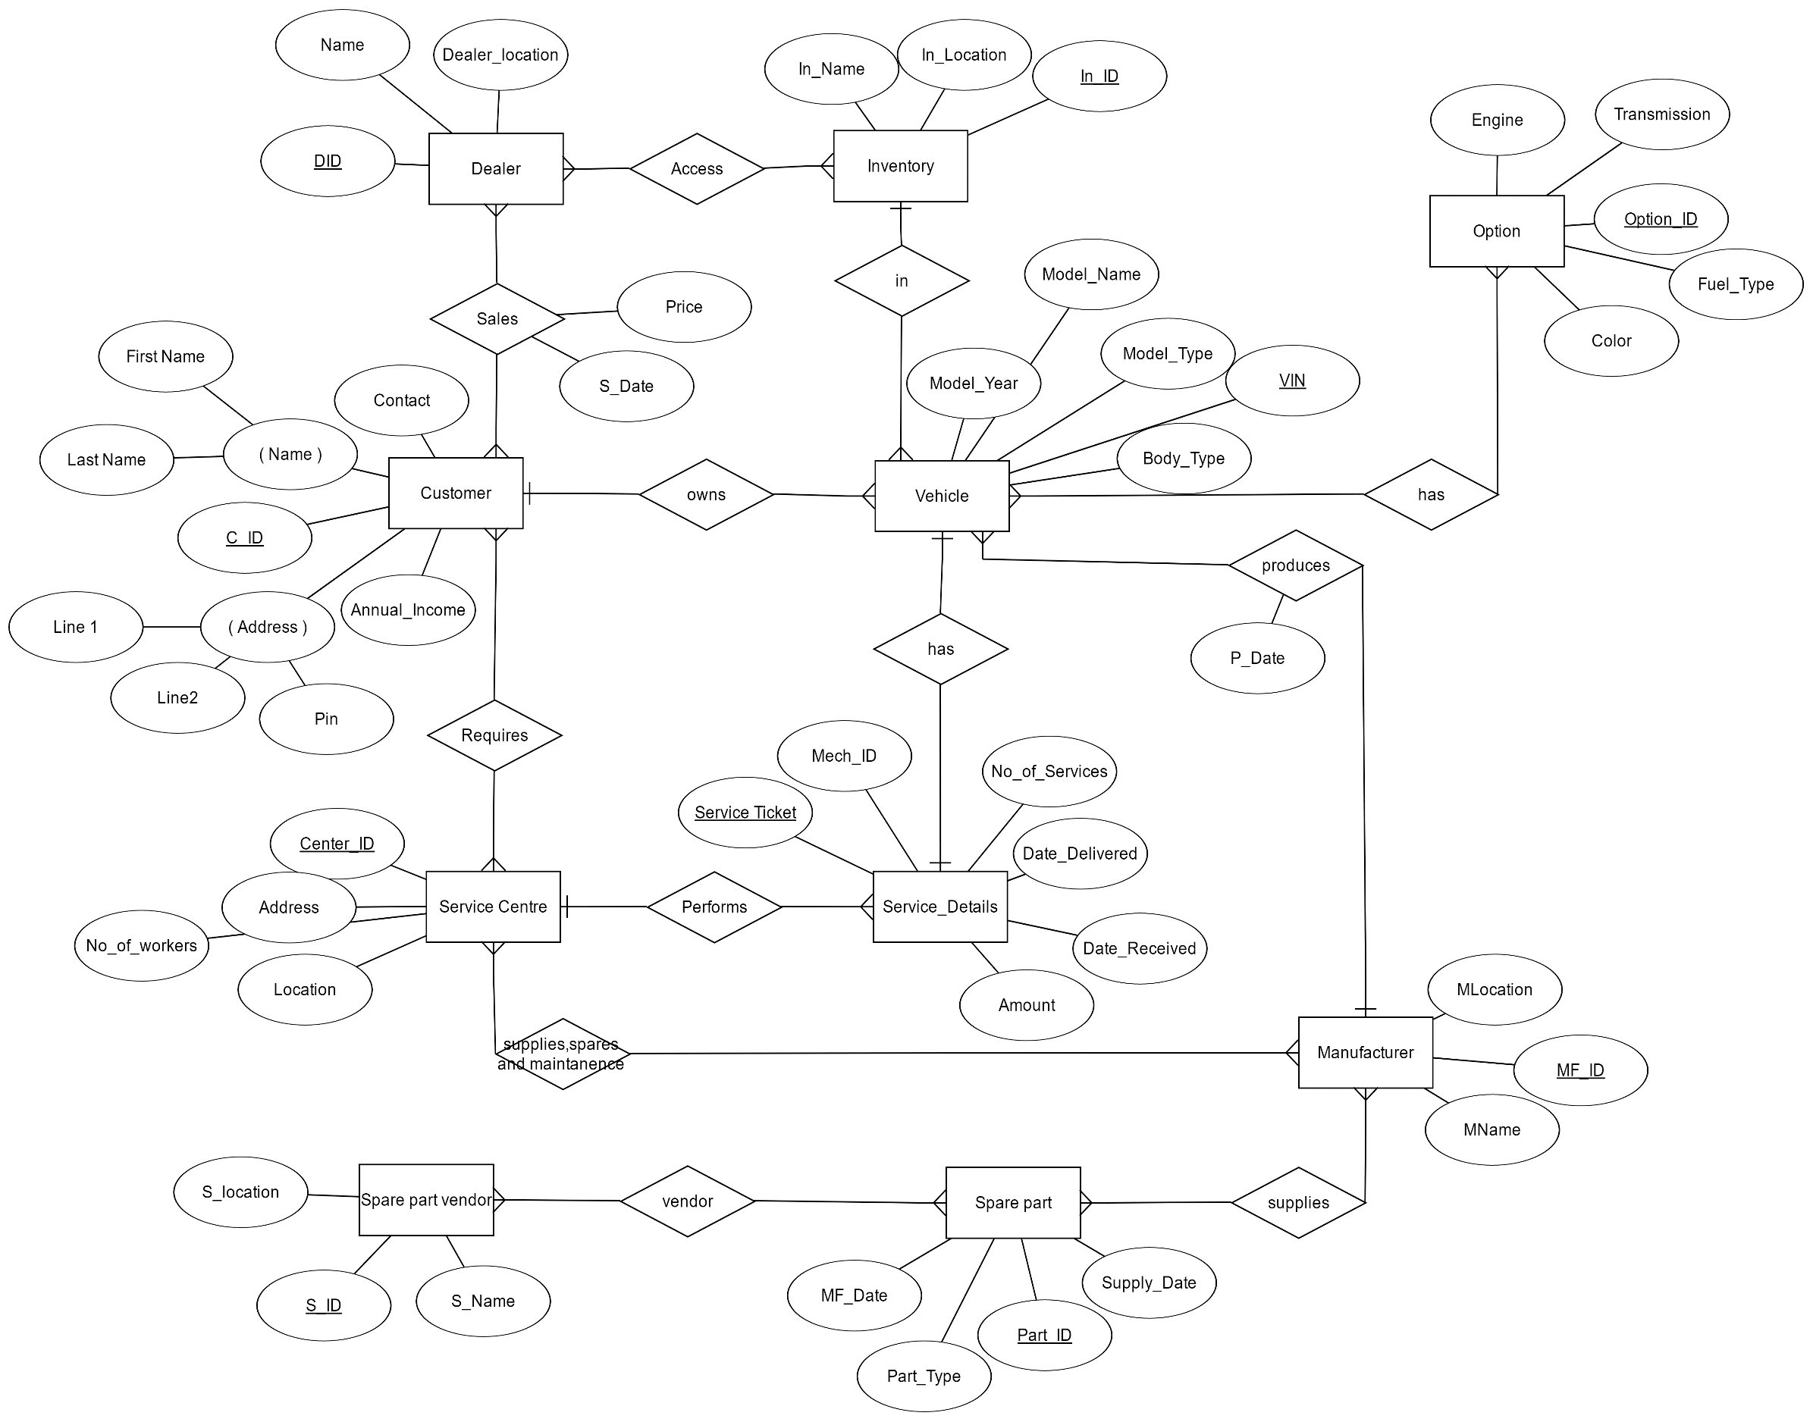

|  |  |
| --- | --- |
| *Entity* | *Attributes* |
| Customer | FirstName, LastName, C_ID, Contact, Line1, Line2, Pin, Annual_Income |
| Dealer | Dealer_location, Name, DId |
| Service Centre | Centre_ID, Address, No._of_workers,Location |
| Manufacturer | MLocation, MName,MF_ID |
| Spare Parts | Supply_Date, Part_ID, Part_Type, MF_Date |
| Spare parts Vendor | S_Name, S_location, S_ID |
| Vehicle | Model_Year, Model_Type, VIN, Model_Name, Body_Type |
| Service Details | Service_Ticket, Mech_ID, Amount, Date_Received,Date_Delivered,No_of_Services |
| Inventory | In_Name, In_Location, In_ID |
| Option | Engine, Transmission, Option_ID, Color, Fuel_Type |

**Table 1. Attributes of Entities/Tables**

**Relational Schema**

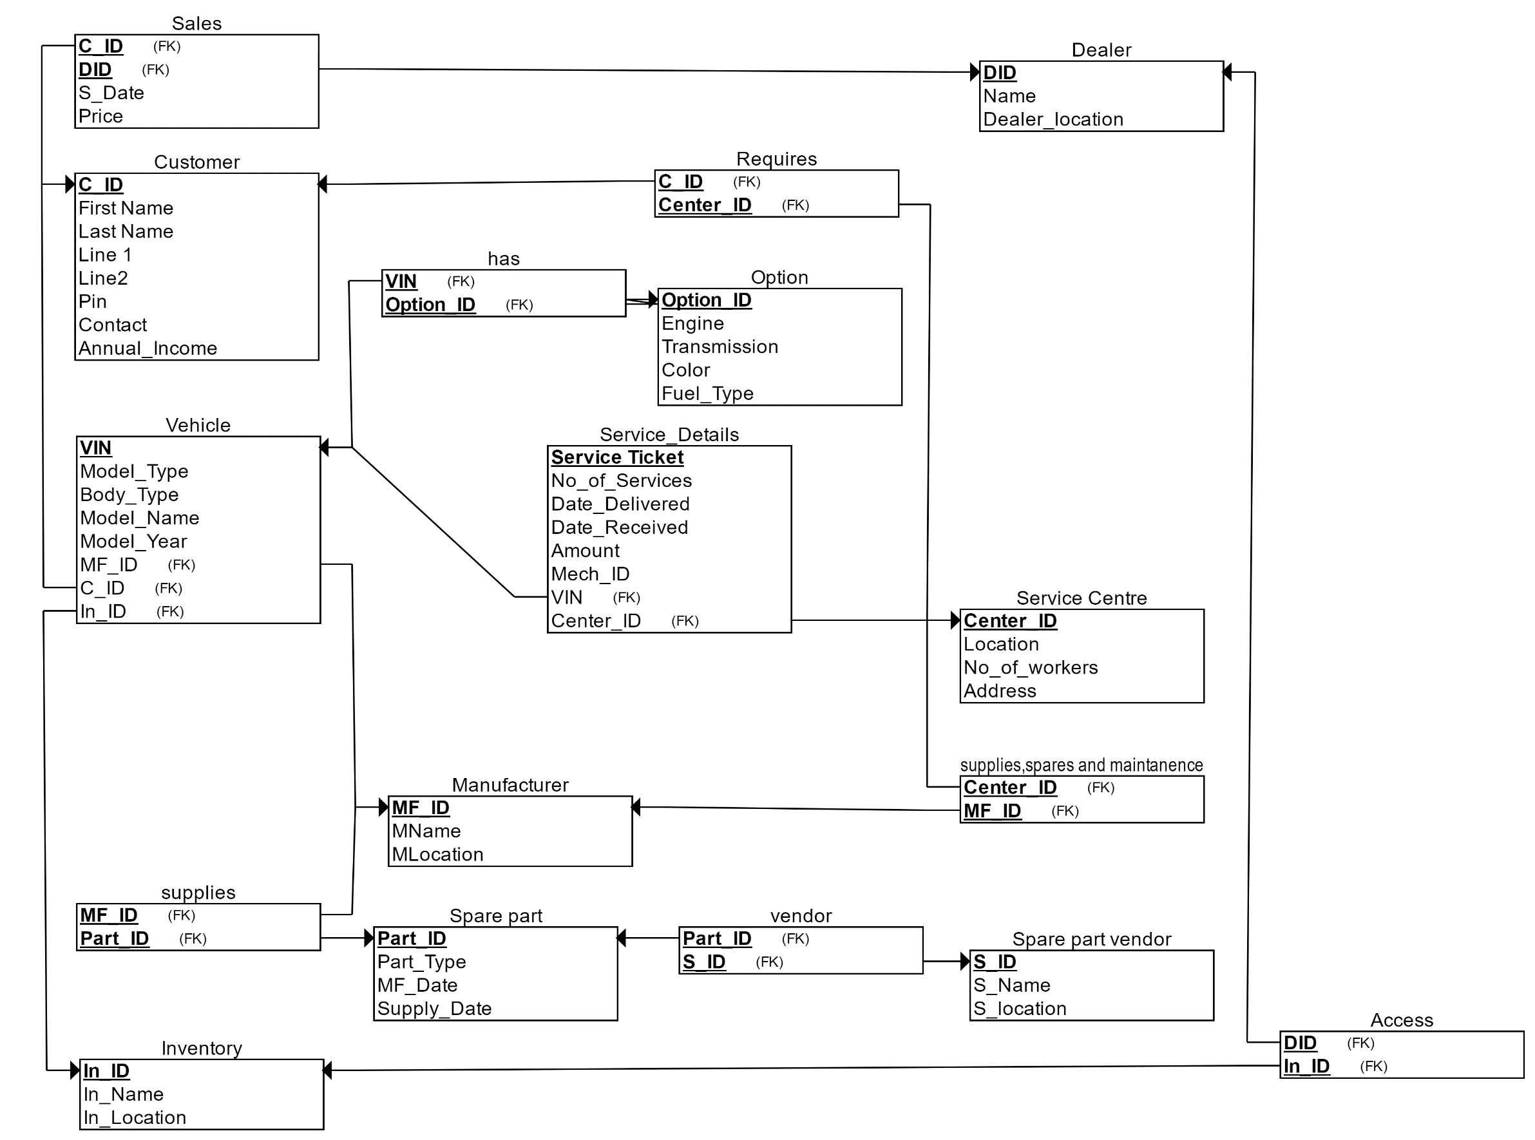

Functional Dependencies of Relation:

|  |  |  |
| --- | --- | --- |
| *Relation* | Description | SQL |
| Customer | A separate table for the given entity “Cutsomer” with entity's attributes becoming columns of the table. And we declare C_ID as the primary key. | CREATE TABLE Customer  (  C_ID VARCHAR(10) NOT NULL,  First_Name VARCHAR(20) NOT NULL,  Last_Name VARCHAR(10) NOT NULL,  Line_1 VARCHAR(50) NOT NULL,  Line2 VARCHAR(40) NOT NULL,  Pin INT NOT NULL,  Contact VARCHAR(10) NOT NULL,  Annual_Income VARCHAR(20) NOT NULL,  PRIMARY KEY (C_ID)  ); |
| Dealer | A separate table for the given entity “Dealer” with entity's attributes becoming columns of the table. And we declare DID as the primary key. | CREATE TABLE Dealer  (  DID VARCHAR(10) NOT NULL,  Name VARCHAR(20) NOT NULL,  Dealer_location VARCHAR(30) NOT NULL,  PRIMARY KEY (DID)  ); |
| Inventory | A separate table for the given entity “Inventory” with entity's attributes becoming columns of the table. And we declare In_ID as the primary key. | *CREATE TABLE Inventory*  *(*  *In_Name VARCHAR(20) NOT NULL,*  *In_Location VARCHAR(20) NOT NULL,*  *In_ID VARCHAR(20) NOT NULL,*  *PRIMARY KEY (In_ID)*  *);* |
| Service_Center | A separate table for the given entity “Service_Center” with entity's attributes becoming columns of the table. And we declare Center_ID as the primary key. | *CREATE TABLE Service_Centre*  *(*  *Location VARCHAR(20) NOT NULL,*  *No_of_workers INT NOT NULL,*  *Center_ID VARCHAR(20) NOT NULL,*  *Address VARCHAR(50) NOT NULL,*  *PRIMARY KEY (Center_ID)*  *);* |
| Spare_part_vendor | A separate table for the given entity “Spare_part_vendor” with entity's attributes becoming columns of the table. And we declare S_ID as the primary key. | *CREATE TABLE Spare_part_vendor*  *(*  *S_Name VARCHAR(20) NOT NULL,*  *S_location VARCHAR(30) NOT NULL,*  *S_ID VARCHAR(10) NOT NULL,*  *PRIMARY KEY (S_ID)*  *);* |
| Opt | A separate table for the given entity “Opt” with entity's attributes becoming columns of the table. And we declare Option_ID as the primary key. | CREATE TABLE Opt  (  Option_ID VARCHAR(10) NOT NULL,  Engine VARCHAR(20) NOT NULL,  Transmission VARCHAR(20) NOT NULL,  Color CHAR(1) NOT NULL,  Fuel_Type CHAR(1) NOT NULL,  PRIMARY KEY (Option_ID)  ); |
| Manufacturer | A separate table for the given entity “Manufacturer” with entity's attributes becoming columns of the table. And we declare MF_ID as the primary key. | *CREATE TABLE Manufacturer*  *(*  *MName VARCHAR(20) NOT NULL,*  *MLocation VARCHAR(20) NOT NULL,*  *MF_ID VARCHAR(10) NOT NULL,*  *PRIMARY KEY (MF_ID)*  *);* |
| Spare_part | A separate table for the given entity “Spare_part” with entity's attributes becoming columns of the table. And we declare Part_ID as the primary key. | CREATE TABLE Spare_part  (  Part_ID VARCHAR(10) NOT NULL,  Part_Type VARCHAR(10) NOT NULL,  MF_Date DATE NOT NULL,  Supply_Date DATE NOT NULL,  PRIMARY KEY (Part_ID)  ); |
| Sales | A separate table for the given entity “Sales” with entity's attributes becoming columns of the table. And we declare (C_ID,DID) as the primary key and C_ID,DID as the Foreign key (Due to Total Participation). | CREATE TABLE Sales  (  S_Date DATE NOT NULL,  Price INT NOT NULL,  C_ID VARCHAR(10) NOT NULL,  DID VARCHAR(10) NOT NULL,  PRIMARY KEY (C_ID, DID),  FOREIGN KEY (C_ID) REFERENCES Customer(C_ID),  FOREIGN KEY (DID) REFERENCES Dealer(DID)  ); |
| Access | A separate table for the given entity “Access” with entity's attributes becoming columns of the table. And we declare (DID,In_ID) as the primary key and DID,In_ID as the Foreign key (Due to Total Participation). | CREATE TABLE Access  (  DID VARCHAR(10) NOT NULL,  In_ID VARCHAR(20) NOT NULL,  PRIMARY KEY (DID, In_ID),  FOREIGN KEY (DID) REFERENCES Dealer(DID),  FOREIGN KEY (In_ID) REFERENCES Inventory(In_ID)  ); |
| Requires | A separate table for the given entity “Requires” with entity's attributes becoming columns of the table. And we declare (C_ID,Center_ID) as the primary key and C_ID,Center_ID as the Foreign key (Due to Total Participation). | CREATE TABLE Requires  (  C_ID VARCHAR(10) NOT NULL,  Center_ID VARCHAR(20) NOT NULL,  PRIMARY KEY (C_ID, Center_ID),  FOREIGN KEY (C_ID) REFERENCES Customer(C_ID),  FOREIGN KEY (Center_ID) REFERENCES Service_Centre(Center_ID)  ); |
| vendor | A separate table for the given entity “vendor” with entity's attributes becoming columns of the table. And we declare (Part_ID,S_ID) as the primary key and Part_ID,S_ID as the Foreign key (Due to Total Participation). | *CREATE TABLE vendor*  *(*  *Part_ID VARCHAR(10) NOT NULL,*  *S_ID VARCHAR(10) NOT NULL,*  *PRIMARY KEY (Part_ID, S_ID),*  *FOREIGN KEY (Part_ID) REFERENCES Spare_part(Part_ID),*  *FOREIGN KEY (S_ID) REFERENCES Spare_part_vendor(S_ID)*  *);* |
| supplies | A separate table for the given entity “supplies” with entity's attributes becoming columns of the table. And we declare (MF_ID,Part_ID) as the primary key and MF_ID,Part_ID as the Foreign key (Due to Total Participation). | *CREATE TABLE supplies*  *(*  *MF_ID VARCHAR(10) NOT NULL,*  *Part_ID VARCHAR(10) NOT NULL,*  *PRIMARY KEY (MF_ID, Part_ID),*  *FOREIGN KEY (MF_ID) REFERENCES Manufacturer(MF_ID),*  *FOREIGN KEY (Part_ID) REFERENCES Spare_part(Part_ID)*  *);* |
| Supplies_spares_and_maintanence | A separate table for the given entity “supplies_spares maintainance” with entity's attributes becoming columns of the table. And we declare (Center_ID, MF_ID) as the primary key and Center_ID, MF_ID as the Foreign key (Due to Total Participation). | *CREATE TABLE supplies_spares_and_maintanence*  *(*  *Center_ID VARCHAR(20) NOT NULL,*  *MF_ID VARCHAR(10) NOT NULL,*  *PRIMARY KEY (Center_ID, MF_ID),*  *FOREIGN KEY (Center_ID) REFERENCES Service_Centre(Center_ID),*  *FOREIGN KEY (MF_ID) REFERENCES Manufacturer(MF_ID)*  *);* |
| Vehicle | A separate table for the given entity “Vehicle” with entity's attributes becoming columns of the table. And we declare VIN as the primary key and MF_ID,C_ID,In_ID as the Foreign key (Due to Total Participation). | *CREATE TABLE Vehicle*  *(*  *VIN INT NOT NULL,*  *Model_Type VARCHAR(10) NOT NULL,*  *Body_Type VARCHAR(20) NOT NULL,*  *Model_Name VARCHAR(20) NOT NULL,*  *Model_Year INT NOT NULL,*  *MF_ID VARCHAR(10) NOT NULL,*  *C_ID VARCHAR(10) NOT NULL,*  *In_ID VARCHAR(20) NOT NULL,*  *PRIMARY KEY (VIN),*  *FOREIGN KEY (MF_ID) REFERENCES Manufacturer(MF_ID),*  *FOREIGN KEY (C_ID) REFERENCES Customer(C_ID),*  *FOREIGN KEY (In_ID) REFERENCES Inventory(In_ID)*  *);* |
| Service_Details | A separate table for the given entity “Service_Details” with entity's attributes becoming columns of the table. And we declare Service_Ticket as the primary key and Center_ID,VIN as the Foreign key (Due to Total Participation). | *CREATE TABLE Service_Details*  *(*  *Service_Number INT NOT NULL,*  *Date_Delivered DATE NOT NULL,*  *Date_Received DATE NOT NULL,*  *Bill INT NOT NULL,*  *Mech_ID VARCHAR(20) NOT NULL,*  *Service_Ticket VARCHAR(20) NOT NULL,*  *Center_ID VARCHAR(10) NOT NULL,*  *VIN VARCHAR(20) NOT NULL,*  *PRIMARY KEY (Service_Ticket),*  *FOREIGN KEY (Center_ID) REFERENCES Service_Centre(Center_ID),*  *FOREIGN KEY (VIN) REFERENCES Vehicle(VIN)*  *);* |
| has | A separate table for the given entity “has” with entity's attributes becoming columns of the table. And we declare (VIN,Option_ID) as the primary key and VIN, Option_ID. as the Foreign key (Due to Total Participation). | *CREATE TABLE has*  *(*  *VIN INT NOT NULL,*  *Option_ID VARCHAR(10) NOT NULL,*  *PRIMARY KEY (VIN, Option_ID),*  *FOREIGN KEY (VIN) REFERENCES Vehicle(VIN),*  *FOREIGN KEY (Option_ID) REFERENCES Opt(Option_ID)*  *);* |

**Table 2. Table Schema**

|  |  |
| --- | --- |
| *Relation* | *Functional Dependencies* |
| Customer | {C_ID} -> {Name}  {C_ID} -> {Address}  {C_ID} -> {Contact}  {C_ID} -> {Annual Income}  {Name,Address} -> {C_ID}  {Name,Address} -> {Annual Income}  {Name,Address} -> {Contact}  {Address,Contact} -> {Name}  {Address,Contact} -> {C_ID}  {Address,Contact} -> {Annual Income}  {Contact} -> {C_ID}  {Contact} -> {Name}  {Contact} -> {Address}  {Contact} -> {Annual Income}  {Name,Contact} -> {C_ID}  {Name,Contact} -> {Annual Income}  {Name,Contact} -> {Address}  {Contact,Gender} -> {C_ID}  {Contact,Gender} -> {Name}  {Contact,Gender} -> {Address}  {Contact,Gender} -> {Annual Income}  {Contact,Annual Income} -> {CID}  {Contact,Annual Income} -> {Name}  {Contact,Annual Income} -> {Address}  {Name,Address,Contact} -> {C_ID}  {Name,Address,Contact} -> {Annual Income}  {Address,Contact,Annual Income} -> {C_ID}  {Address,Contact,Annual Income} -> {Name}  {Contact,Annual Income,Name} -> {C_ID}  {Contact,Annual Income,Name} -> {Address}  {Name,Address,Contact,Annual Income} -> {C_ID} |
| Manufacture | {MF_ID} -> {MLocation}  {MF_ID} -> {M_Name}  {M_Name,MLocation} -> {MF_ID} |
| Inventory | {IN_ID} -> {IN_Name}  {IN_ID} -> {IN_Location}  {IN_Location,IN_Name} -> {IN_ID} |
| Spare Parts | {Part_ID} -> {Supply_Date}  {Part_ID} -> {Type}  {Part_ID} -> {MF_Date} |
| Spare Part Vendors | {S_ID} -> {S_location}  {S_ID} -> {S_Name}  {S_Name,S_location} -> {S_ID} |
| Option | {Option_ID} -> {Engine}  {Option_ID} -> {Transmission}  {Option_ID} -> {Fuel_Type}  {Option_ID} -> {Color} |
| Dealer | {DID} -> {Name}  {DID} -> {Dealer_Location}  {Name,Dealer_Location} -> {DID} |
| Service Center | {Center_ID} -> {Location}  {Center_ID} -> {No_of_workers}  {Center_ID} -> {Address}  {Address} -> {Center_ID}  {Address} -> {No_of_workers}  {Address} -> {Location} |
| Service Details | {Service_Ticket} -> {No_of_Services}  {Service_Ticket} -> {Mech_ID}  {Service_Ticket} -> {Date_Recieved}  {Service_Ticket} -> {Date_Delivered}  {Service_Ticket} -> {Center_ID}  {Service_Ticket} -> {VIN}  {Service_Ticket} -> {Amount}  {Service_Ticket,VIN} -> {No_of_Services}  {Service_Ticket,VIN} -> {Mech_ID}  {Service_Ticket,VIN} -> {Date_Recieved}  {Service_Ticket,VIN} -> {Date_Delivered}  {Service_Ticket,VIN} -> {Center_ID}  {Service_Ticket,VIN} -> {Amount}  {Service_Ticket,Center_ID} -> {No_of_Services}  {Service_Ticket,Center_ID} -> {Mech_ID}  {Service_Ticket,Center_ID} -> {Date_Recieved}  {Service_Ticket,Center_ID} -> {Date_Delivered}  {Service_Ticket,Center_ID} -> {Amount} |
| Vehicle | {VIN} -> {Model_Type}  {VIN} -> {Body_Type}  {VIN} -> {Model_Name}  {VIN} -> {Model_Year}  {VIN} -> {MF_ID}  {VIN} -> {C_ID}  {VIN} -> {IN_ID}  {VIN,MF_ID} -> {Model_Type}  {VIN,MF_ID} -> {Body_Type}  {VIN,MF_ID} -> {Model_Name}  {VIN,MF_ID} -> {Model_Year}  {VIN,MF_ID} -> {C_ID}  {VIN,MF_ID} -> {IN_ID}  {VIN,C_ID} -> {Model_Type}  {VIN,C_ID} -> {Body_Type}  {VIN,C_ID} -> {Model_Name}  {VIN,C_ID} -> {Model_Year}  {VIN,C_ID} -> {MF_ID}  {VIN,C_ID} -> {IN_ID}  {VIN,IN_ID} -> {Model_Type}  {VIN,IN_ID} -> {Body_Type}  {VIN,IN_ID} -> {Model_Name}  {VIN,IN_ID} -> {Model_Year}  {VIN,IN_ID} -> {MF_ID}  {VIN,IN_ID} -> {C_ID} |

**Table 3. Functional Dependencies of Relation**

|  |  |
| --- | --- |
| *Relation* | *Normalization* |
| Customer | {C_ID} -> {Name}  {C_ID} -> {Address}  {C_ID} -> {Contact}  {C_ID} -> {Annual Income} |
| Manufacture | {MF_ID} -> {MLocation}  {MF_ID} -> {M_Name} |
| Inventory | {IN_ID} -> {IN_Name}  {IN_ID} -> {IN_Location} |
| Spare Parts | {Part_ID} -> {Supply_Date}  {Part_ID} -> {Type}  {Part_ID} -> {MF_Date} |
| Spare Part Vendors | {S_ID} -> {S_location}  {S_ID} -> {S_Name} |
| Option | {Option_ID} -> {Engine}  {Option_ID} -> {Transmission}  {Option_ID} -> {Fuel_Type}  {Option_ID} -> {Color} |
| Dealer | {DID} -> {Name}  {DID} -> {Dealer_Location} |
| Service Center | {Center_ID} -> {Location}  {Center_ID} -> {No_of_workers}  {Center_ID} -> {Address} |
| Service Details | {Service_Ticket} -> {No_of_Services}  {Service_Ticket} -> {Mech_ID}  {Service_Ticket} -> {Date_Recieved}  {Service_Ticket} -> {Date_Delivered}  {Service_Ticket} -> {Center_ID}  {Service_Ticket} -> {VIN}  {Service_Ticket} -> {Amount}  {Service_Ticket,VIN} -> {No_of_Services}  {Service_Ticket,VIN} -> {Mech_ID}  {Service_Ticket,VIN} -> {Date_Recieved}  {Service_Ticket,VIN} -> {Date_Delivered}  {Service_Ticket,VIN} -> {Center_ID}  {Service_Ticket,VIN} -> {Amount}  {Service_Ticket,Center_ID} -> {No_of_Services}  {Service_Ticket,Center_ID} -> {Mech_ID}  {Service_Ticket,Center_ID} -> {Date_Recieved}  {Service_Ticket,Center_ID} -> {Date_Delivered}  {Service_Ticket,Center_ID} -> {Amount} |
| Vehicle | {VIN} -> {Model_Type}  {VIN} -> {Body_Type}  {VIN} -> {Model_Name}  {VIN} -> {Model_Year}  {VIN} -> {MF_ID}  {VIN} -> {C_ID}  {VIN} -> {IN_ID}  {VIN,MF_ID} -> {Model_Type}  {VIN,MF_ID} -> {Body_Type}  {VIN,MF_ID} -> {Model_Name}  {VIN,MF_ID} -> {Model_Year}  {VIN,MF_ID} -> {C_ID}  {VIN,MF_ID} -> {IN_ID}  {VIN,C_ID} -> {Model_Type}  {VIN,C_ID} -> {Body_Type}  {VIN,C_ID} -> {Model_Name}  {VIN,C_ID} -> {Model_Year}  {VIN,C_ID} -> {MF_ID}  {VIN,C_ID} -> {IN_ID}  {VIN,IN_ID} -> {Model_Type}  {VIN,IN_ID} -> {Body_Type}  {VIN,IN_ID} -> {Model_Name}  {VIN,IN_ID} -> {Model_Year}  {VIN,IN_ID} -> {MF_ID}  {VIN,IN_ID} -> {C_ID} |

**Table 4. Normalized table**

**Customer** 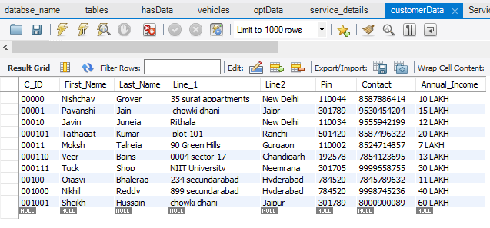

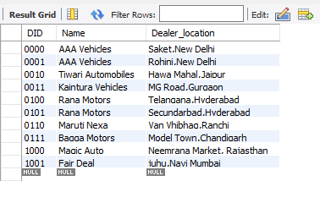**Dealer**

**ACCESS**

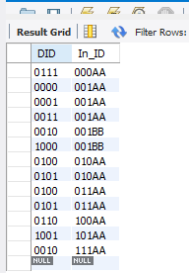

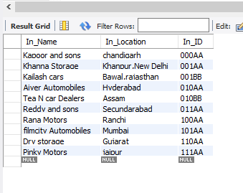**Inventory**

**Manufacturer**

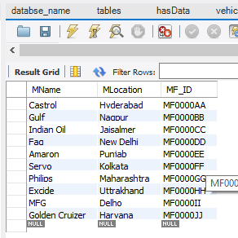

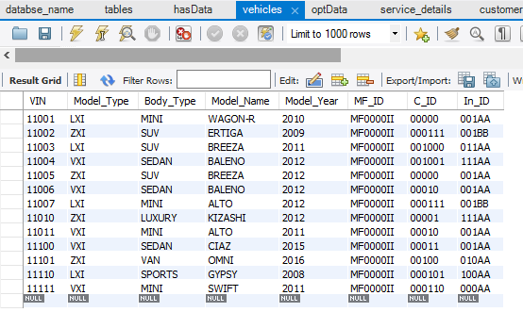**Vehicle**

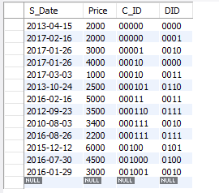**Sales**

**OPT**

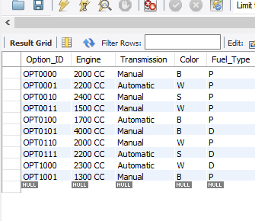

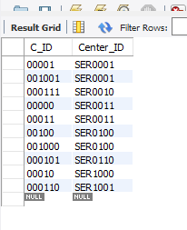**Require**

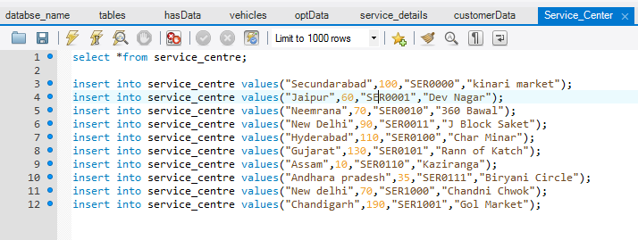**Service Center**

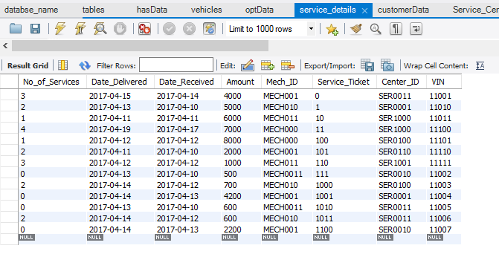**Service Details**

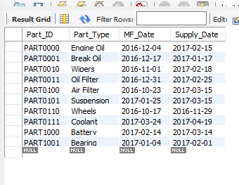**Spare Part**

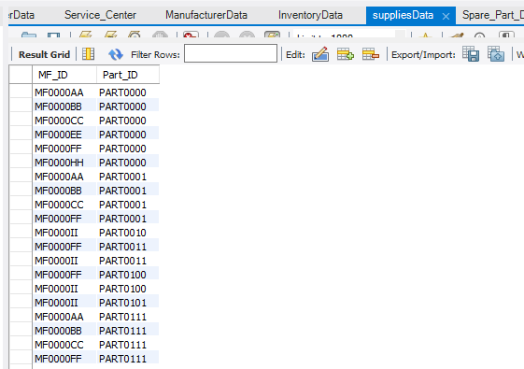**Supplies**

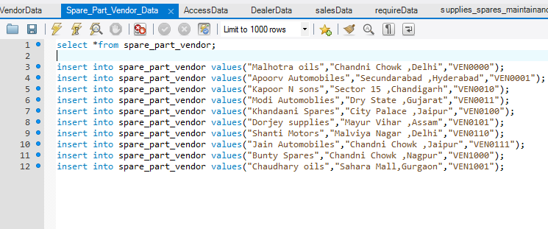**Spare Part Vendor**

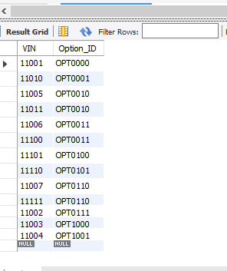**Has**

\

**Supplies Spares**

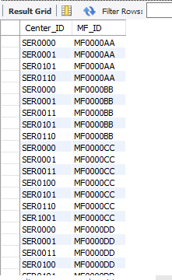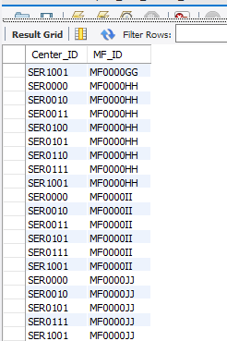

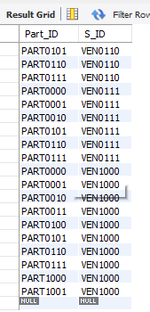**Vendor**

