# INTRODUCTION

## **1.PYHTON:**

## Python is a widely used general-purpose, high level programming language. It was initially designed by Guido van Rossum in 1991 and developed by Python Software Foundation. It was mainly developed for emphasis on code readability, and its syntax allows programmers to express concepts in fewer lines of code.

Python is a programming language that lets you work quickly and integrate systems more efficiently.

Python community has developed many modules to help programmers implement machine learning. In this article , we will be using numpy, scipy and scikit-learn modules. We can install them using cmd command:

pip install numpy scipy scikit-learn

A better option would be downloading anaconda packages for python, which come preloaded with these packages. Follow the instructions given here to use anaconda.

**2.ARTIFICIAL INTELLIGENCE:**

The most common answer that one expects is **“to make computers intelligent so that they can act intelligently!”**, but the question is how much intelligent? How can one judge the intelligence?

…as intelligent as humans. If the computers can, somehow, solve real-world problems, by improving on their own from the past experiences, they would be called “intelligent”.

Intelligence, as we know, is the ability to acquire and apply the knowledge. Knowledge is the information acquired through experience. Experience is the knowledge gained through exposure(training). Summing the terms up, we get **artificial intelligence** as the “copy of something natural (i.e., human beings) ‘WHO’ is capable of acquiring and applying the information it has gained through exposure.”

**Intelligence is composed of:**

* Reasoning
* Learning
* Problem Solving
* Perception
* Linguistic Intelligence

Many tools are used in AI, including versions of search and mathematical optimization, logic, methods based on probability and economics. The AI field draws upon computer science, mathematics, psychology, linguistics, philosophy, neuro-science, artificial psychology and many others.

## **3.MACHINE LEARNING:**

Machine learning is a type of artificial intelligence (AI) that provides computers with the ability to learn without being explicitly programmed. Machine learning focuses on the development of Computer Programs that can change when exposed to new data.

Machine learning involves computer to get trained using a given data set and use this training to predict the properties of a given new data. For example, we can train computer by feeding it 1000 images of cats and 1000 more images which are not of a cat and tell each time to computer whether a picture is cat or not. Then if we show the computer a new image, then from the above training, computer should be able to tell whether this new image is cat or not.

Process of training and prediction involves use of specialized algorithms. We feed the training data to an algorithm, and the algorithm uses this training data to give predictions on a new test data. One such algorithm is [K-Nearest-Neighbour](https://www.geeksforgeeks.org/k-nearest-neighbours/) classification (KNN classification). It takes a test data and finds k nearest data values to this data from test data set.

# OBJECTIVES OF RESEARCH

Wind energy is eco-friendly, it does not emit harmful gases into the atmosphere like CO2, CO and many more.

Carbon-free technologies like renewable energy help combat climate change, but many of them have not reached their full potential.

Consider wind power: over the past decade, wind farms have become an important source of carbon-free electricity as the cost of turbines has plummeted and adoption has surged.

However, the variable nature of wind itself makes it an unpredictable energy source—less useful than one that can reliably deliver power at a set time.

Wind power output is based on the attributes such as wind energy, wind speed, wind direction and date/time.

 Based on these predictions, our model recommends how to make optimal hourly delivery commitments to the power grid a full day in advance.

This is important, because energy sources that can be scheduled (i.e. can deliver a set amount of electricity at a set time) are often more valuable to the grid.

We have used multiple linear regression model to build our project. Multilinear regression is such a technique and the most commonly used short term prediction method, which will predict wind speed. which method gives less prediction error.

The main objective of our project is to predict the wind power output generated based on the attributes given in the datasets which include wind speed , wind direction and constants.

## PROBLEM STATEMENT

**Fossil fuels have been used extensively all over the world to satisfy energy demands. However, their availability is limited and their negative impact on the environment undeniable.**

**Due to this, the need to develop alternative energy resources was recognized a few decades ago. Among different alternatives that have been developed, wind energy appears as a promising option to be implemented in many parts of the world. In order to make wind energy more competitive and attractive to investors, new energy systems are desired. Specifically, it is desired to have a higher energy output.**

In search of a solution to this problem, last year, DeepMind and Google started applying machine learning algorithms to 700 megawatts of wind power capacity in the central United States. These wind farms—part of Google’s global fleet of [renewable energy projects](https://about.google/intl/en-GB/stories/renewable-energy-is-boosting-economies/)—collectively generate as much electricity as is needed by a medium-sized city.

It is also important to take into consideration all the factors that affect the wind power i.e, wind speed, direction, weather conditions like temperature, season, date/time.

The main moto of this project is to predict power output based on weather conditions which affects the wind power.

## DATA COLLECTION

### **Context**

In Wind Turbines, This Systems measure and save data's like wind speed, wind direction, generated power etc. for 10 minutes intervals. This file was taken from a wind turbine's system that is working and generating power in Turkey.

### **Content**

The data's in the file are:

* Date/Time (for 10 minutes intervals)
* LV ActivePower (kW): The power generated by the turbine for that moment
* Wind Speed (m/s): The wind speed at the hub height of the turbine (the wind speed that turbine use for electricity generation)
* Theoretical_Power_Curve (KWh): The theoretical power values that the turbine generates with that wind speed which is given by the turbine manufacturer
* Wind Direction (°): The wind direction at the hub height of the turbine (wind turbines turn to this direction automatically)

METHODOLOGY

## EXPLORATORY DATA ANALYSIS:

Dataset imported is analysed through various means of regression methods.

We predicted accuracy value of dataset using all the regression methods and the one with best accuracy is selected.

Multilinear regression is the best method for this dataset.

### FIGURES AND TABLES:

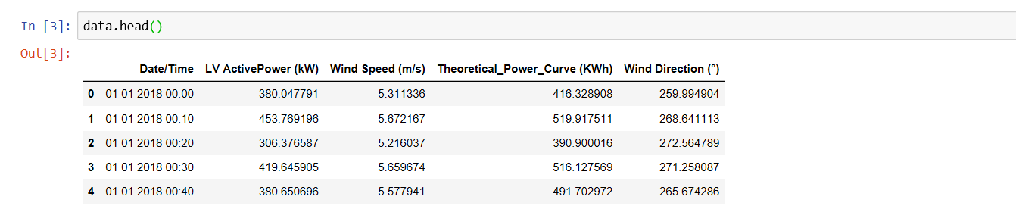

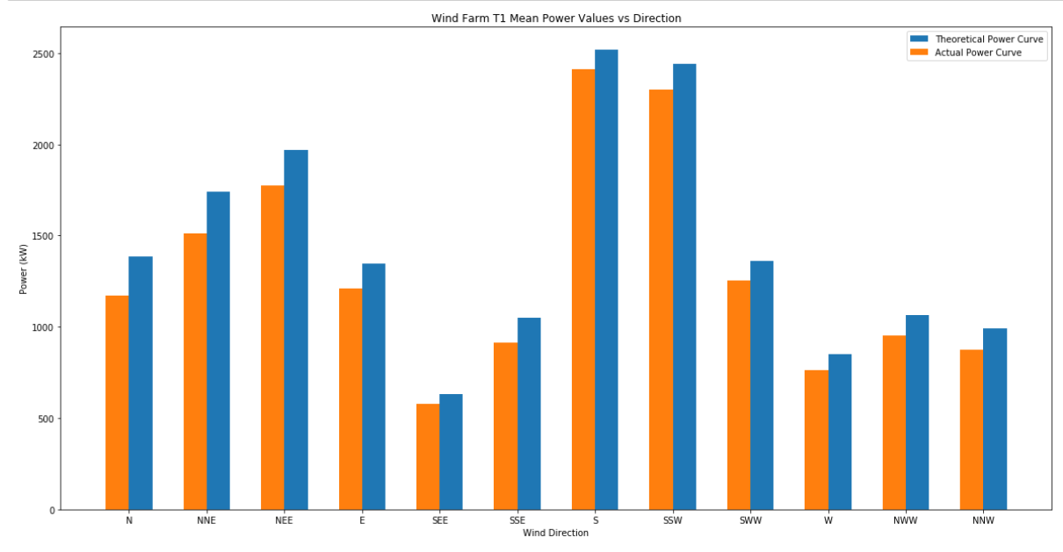

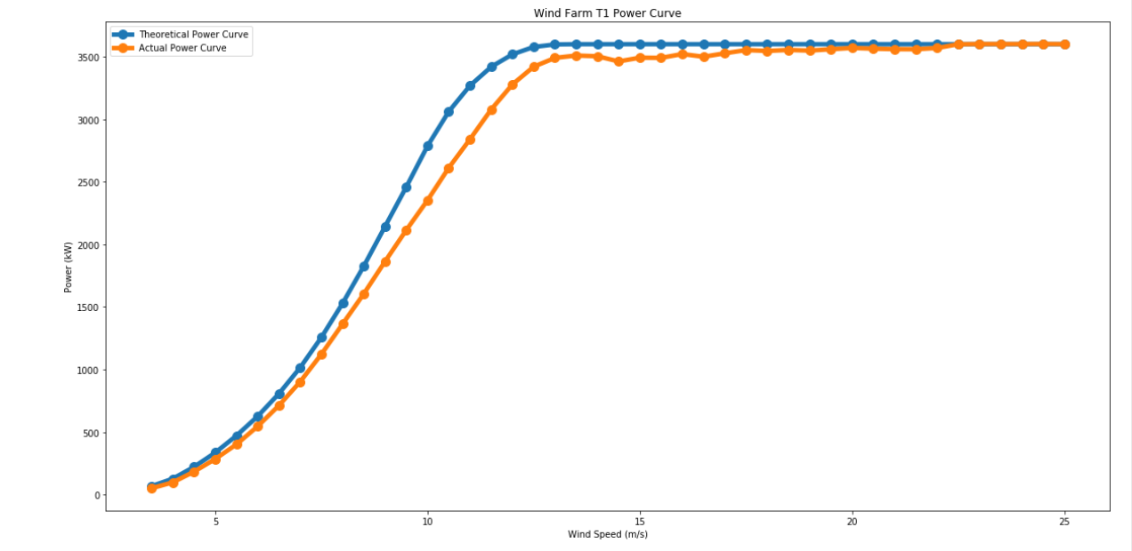

# DATA MODELLING

The data model that we have used in our project is “Multiple Linear Regression” model.

Multiple Linear Regression attempts to model the Relationship between two or more features and a response by fitting a linear equation to observed data.

Multiple Linear Regression is a simple and common way to analyse linear regression. The model is often used for predictive analysis since it defines the relationship between two or more variables.

The steps to perform multiple linear Regression are almost similar to that of simple linear Regression.

The Difference Lies in the evaluation. We can use it to find out which factor has the highest impact on the predicted output and now different variable relate to each other.

*Here:****Y=b0+b1*x1+b2*x2+b3*x3+……bn*xn*** *Y = Dependent variable and x1, x2, x3, …… xn = multiple independent variables*

The dataset collected is tested using all the regression models and the one which gives maximum accuracy is selected. For our dataset multiple linear regression gives 90% accuracy so this model is selected.

# FINDINGS AND SUGGESTIONS

## SOURCES:

* <https://en.wikipedia.org/wiki/Wind_power#Public_opinion>
* <https://medium.com/@manjabogicevic/multiple-linear-regression-using-python-b99754591ac0>
* <https://www.kaggle.com/berkerisen/wind-turbine-scada-dataset>
* <https://www.researchgate.net/publication/268966331_Wind_Power_Prediction_with_Machine_Learning_chapter>

In this section, we present a thorough evaluation of our models trained with weather station data. First set of results show prediction accuracy while increasing training data by more weather conditions. The second set of results mostly emphasize on the noticeable performance improvement of our models when different weather condition values are included in training data.

In this section, we present a thorough evaluation of our models

trained with the weather station data. First set of results show

prediction accuracy while increasing training data by adding more

neighboring cities, and by adding more weeks. Second set of results

mostly emphasize the noticeable performance improvement of our

models when neighboring cities are included in the training data

# CONCLUSION

Simulations of a wind turbine have been used to develop a database and to show the complex response of the wind turbine to changes in hub height wind speed, turbulence intensity and rotor disk shear. The database of forcing conditions has been combined with the turbine rated speed to define the turbine operating region. Together, these data were used to generate a regression-tree model of the wind turbine’s power generation. The simulations suggest and the model clearly demonstrates that the response of the turbine is a complex non-linear function of hub height wind speed, turbulence intensity, and rotor disk shear. At wind speeds below rated speed, the turbine power output is most sensitive to changes in wind speed and speed, turbulence.

At rated speed, the turbine is most sensitive to turbulence intensity and shear, and power can change by 10% under typical atmospheric conditions. At wind speeds greater than rated, the turbine responds most to changes in turbulence intensity. Predictions of power output using the regression tree model are approximately three times more accurate than power predictions using the power curve.

Although this method has been demonstrated using simulated inflow and turbine response data, the method could be used to generate turbine performance models from turbine power testing data. Changes of wind direction with height, non-uniform shear, and the state of the turbine were not considered here but may impact turbine deployment sites, and their effect should be investigated using field data.

Application of the data to wind turbine deployment sites does not require any new instrumentation compared to what is currently used. Using this regression tree method helps eliminate biases resulting from deployment site wind conditions (turbulence intensity, shear, and their correlations with wind speed) that differ from the turbine test site.

we presented a technology to utilize machine learning techniques to provide weather forecasts. Machine learning technology can provide intelligent models, which are much simpler than traditional physical models. They are less resource-hungry and can easily be run on almost any computer including mobile devices. Our evaluation results show that these machine learning models can predict weather features accurately enough to compete with traditional models. We also utilize the historical data from surrounding areas to predict weather of a particular area. We show that it is more effective than considering only the area for which weather forecasting is done.

In future, we have plans to utilize low-cost Internet of Things (IoT) devices, such as temperature and humidity sensors, in collecting weather data from different parts of a city. The use of different sensors could increase the number of local features in the training dataset. This data, along with the weather station data, will further improve the performance of our prediction.

we presented a technology to utilize machine learning

techniques to provide weather forecasts. Machine learning tech-

nology can provide intelligent models, which are much simpler

than traditional physical models. They are less resource-hungry

and can easily be run on almost any computer including mobile

devices. Our evaluation results show that these machine learning

models can predict weather features accurately enough to compete

with traditional models. We also utilize the historical data from

surrounding areas to predict weather of a particular area. We show

that it is more eective than considering only the area for which

weather forecasting is done.

In future, we have plans to utilize low-cost Internet of Things

(IoT) devices, such as temperature and humidity sensors, in collect-

ing weather data from dierent parts of a city. The use of dierent

sensors could increase the number of local features in the training

dataset. This data, along with the weather station data, will further

improve the performance of our prediction models

In this paper, we presented a technology to utilize machine learning

techniques to provide weather forecasts. Machine learning tech-

nology can provide intelligent models, which are much simpler

than traditional physical models. They are less resource-hungry

and can easily be run on almost any computer including mobile

devices. Our evaluation results show that these machine learning

models can predict weather features accurately enough to compete

with traditional models. We also utilize the historical data from

surrounding areas to predict weather of a particular area. We show

that it is more eective than considering only the area for which

weather forecasting is done.

In future, we have plans to utilize low-cost Internet of Things

(IoT) devices, such as temperature and humidity sensors, in collect-

ing weather data from dierent parts of a city. The use of dierent

sensors could increase the number of local features in the training

dataset. This data, along with the weather station data, will further

improve the performance of our prediction models

we presented a technology to utilize machine learning

techniques to provide weather forecasts. Machine learning tech-

nology can provide intelligent models, which are much simpler

than traditional physical models. They are less resource-hungry

and can easily be run on almost any computer including mobile

devices. Our evaluation results show that these machine learning

models can predict weather features accurately enough to compete

with traditional models. We also utilize the historical data from

surrounding areas to predict weather of a particular area. We show

that it is more eective than considering only the area for which

weather forecasting is done.

In future, we have plans to utilize low-cost Internet of Things

(IoT) devices, such as temperature and humidity sensors, in collect-

ing weather data from dierent parts of a city. The use of dierent

sensors could increase the number of local features in the training

dataset. This data, along with the weather station data, will further

improve the performance of our prediction models

we presented a technology to utilize machine learning

techniques to provide weather forecasts. Machine learning tech-

nology can provide intelligent models, which are much simpler

than traditional physical models. They are less resource-hungry

and can easily be run on almost any computer including mobile

devices. Our evaluation results show that these machine learning

models can predict weather features accurately enough to compete

with traditional models. We also utilize the historical data from

surrounding areas to predict weather of a particular area. We show

that it is more eective than considering only the area for which

weather forecasting is done.

In future, we have plans to utilize low-cost Internet of Things

(IoT) devices, such as temperature and humidity sensors, in collect-

ing weather data from dierent parts of a city. The use of dierent

sensors could increase the number of local features in the training

dataset. This data, along with the weather station data, will further

improve the performance of our prediction models

we presented a technology to utilize machine learning

techniques to provide weather forecasts. Machine learning tech-

nology can provide intelligent models, which are much simpler

than traditional physical models. They are less resource-hungry

and can easily be run on almost any computer including mobile

devices. Our evaluation results show that these machine learning

models can predict weather features accurately enough to compete

with traditional models. We also utilize the historical data from

surrounding areas to predict weather of a particular area. We show

that it is more eective than considering only the area for which

weather forecasting is done.

In future, we have plans to utilize low-cost Internet of Things

(IoT) devices, such as temperature and humidity sensors, in collect-

ing weather data from dierent parts of a city. The use of dierent

sensors could increase the number of local features in the training

dataset. This data, along with the weather station data, will further

improve the performance of our prediction models