**Read the following instructions before completing the given task.  
  
Step 1: Click on the Online Task Link**

**Step 2: Download the document**

**Step 3: Check the online questions**

**Step 4: Complete the task and take a screenshot for each and every task and upload**

**Step 5: Save the document**

**Step 6: Upload the document in Google form**

1. 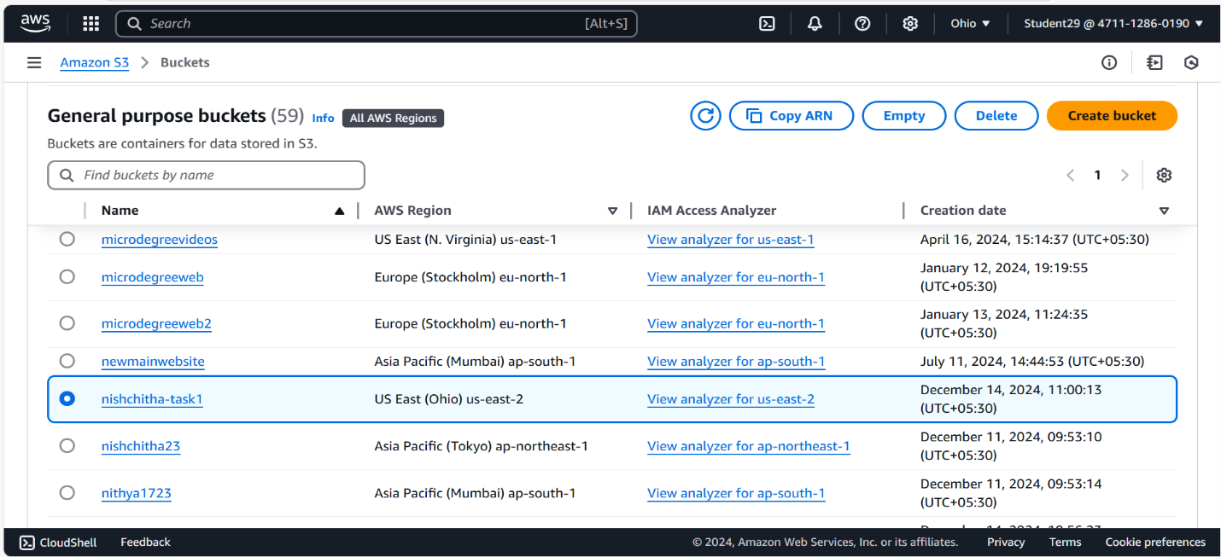**Hosting static website using Amazon S3 bucket**

