**Requirement Document**

**29/06/2020 || Task 7 || Systems Engineering**

Submitted by –

-Nishanth Joseph Delavictoire

Mat no. 3260057

-Raj Sakhrekar

Mat no. 3259812

**Table of Contents**

1. The Purpose of the Project 1

2. The Client, the Customer, and Other Stakeholders 2

3. Users of the Product 2

4. Mandated Constraints 2

5. Naming Conventions and Definitions 9

6. Relevant Facts and Assumptions 9

7. The Scope of the Work 9

8. Scope of the Product 12

9. Functional and Data Requirements 13

10. Look and Feel Requirements 15

11. Usability and Humanity Requirements 15

12. Performance Requirements 16

13. Operational and Environmental Requirements 16

14. Maintainability and Support Requirements 16

15. Legal Requirements 16

16. Open Issues 16

17. Off-the-Shelf Solutions 17

18. New Problems 18

19. Migration to the New Product 18

20. Risks 18

21. User Documentation and Training 18

22. Waiting Room 19

23. Ideas for Solutions 19

### 1. The Purpose of the Project

The purpose of the project is the effective learning of systems-engineering for mechatronics systems. The main problem is, that the conventional lecture systems engineering is often misunderstood as project management. Both disciplines are necessary but systems engineering is the process to develop systems and project management deals with the operative techniques to manage projects. In this specific project the mechatronics product is a mower robot. Based on a low-cost robot platform, enhanced with a nodeMCU for WiFi connectivity, controlled by a mobile-phone.

### 2. The Client, the Customer, and Other Stakeholders

2a. The Client-

The client here is the professor or the university itself, since the requirements and working material is sponsored by them.

2b. The Customer-

The customer is also the professor here, since the money (grades in our case) are in the professor’s hands.

### 3. Users of the Product

3a. The Hands-On Users of the Product-

As this product is meant to be developed and manufactured for the sole purpose of learning, the hands-on user, key user, and maintenance user are all the students that will be involved in the process. As the product may be dismantled again after completion of the project, no other entities/users are involved.

### 4. Mandated Constraints

The product will be built using the Smart Robot Car Assembly DIY Kit Set as its base. This kit is available on eBay for a cost of 20 Euros on top of which, an addition of 20 Euros to the budget to tailor make the solutions will be provided. The project hence has a budget total of 40 Euros within which the final fully-functional product must be realized.

The product is to also use an Arduino programmable Node MCU for communication between robot and mobile- phone. Depending on the project requirements, a WiFi only ESP8266 system can be used, or a WiFi and Bluetooth 4.2, ESP32 based system can be used.

4a. Solution Constraints-

Description- The mower must be able to return to charging station autonomously

Rationale- The client should not have to search for the mower in the lawn and change the batteries

Fit Criterion- The product will be programmed to return to a charging station for ease of access by the client

4b. Partner or Collaborative Applications-

The robot mower is to make use of a html-based web browser application which can be utilized on a smartphone / tablet / computer or any other device with a WiFi signal and web browser. As a result, the WiFi signal must always be active and the mower should be within signal range. On board keypad and display will also allow for the mower to be utilized without the need of one of the aforementioned devices.

4c. Off-the-Shelf Software/Hardware-

The controllers to be used are Arduino programmable. This means that the base foundation for coding will be done in the C/C++ languages.

Arduino is an open-source electronics platform based on easy-to-use hardware and software. Arduino boards are able to read inputs - light on a sensor, a finger on a button, or a Twitter message - and turn it into an output - activating a motor, turning on an LED, publishing something online, etc.

Programming for the Arduino, and controller will be done on an open source IDE such as Code Blocks.

The main components will be borrowed from the Smart robot Car Assembly DIY Kit Set which is available for purchase from eBay for a cost of 20 Euros.

Infrared sensors will also be used. They are used for boundary detection, obstacle avoidance, etc.

In order to handle the wireless connectivity and communication, nodeMCU ESP8266 will be used. It is used in microcontroller applications as well as in IoT applications for integration of devices.

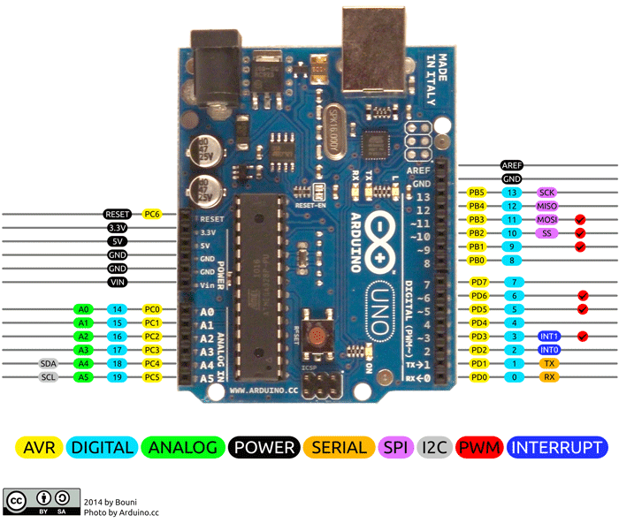

Pin Description-

|  |  |  |
| --- | --- | --- |
| **Pin Category** | **Pin Name** | **Details** |
| Power | Vin, 3.3V, 5V, GND | Vin: Input voltage to Arduino when using an external power source.  5V: Regulated power supply used to power microcontroller and other components on the board.  3.3V: 3.3V supply generated by on-board voltage regulator. Maximum current draw is 50mA.  GND: ground pins. |
| Reset | Reset | Resets the microcontroller. |
| Analog Pins | A0 – A5 | Used to provide analog input in the range of 0-5V |
| I/O Pins | Digital Pins 0 - 13 | Can be used as input or output pins. |
| Serial | 0(Rx), 1(Tx) | Used to receive and transmit TTL serial data. |
| External Interrupts | 2, 3 | To trigger an interrupt. |
| PWM | 3, 5, 6, 9, 11 | Provides 8-bit PWM output. |
| SPI | 10 (SS), 11 (MOSI), 12 (MISO) and 13 (SCK) | Used for SPI communication. |
| Inbuilt LED | 13 | To turn on the inbuilt LED. |
| TWI | A4 (SDA), A5 (SCA) | Used for TWI communication. |
| AREF | AREF | To provide reference voltage for input voltage. |

Arduino Uno Technical Specifications-

|  |  |
| --- | --- |
| Microcontroller | [ATmega328P](https://components101.com/microcontrollers/atmega328p-pinout-features-datasheet) – 8-bit AVR family microcontroller |
| Operating Voltage | 5V |
| Recommended Input Voltage | 7-12V |
| Input Voltage Limits | 6-20V |
| Analog Input Pins | 6 (A0 – A5) |
| Digital I/O Pins | 14 (Out of which 6 provide PWM output) |
| DC Current on I/O Pins | 40 mA |
| DC Current on 3.3V Pin | 50 mA |
| Flash Memory | 32 KB (0.5 KB is used for Bootloader) |
| SRAM | 2 KB |
| EEPROM | 1 KB |
| Frequency (Clock Speed) | 16 MHz |

Smart robot Car Assembly DIY Kit Set provided-

|  |  |
| --- | --- |
| Component | Quantity |
| UNO R3 Board | 1 |
| USB Cable | 1 |
| Motor Driver Module L298N | 1 |
| Sensor Shield V5.0 for Arduino UNO | 1 |
| Switch 3A / 250VAC | 1 |
| Ultrasonic Sensor HC-SR04 | 1 |
| Fork light barrier MOC7OT2 | 2 |
| Distance sensor Sharp GP2YOA21YKOF | 2 |
| velocimetry code disk | 2 |
| Car Chassis | 1 |
| Chassis Connectors | 4 |
| Gear Motor with Wires | 2 |
| Wheel | 2 |
| Universal Wheel | 1 |
| Box for AA-Batteries | 1 |
| Micro-Servo Tower Pro SG90 | 1 |
| Set of servo connectors w screws and nuts | 1 |
| Dupont cable ff 20cm | 10 |
| Dupont cable fm 20cm | 10 |
| Dupont cable mm 20cm | 10 |
| M3 * 5 Screw | 8 |
| M3 * 8 Screw | 2 |
| M3 30 Screw | 4 |
| M3 Nut | 6 |
| M3 12 Brass Pillar | 4 |

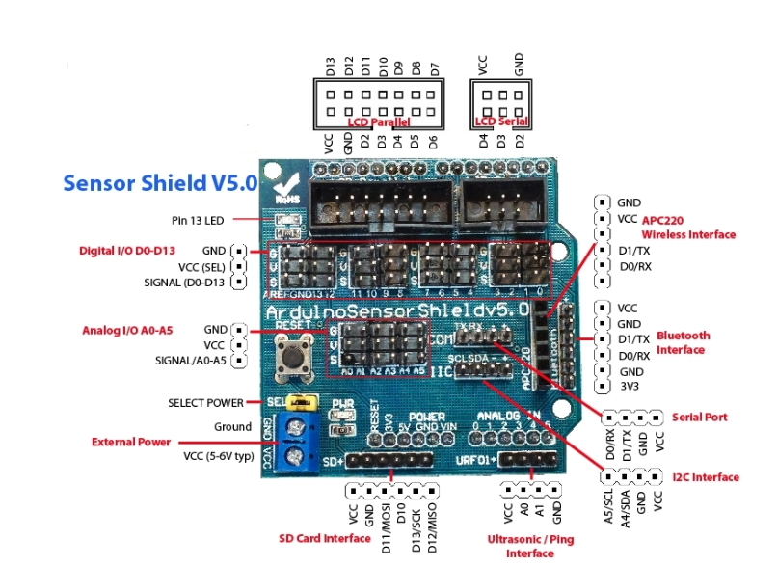

Sensor Shield V5.0 for Arduino UNO

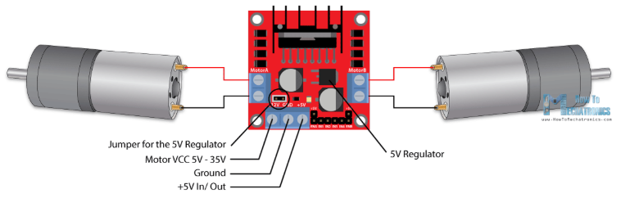

Motor Driver Module L298N

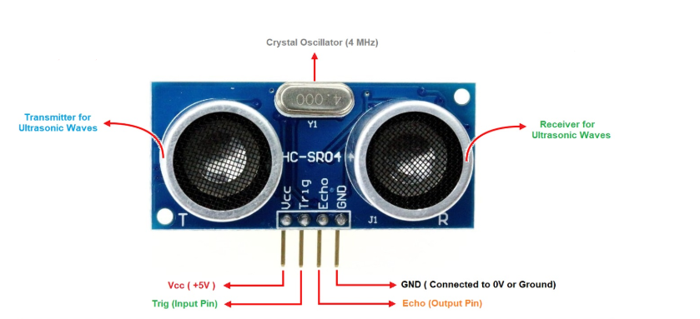

Ultrasonic Sensor HC-SR04

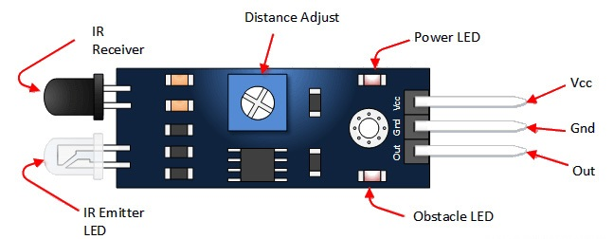

Infrared Sensor

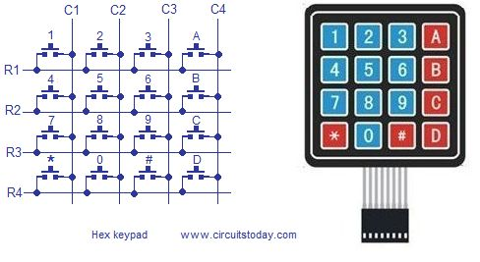

4x4 Keypad

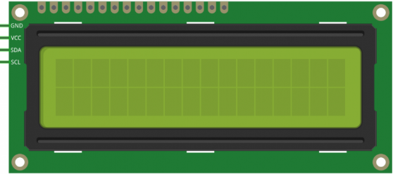

16x2 I2C LCD

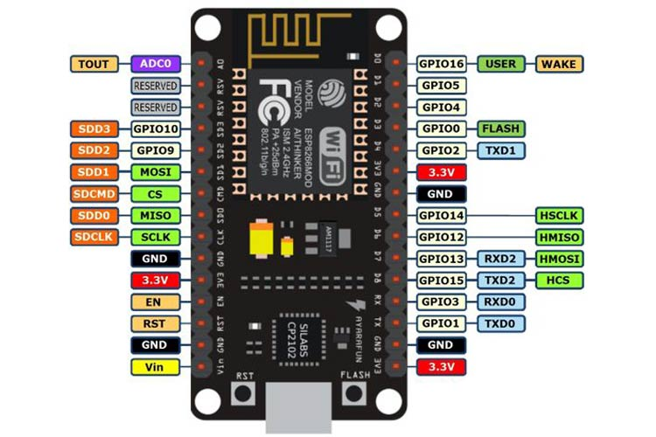

nodeMCU ESP8266

Pin Description-

|  |  |  |
| --- | --- | --- |
| Power | Micro-USB, 3.3V, GND, Vin | Micro-USB: NodeMCU can be powered through the USB port  3.3V: Regulated 3.3V can be supplied to this pin to power the board  GND: Ground pins  Vin: External Power Supply |
| Control Pins | **EN, RST** | The pin and the button resets the microcontroller |
| Analog Pin | A0 | Used to measure analog voltage in the range of 0-3.3V |
| GPIO Pins | GPIO1 to GPIO16 | NodeMCU has 16 general purpose input-output pins on its board |
| SPI Pins | SD1, CMD, SD0, CLK | NodeMCU has four pins available for SPI communication. |
| UART Pins | TXD0, RXD0, TXD2, RXD2 | NodeMCU has two UART interfaces, UART0 (RXD0 & TXD0) and UART1 (RXD1 & TXD1). UART1 is used to upload the firmware/program. |
| I2C Pins |  | NodeMCU has I2C functionality support but due to the internal functionality of these pins, you have to find which pin is I2C. |

ESP8266 Technical Specifications-

|  |  |
| --- | --- |
| Microcontroller | Tensilica 32-bit RISC CPU Xtensa LX106 |
| Operating Voltage | 3.3V |
| Input Voltage | 7-12V |
| Digital I/O Pins (DIO) | 16 |
| Analog Input Pins (ADC) | 1 |
| UARTs | 1 |
| SPIs | 1 |
| I2Cs | 1 |
| Flash Memory | 4 MB |
| SRAM | 64 KB |
| Clock Speed | 80 MHz |
| USB-TTL based on CP2102 is included onboard | Enables Plug n Play |
| PCB Antenna |  |

4d. Anticipated Workplace Environment-

The product is intended for outdoor use on lawns. The design of the product should ensure safety of those present in the lawn at the time of usage as well as the safety of other equipment and other obstacles present in the lawn environment at the given time.  The design should also ensure reliable functioning and safety of the product itself given environment it is being placed in. As such, the product must be able to detect and avoid obstacles, have a display that is visible outdoors, and sensors to detect if the product has been knocked over or stuck due to external factors. The product should also be enclosed within a protective housing to ensure its optimal functioning regardless of the weather conditions.

4e. Schedule Constraints-

The deadlines have been set keeping in mind the date of the final project demonstration.

The deliverables have to be submitted on time in order to ensure progress of the project.

The deadlines have to be met in order to ensure efficient running of the company/team and usage of minimum resources along with bringing the product out to the client/market in time for summer, which is the peak season for customers to invest in this product.

Failing to do so would result in losses for the company in terms of resources, sales and market share (in our case grades).

Task 1: Analysis State of the Art || Deadline: 22. Apr 2020, 00:00

This deadline has been set keeping the final project demonstration in mind. This task comprises the analysis of current state of the art solutions in order to make the correct choices of technology and equipment when designing the Robot mower. This task has to be delivered within the specified date in order to ensure the progress of the project.

Task 2: Requirement Document ||Deadline: 29. Apr 2020, 00:00

This deadline has been set keeping the final project demonstration in mind. This task comprises the accounting for and documentation of the project’s constraints, requirements and potential issues in order to maintain an organized approach to realizing the final product by focussing first on what the product should accomplish and not on how the product should accomplish its tasks. This task has to be delivered within the specified date in order to ensure the progress of the project.

Task 3: Use-Case Diagram and SysML || Deadline: 06. Mai 2020, 00:00

This deadline has been set keeping the final project demonstration in mind. The aim of this deadline is to familiarize ourselves with SysML and UML in order to proceed with the future tasks. A use-case diagram with all actors and the system-boarder. A parametric/block diagram of the whole system. The state-machine of the main functionality of the machine. This task has to be delivered within the specified date in order to ensure the progress of the project.

Task 4: Refinement Requirement Document || Deadline: 20. Mai 2020, 00:00

This deadline has been set keeping the final project demonstration in mind. This task comprises refining the initial requirement document as deemed fit by the team in order to ensure that the product can be completely realized as mentioned within the document, after gaining a deeper understanding of the limitations and functionalities possible in the course of the project. This task has to be delivered within the specified date in order to ensure the progress of the project.

Task 5: Intermediate Presentation - A || Deadline: 26. Mai 2020, 00:00

This deadline has been set keeping the final project demonstration in mind. This task comprises an initial product review with the project manager and client in order to ensure the progress of the product in the right direction and to implement any changes as deemed fit by the manager and client. This task has to be delivered within the specified date in order to ensure the progress of the project.

Task 6: Intermediate Presentation – B || Deadline: 09. June 2020, 00:00

This deadline has been set keeping the final project demonstration in mind. This task comprises a product review with the project manager and client in order to ensure the progress of the product in the right direction and to implement any changes as deemed fit by the manager and client. This task has to be delivered within the specified date in order to ensure the progress of the project.

Task 7: Final Presentation || Deadline: 30. Jun 2020, 00:00

This deadline has been set as the date the product is introduced into the market (presented to the client) by which all functionality should be implemented and the product fully functional.

4f. Budget Constraints-

The budget set for this project is a total of 40 Euros.

This includes 20 Euros towards a Smart robot Car Assembly DIY Kit Set on eBay. The remaining 20 Euros will be used to fund the individual solutions implemented to realize the final product. Failure to do so will result in losses from the company and possible withdrawal of investors.

After conducting an analysis of the state of the art, it has been concluded that the budget of 40 euros will make the product competitive and give it an upper hand in the market, aside from being realizable withing budget.

Given the current market release date in June, the product will hit the market in the peak of summer time, which is considered the peak sales time of the year for such products. To conclude, the budget and timeline are well thought through and realizable.

**5. Naming Conventions and Definitions**

5a. Definitions of All Terms, Including Acronyms, Used in the Project-

IDE - Integrated development environment (IDE) is a software application that provides comprehensive facilities to computer programmers for software development. An IDE normally consists of at least a source code editor, build automation tools and a debugger.

### 6. Relevant Facts and Assumptions

Additional sensors needed to realize the product will be accounted for as long as it lies within the stipulated budget. Exceeding the budget will lead to losses to the company/team. Refunds for additional expenditure will be met provided invoices are produced at the time of audit.

### 7. The Scope of the Work

7a. Current Situation-

Cutting performance is the primary objective of the product in today’s market. While new features and performance improvements are being constantly implemented, the focus is no longer limited to the mowing operation, and more emphasis is being given to new fields such as connectivity and integration with smartphones, security, tracking, intuitive and seamless interaction with the robot, etc.

7b. Context of the Work-

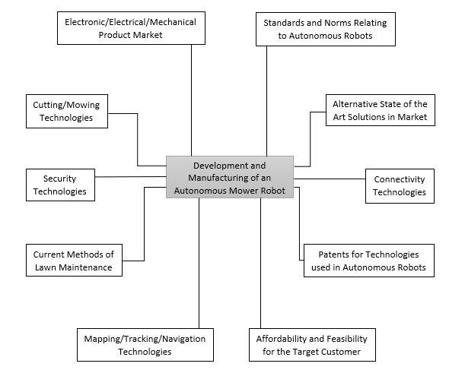

The development and manufacturing of an autonomous mower robot deals with various fields and domains such as-

1. Electronic/Electrical/Mechanical Product Market-

Survey of products in these fields is necessary to check the availability and cost of products required in the development and manufacturing process

1. Standards and Norms Relating to Autonomous Robots-

Standards and norms need to be studied to define legal and compliance requirements of the product and to avoid future legal problems

1. Cutting/Mowing Technologies-

The current technologies in cutting/mowing process must be studied to formulate a feasible and cost-effective mowing solution

1. Alternative State of the Art Solutions in Market-

Market survey should be conducted to understand what the competition offers and what improvements are possible

1. Security Technologies-

To eliminate or minimize the risk of theft of any kind, security measures must be incorporated into the product, for which available solutions must be studied

1. Connectivity Technologies-

In today’s digital age, integration with various handheld devices and platforms is a must, which is why connectivity technologies and opportunities must be explored

1. Current Methods of Lawn Maintenance-

Current scenario of lawn maintenance industry must be studies to provide innovative and effective solutions

1. Patents for Technologies used in Autonomous Robots-

Patents regarding any technologies to be implemented in the product must be appropriately cited and given credit to, to avoid issues such as plagiarism

1. Mapping/Tracking/Navigation Technologies-

As an integral part of an autonomous device, navigation technology is a need of the product and thus, must be studied in detail to provide efficient solutions

1. Affordability and Feasibility for the Target Customer-

While offering the best possible technological solution, it is also necessary to gauge whether the product is suited for the target customer’s use and need, and if it is cost effective. Thus, the target customer must be identified beforehand to determine the technological and monetary extent of the product

### 8. Scope of the Product

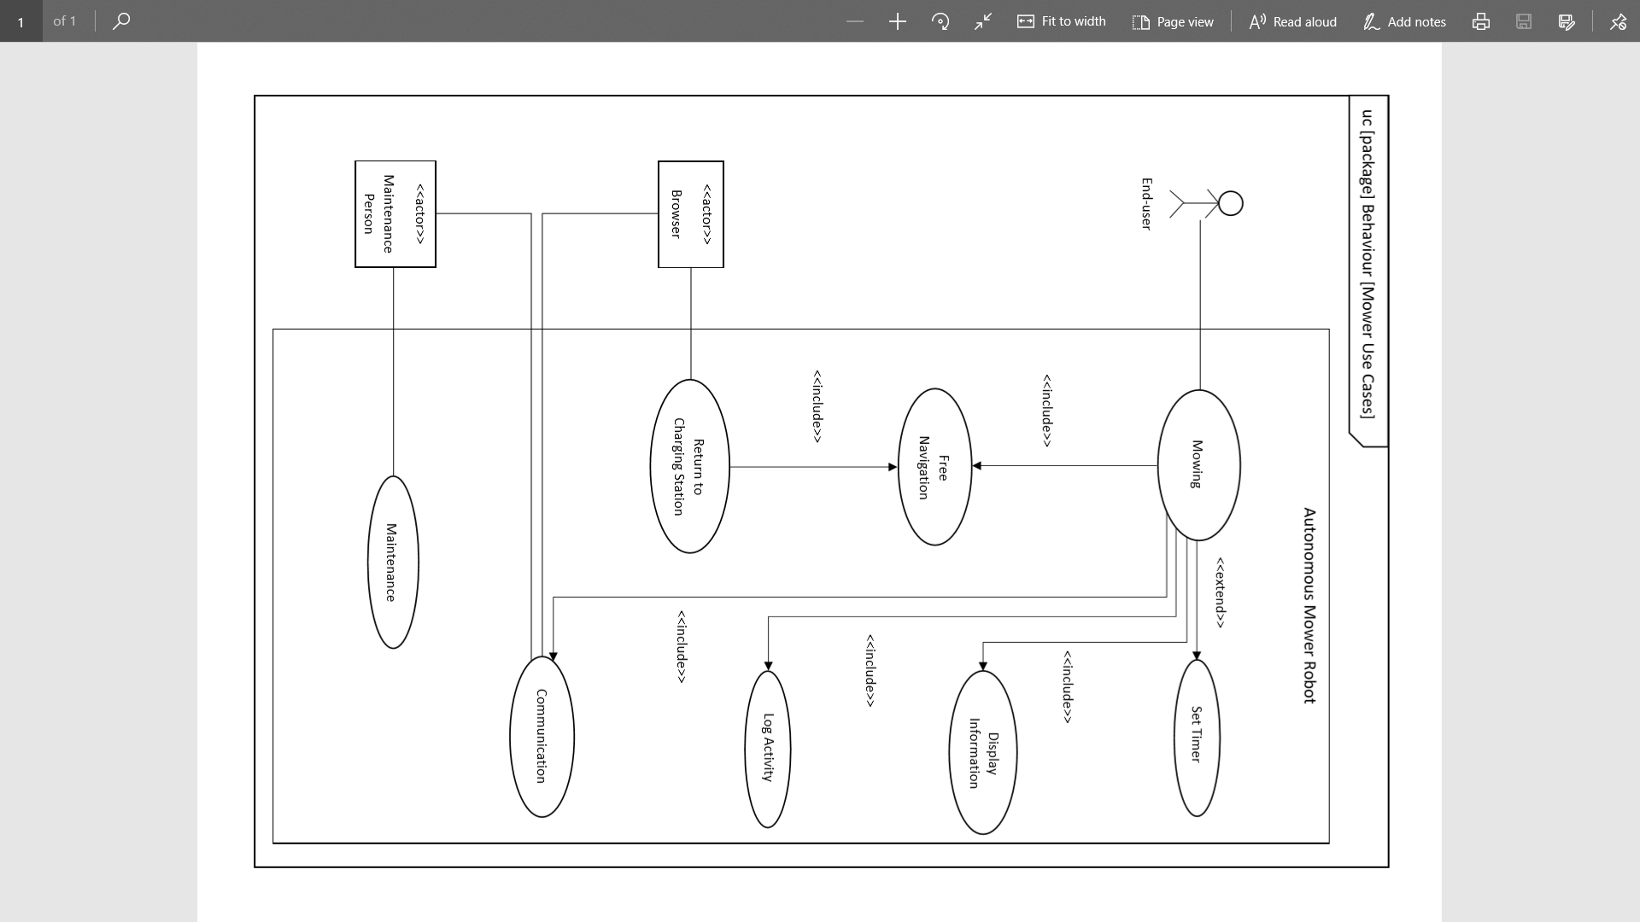

### 9. Functional and Data Requirements

9a. Functional Requirements-

1. Description- To enable the robot to map the mowing area, either on its own, or by using a pre-programmed map

Rationale- To prevent unwanted mowing and protect the environment and the robot from harm

Fit Criterion- During testing, the robot doesn’t go beyond a few cm of the region boundary

1. Description- To detect and stop before any obstacles in the way and reroute mowing path avoiding the object

Rationale- To prevent harm to any humans/objects and ensure uninterrupted mowing

Fit Criterion- The robot detects an obstacle from a few cm and stops/reroutes instantaneously

1. Description- To start the mowing process either manually or using a timer

Rationale- To provide easy control and convenient timing of operation for the customer

Fit Criterion- During testing, the robot starts mowing immediately after receiving start command and doesn’t show any time lag

1. Description- To provide onboard switches on the robot and in the mobile UI to start mowing process

Rationale- To provide the customer easy and instantaneous access to start the mowing process

1. Description- To make the robot automatically return to the recharging dock location when battery falls below a certain limit

Rationale- To eliminate the need of manually fetching the robot and recharging it

Fit Criterion- During testing, the robot successfully retreats to charging position just before battery is depleted

1. Description- To provide an intuitive and smooth onboard HMI and mobile UI for customer-product interaction

Rationale- To provide convenience and comfort to the customer when interacting with the robot

1. Description- To provide one-touch operation for all possible functions of the robot

Rationale- To make the interaction with the robot as quick and smooth as possible

Fit Criterion- During testing, robot successfully carries out specified function at the press of a button

1. Description- To prevent overcharging/oversurging of battery using internal systems for battery management

Rationale- To ensure healthy operation of battery and prevent harm to the robot or customer

Fit Criterion- During maintenance check, analysis of battery shows healthy result

1. Description- To provide access to the robot interface using a browser

Rationale- To simplify development of customer-robot interface and eliminate the need to install another app/software

9b. Data Requirements-

1. Description- To display current state of the robot on the onboard robot display and mobile UI

Rationale- To ensure the customer access to all relevant information regarding the working and state of the robot

Fit Criterion- Battery level, operating status, etc. is continuously shown on the HMI and mobile UI

1. Description- To provide battery level information to the customer at all times

Rationale- To enable the customer to predict operating times and schedule charging process

1. Description- To store information about operating times of the robot and provide the customer access to it

Rationale- To enable the customer to analyse and monitor robot usage and to assist maintenance processes

Fit Criterion- Operation time logs are accessible

1. Description- To store exact date and time of mowing and provide the customer access to it

Rationale- To enable the customer to analyse and monitor robot usage and to assist maintenance processes

Fit Criterion- Operation time logs are accessible UI

1. Description- To sync smartphone real-time clock with the robot

Rationale- To enable logging of mowing times and scheduling mowing process

Fit Criterion- Time shown on robot HMI and smartphone should be same with minimal error difference

stm [stateMachine] Mower Behaviour

Stand by

Pin verification

Do/Stay at Dock, Motors and Sensors OFF

Exit/Initialize

Do/Motors and Sensors ON

Start mowing

On-Board instruction

Obstacle Detected

On-Board instruction

Do/Reroute

Mobile app

[Pin code == setValue]

[UltrasoundDistance<=10cm || InfraredDetection==Yes]

Emergency Stop

Do/Motors and Sensors OFF

[InfraredDetection==Yes]

Mobile app

On-Board Instruction

Boundary Detected

Mobile app

Do/Reroute

[BatteryLife<=10%] seconds]

Completed

Mowing

On-Board Instruction

Low Battery

Do/Go to Dock, Cutting motor OFF

Do/Alert user, Cutting motor OFF, Go to Dock

Mobile app

[InfraredDetection==Yes]

Boundary Detected

Do/Adjust Path

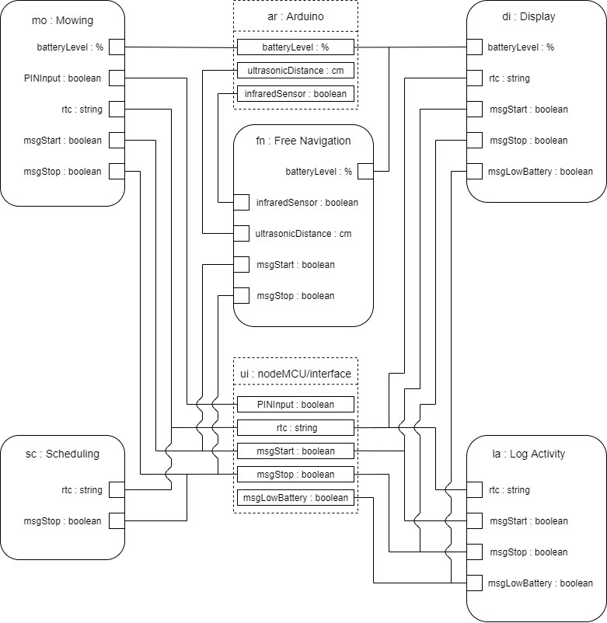

par [block] Mowing [Constraint Parameter – Value Property Bindings]

### 10. Look and Feel Requirements

10a. Appearance Requirements-

1. Description- To have minimal buttons/switches
2. Description- To make a clean minimalistic HMI
3. Description- To sync mower behaviour well with the mobile unit

10b. Style Requirements-

1. Description- To develop a clean “Apple-like” UI

### 11. Usability and Humanity Requirements

11a. Learning Requirements-

1. Description- The customer should be able to get acquainted with the robot HMI and mobile UI in a couple minutes without having to refer to a user manual

11b. Understandability and Politeness Requirements-

1. Description- The surface of the robot should be self-explanatory

### 12. Performance Requirements

12a. Speed and Latency Requirements-

1. Description- The robot should be able to cover an area of minimum 4x5 m2 on a full single charge

12b. Capacity Requirements-

1. Description- The robot should complete mowing in at most 12 hours

12c. Longevity Requirements-

1. Description- The robot should operate without failure for at least some weeks/months

### 13. Operational and Environmental Requirements

13a. Expected Physical Environment-

1. Description- The robot should be able to scale a slope of up to 20% without slipping or reducing speed
2. Description- The robot should be able to move over obstacles of size up to 1 cm without stopping

### 14. Maintainability and Support Requirements

14a. Maintenance Requirements-

1. Description- The recharging/replacement of batteries should be done by the customer
2. Description- The replacements of parts such as the knives/cutting blades should be done by the customer

### 15. Legal Requirements

15a. Standards Requirements-

1. Description- The robot should comply with safety regulations according to ISO12100 and be justified by a risk analysis

### 16. Open Issues

1. The size and shape of the lawn to be mowed is ambiguous. In order to deal with the given requirement specification, new methods of navigating the lawn have to be thought of and implemented.
2. Locating of the mower in real time is yet to be discussed as the current GPS technology available is not accurate enough for the purpose. The path planning method is being looked into as a resolution

### 17. Off-the-Shelf Solutions

17a. Ready-Made Products-

1. Husqvarna Automower 450xh

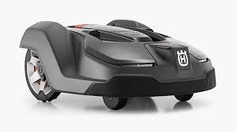

1. Honda Miimo HRM310

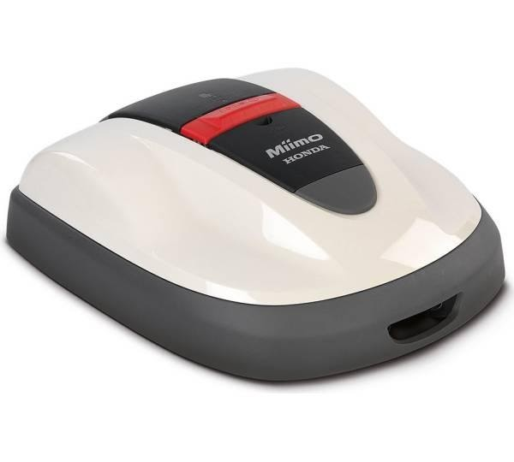

1. Smart Robotic Mower Sileno Life 1250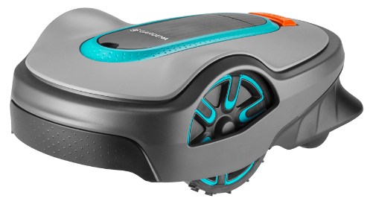
2. Robomow RS622

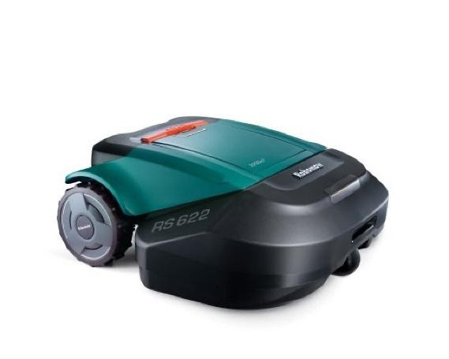

1. Yard Force X100i

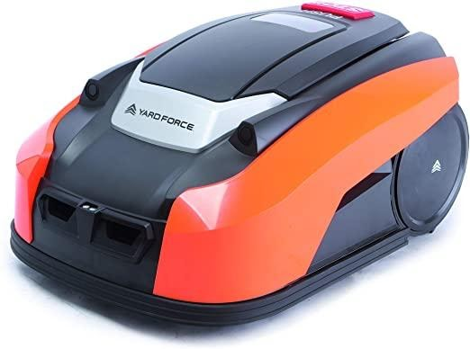

These robot mowers were taken into consideration. It was found that while these mowers are perfectly functional and potent to handle the task, they are often extremely expensive and offer a lot of features that are not required by the client and hence, are noted as un- viable solutions in the market today.

17b. Reusable Components-

Creating new controllers, motors and sensors would incur a heavy cost in terms of personnel, equipment and research and development and hence, the best approach would be to use easily available, preferably open source technologies to implement solutions and realize our final product. As such, Arduino, the controller, motors, battery technology and even the base architecture for the product would be purchased from vendors and utilized in the project, thereby cutting our costs and shortening our timeline to develop an effective product for the market.

### 18. New Problems

17a. Effects on the Current Environment-

The mower may interrupt people walking in its working environment, i.e. the lawn.  To take care of this however, and in order to provide obstruction free usage of the lawn, the user can schedule mowing activities according to the time of day the lawn is used the least. The mower also detects objects and people in the lawn and will avoid and change its path to avoid being an obstruction and potential safety hazard.

18b. Limitations in the Anticipated Implementation-

Given the size of the mower being developed, the wheels may be too small to traverse over slightly larger obstacles (e.g - large stones) in the working environment.

### 19. Migration to the New Product

The migration to the product is intended to be easy and fast.

The charging dock for the mower has to be set up in an easy to access location, for easy changing of the battery.

The mower must also be connected to the WiFi using the web-based application.

### 20. Risks

The main risks include failure of equipment such as sensors and motors which would impact the even the basic functionality of the project. Care is to be taken while developing the product to protect these resources.

Given the budget of 20 Euros, the housing for the system may not be of very high quality and hence electrical damage or other damages due to external factors, be it obstructions or weather conditions or even objects stuck in functional components of the mower may pose a problem.

### 21. User Documentation and Training

21a. User Documentation Requirements-

Technical specifications

User manuals

Service manuals

Emergency procedure manuals and warnings

Warranty Card

21b. Training Requirements-

The product is meant to be as simple as possible and hence no training would be required. However, a brief guide to using the product could be offered if requested by the customer at installation time, and further, a helpline would be setup to answer any queries that the customer may have about the setup and functioning of the mower.

### 22. Waiting Room

The product will come with its own self recharging. This will free users completely of the hassle to changing the battery of the mower, thereby increasing the autonomous functioning of the mower.

The product will have a blade life indicator to indicate to the user when the ideal time to change the blade would be, instead of the user having to guess the approximate duration of use after which the blades require maintenance

The product would be able to cut at different heights, thereby improving the functionality of the mower.

The product could also be synced to the local weather stations in order to know the impending weather conditions and hence this could prevent the deployment of the mower in bad weather conditions. This could also prevent the mowing of the lawn in case of ice formation, which would otherwise harm the lawn.

### 23. Ideas for Solutions

In order to prevent failure of equipment, care is to be taken while developing the product to protect these resources, in particular the sensors and the motors.

The housing should be made in such a way that all electrical and functional equipment is protected from external factors such as obstructions or weather conditions or even objects stuck in functional components of the mower. The design and looks will be given a lower priority than maintaining the functionality of the system/product

The product could also be synced to the local weather stations in order to know the impending weather conditions and hence this could prevent the deployment of the mower in bad weather conditions. This could also prevent the mowing of the lawn in case of ice formation, which would otherwise harm the lawn.

A bumper could be installed on the mower in order to minimize damages to both impacted parties in case such a situation occurs.