SRM INSTITUTE OF SCIENCE AND TECHNOLOGY
School of Computing • Department of Computing Technologies
Course: Indian Art Form (21LEM301T / 21CSC301T) • Component: CLA-II Assignment 2 (CO2 • 10 Marks)
_________________________________________________________________________________
Sacred Topography, Imperial Ideology, and Monolithic Innovation:
A Thematic and Iconographical Analysis of the Pallava Rock-Cut Sculptures at Mahabalipuram
A Seven-Page Academic Research Monograph on the 7th–8th Century Coromandel Sacred Landscape
RESEARCH PROJECT INVESTIGATORS & AUTHORS:
Nisheed Kumar Rout (Reg. No: RA2411003011822) • Rudra Prakash Swain (Reg. No: RA2411003011778)
Abhinav Singh (Reg. No: RA2411003011820) • Krishan Kumar (Reg. No: RA2411003011812)
Samant Kumar Mishra (Reg. No: RA2411003011790)
Department of Computing Technologies, SRM Institute of Science and Technology, Kattankulathur, Tamil Nadu
Date of Submission: October 2026

ABSTRACT: This research paper provides a comprehensive thematic, iconographical, and architectural investigation into the 7th-to-8th-century CE rock-cut monuments and monumental bas-reliefs of Mahabalipuram (Mamallapuram), situated on the coastal granite littoral of northern Tamil Nadu. Carved under the visionary royal patronage of the Pallava dynasty—predominantly King Mahendravarman I (r. 600–630 CE) and his martial successor Narasimhavarman I 'Mamalla' (r. 630–668 CE)—the site exemplifies a paradigm shift in South Asian lithic technology. The monuments are critically evaluated across four distinct structural categories: the rock-excavated pillared sanctuaries (mandapas), the monolithic free-standing shrines sculpted top-down from living granite ridge outcrops (the Pancha Rathas), the colossal open-air cliff-face relief friezes (Descent of the Ganges / Arjuna's Penance), and the early maritime structural masonry temples (the Shore Temple). Through an interdisciplinary synthesis of sacred iconography, epigraphical panegyrics (prasastis), hydrological engineering, and Indian Ocean maritime trade networks, this study elucidates how Pallava artisans harmonized cosmic theological allegories with royal imperial propaganda. Special attention is directed to the polysemic narrative structure of the great bas-relief, the architectural prototyping of Dravidian vimanas, the dramatic kinetics of the Mahishasuramardini Cave, and the pastoral humanism of the Krishna Mandapa. Ultimately, the paper demonstrates how Mahabalipuram served as an experimental architectural crucible that established the formal syntax of South Indian Dravidian sacred art and disseminated its sculptural vocabulary across Southeast Asia.
Keywords: Mahabalipuram, Pallava Dynasty, Descent of the Ganges, Arjuna's Penance, Pancha Rathas, Monolithic Architecture, Rock-Cut Caves, Dravidian Vimana, Iconography, Narasimhavarman I.

1. Introduction: The Pallava Dynastic Horizon and the Sacred Landscape of Mamallapuram
Geopolitical Context and Royal Hegemony: The ancient coastal settlement of Mahabalipuram (traditionally known as Mamallapuram or Kadalmallai), positioned on the wind-swept Coromandel Coast of northern Tamil Nadu, represents one of the most astonishing monumental achievements in ancient and early medieval South Asian civilization. Inscribed on the UNESCO World Heritage list in 1984, the site preserves an unparalleled concentration of 7th- and 8th-century rock-cut caves, free-standing monoliths, open-air cliff bas-reliefs, and maritime masonry temples. These works were executed during the zenith of the Pallava dynasty (circa 575–897 CE), a regional imperial power that governed the historical region of Tondaimandalam from their inland royal capital at Kanchipuram (Nilakanta Sastri, 1955).
The Epigraphical Paradigm Shift: The geological terrain of Mahabalipuram is distinguished by its dramatic outcrops of grey charnockite and granitic diorite boulders, stretching along a north-south whaleback ridge adjacent to the Bay of Bengal. Prior to the 7th century, stone was considered an intractable, spiritually inert substance in the Tamil country; monumental religious structures were predominantly fabricated from perishable organic materials, including seasoned timber, sun-dried brick, bamboo, and lime plaster (chunam). The revolutionary decision to carve sacred shrines directly out of intractable living bedrock was initiated by King Mahendravarman I (r. 600–630 CE), an illustrious monarch celebrated by the royal epithets Vichitrachitta ('Curious-Minded' or 'Innovator in Art') and Mattavilasa ('Addicted to Pleasure'). In his famous Sanskrit foundation inscription in the cave temple at Mandagapattu, Mahendravarman triumphantly proclaimed that he had constructed a mansion for the Trimurti (Brahma, Ishvara, and Vishnu) without employing brick, timber, metal, or mortar, thereby inaugurating the lithic era of Tamil sacred architecture (Dehejia, 1997).
Maritime Emporium and Trans-Oceanic Nexus: Following Mahendravarman's reign, his illustrious son and martial successor, King Narasimhavarman I (r. 630–668 CE), assumed the sovereign title of 'Mamalla' ('The Great Wrestler') after his decisive military triumph over the Western Chalukyan Emperor Pulakeshin II and the subsequent sack of the Chalukyan capital at Vatapi (Badami) in 642 CE. Narasimhavarman transformed the maritime port into an imperial showcase of dynastic majesty, commissioning the world's most expansive cliff bas-reliefs and the monolithic prototypes known as the Pancha Rathas. Mahabalipuram operated concurrently as a thriving international maritime emporium. Merchant fleets, envoys, and pilgrims from Sri Lanka, the Srivijaya Empire of Sumatra, Java, Funan, and imperial Tang China frequented the harbor, anchoring beneath the towering granite headlands. The sculpted monuments served not merely as inward-looking liturgical shrines, but as colossal imperial beacons that broadcast the theological sophistication and sovereign majesty of the Pallava state across the Indian Ocean basin (Lockwood et al., 1974).

2. The Four Architectural-Sculptural Typologies of Pallava Art
Taxonomy of Lithic Forms: Scholars of Indian temple architecture (notably Percy Brown, Stella Kramrisch, and Meister & Dhaky) classify the monuments of Mahabalipuram into four distinct structural and technological categories, each reflecting an evolutionary phase in stone excavation techniques and liturgical planning:
1. Rock-Cut Cave Mandapas: These pillared cave temples represent the earliest phase of rock architecture at the site. Excavated horizontally into the vertical faces of granite hills, mandapas feature an open colonnaded verandah (mukhamandapa), an inner hall (ardhamandapa), and one or more rectangular sanctum niches (garbhagrihas) hollowed into the rear wall to enshrine lingas or painted deities. Pillars evolved rapidly from the heavy, unadorned cubical shafts with octagonal middle sections characteristic of Mahendravarman's reign into slender, fluted columns supported by seated leonine caryatids (vyala-stambhas) under Narasimhavarman I. Prominent examples include the Varaha Cave, Mahishasuramardini Cave, Trimurti Cave, and the Krishna Mandapa.
2. Monolithic Shrines (Rathas): The rathas represent a daring technological breakthrough unique to Mahabalipuram: free-standing monolithic temples carved top-down (ex-rupe) from isolated whaleback boulders and granite outcrops. Unlike excavated cave interiors, rathas were treated as complete three-dimensional sculptures, replicating in stone the multi-storied timber-and-thatch pavilions, chaitya assembly halls, and thatched village huts of contemporary vernacular architecture. The primary cluster, the Pancha Rathas, served as an open-air architectural design workshop or experimental design studio where architects tested full-scale models of vimana superstructures.
3. Colossal Open-Air Cliff Reliefs: Mahabalipuram houses two colossal open-air bas-relief friezes sculpted directly upon natural granite cliff faces. The most celebrated of these is the monumental composition spanning two boulders commonly identified as the 'Descent of the Ganges' or 'Arjuna's Penance'. Measuring 96 feet in length by 43 feet in height, it integrates natural geological clefts, rainwater drainage channels, and over one hundred sculpted figures into an integrated sacred tableau without precedent in world art.
4. Structural Masonry Temples: Constructed during the reign of King Narasimhavarman II Rajasimha (r. 700–728 CE), the Shore Temple represents the decisive transition from rock-cut excavation to free-standing structural masonry architecture. Built of dressed granite blocks right at the ocean's water edge, the complex features two tiered pyramidal vimanas dedicated to Shiva flanking an intervening rectangular shrine housing a monolithic reclining Vishnu (Anantasayana). The complex was enclosed by a prakara wall surmounted by sculpted granite Nandi bulls, braving salt-laden oceanic winds for over thirteen centuries.

3. The Monumental Cliff: Iconographical Exegesis of the 'Descent of the Ganges' (Arjuna's Penance)
Spatial Choreography and Geological Integration: Spanning an expanse of nearly four thousand square feet across two titanic diorite boulders, the monumental open-air relief at Mahabalipuram is unanimously regarded by art historians as the supreme masterpiece of South Asian narrative sculpture. The composition is bisected down its center by a deep, natural vertical fracture or cleft in the living rock. Pallava master sculptors demonstrated astonishing ecological and artistic ingenuity by incorporating this natural fissure directly into the sacred narrative as the cosmic conduit through which the celestial river Ganga descends from the heavens to sanctify the mortal world and purify the ashes of King Sagara's sixty thousand cursed sons (Huntington, 1985).

Figure 1: The colossal open-air granite bas-relief 'Descent of the Ganges' (Arjuna's Penance), measuring 96 ft by 43 ft across two natural granite boulders at Mahabalipuram (7th Century CE, Pallava Dynasty).
The Polysemic Debate: Dual Interpretations: The relief has generated an enduring academic debate regarding its primary theological subject, centered on two non-mutually exclusive hypotheses:
• The Puranic Myth of Bhagiratha (Descent of the Ganges): In this reading, the emaciated ascetic standing on one leg with arms raised high above his head (urdhva-bahu) is King Bhagiratha performing severe ascetic penance (tapasya) to entreat Lord Shiva to break the catastrophic impact of Ganga's torrential celestial descent using his tangled matted locks (jata-mukuta). In support of this interpretation, Pallava hydraulic engineers constructed a masonry reservoir atop the cliff boulders; during temple celebrations and monsoon festivals, water was released down the central fissure, causing the sculpted nagas (serpentine water deities) to appear as though they were undulating dynamically upward through actual rushing waters.
• The Epic Narrative of Arjuna's Penance (Kiratarjuniya): Drawing from the Mahabharata and Bharavi's celebrated 6th-century courtly poem Kiratarjuniya (a literary work well known in the Pallava court), the ascetic is identified as the Pandava hero Arjuna performing severe tapas in the Himalayas to secure the celestial weapon Pasupatastra from Lord Shiva. In the relief, Shiva is depicted standing immediately to the ascetic's right as a towering four-armed divinity brandishing his battle axe and attended by dwarfish ganas, holding his lower right hand in the varada (boon-bestowing) mudra (Lockwood, 1974).
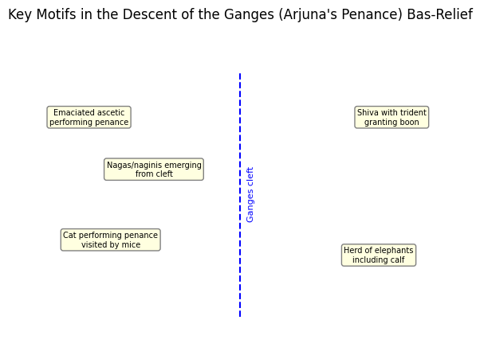
Figure 2: Architectural and iconographical schematic mapping the key motifs: the central river cleft, Shiva's boon, the meditating ascetic, ascending nagas, the satirical cat, and the elephant herd in the Mamallapuram relief.
Poetic Shlesha in Granite: Contemporary art historians (including Vidya Dehejia and Padma Kaimal) emphasize that this visual ambiguity was deliberate and intentional—a hallmark of Sanskrit courtly double entendre (shlesha). By conflating the ascetic devotion of Bhagiratha with the warrior valour of Arjuna, the Pallava sovereign Narasimhavarman I aligned his own kingly authority with both royal piety and martial invincibility.
Sculptural Motif | Iconographical & Mythological Identification | Semiotic and Symbolic Function
The Central Vertical Cleft | Cosmic River Ganga & Nagas | Physical manifestation of celestial waters descending to earth; inhabited by King Nagaraja and Queen Nagini with folded hands (anjali mudra).
The Emaciated Ascetic | Bhagiratha / Arjuna in Tapasya | Depicted with exposed ribcage and sunken stomach; embodies absolute spiritual concentration (dhyana) on one leg with arms raised skyward.
Four-Armed Lord Shiva | Pasupata-murti / Boon Bestower | Flanked by rotund ganas; holds battle axe; grants divine audience to the ascetic in the varada-mudra of absolute grace.
The Life-Sized Elephant Herd | Airavata Progeny & Water Spirits | A massive bull elephant (over 17 ft wide), protective cow, and four calves nestling between adult legs; symbols of imperial majesty and rain clouds.
The Satirical Penitent Cat | Panchatantra / Hitopadesha Parody | A hypocritical cat standing on its hind legs imitating an ascetic while unsuspecting mice dance around its feet; folk humor humanizing high theology.
Celestial Kinship Assemblage | Gandharvas, Kinnaras, Vidyadharas | Over 100 celestial couples and forest animals (lions, deer, monkeys, birds) flying toward the river cleft in reverent adoration.

4. Monolithic Architectural Prototyping: The Pancha Rathas as Lithic Blueprints
The Monolithic Laboratory: Situated eight hundred meters south of the main village settlement, the Pancha Rathas (colloquially named after the five Pandava brothers and Draupadi from the Mahabharata epic) represent an unprecedented laboratory of temple architecture. Despite their popular nomenclature, these monuments bear no epigraphical or structural connection to the epic figures; they are consecrated Hindu shrines dedicated to Shiva, Vishnu, Durga, and Indra (Meister & Dhaky, 1983). Carved out of a single continuous sloping granite whaleback ridge, the sculptors worked strictly from top to bottom, quarrying waste material away to reveal five distinct freestanding architectural typologies:
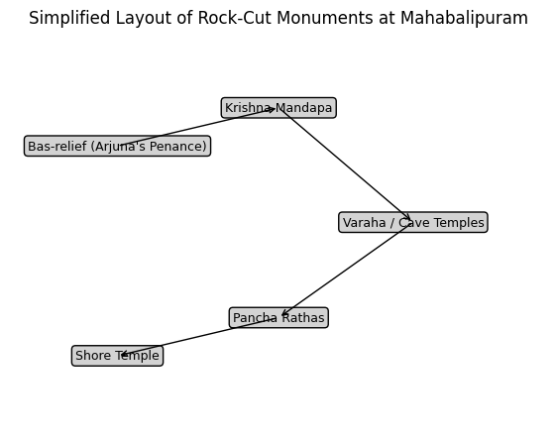
Figure 3: Panoramic view of the Pancha Rathas monolithic complex at Mahabalipuram, carved top-down from a single diorite ridge in the 7th century under King Narasimhavarman I Mamalla.
Morphological Analysis of the Five Shrines: 1. Dharmaraja Ratha: The largest, tallest, and most structurally complex monument in the complex. It features a square plan surmounted by a three-tiered pyramidal vimana (tritala), crowned by an octagonal crowning dome (shikhara) and stupika. Each tier is embellished with miniature dormer pavilions—barrel-vaulted salas and square kutas—interconnected by covered passages (haras). The lower tier contains twenty-two sculpted niches housing extraordinary iconographic masterworks, including Ardhanarishvara (the half-male Shiva, half-female Parvati composite form displaying exquisite gender synthesis), Harihara, Brahma, and the earliest known royal portrait sculpture of King Narasimhavarman I, inscribed with his royal titles Sri Megha ('Cloud of Prosperity') and Trailokyanatha ('Lord of the Three Realms') (Nilakanta Sastri, 1955).
2. Bhima Ratha: An elongated rectangular monolith characterized by a grand barrel-vaulted roof (sala-shikhara) with gable ends resembling horseshoe-shaped chaitya arches (kudus). Supported by open colonnaded verandahs resting on seated lion pillars (vyala-stambhas), this shrine was intended to enshrine a colossal reclining Vishnu (Anantasayana), reflecting architectural adaptations from ancient Buddhist congregational halls.
3. Arjuna Ratha: Sharing the same continuous plinth as the Draupadi Ratha, this shrine mirrors the Dharmaraja Ratha on a smaller scale. It exhibits a two-tiered square vimana (dvitala) with a circular shikhara. Its exterior walls are adorned with refined relief sculptures of Shiva leaning casually on Nandi, Vishnu holding his conch and discus, royal couples in aristocratic pose, and an attendant priest.
4. Draupadi Ratha: The simplest and most poetic shrine, sculpted in the form of a square rural village thatched hut with curving convex roof eaves reminiscent of the Bengali bangala pavilion. Dedicated to Goddess Durga (Kottravai), the interior sanctum houses a four-armed relief of the goddess standing on a lotus pedestal, flanked by two kneeling devotees—one of whom offers the ultimate devotional sacrifice of his own head (navakandam) in accordance with ancient Tamil martial customs.
5. Nakula-Sahadeva Ratha: Positioned slightly apart from the main axial row, this shrine exhibits an apsidal (semi-circular) rear ground plan termed gajaprishta ('elephant's backside'). Carved with a barrel-vaulted chaitya roof, it stands immediately adjacent to a life-sized monolithic granite elephant statue, demonstrating the artisan's witty visual analogy between the animal's physical anatomy and the temple's apsidal contour.

Figure 4: Monolithic pyramidal vimana and lion-based pillars of the Dharmaraja Ratha, exhibiting the prototype multi-tiered Dravidian tower architecture.

5. The Pillared Sanctuaries: Dramatic Kinetics and Theological Conflict in Cave Mandapas
Compositional Kinetics and Spatial Narrative: While the rathas demonstrate formal architectural prototyping, the interior reliefs of the rock-cut cave mandapas reveal the Pallava sculptors' unrivaled mastery over spatial kinetics, narrative drama, and physiological psychology. In contrast to the static, frontal hieratic imagery common to contemporary North Indian shrines, the cave panels at Mahabalipuram are imbued with diagonal tension, atmospheric depth, and heroic vigor (Brown, 1959).

Figure 5: Frontal view of the Rock-Cut Cave Mandapa, illustrating cushion capitals, fluted shafts, and seated vyala (lion) column bases characteristic of the Mamalla sculptural style.
The Iconic Masterpieces of the Mahishasuramardini Cave: The Mahishasuramardini Cave contains two monumental narrative reliefs carved on opposing lateral walls, forming a supreme theological counterpoint:
• Durga Mahishasuramardini (The Vanquishing of the Buffalo Demon): Sculpted across a grand rectangular panel, this relief is celebrated globally as one of the greatest compositional achievements in the history of art. The eight-armed Goddess Durga lunges aggressively forward atop her roaring maned lion, drawing her bowstring taut with relentless divine fury. She is accompanied by an army of flying ganas wielding clubs and swords. Opposing her on the right half of the panel is the colossal, muscular figure of Mahishasura, depicted not as a crude beast, but with a human body and a powerful buffalo head. Armed with a heavy iron mace, the demon king recoils on his back foot, his knees buckling under the goddess's righteous onslaught. The diagonal thrust of the composition vividly captures the psychological moment of demonic collapse, balancing cosmic equilibrium against chaos.
• Vishnu Anantasayana (The Cosmic Slumber): Directly facing the furious kinetics of the Durga panel, the opposing wall presents an oasis of cosmic tranquility. Lord Narayana reclines in deep yoga-nidra upon the undulating five-headed coils of the serpent Adishesha, floating upon the primordial cosmic ocean. Above him hover the personified anthropomorphic weapons (ayudha-purushas), while at his feet, the ferocious demons Madhu and Kaitabha stand hesitating, poised to attack yet immobilized by the sheer aura of divine serenity. This dialectical pairing of kinetic martial righteousness and serene cosmic preservation encapsulates the dual theological pillars of Pallava royal ideology (Kramrisch, 1946).

6. Pastoral Naturalism, Animal Realism, and the Emerging Bhakti Ethos
Sympathetic Naturalism and Vernacular Intimacy: A profound and distinguishing hallmark of Pallava sculptural art at Mahabalipuram is its affectionate, keenly observed naturalism—particularly in the depiction of animals and everyday rural agrarian life. Unlike classical Greco-Roman art, which focused almost exclusively on idealized human anatomy, or later medieval Indian sculpture, which increasingly formalized figures into codified iconic poses, Pallava artists treated animals and village folk with astonishing empathy and tenderness (Dehejia, 1997).

Figure 6: Tenderly sculpted monolithic elephant family relief from the Descent of the Ganges, displaying anatomical precision, soft skin folds, and playful calves nestling beneath the parent bull.
The Krishna Mandapa and Agrarian Devotion: This pastoral realism achieves its most sublime expression in the Krishna Mandapa. Here, Lord Krishna is depicted effortlessly lifting Mount Govardhana on the palm of his left hand to protect the pastoral community of Gokula from the tempestuous deluge unleashed by a jealous Indra. Beneath the sheltering canopy of the mountain, the artist captures an authentic tableau of 7th-century Tamil rural life: an agrarian milkman squats comfortably on his haunches milking a cow, while the cow affectionately turns her head to lick her newborn calf standing beside her; a village milkmaid gracefully balances a stack of milk pots upon her head while holding a woven basket; a shepherd plays a bamboo flute; and an elderly grandfather carries a smiling child on his shoulders.
This deliberate embrace of humble, everyday pastoral intimacy reflects the profound ideological impact of the emerging Tamil Bhakti movement. During this period, Tamil Alvar (Vaishnavite) and Nayanar (Shaivite) saint-poets—several of whom, such as Tirumangai Alvar, composed hymns specifically celebrating the sacred shrines of 'Kadalmallai'—democratized religious devotion, proclaiming that God was accessible not through esoteric Vedic sacrifices, but through emotional intimacy, unconditional love, and humble devotion. The Krishna Mandapa translates this democratic Bhakti theology into timeless stone reliefs (Nilakanta Sastri, 1955).

7. Royal Ideology, Maritime Trade, and Indian Ocean Trans-Oceanic Legacy
Divine Kingship and Imperial Allegory: Beyond their immediate liturgical and mythological functions, the monuments of Mahabalipuram functioned as potent instruments of imperial legitimacy and dynastic statecraft. The Pallava rulers astutely aligned their own monarchical reign with divine cosmic victories. In the Varaha Cave, King Narasimhavarman I is subtly equated with Vishnu's boar avatar Bhu-Varaha: just as Varaha dived into the cosmic abyss to rescue Mother Earth (Bhudevi) from the demonic titan Hiranyaksha, so too did the Pallava monarch rescue his kingdom from Chalukyan invasion and restore peace and cosmic righteousness (dharma) to the realm (Lockwood et al., 1974).
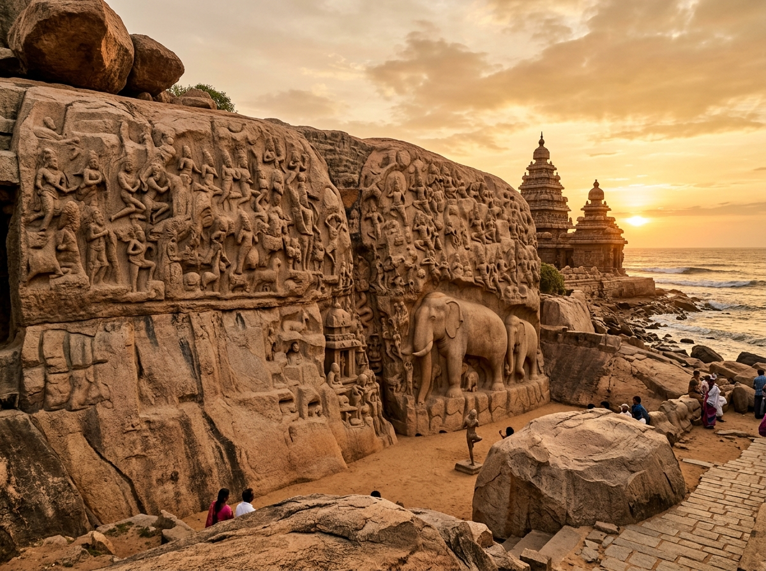
Figure 7: The Coastal Shore Temple at Mamallapuram, built circa 700–728 CE under King Narasimhavarman II Rajasimha, marking the historical transition to structural masonry Dravidian architecture on the Coromandel coast.
Indian Ocean Diffusion and the Pallava Grantha Horizon: Furthermore, Mahabalipuram served as the primary launching port for the extensive maritime, cultural, and religious transmission of Indian art and architecture across Southeast Asia during the first millennium CE. Epigraphical records written in the distinct Pallava Grantha script have been discovered throughout Thailand, Cambodia, Vietnam, Sumatra, and Java. The architectural and iconographical vocabulary developed at Mahabalipuram—particularly the multi-tiered vimana, the barrel-vaulted sala roof, the seated vyala column capitals, and the majestic dvarapala guardians—directly shaped early Hindu-Buddhist stone architecture in the Kingdom of Champa (Mỹ Sơn sanctuaries in Vietnam), the pre-Angkorian Chenla and Angkorian temples of Cambodia (Sambor Prei Kuk and Banteay Srei), and the early Sanjaya dynasty temples on the Dieng Plateau and Prambanan in Central Java (Dehejia, 1997). Mahabalipuram was thus not merely an isolated coastal pilgrimage town, but the vibrant intellectual and artistic nexus of a vast maritime cultural sphere encompassing the Bay of Bengal.

8. Conclusion and Historiographical Synthesis
Synthesis of the Lithic Revolution: The rock-cut monuments of Mahabalipuram occupy an exceptional, transformative position in the historiography of South Asian art. Over a span of less than a century, under the visionary patronage of Mahendravarman I, Narasimhavarman I Mamalla, and Rajasimha, Pallava artisans achieved a breathtaking technological and conceptual revolution. By transmuting fragile timber, brick, and thatch traditions into eternal granite, they established the enduring structural grammar, decorative vocabulary, and iconographic conventions of classical Dravidian temple architecture.
From the monumental narrative ambition of the Descent of the Ganges—which transformed living geological cliffs into cosmic canvases—to the monolithic typological experiments of the Pancha Rathas, the kinetic drama of the cave mandapas, and the poetic pastoral naturalism of the Krishna Mandapa, Mahabalipuram synthesizes religious devotion, sovereign imperial ideology, and natural landscape into an organic unity. The site stands as an immortal monument to the human artistic spirit, continuing to inspire architects, historians, and devotees worldwide.

9. Scholarly Bibliography & Works Cited
Brown, Percy. (1959). Indian Architecture (Buddhist and Hindu Periods). D. B. Taraporevala Sons & Co., Bombay.
Dehejia, Vidya. (1997). Indian Art. Phaidon Press, London.
Huntington, Susan L. (1985). The Art of Ancient India: Buddhist, Hindu, Jain. Weatherhill, New York & Tokyo.
Kaimal, Padma. (1994). Playful Ambiguity and Political Meaning in the Large Relief at Mamallapuram. Ars Orientalis, Vol. 24, pp. 1-27.
Kramrisch, Stella. (1946). The Hindu Temple (Vol. I & II). University of Calcutta, Calcutta.
Lockwood, Michael, Gift Siromoney, and P. Dayanandan. (1974). Mahabalipuram Studies. Christian Literature Society, Madras.
Meister, Michael W., and M. A. Dhaky. (1983). Encyclopaedia of Indian Temple Architecture: South India, Lower Dravidadesa (Vol. I, Part 1). American Institute of Indian Studies, New Delhi.
Nilakanta Sastri, K. A. (1955). A History of South India from Prehistoric Times to the Fall of Vijayanagar. Oxford University Press, Madras.
Sivaramamurti, C. (1952). Mahabalipuram. Archaeological Survey of India (ASI), New Delhi.
UNESCO World Heritage Centre. (1984). Group of Monuments at Mahabalipuram (Advisory Body Evaluation No. 249). UNESCO, Paris.

