Lab-9
Question 9:
• Prepare screen list
Solution:

Screen-1: Patient information form
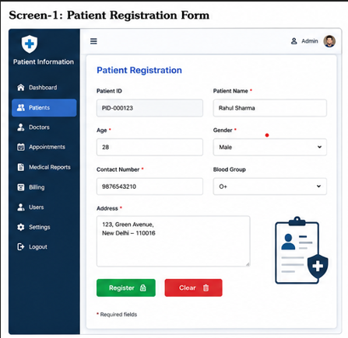
Figure 3.1-1 Screen-1: Patient information Form

Sr. | Screen Element | Input Type | O/M | 1/N | Description
1 | Patient ID | Textbox | M | 1 | Display auto generated patient ID
2 | Patient name | Textbox | M | 1 | Accept patient full name
3 | Age | Textbox | M | 1 | Accept patient age
4 | Gender | Dropdown | M | 1 | Select patient gender
5 | Contact number | Textbox | M | 1 | Accept valid mobile number
6 | Blood group | Dropdown | O | 1 | Select patient blood group
7 | Address | Textarea | M | 1 | Accept patient address
8 | Register button | Button | M | 1 | Save patient details into database
9 | Clear button | Button | O | 1 | Clear entered details

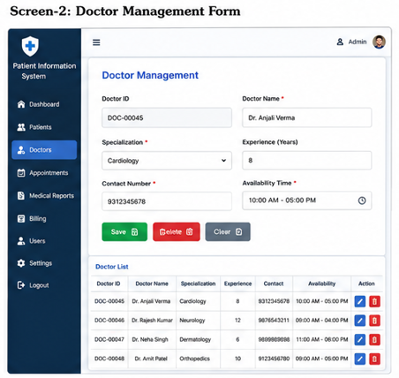
Figure 3.2-1 Screen-2: Doctor detail form

Sr. | Screen Element | Input Type | O/M | 1/N | Description
1 | Doctor ID | Textbox | M | 1 | Display auto-generated doctor ID
2 | Doctor name | Textbox | M | 1 | Accept doctor full name
3 | Specialization | Dropdown | M | 1 | Select doctor specialization
4 | Experience | TextBox | O | 1 | Accept years of experience
5 | Contact number | TextBox | M | N | Accept valid 10 digit contact number
6 | Availability time | Dat time | M | 1 | Check and select doctor available timing
7 | Save button | Button | M | 1 | Save doctor details
8 | Cancel Button | Button | O | 1 | Save doctor details

Screen-3: Appointment booking form
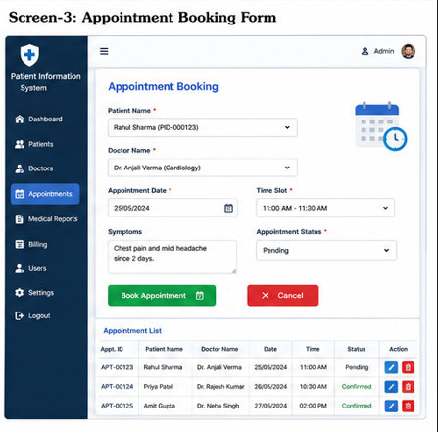
Figure 3.3-1 Screen-3: Appointment booking form

Sr. | Screen Element | Input Type | O/M | 1/N | Description
1 | Patient name | Dropdown | M | 1 | Select registered patient
2 | Doctor name | Drop down | M | 1 | Select doctor for appointment
3 | Appointment date | Date picker | M | 1 | Select appointment date
4 | Time slots | Time picker | M | 1 | Select appointment time
5 | Symptoms | Text area | O | 1 | Enter patient symptoms
6 | Appointment status | Dropdown | M | 1 | Select pending or confirmed status
7 | Book appointment | Button | M | 1 | Confirm or approve appointment booking
8 | Cancel button | Button | O | 1 | Cancel booking process

• Prepare database schema
  - List of Tables

2 Product view Database design

2.1 List of Tables
- UserAccount
- Song
- Playlist
- Artist Profile
Table 4.1-1 Table: UserAccount
Column | Data Type | Null | Keys & Constrains | Default Value & Description
Email address | Varchar(150) | NN | PK (Auto Increment) | Unique user login
Password | varchar(100) | NN
Role | Varchar(50) | NN |  | Account type selector
Display name | Varchar(100) | NN |  | User name shown on screen dashboard
IsRemembered | boolean | NN |  | Maps “Remember me” checkbox state

Table 1.1-2 Table: Song
Column | Data Type | Null | Keys & Constrains | Default Value & Description
SongID | int | NN | PK (Auto Increment) | Unique internal track
SongTitle | Varchar(150) | NN |  | Main title text field
AlbumName | Varchar(150) | AN |  | Optional container album value
Genre | Varchar(50) | NN |  | Dropdown-genre selection
Language | Varchar(50) | NN |  | Dropdown audio language selection
ReleasesDate | Date | NN |  | Calendar publication selector

Table 1.1-3 Table: Playlist
Column | Data Type | Null | Keys & Constrains | Default Value & Description
PlaylistID | int | NN | PK (Auto Increment) | Unique playlist identity code
PlaylistName | varchar(100) | NN |  | User name assignment
PlaylistType | varchar(50) | NN |  | Access selection dropdown
TotalTrack | int | NN |  | Counter tracking total added songs
DateCreated | Date | NN |  | Auto-generated timestamp for folder setup
CreatedEmail | Varchar(150) | NN | FK | References UserAccount

Table 1.1-4 Table: Artist Profile
Column | Data Type | Null | Keys & Constrains | Default Value & Description
ArtistID | int | NN | PK (Auto Increment) | Unique identity code for the creator
UserEmail | Varchar(150) | NN | FK,Unique | Reference UserAccount
ArtistName | Varchar(100) | NN |  | Stage name displayed under tracks
Biography | text | AN |  | Brief text description for the profile page
IsVerified | boolean | NN |  | Maps the blue verification badge state
FollowerCount | int | NN |  | Default: counter tracking total fans

