**WEEK 2**

**Exercise 1: Mocking and Stubbing**

ExternalAPI Interface

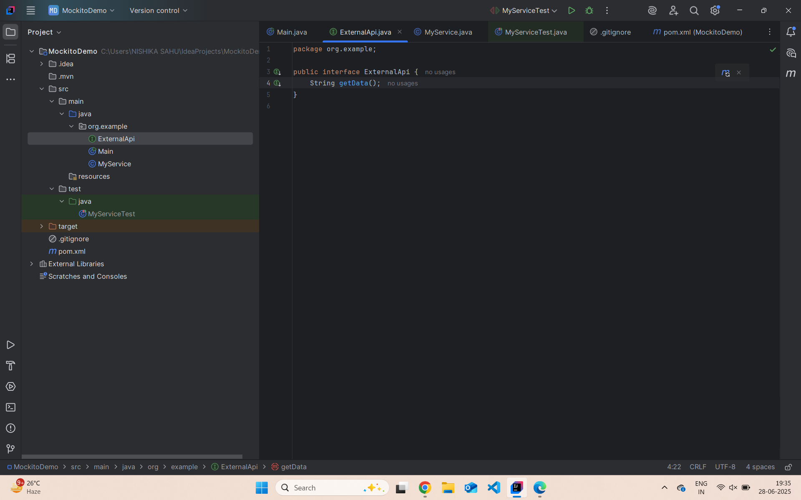

MyService Class

MyServiceTest Class

**Exercise 2: Verifying Interactions**

ExternalAPI interface

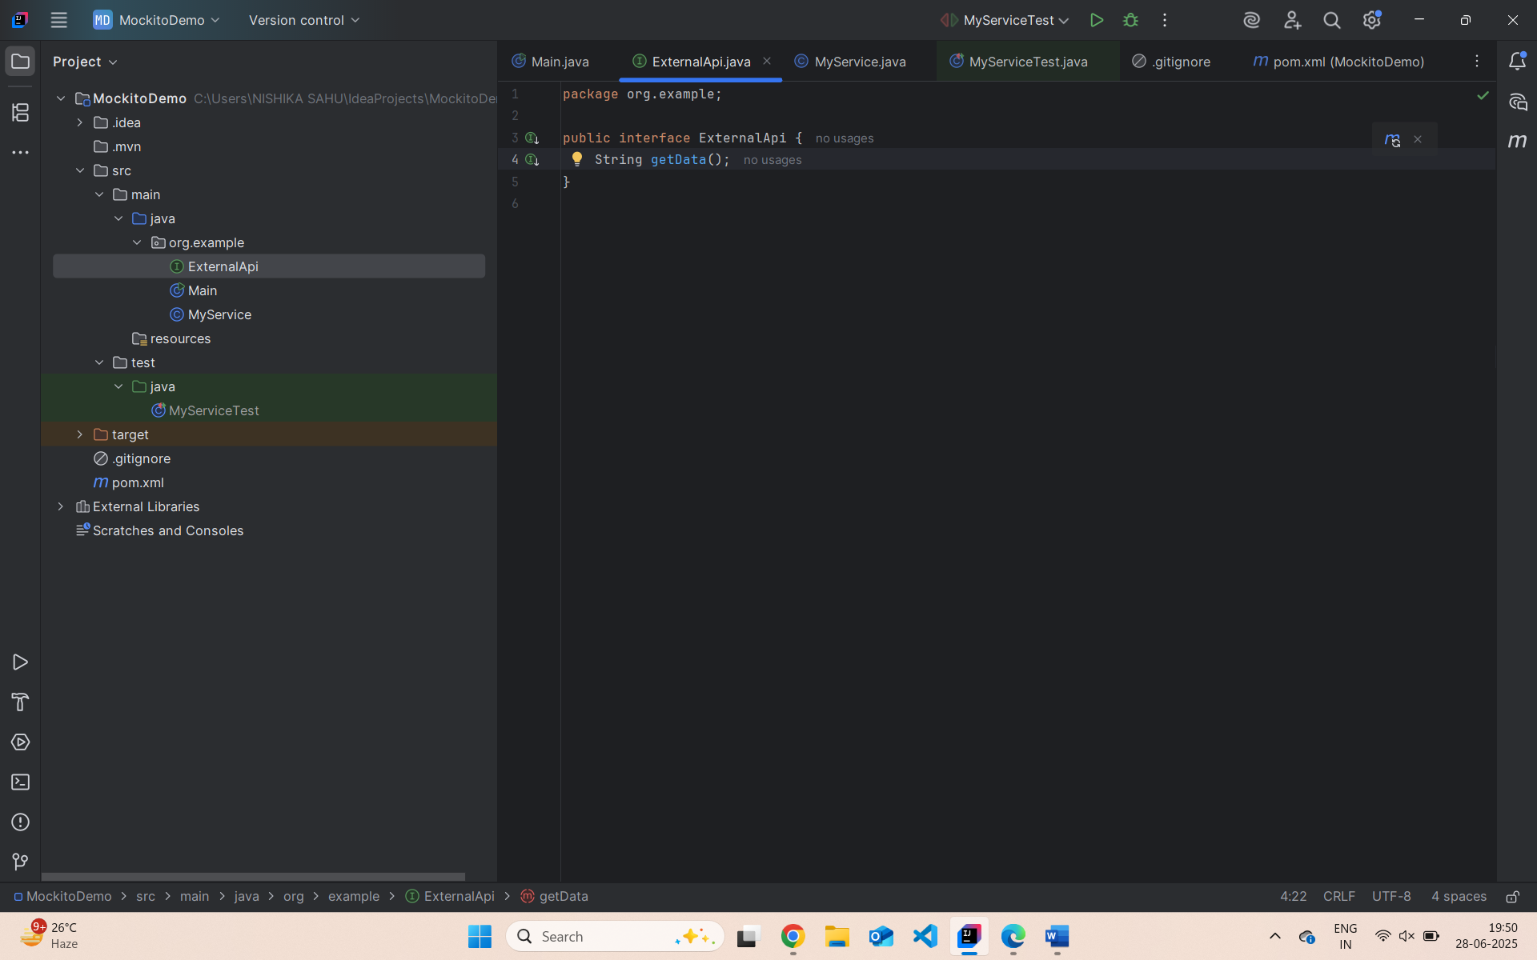MyService class

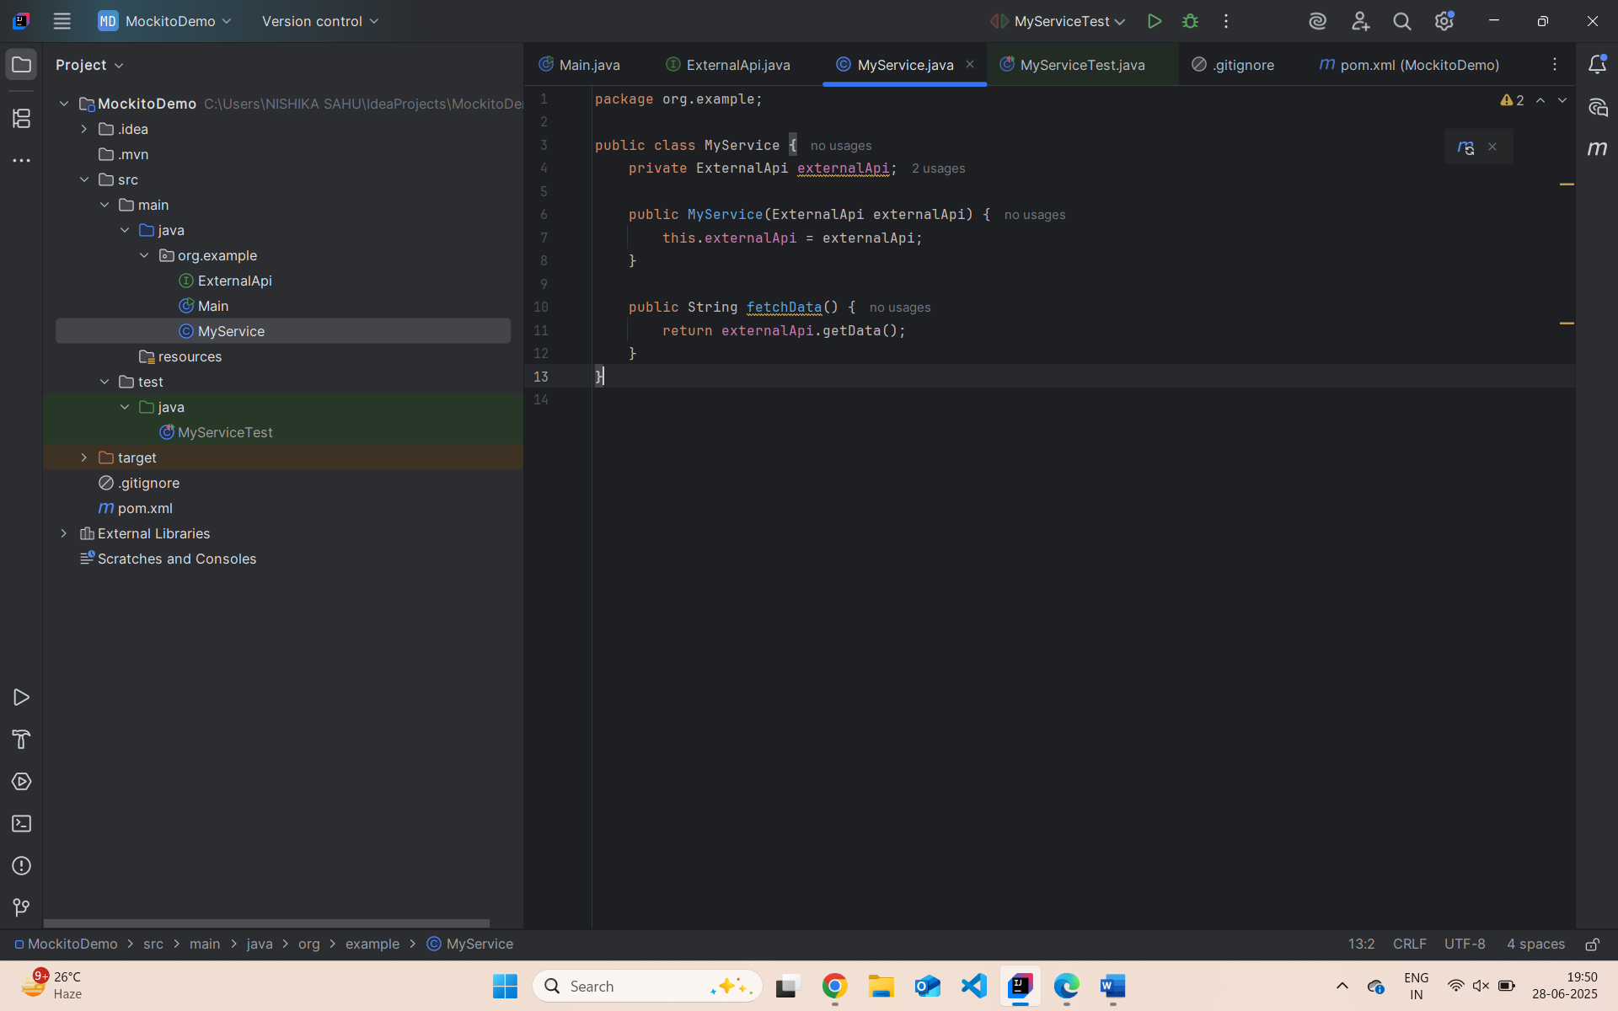

Output

