Git-HOL 1
The following steps were followed to complete this exercise:
- Checking Git version
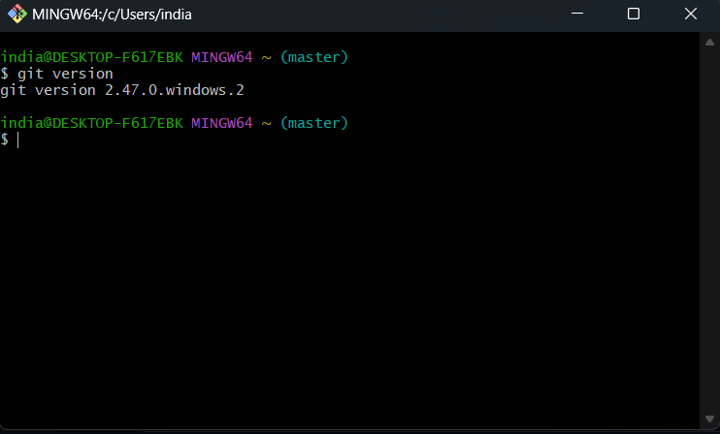

- Git Configuration

I have used git before therefore, configuration was already setup.
(The screenshot was taken after setting up Notepad++ as default editor.
Therefore, it is also displaying that.)
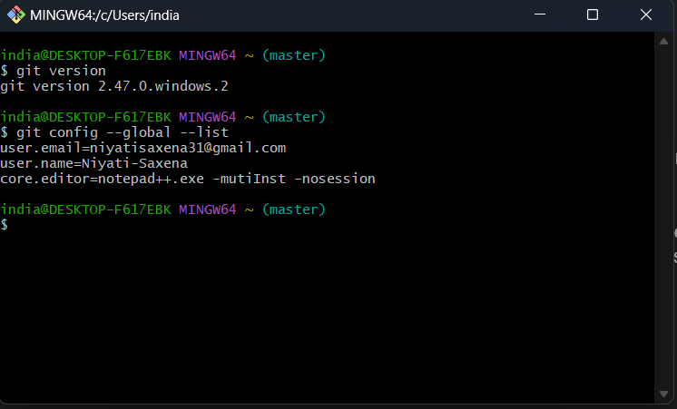
- Integrating Notepad++
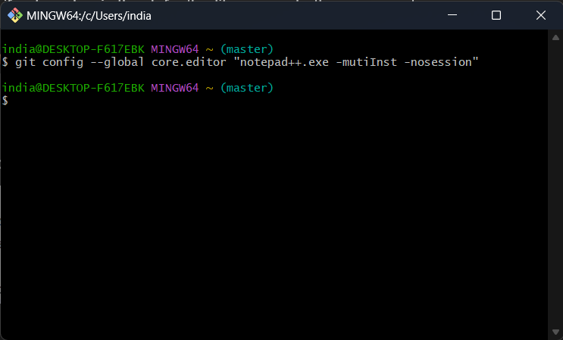

- Creating GitDemo
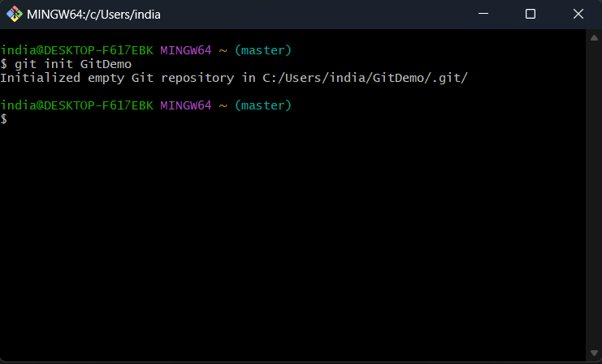

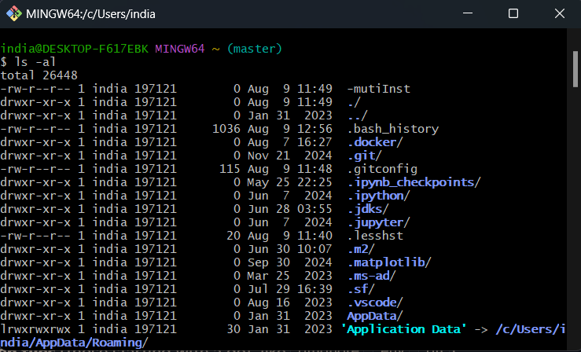
- Listing down all the files available currently

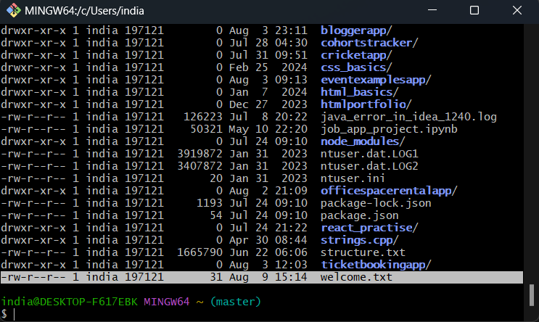
- Creating Welcome.txt

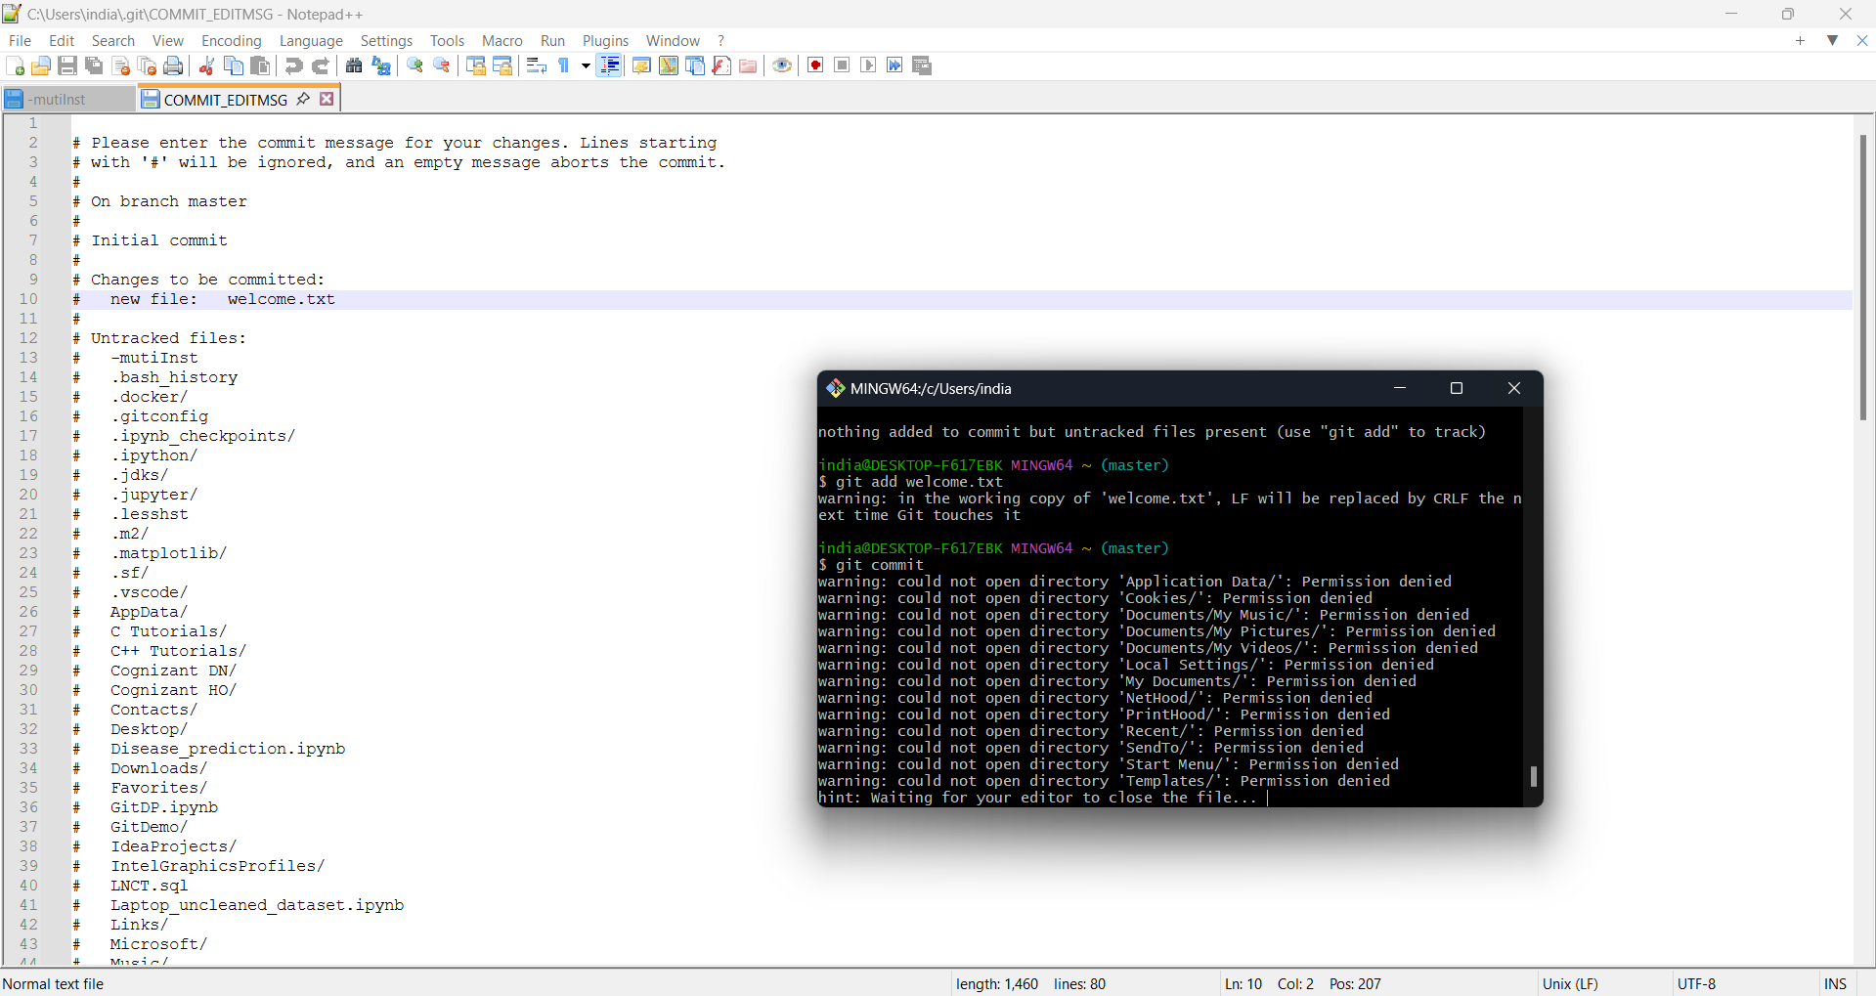
- Adding and Committing Welcome.txt

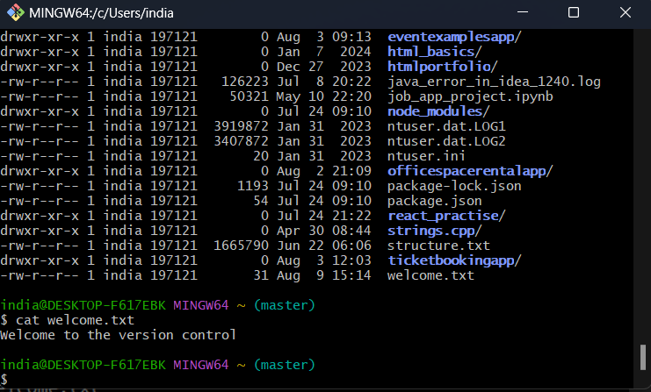
- Implementing Welcome.txt

- Created Account on GitLab and ran the following commands
