GIT-HOL 2
The following steps were followed to complete this exercise:
- Creating a working Directory
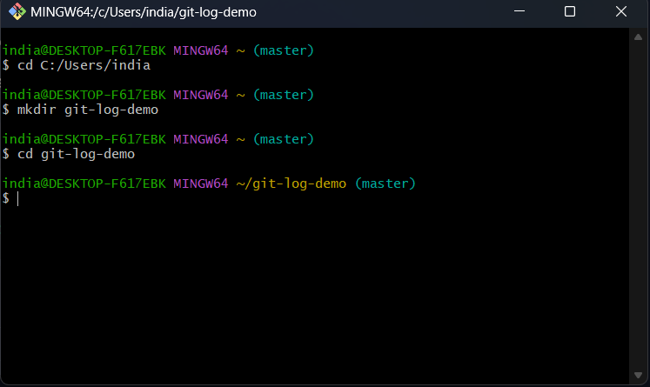

- Initializing git repository
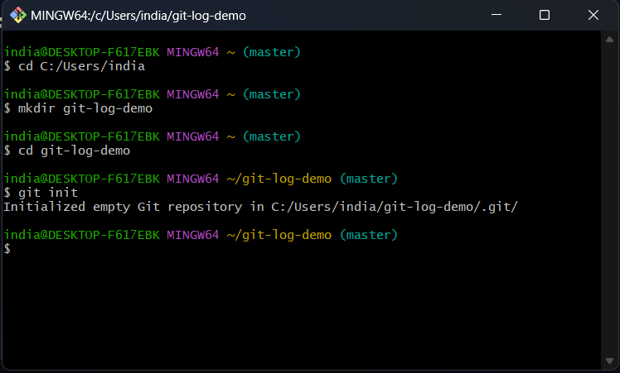

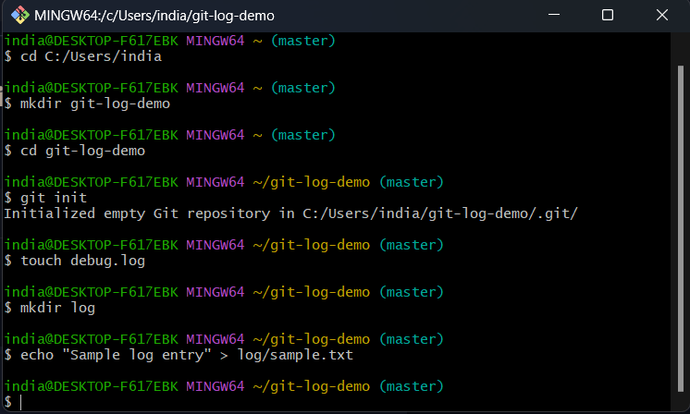
- Creating .log file and /log folder

- Create gitignore file
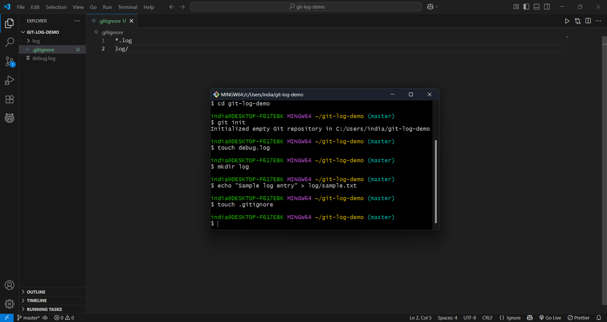
The code written inside gitignore file will tell git to ignore these files and folders.

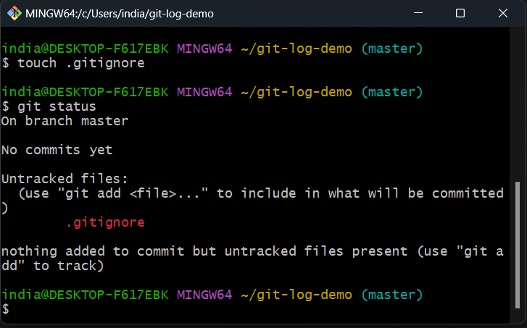
- As we can see debug.log and /log is not displayed.

