GIT-HOL 3
The following steps were followed to complete this exercise:

Branching
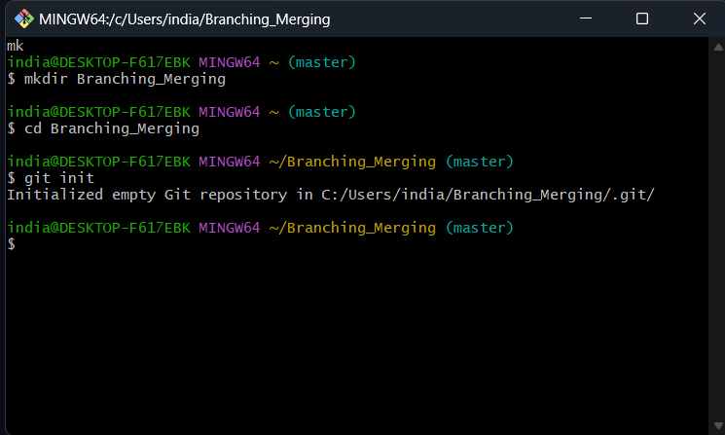
- Making a directory to work with

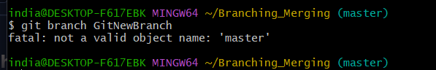
- Since the repo was empty therefore, I was not able to create a branch

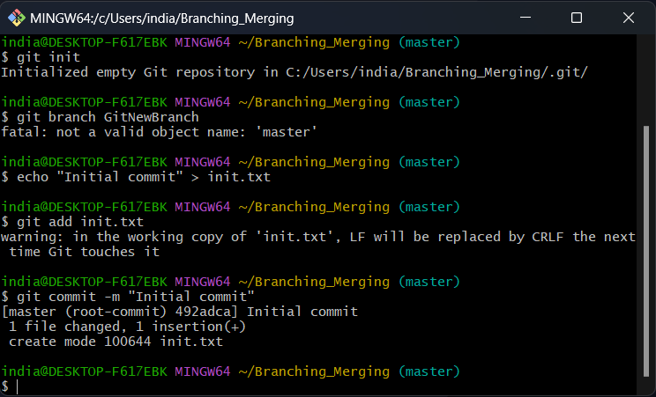
- Adding an initial file to solve the problem

- Creating the branch and listing all local and remote branches

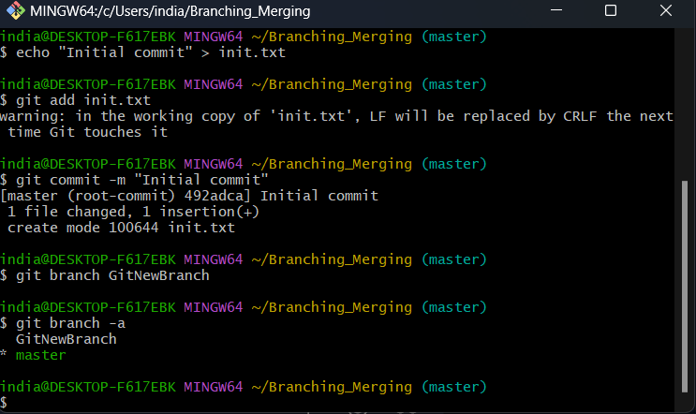
The star (*) symbol indicates currently active branch.

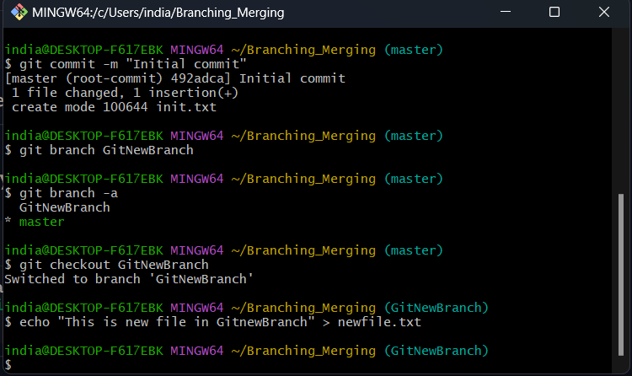
- Switching to newly Created branch and adding files.

- Commit changes to the file
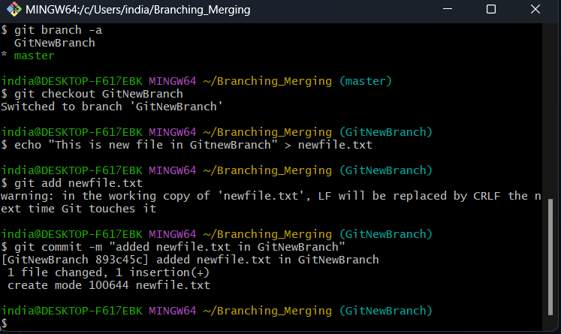

- Checking the status
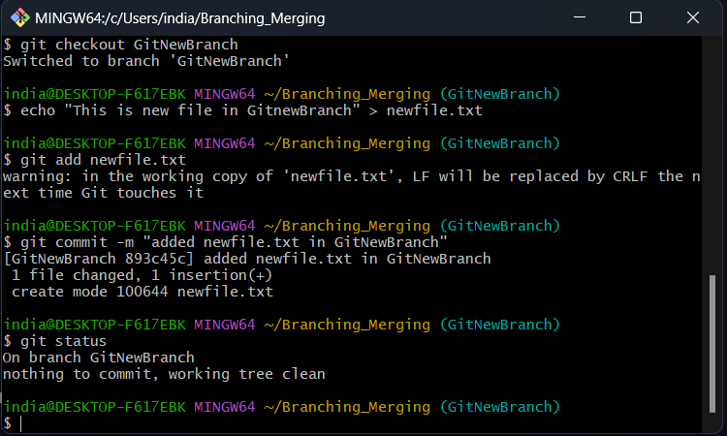

Merging
- Switching to master branch
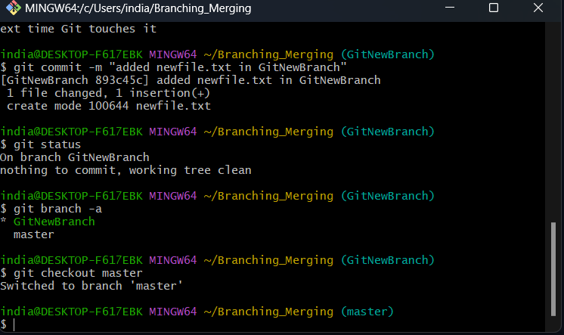
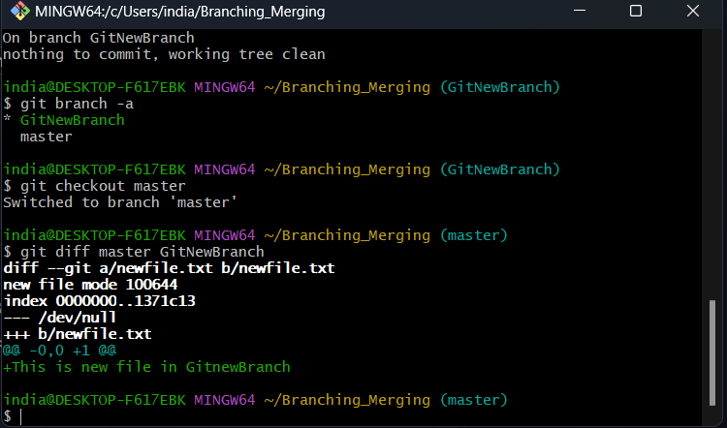
- List Difference between master and GitNewBranch

- Listing difference using P4Merge tool.

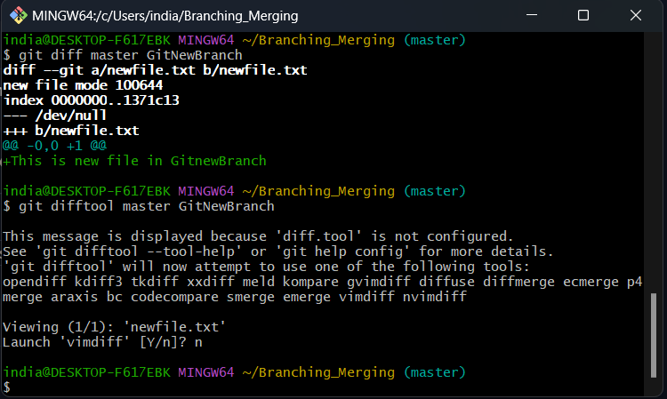
p4Merge tool is not installed and setup in my system.

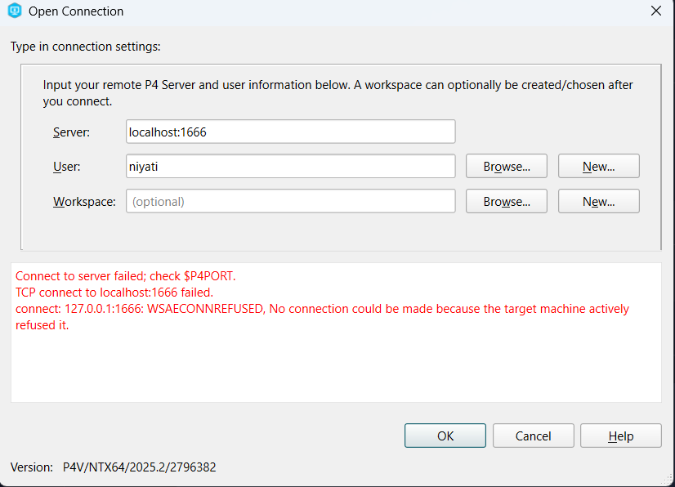
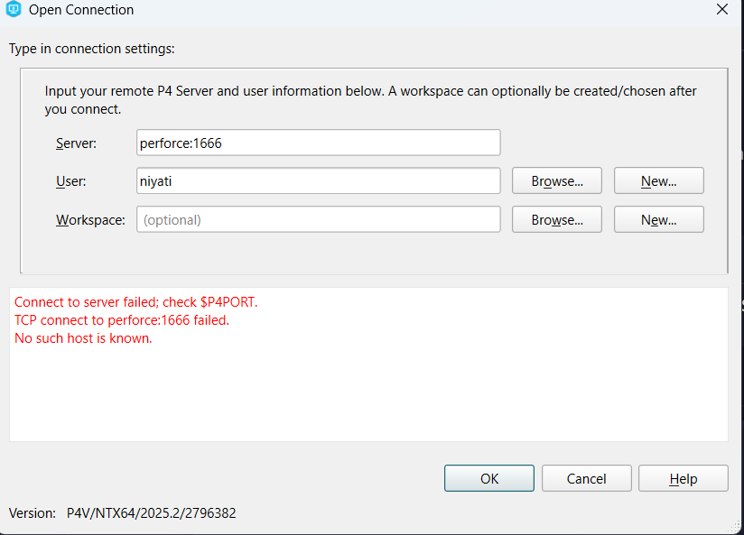
- Tried to setup the P4Merge tool but getting this error repeatedly.
- Merging GitNewBranch into master
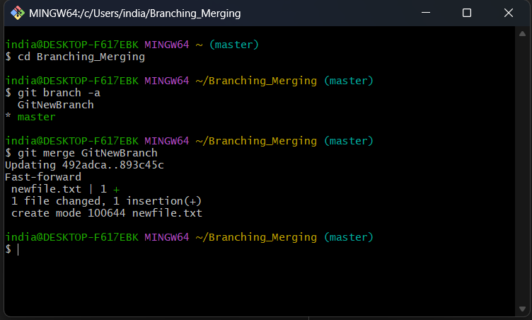

- To view merge log
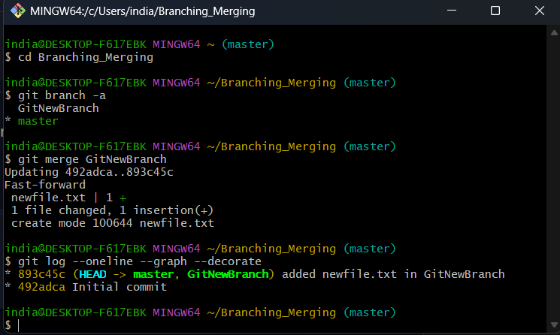

- Deleting branch and checking status
