GIT-HOL 4
The following steps were followed to complete this exercise:
Using the same Branching_Merging repository that we used in the 3rd hands-on
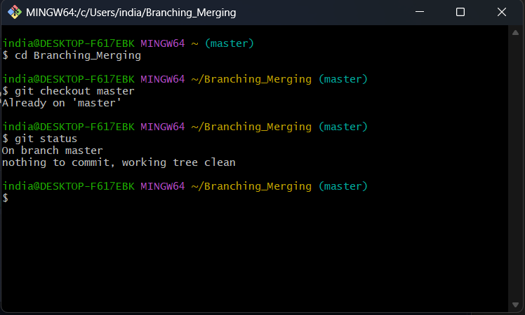
- Verifying if master is in clean state

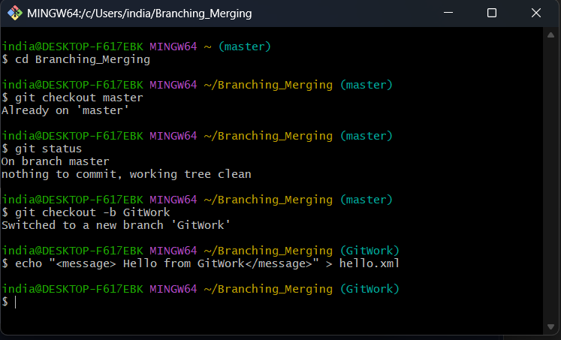
- Creating a branch GitWork and adding hello.xml
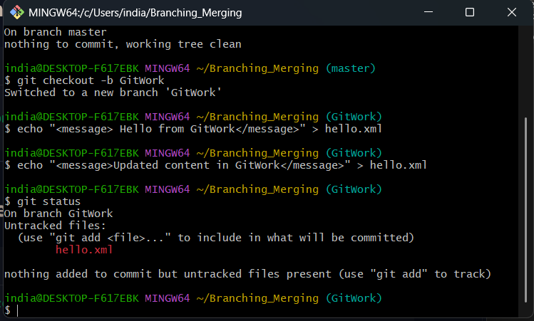
- Updating content of hello.xml and checking status

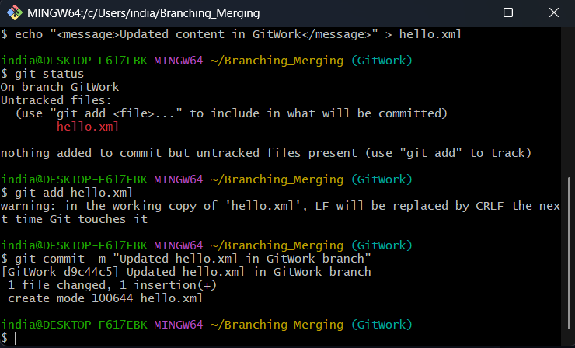
- Committing the changes in GitWork

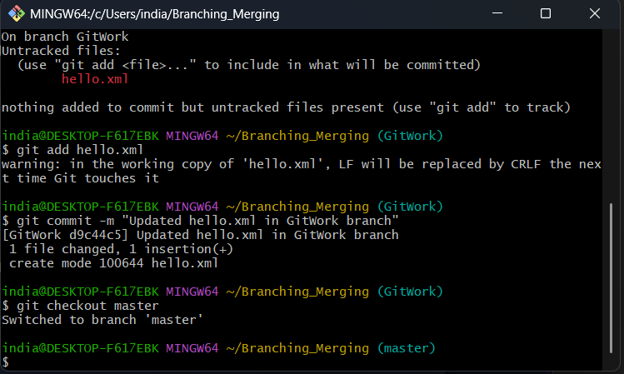
- Switching back to master

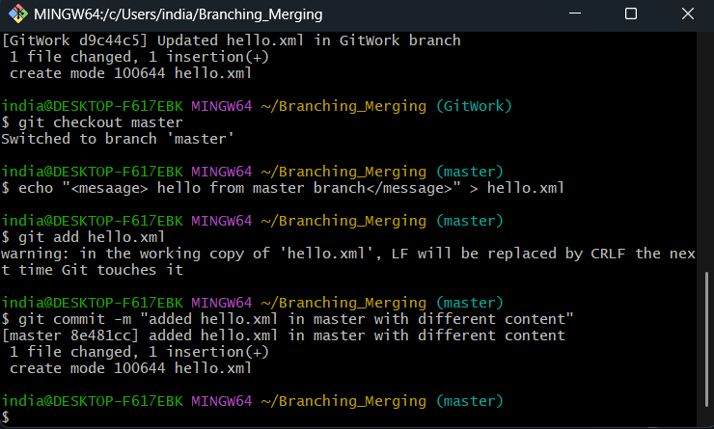
- Add a different hello.xml in master branch and committing changes

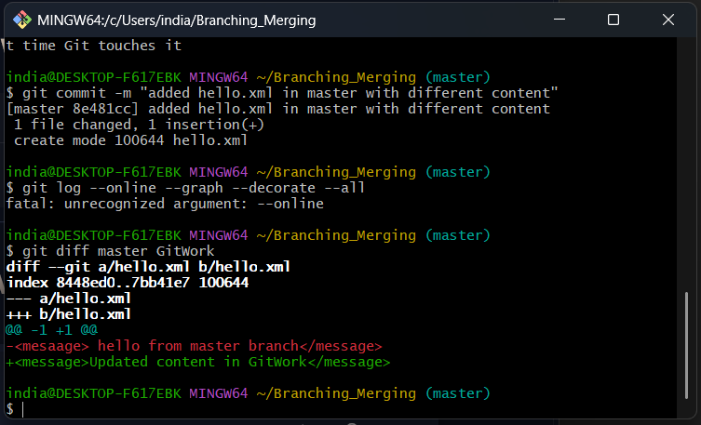
- Checking Differences

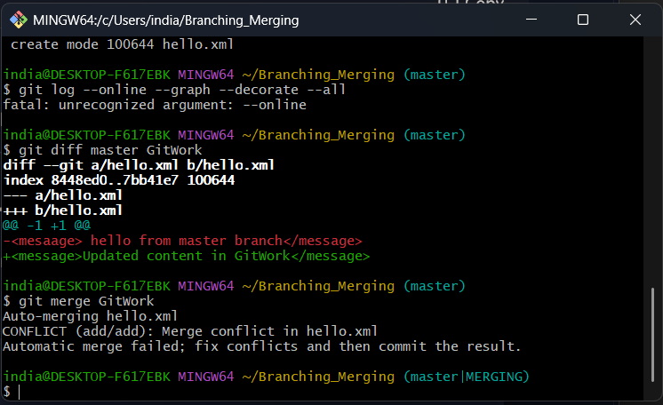
- Merging GitWork into master branch. Git is notifying us about the conflict.

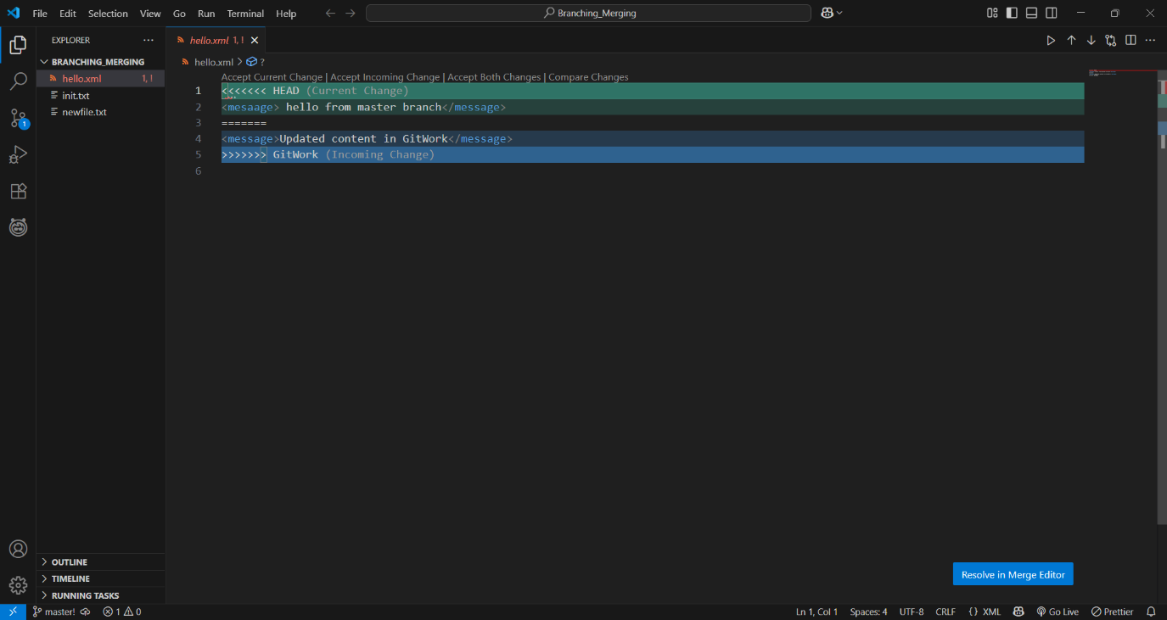
- Resolving the conflict manually. Conflict indicators are being displayed on VS code.

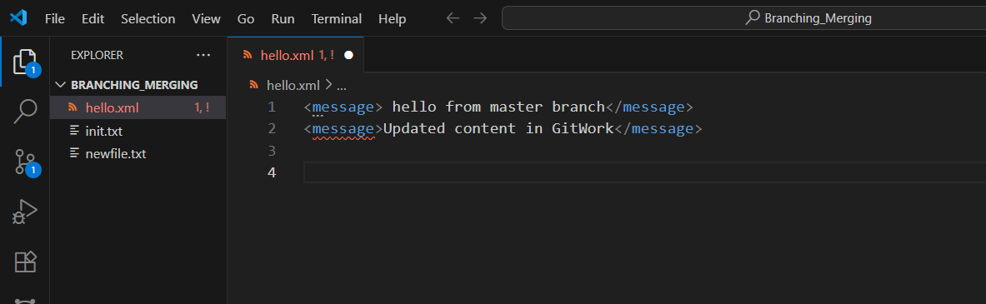
- Conflict resolved

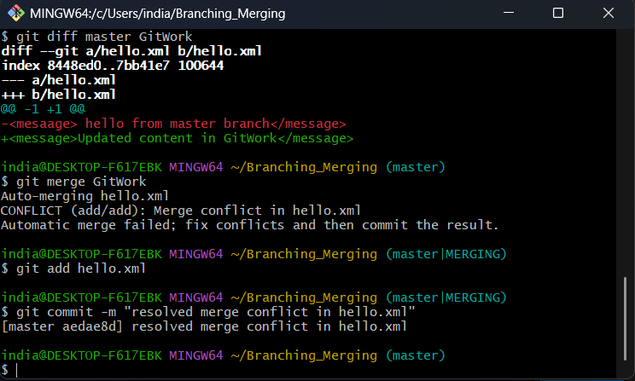
- Committing the resolved merge

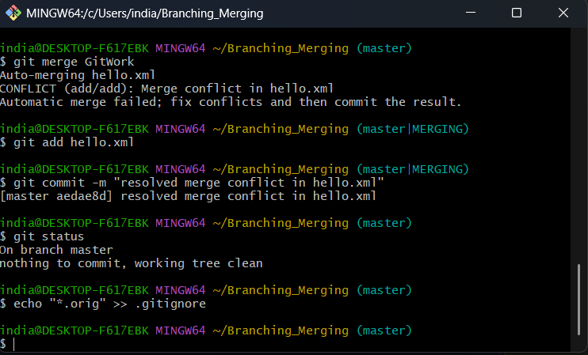
- Observing git status and adding backup files to gitignore

- Commiting gitignore changes
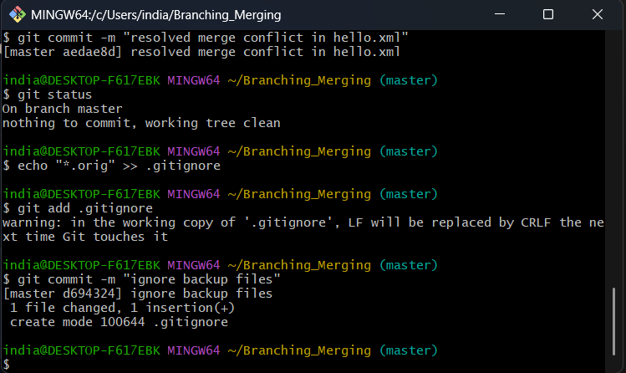

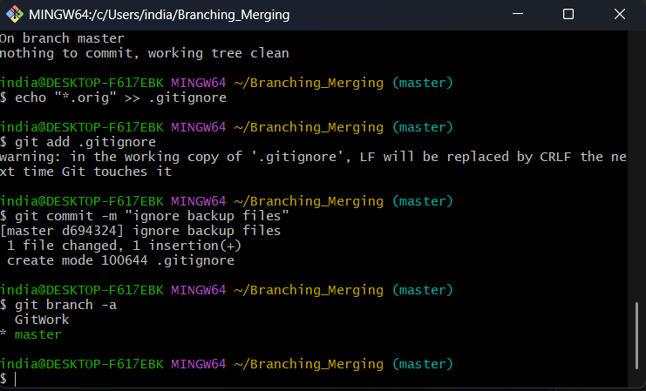
- Listing all available branches

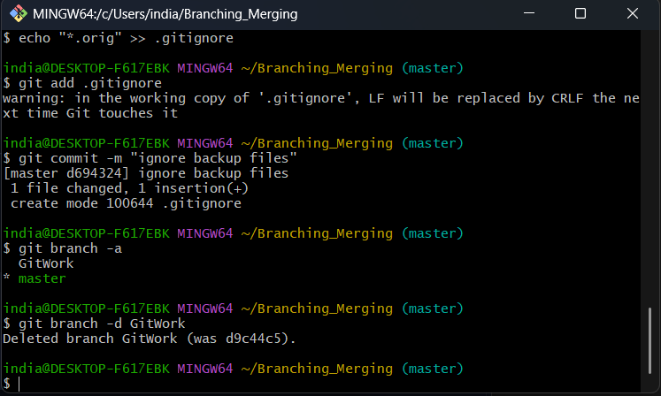
- Deleting merged branch GitWork

- Viewing final git log
