**Work Sheet-8**

**AC Network Analysis**

T3.1 The instantaneous voltage and current for an ac circuit are v = 155.6 sin 377t V - = 7.07 sin (377t- 36.87°) A. Represent these (a) as complex exponentials

(b) In a phasor diagram.

(c) The frequency (in hertz),

(d) The period

(c) The phase angle between v and i (in radians).

[, 60Hz, 0.0167 s, 0.64 rad]

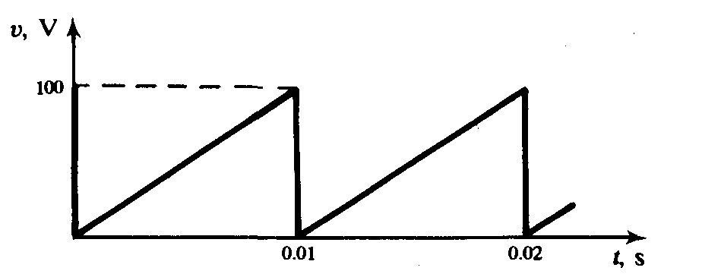T3.2 The voltage wave of Fig. is applied to a 20Ω resistor. If electrical energy costs 6 per kWh, how much would it cost to operate the circuit for 24 hours?[Rs24]

T3.3 Given v = 200 sin 377t V and i = 8 sin (377t - 30°) A for an ac circuit. Determine (a) the power factor, (b) true power, (c) apparent power, and (d) reactive power. [ 0.866 lagging, 692.8 W, 800VA, 400VAR]

T3.4 A coil has a resistance of 10 Ω and draws a current of 5 A when connected across a 100-V, 60-Hz source. Determine (a) the inductance of the coil, (b) the power factor of the circuit, and (c) The reactive power

[45.94 mH, 0.5 lag. 433VAR]

T3.5 A series RLC circuit is excited by a 100-V, 79.6-Hz source and has the following data: R = 100 ft, L = 1 H, C = 5 µF. Calculate (a) the input current, and (b) the voltages across the elements.

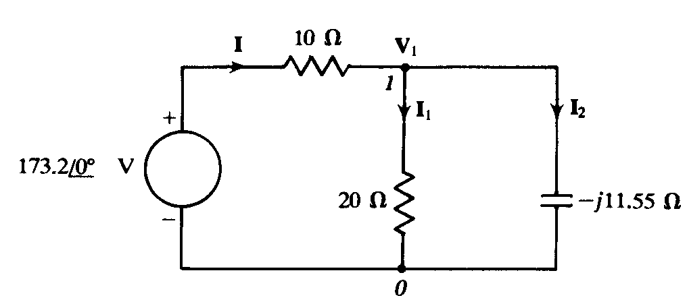[0.707∠-45˚, 70.7∠-45˚ V, 353.5∠45˚, 282.8∠-135°]

T3.6 For the circuit shown in Fig. 5-17(a), evaluate the current through, and the voltage across, each element. Then draw a phasor diagram showing all the voltages and currents.

[100∠-30˚V, 100∠30˚V, 10∠30˚A, 5∠-30˚A, 8.66∠60˚A]

T3.7 A 20 Ω resistance is connected in series with a parallel combination of a capacitance C and a 15 mH pure inductance. At angular frequency w = 1000 rad/s, find C such that the line current is 45° out of phase with the line voltage.[16.67µF, 116.7µF]

T3.8 A 46-mH inductive coil has a resistance of 10 Ω. (a) How much current will it draw if connected across a 100-V, 60-Hz source? (b) What is the power factor of the coil? (c) Determine the value of the capacitance that must be connected across the coil to make the power factor of the overall circuit unity.

[5.0∠-60A, 0.5 lagging, 115µF]

T3.9 The instantaneous values of two alternating voltages are given by *v*1 =5 sin *ωt* and *v*2 =8 sin (*ωt* −*π/*6) obtain expressions for (a) *v*1 + *v*2 and (b) *v*1 −*v*2 [(a) 12*.*58 sin (*ωt* −0*.*324), (b) 4*.*44 sin (*ωt* +2*.*02)]

T3.10 A coil of inductance 636.6mH and negligible resistance is connected in series with a 100*Ω* resistor to a 250V, 50 Hz supply. Calculate (a) the inductive reactance of the coil, (b) the impedance of the circuit, (c) The current in the circuit, (d) the p.d. across each component, and (e) the circuit phase angle.

[(a) 200*Ω* (b) 223.6*Ω* (c) 1.118A (d) 223.6V, 111.8V (e) 63.43◦ lagging]

T3.11 An alternating voltage given by *v*=100 sin 240*t* volts is applied across a coil of resistance 32*Ω*and inductance 100 mH. Determine (a) the circuit impedance, (b) the current flowing, (c) the p.d. across the resistance, and (d) the p.d. across the inductance. [(a) 40*Ω* (b) 1.77A (c) 56.64V (d) 42.48V]

T3.12 An alternating voltage *v*=250 sin 800*t* volts is applied across a series circuit containing a 30*Ω* resistor and 50μF capacitor. Calculate (a) the circuit impedance, (b) the current flowing, (c) the p.d.across the resistor, (d) the p.d. across the capacitor, and (e) the phase angle between voltage and current. [(a) 39.05*Ω* (b) 4.526A (c) 135.8V (d) 113.2V (e) 39.81◦ leading]

T3.13 A coil takes a current of 5A from a 20V d.c. supply. When connected to a 200V, 50 Hz a.c. supply the current is 25A. Calculate the (a) resistance, (b) impedance, and (c) inductance of the coil. [(a) 4*Ω* (b) 8*Ω* (c) 22.05 mH]

T3.14 1 A voltage of 35V is applied across a *C*–*R* series circuit. If the voltage across the resistor is 21V, find the voltage across the capacitor. [28 V]

T3.15 A resistance of 50*Ω* is connected in series with a capacitance of 20μF. If a supply of 200V, 100 Hz is connected across the arrangement find (a) the circuit impedance, (b) the current flowing, and (c) the phase angle between voltage and current.

[(a) 93.98*Ω* (b) 2.128A (c) 57.86˚ leading]

T3.16 An alternating voltage *v*=250 sin 800*t* volts is applied across a series circuit containing a 30*Ω* resistor and 50μF capacitor. Calculate (a) the circuit impedance, (b) the current flowing (c) The p.d. across the resistor, (d) the p.d. across the capacitor, and (e) the phase angle between voltage and current. [(a) 39.05*Ω* (b) 4.526A (c) 135.8V (d) 113.2V (e) 39.81˚ leading]

T3.17 A 400*Ω* resistor is connected in series with a 2358 pF capacitor across a 12V a.c. supply. Determine the supply frequency if the current flowing in the circuit is 24 mA. [225 kHz]

T3.18 A 40μF capacitor in series with a coil of resistance 8*Ω* and inductance 80mH is connected to a 200V, 100 Hz supply. Calculate (a) the circuit impedance, (b) the current flowing, (c) the phase angle between voltage and current, (d) the voltage across the coil, and (e) the voltage across the capacitor. [(a) 13.18*Ω* (b) 15.17A (c) 52.63◦ lagging (d) 772.1V (e) 603.6V]

T3.18 Find the values of resistance *R* and inductance *L* in the circuit of Figure [*R*=131*Ω*, *L* =0.545 H]

T3.19 Three impedances are connected in series across a 100V, 2 kHz supply. The impedances comprise: (i) an inductance of 0.45mH and 2*Ω* resistance, (ii) an inductance of 570μH and 5*Ω* resistance, and (iii) a capacitor of capacitance 10μF and resistance 3*Ω*. Assuming no mutual inductive effects between the two inductances calculate (a) the circuit impedance, (b) the circuit current, (c) the circuit phase angle and (d) the voltage across each impedance. [(a) 11.12*Ω* (b) 8.99A (c) 25.92◦ lagging (d) 53.92V, 78.53V, 76.46V]



T3.20 For the circuit shown in Figure 15.20 determines the voltages *V*1 and *V*2 if the supply frequency is 1 kHz. Draw the phasor diagram and hence determine the supply voltage *V* and the circuit phase angle. [*V*1 =26.0V, *V*2 =67.05V, *V* =50V, 53.14◦ leading]

T3.21 An impedance 15 + j20 Ω is connected across a 125-V, 60-Hz source. Find (a) the instantaneous current through the load, (b) the instantaneous power, and (c) the average active and reactive powers.

[(a) 7.07 sin (377t - 53.1°) A; (b) 1250 sin 377t sin (377t - 53.1°) (W); (c) 375 W, 500 VAR]

T3.22 A voltage source of 100 V has internal impedance 0.1 + j0.1 Ω and supplies a load having that same impedance. Calculate the power absorbed by the load. [125 W]

T3.23 A 75 Ω resistance is connected in parallel with a 10 /j.F capacitance. Determine an equivalent series RC circuit such that the two circuits have the same impedance at an angular frequency of 1000 rad/s. [R = 48 Ω, C = 27.8 µF]

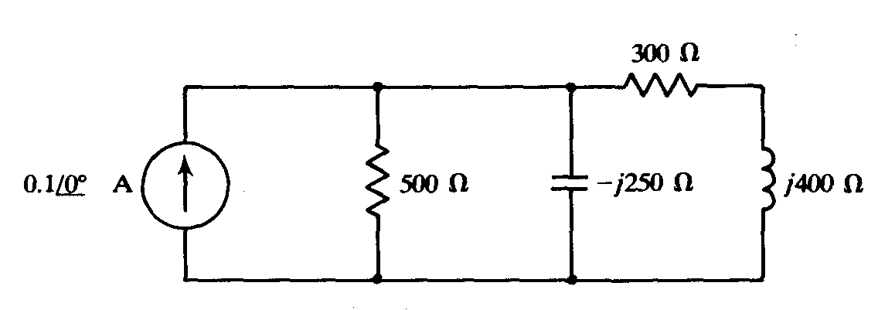

T3.24 An ac circuit with a current excitation is shown in Fig. Determine (a) the voltage across the inductance, and (b) the power dissipated in the two resistances. [ (a) 20∠0V; (b) 2 W]

T3.25 A 30*Ω* resistor is connected in parallel with a pure inductance of 3mH across a 110V, 2 kHz supply. Calculate (a) the current in each branch, (b) the circuit current, (c) the circuit phase angle, (d) the circuit impedance, (e) the power consumed, and (f) the circuit power factor. [(a) *IR* =3.67A, *IL* =2.92A (b) 4.69A (c) 38.51◦ lagging (d) 23.45*Ω* (e) 404W (f ) 0.782 lagging]2.

T3.26 A 40 *Ω* resistance is connected in parallel with a coil of inductance *L* and negligible resistance across a 200V, 50 Hz supply and the supply current is found to be 8 A. Sketch a phasor diagram and determine the inductance of the coil. [102 mH]

T3.27 A 1500 nF capacitor is connected in parallel with a 16*Ω* resistor across a 10V, 10 kHz supply. Calculate (a) the current in each branch, (b) the supply current, (c) the circuit phase angle, (d) the circuit impedance, (e) the power consumed, (f) the apparent power, and (g) the circuit power factor. Sketch the phasor diagram. [(a) *IR* =0.625A, *IC* =0.943A (b) 1.131 A (c) 56.46◦ leading (d) 8.84*Ω* (e) 6.25W (f ) 11.31VA (g) 0.553 leading]

T3.28 A capacitor *C* is connected in parallel with a resistance *R* across a 60V, 100 Hz supply. The supply current is 0.6A at a power factor of 0.8 leading. Calculate the values of *R* and *C*. [*R*=125*Ω*, *C* =9*.*55μF]

T3.29 An inductance of 80mH is connected in parallel with a capacitance of 10μF across a 60V, 100 Hz supply. Determine (a) the branch currents, (b) the supply current, (c) the circuit phase angle, (d) the circuit impedance and (e) the power consumed.

[(a) *IC* =0*.*377A, *IL* =1.194A (b) 0.817A (c) 90◦ lagging (d) 73.44*Ω* (e) 0 W]

T3.30 Acoil of resistance 60*Ω*and inductance 318.4mHis connected in parallel with a 15μF capacitor across a 200V, 50 Hz supply. Calculate (a) the current in the coil, (b) the current in the capacitor, (c) the supply current and its phase angle, (d) the circuit impedance, (e) the power consumed, (f) the apparent power and (g) the reactive power. Sketch the phasor diagram.

[(a) 1.715A (b) 0.943A (c) 1.028A at 30.88◦ lagging (d) 194.6*Ω* (e) 176.5W (f) 205.6VA (g) 105.5 var]

T3.31 A 25 nF capacitor is connected in parallel with a coil of resistance 2 k*Ω* and inductance 0.20H across a 100V, 4 kHz supply. Determine (a) the current in the coil, (b) the current in the capacitor, (c) the supply current and its phase angle (by drawing a phasor diagram to scale, and also by calculation), (d) the circuit impedance, and (e) the power consumed.

[(a) 18.48mA (b) 62.83mA (c) 46.17mA at 81.49◦ leading (d) 2.166 k*Ω* (e) 0.683W]

T3.32 Find the resonant frequency of a series a.c. circuit consisting of a coil of resistance 10*Ω* and inductance 50mH and capacitance 0.05μF. Find also the current flowing at resonance if the supply voltage is 100V. [3.183 kHz, 10A]

T3.33 The current at resonance in a series *L*–*C*–*R* circuit is 0.2 mA. If the applied voltage is 250mV at a frequency of 100 kHz and the circuit capacitance is 0.04μF, find the circuit resistance and inductance. [1.25 k*Ω*, 63.3μH]

T3.34 A coil of resistance 25*Ω* and inductance 100mH is connected in series with a capacitance of 0.12μF across a 200V, variable frequency supply. Calculate (a) the resonant frequency, (b) the current at resonance and (c) the factor by which the voltage across the reactance is greater than the supply voltage. [(a) 1.453 kHz (b) 8A (c) 36.51]

T3.35 Calculate the inductance which must be connected in series with a 1000 pF capacitor to give a resonant frequency of 400 kHz. [0.158 mH]

T3.36 A series circuit comprises a coil of resistance 20*Ω* and inductance 2mH and a 500 pF capacitor. Determine the Q-factor of the circuit at resonance. If the supply voltage is 1.5V, what is the voltage across the capacitor? [100, 150V]

T3.37 A0.15μF capacitor and a pure inductance of 0.01H are connected in parallel across a 10V, variable frequency supply. Determine (a) the resonant frequency of the circuit, and (b) the current circulating in the capacitor and inductance. [(a) 4.11 kHz (b) 38.74 mA]

T3.38 A 30μF capacitor is connected in parallel with a coil of inductance 50mH and unknown resistance *R* across a 120V, 50 Hz supply. If the circuit has an overall power factor of 1 find (a) the value of *R*, (b) the current in the coil, and (c) the supply current.

[(a) 37.68*Ω* (b) 2.94A (c) 2.714A]

T3.39 A coil of resistance 25*Ω* and inductance 150mH is connected in parallel with a 10μF capacitor across a 60V, variable frequency supply. Calculate (a) the resonant frequency, (b) the dynamic resistance, (c) the current at resonance and (d) the Q-factor at resonance. [(a) 127.2 Hz (b) 600*Ω* (c) 0.10A (d) 4.80]

T3.40 A coil of resistance 1.5 k*Ω* and 0.25H inductance is connected in parallel with a variable capacitance across a 10V, 8 kHz supply. Calculate (a) the capacitance of the capacitor when the supply current is a minimum, (b) the dynamic resistance, and (c) the supply current. [(a) 1561 pF (b) 106.8 k*Ω* (c) 93.66μA]