**Module 7) JQuery Basic, Effects & Advanced**

**Q.1 What is jQuery?**

**A.1** JQuery is a lightweight, "write less, do more", JavaScript library

The purpose of jQuery is to make it much easier to use JavaScript on your website.

jQuery also simplifies a lot of the complicated things from JavaScript, like AJAX calls and DOM manipulation.

The jQuery library contains the following features:

* HTML/DOM manipulation
* CSS manipulation
* HTML event methods
* Effects and animations
* AJAX
* Utilities

**Q.2 How to Apply CSS Using JQuery, How to Add Class and Remove Class in Jquery, JQuery Animation?**

**A.2 Apply CSS in Jquery :-** We can use jquery’s .css() method to apply CSS style on the given webpage.eg,

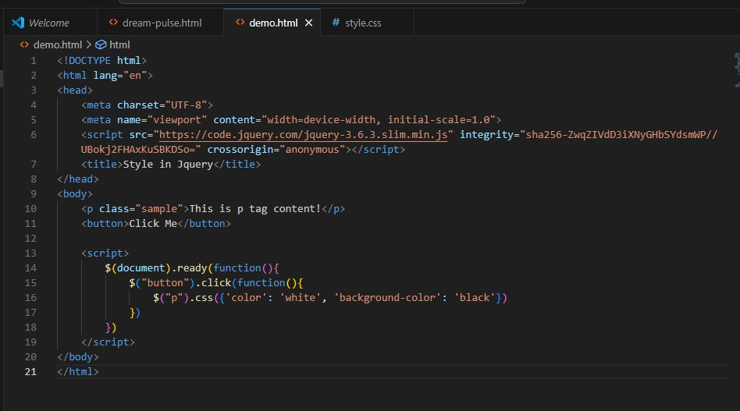

**Output:-**

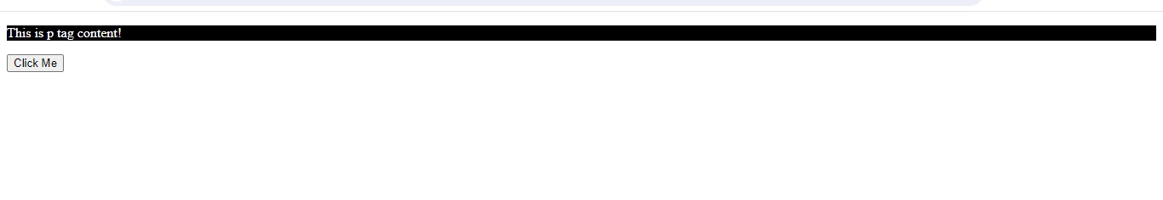

Now, we show add and remove class in jquery

The jQuery addClass() method adds one or more classes to the selected elements.

The following example will add the class .page-header to the [<h1>](https://www.tutorialrepublic.com/html-reference/html-headings-tag.php) and the class .highlight to the [<p>](https://www.tutorialrepublic.com/html-reference/html-p-tag.php) elements with class .hint on button click.

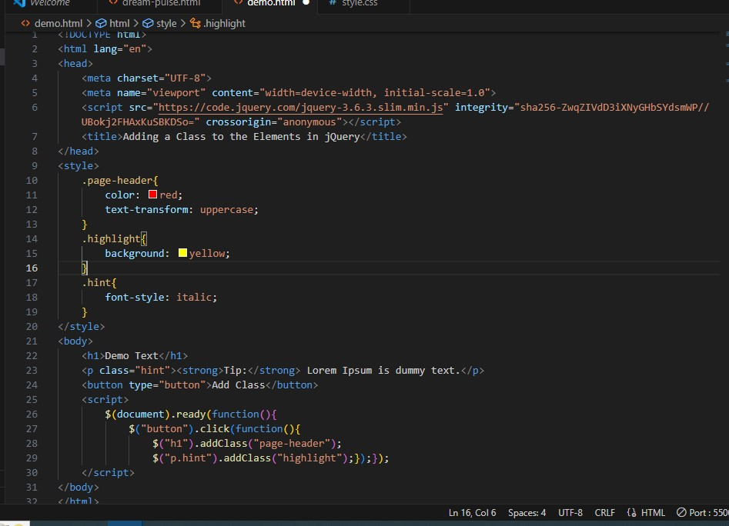

**Output:-**

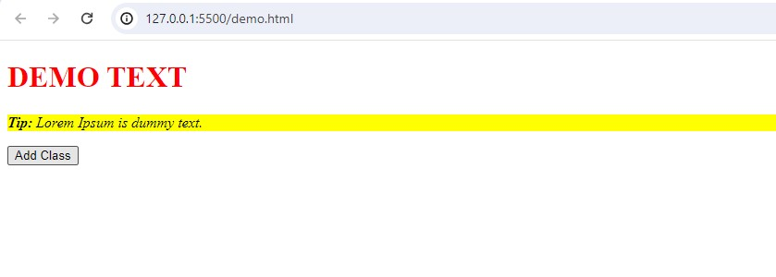The removeClass() method can remove a single class, multiple classes, or all classes at once from the selected elements.

The following example will remove the class .page-header from the <h1> and the class .hint and .highlight from the <p> elements on button click.

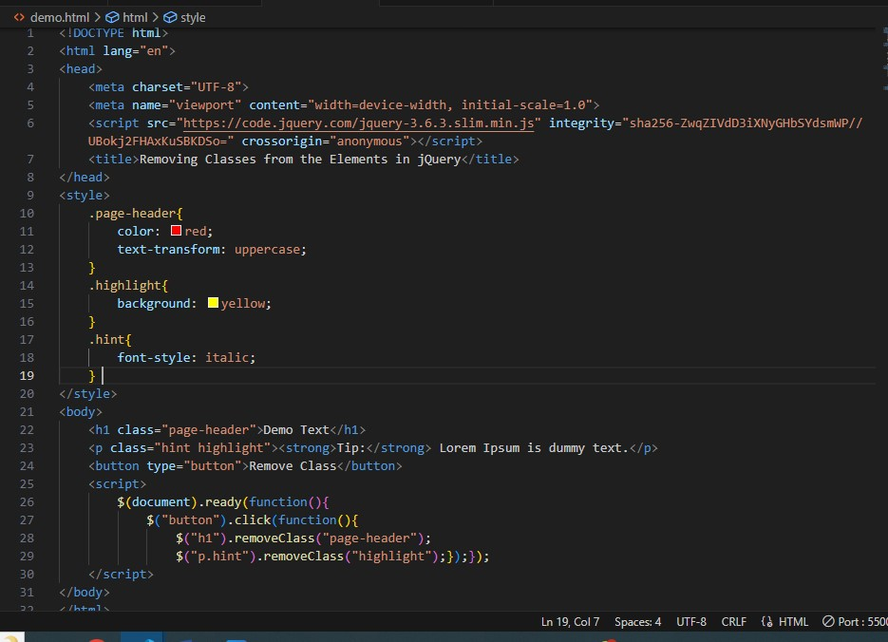

**Output:-**

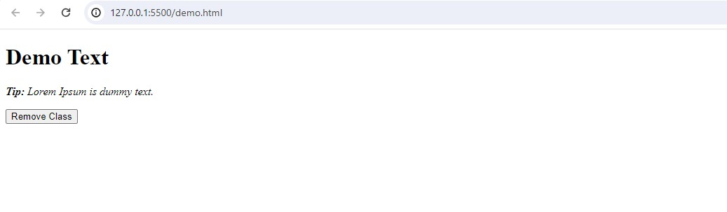Now, we can show **Jquery Animation :-**

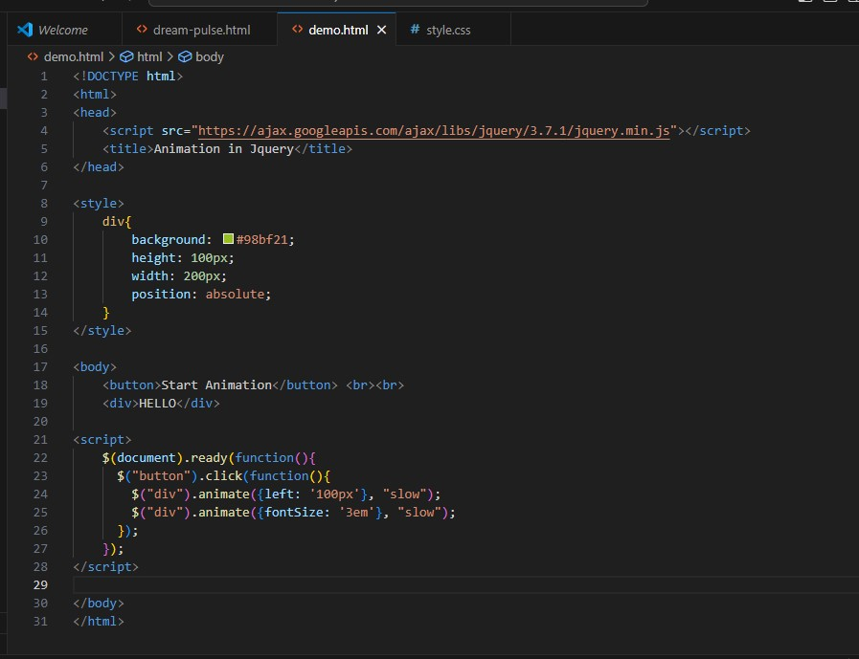

Our Outputs, when we don’t click the button(Start Animation),result will be this,

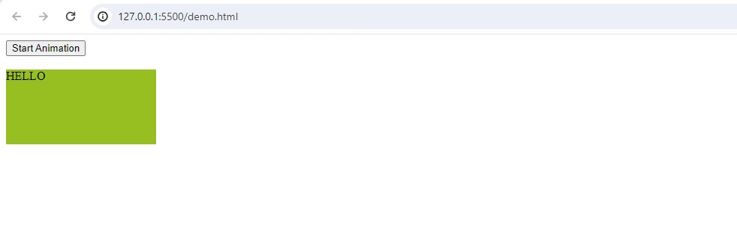

Now,we click the button(Start Animation),result will be this,

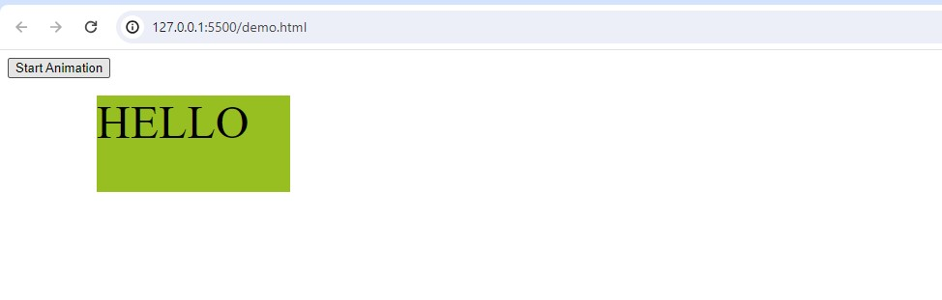**Q.3 How to create slider with animation?**

**A.3** Using jQuery , we can add the slide up or down effect in our web page .

There are three methods to add the sliding effects in our web page .

1. **slideDown() :-** This method makes the element to slide down.

Syntax:-

$(*selector*).slideDown(*speed,callback*);

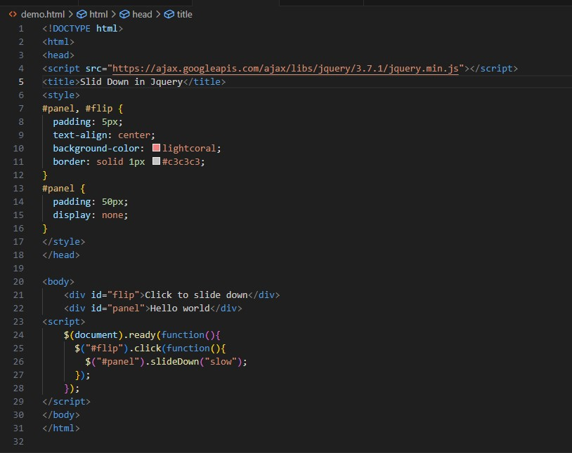

**Output:-** Before the slide down effect

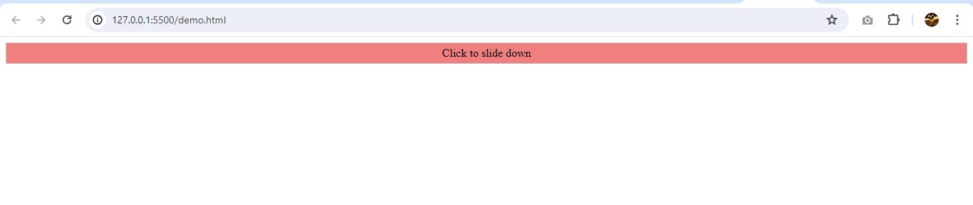

**Output:-** After the slide down effect

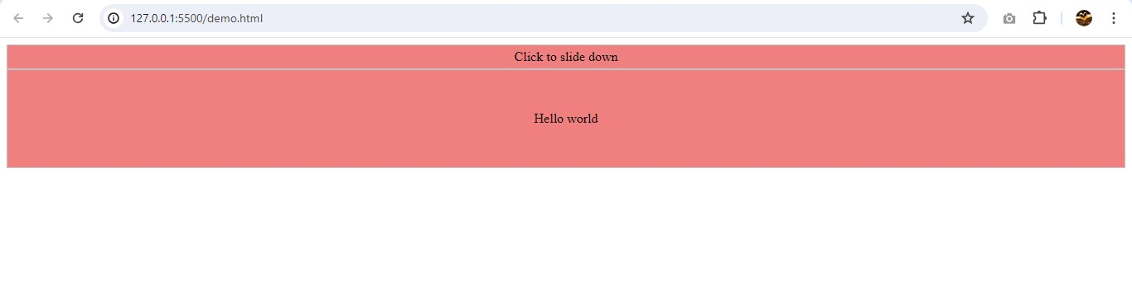

1. **slideUp():-**This method makes the element to slide up.

Syntax:- $(*selector*).slideUp(*speed,callback*);

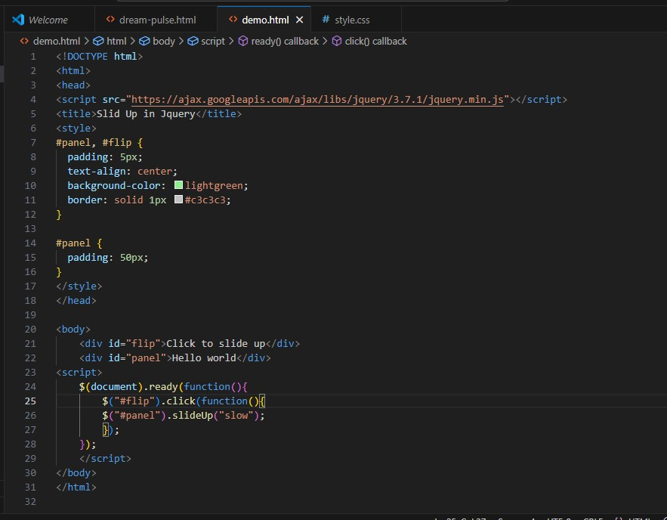

**Output:-** Before the slide up effect

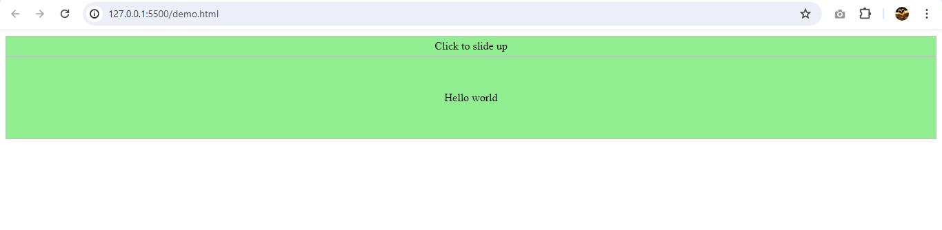

**Output:-** After the slide up effect

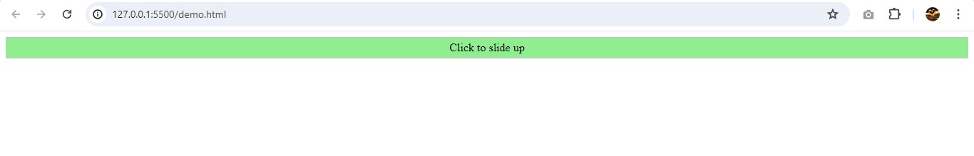

1. **slideToggle() :**This method makes the element to slide up/down.

Syntax:- $(*selector*).slideToggle(*speed,callback*);

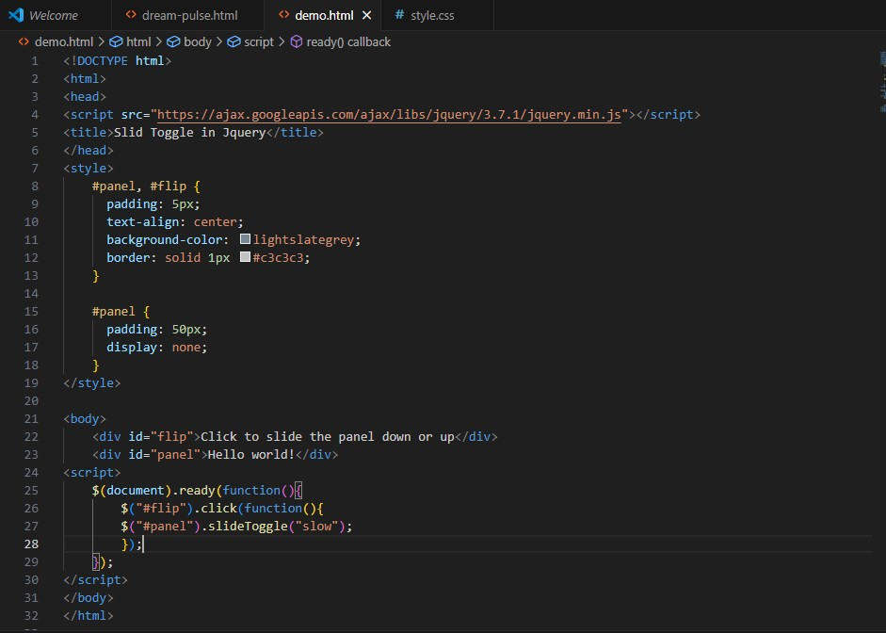

**Output:-**  Before the Up/Down effect

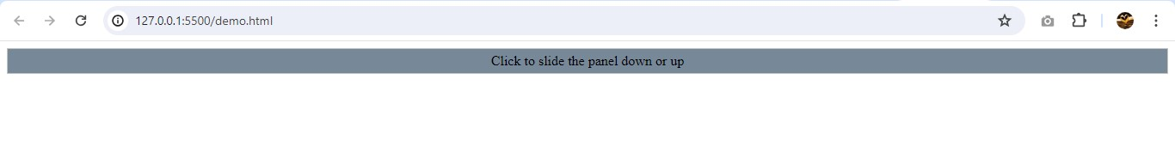

**Output**:- When the Up/Down Strip is clicked first time

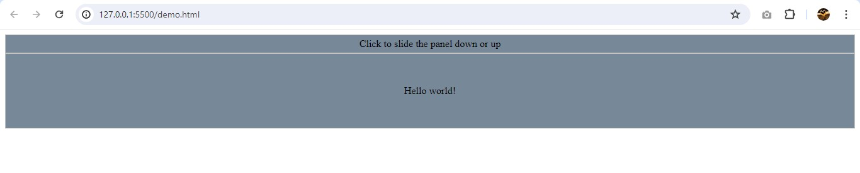

**Output**:- When the Up/Down Strip is clicked second time

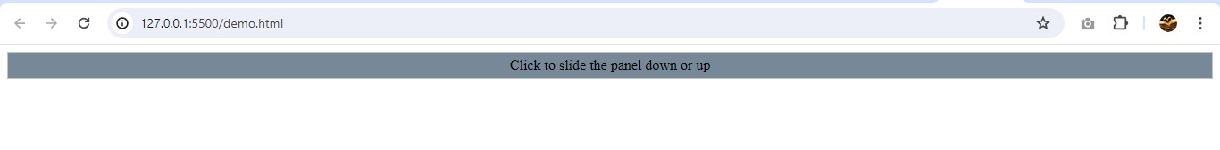

**Q.4 Event bubbling tickling example**

**A.4**

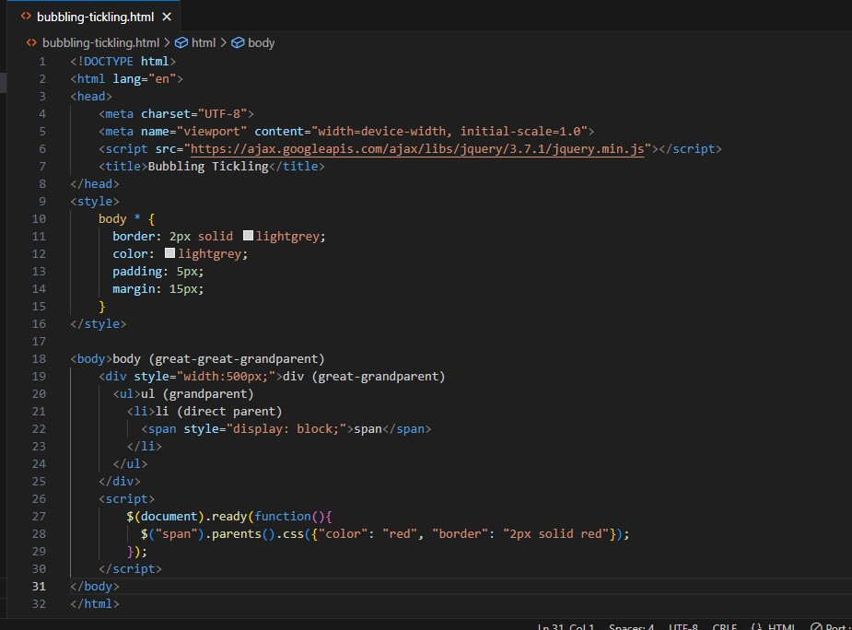

**Output:-**

