**Module 8) Bootstrap Basic & Advanced**

**Q.1 What are the advantages of Bootstrap?**

**A.1 Advantages of Bootstrap :-**

**Rapid Development**: Bootstrap provides a framework of pre-built design components, styles, and layouts, saving developers time in coding from scratch.

**Responsive Design**: With Bootstrap, websites automatically adapt to different screen sizes, ensuring a consistent user experience across devices like desktops, tablets, and smartphones.

**Consistency**: Bootstrap ensures consistency in design and behavior across different browsers, reducing compatibility issues.

**Customizable**: While Bootstrap provides ready-made components, it's also highly customizable. Developers can easily modify and extend Bootstrap's CSS and JavaScript to fit specific project needs.

**Community Support**: Being widely adopted, Bootstrap has a vast community of developers, offering resources, documentation, and plugins. This community support can be invaluable for troubleshooting and finding solutions.

**Cross-browser Compatibility**: Bootstrap handles many of the inconsistencies between browsers, ensuring that your website looks and functions similarly across various browsers.

**Accessibility**: Bootstrap includes built-in accessibility features and follows best practices, making it easier to create websites that are usable by people with disabilities.

**Q.2 What is a Bootstrap Container, and how does it work?**

**A.2**  Containers are used to pad the content inside of them, and there are two container classes available:

1. The .container class provides a responsive fixed width container
2. The .container-fluid class provides a full width container, spanning the entire width of the viewport

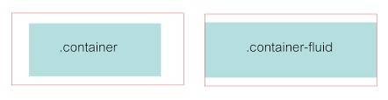

**Q.3 What are the default Bootstrap text settings?**

**A.3** Bootstrap's default text settings include:

**Font-Family:-** Generally, Bootstrap uses a sans-serif font stack for its text, providing a clean and modern look.

**Font-Size:-** The default font size is usually 16 pixels (1rem), providing good readability across various screen sizes.

**Font Weight:-** Bootstrap typically uses a normal font weight for regular text and a bold font weight for headings and emphasized text.

**Line Height:-** The line height is usually set to 1.5, ensuring comfortable spacing between lines of text for easier reading.

**Text-color:-** By default, Bootstrap text is often black or dark gray on a white or light background, providing high contrast a nd readability.

**Q.4 What do you know about the Bootstrap Grid System?**

**A.4** The Bootstrap Grid System is a powerful layout system that allows developers to create responsive and flexible web layouts with ease. Here are some key points about the Bootstrap Grid System:

**12-column Grid**: Bootstrap divides the page into 12 columns, providing a flexible and customizable grid layout system. Developers can allocate different numbers of columns to different elements to create various layout configurations.

**Responsive Design**: The grid system is built to be responsive, meaning it automatically adjusts and reflows content based on the screen size and device. This ensures that websites built with Bootstrap look good and function well on desktops, tablets, and smartphones.

**Container**: The grid system is contained within a **.container** class, which helps to center and align the grid within the viewport. There are two types of containers in Bootstrap: **.container** for fixed-width containers and **.container-fluid** for full-width containers that span the entire viewport width.

**Rows and Columns**: Grid layouts are structured using rows and columns. Rows (**<div class="row">**) are horizontal containers that hold columns. Columns (**<div class="col">**) are the vertical building blocks where content resides. Columns must be placed within rows, and their widths are specified using predefined classes like **.col-**, **.col-sm-**, **.col-md-**, **.col-lg-**, and **.col-xl-**.

**Responsive Breakpoints**: Bootstrap provides predefined breakpoints (extra small, small, medium, large, and extra-large) to create responsive layouts. Developers can specify different column widths for different screen sizes using classes like **.col-sm-**, **.col-md-**, etc.

**Offsetting Columns**: Bootstrap allows developers to offset columns horizontally using classes like **.offset-**, which adds space to the left of the column.

**Nesting Columns**: Developers can nest rows and columns within other columns to create more complex layouts. This nesting allows for greater flexibility in design.

**Q.5 What is the difference between Bootstrap 4 and Bootstrap 5**

**A.5 Difference between Bootstrap 4 and Bootstrap 5**

| **BASIS OF** | **BOOTSTRAP 4** | **BOOTSTRAP 5** |
| --- | --- | --- |
| **Grid System** | It has 5 tier (xs, sm, md, lg, xl). | It has 6 tier (xs, sm, md, lg, xl, xxl). |
| **Color** | It has limited colors. | Extra colors added with the looks, A card improved color palette. there are various shades available to choose. |
| **Jquery** | It has jquery and all related plugins. | Jquery is removed and switched to vanilla JS with some working plugins |
| **Internet Explorer** | Bootstrap 4 supports both IE 10 and 11. | Bootstrap 5 doesn’t support IE 10 and 11. |
| **Form elements** | Radio buttons, checkboxes have different look in different OS and browsers. The form uses whatever default browsers provide. | The look of form elements will not change, on different OS or browser. The forms can be customized and form controls can be added, they would not depend on browser. |
| **Utilities API** | We cannot modify utilities in bootstrap 4 | Bootstrap 5 gave freedom to modify and also create our own utility |
| **Vertical Classes** | Columns can be positioned relative | Columns cannot be positioned relative |
| **Bootstrap Icons** | Bootstrap 4 doesn’t have its own SVG icons, we have to use font-awesome for icons. | Bootstrap 5 have its own SVG icons |
| **Jumbotron** | It supports. | It doesn’t support jumbotron. |
| **Navbar** | We have inline-block property and we will get white dropdown as default for dropdown-menu-dark class. | Inline-block property is removed and we will get black dropdown as default for dropdown-menu-dark class. |
| **flexbox grid** | this makes easier to implement vertical designs, and the columns and rows can easily be implemented. the classes justify-center-content can directly be used to align according to the requirement. | advanced grid system is made available , also columns don’t have relative positions. |
| **RTL Support** | It does not enable RTL(Right to Left) switching. | It enables RTL(Right to Left) switching. |

**Q.6 What is a Button Group, and what is the class for a basic Button Group?**

**A.6** Button Groups in bootstrap is used to create a series of buttons in groups (without spaces) vertically or horizontally.

**Syntax:**This is the basic syntax of the button group class where each button has its own class of btn**.**

<div class="btn-group">

<button type=="button" class="btn">Click</button>

</div>

**Q.7 How can you use Bootstrap to make thumbnails?**

**A.7** In Bootstrap, you can use the **card** component to create thumbnails. Cards are flexible and versatile components that can be easily customized to display various types of content, including images. Here's how you can use Bootstrap to create thumbnails using cards:

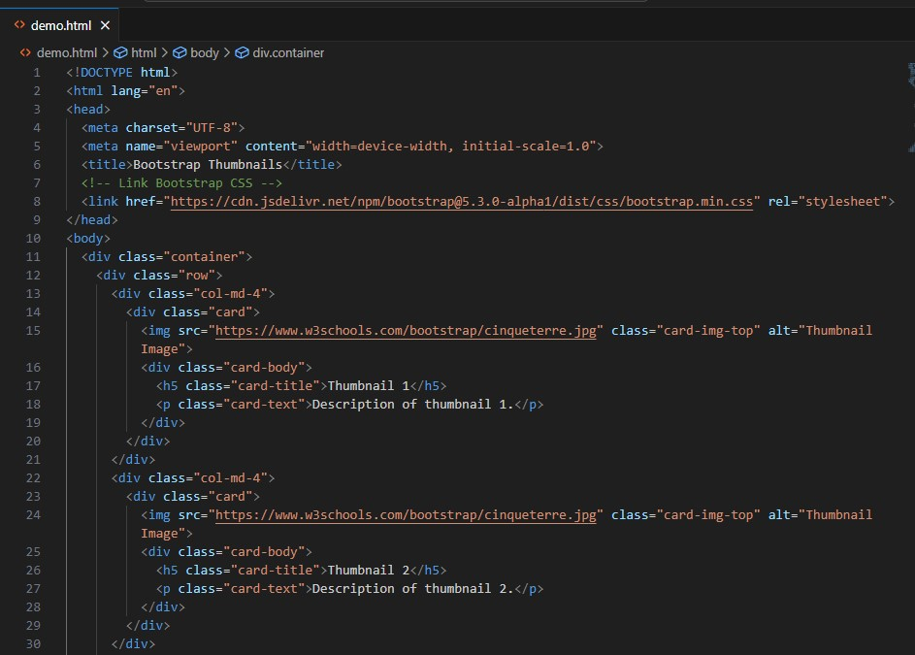

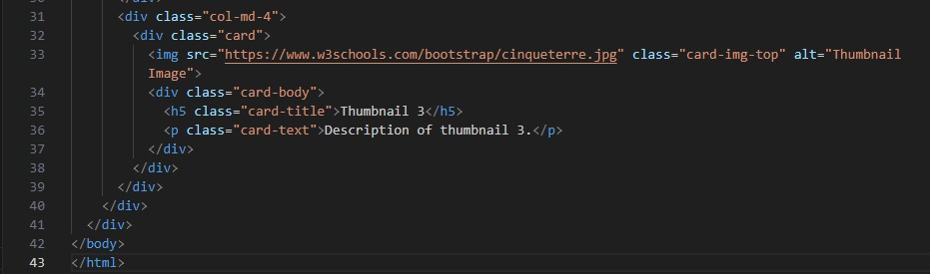

**Output:-**

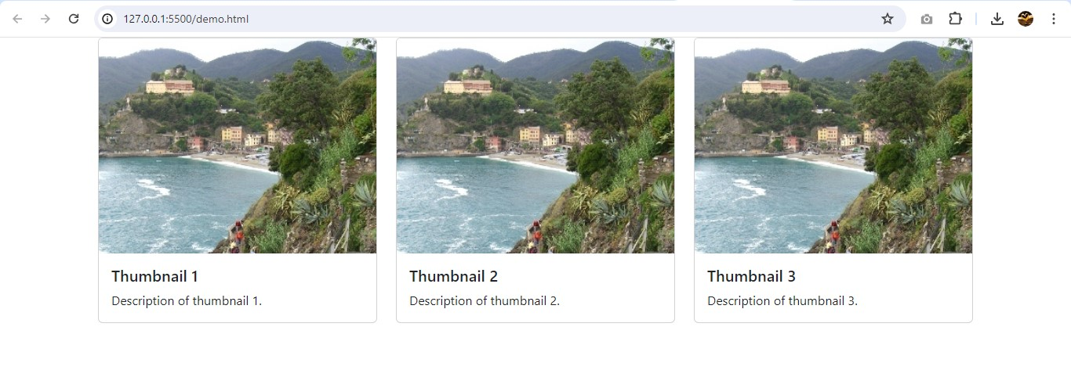In this example:

Each thumbnail is wrapped inside a col-md-4 column to create a responsive layout that displays three thumbnails per row on medium and larger screens.

The card component is used to create the structure for each thumbnail, with an image (card-img-top) and a card-body containing the title (card-title) and description (card-text) of the thumbnail.

**Q.8 In Bootstrap 4, what is flexbox?**

**A.8** In [Bootstrap 4](https://www.javatpoint.com/bootstrap-4), flex box is used to control the layout and alignment specification of Bootstrap 4 components. This box makes it easier to design flexible responsive layout structures without using float or positioning attributes.

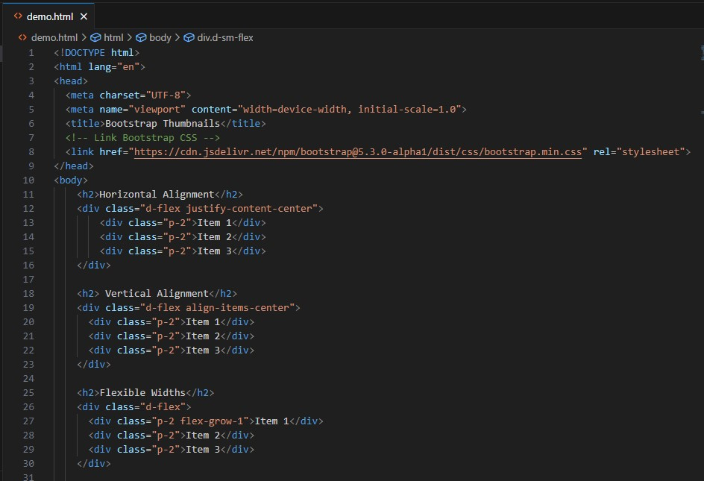

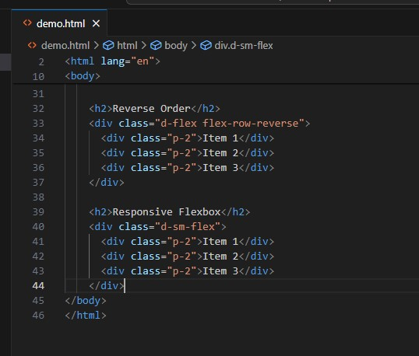

**Output:-**

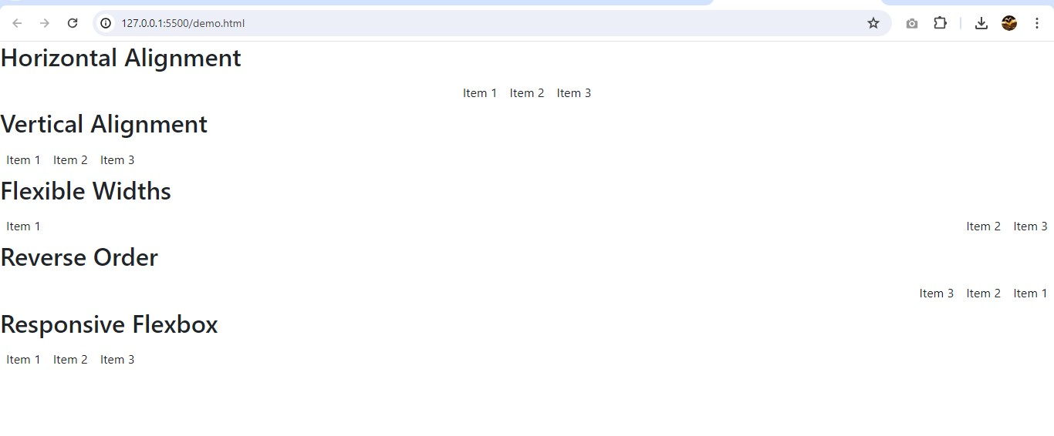

**Q.9 How can one create an alert in Bootstrap?**

**A.9** Bootstrap provides an easy way to create predefined alert messages:

Alerts are created with the .alert class, followed by one of the four contextual classes .alert-success, .alert-info, .alert-warning or .alert-danger.

Different contextual classes like .alert-success, .alert-danger, .alert-warning, and .alert-info are applied to create alerts with different colors and styles.

Inside each div with the .alert class, we include the text content of the alert message.

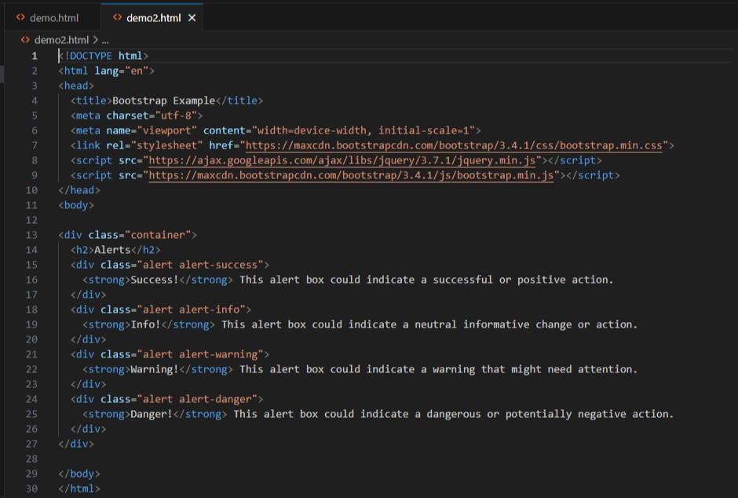

**Output:-**

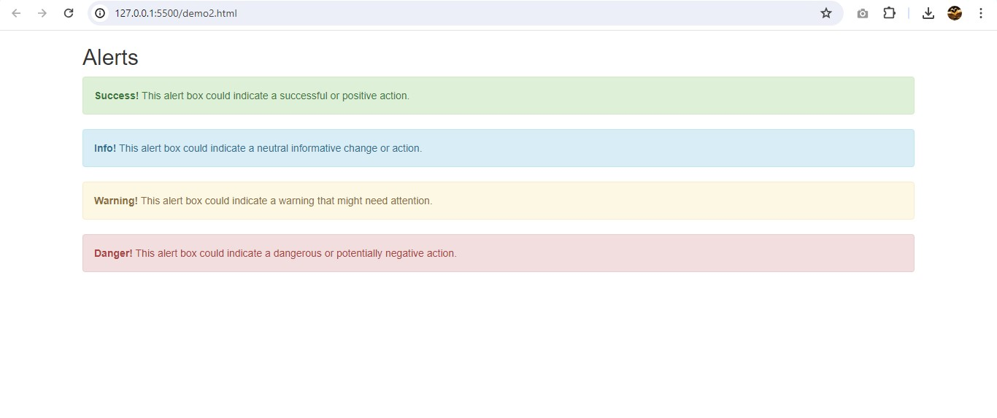

**Q.10 What is a bootstrap card and how would you create one?**

**A.10** A card in Bootstrap 5 is a bordered box with some padding around its content. It includes options for headers, footers, content, colors, etc.

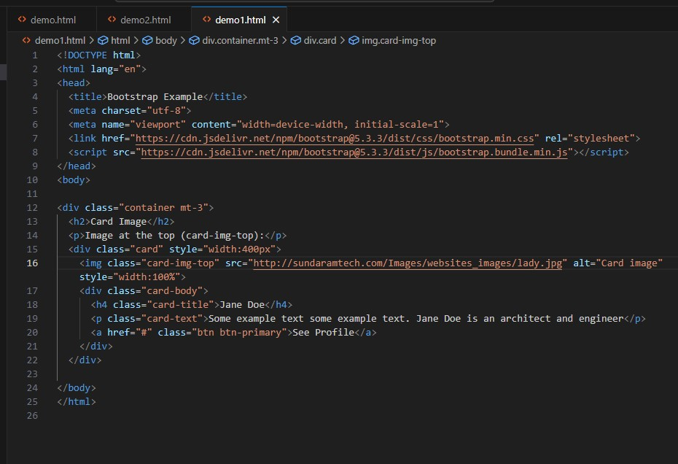

**Output:-**

