ПОД-СЕКЦИЯ 3. Информатика, вычислительная техника и автоматизация
Davydov O.P.
Student
Kharkiv National University of Radio Electronics

GAME THEORY IN GAME DESIGN

Keywords: game design, game theory, dominant strategies, payoff matrix.

It is a common practice to face with some difficulties while designing your game. One of the most vulnerable and crucial part of it is balance. Ask yourself “How can we make it the strongest part of our game?” The first idea that springs up to most game designers is “Let’s make alpha-version (beta-version, it does not matter) and test it”. What can go wrong, we are testing our game in the field, so to speak, and we can ask our testers about unbalanced parts of it and fix them. However, when the game or patch is released gamers find several top strategies that dominate over other ones. We have to ask ourselves one more time “What the reason of our mistake?” The answer is all of us have cognitive disorders.
To avoid the above situation we need to use the most powerful game design instrument called math. We can use such things as probabilities, golden ratio, Fibonacci numbers, power and cost, but the most complicated, most versatile and hazy section of math is game theory.
Game theory is the study of mathematical models of conflict and cooperation between intelligent rational decision-makers [3]. As you can see, conflict and cooperation is always present in some form in every game. That means we can represent our game or its part in game theory terms.
The simplest mathematical description of a game is the strategic form. We will take a closer look at the strategic form for a two-person zero sum game because almost all mechanics can be presented in that form. Here we have two parties of the conflict. When one of the parties gain a value, its opponent lose the same value. A triplet (P, Q, A) gives the strategic form for such a game, where P and Q is a nonempty set of strategies of Player I and Player II, respectively; and A is a real-valued function defined on P×Q [1]. The best way to imagine A is to present it as a m×n matrix (f.1) called payoff matrix, where m ‒ cardinality of set P and n ‒ cardinality of set Q.
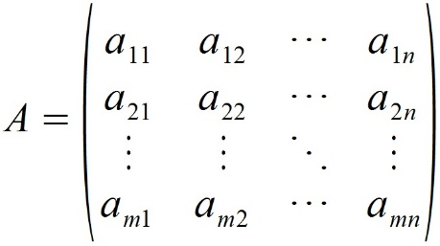 (formula 1)
One of the most confusing steps is to transform your game in a payoff matrix for Player I (mention that payoff matrix for Player II in our case should be an inverse matrix of Player I where all elements are with opposite signs); it requires a lot of time for reflection. The main idea of that matrix is to show us advantages and disadvantages a_{ij} where i is the strategy number for Player I and j for Player II.
The next step is to analyze a payoff matrix. It is divided in several steps:
- Removing rows and columns.
- Finding saddle points.
- If there is no saddle points, finding mixed strategies.
- Finding game value.
Removing rows and columns mean that we will reduce our matrix in size by removing obviously bad player strategies. We remove the kth row of matrix when it is dominated by ith row for all j (a_{ij} ≥ a_{kj}). We remove the kth column when it is dominated by jth column for all i (a_{ij} ≤ a_{ik}).
When our matrix finally reduced, we can find saddle points. Saddle point in a payoff matrix is the optimal strategy for both players. If a_{ij} is the minimum of ith row and maximum of jth column, it is a saddle point of the game. If there is no saddle point in our game, we go to the third step.
Now our goal is to define mixed strategies. First, one should define pure and mixed strategies. Mixed strategy for Player I is ordered system of m real non-negative numbers that satisfies the condition [2]:
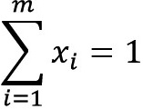 (formula 2)
We consider x_{i} to be probability of Player I to pick ith strategy, the same for y_{j} and Player II. Pure strategy k is a mixed strategy where one of x_{k}=1 and x_{i}=0 for all i≠k. In mixed strategies we are talking about average return, so when Player I uses mixed strategy X=||x₁ … x_{m}|| and Player II uses mixed strategy Y=||y₁ … y_{n}|| than mathematical expectation of Player I gain is given by the formula:
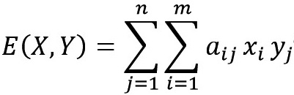 (formula 3)
There several ways to find dominant mixed strategies: equalizing strategies method, graphical method, simplex method. We will skip their description.
The fourth step is to find the value of the game. If the value number is positive, we say the game favors Player I, if value is negative ‒ favors Player II. When value is zero, game is fair. Saddle point is considered as a game value for a game; when there is no saddle points, we need to find dominative mixed strategy.
At the end of our researches, we get data about our game to analyze. First, we should pay our attention at saddle points and remove them if we want our players use more than one strategy. Then, we have to ensure that our mixed strategies complicated enough and not so obvious for the average player. We have to check the number of strategies included in mixed strategy and probabilities distribution inside of it; if one is low it means that player can almost get the best results by throwing out rarely used strategies. In addition, we have game value as evidence of balance or imbalance. Then we can start working with values in our game, based on the results of earlier.
As a result of applying game theory to our game we get mathematical model that is easy to use. Now we can work with model before adding some changes to our game. The main problem we can face is a great number of strategies that we can hardly trace. In that case, we have to split and work with them separately, or simplify our math model by throwing out insignificant parts.

References
- Thomas S. Ferguson, Game theory, 2nd ed., 2014.
- J.C.C. McKinsey, Introduction to the Theory of Games, 2003. ‒ 369p.
- Roger B. Myerson, Game Theory: Analysis of Conflict, 1997. ‒ 553p.

