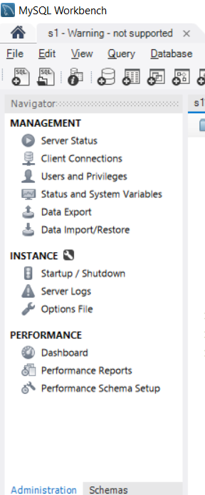
1. Install MySQL Workbench and connect to MySQL Server
- Download and install MySQL Workbench from the official MySQL website.
- Make sure MySQL Server is also installed and running.
- Open MySQL Workbench.
- On the Home screen, select your local MySQL connection, usually something like Local instance MySQL80.
- Enter your MySQL root password.
- After connecting, look at the SCHEMAS panel on the left.
You should see default databases/schemas such as:
- information_schema
- mysql
- performance_schema
- sys

2.Create a new database called InstaClone in MySQL Workbench, then create a table named Users with columns: user_id (INT, primary key), username (VARCHAR), email (VARCHAR), and followers_count (INT).

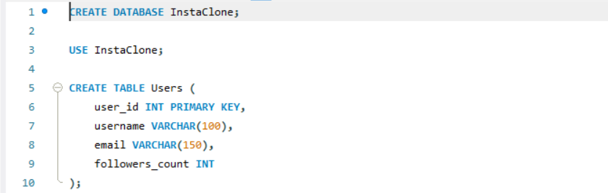
3.Insert 3 sample users into the Users table you created, using realistic Instagram-style usernames and follower counts.
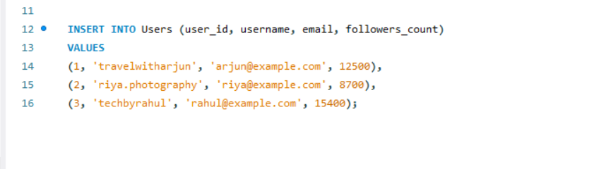
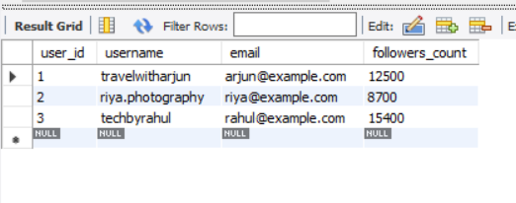
4. Create another table in the InstaClone database called Posts with columns: post_id (INT, primary key), user_id (INT), caption (VARCHAR), and post_date (DATE). Add a foreign key from Posts.user_id to Users.user_id to establish a relationship.
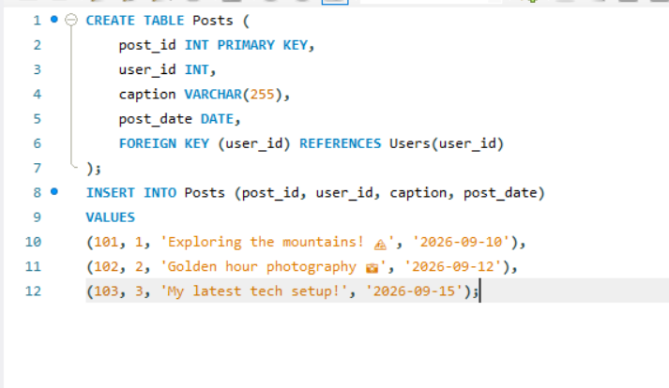
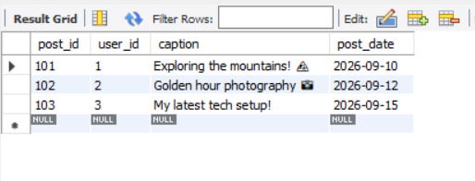
5. Write a short comparison (3-4 lines each) of MySQL, PostgreSQL, Oracle, and SQLite, focusing on where each one is commonly used (for example: web apps, mobile apps, enterprise systems, etc.).

MySQL
MySQL is a popular relational database commonly used for web applications.
It is widely used with PHP, WordPress, Laravel, and other web technologies.
It is suitable for websites ranging from small projects to large-scale applications.

PostgreSQL
PostgreSQL is an advanced open-source relational database known for its powerful SQL features and extensibility.
It is commonly used for web applications, analytics, geographic applications, and complex data systems.
It is particularly useful when applications require advanced queries and strong data integrity.

Oracle
Oracle Database is a commercial enterprise-level database system.
It is commonly used by large businesses, banks, governments, and enterprise applications.
It provides extensive features for security, high availability, scalability, and transaction processing.

SQLite
SQLite is a lightweight, serverless relational database stored in a single file.
It is commonly used in mobile applications, desktop applications, embedded systems, and small-scale applications.
For example, many applications use SQLite when a full database server would be unnecessary.

