Steps for getting google developer custom search credentials:

For **GCS_DEVELOPER_KEY & GCS_CX:**

1. Visit <https://console.developers.google.com> and create a project.
2. Visit <https://console.developers.google.com/apis/library/customsearch.googleapis.com> and enable "Custom Search API" for your project.
3. Visit <https://console.developers.google.com/apis/credentials> and generate API key credentials for your project by clicking create credentials->api key.

Your api key is your **GCS_DEVELOPER_KEY**

1. Visit [https://cse.google.com/cse/all](https://cse.google.com/cse/all%20) ,create **new search engine** add <https://images.google.com/> url in sites to search section give any name and hit create button.
2. Click on get code and you will see something like this

<script async src="https://cse.google.com/cse.js?cx=b9b7c4211a73eae3c"></script>

<div class="gcse-search"></div> you will come across something like this, you will find the **GCS_CX as** cx=b9b7c4211a73eae3c use this as that key.

OR on left hand side panel you can see setup option under edit search engine click on that , and you will find **Search engine ID** that is your **GCS_CX key.**

Steps for getting Twitter developer credentials:

1. Create your app and then proceed forward normally by clicking ok, until you reach this screen**(DASHBOARD)**

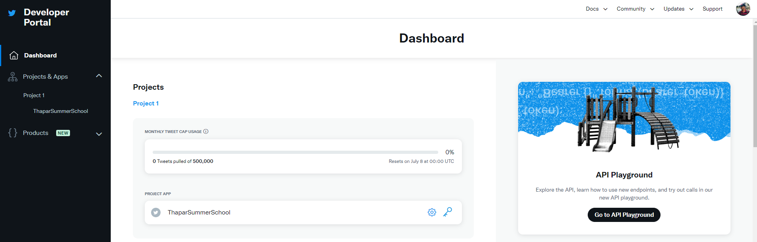

1. As you can see I named my project app as Thapar Summer school I can see its visible on my dashboard.
2. Click on that key symbol marked with red
3. You will reach the page below. Click on regenerate keys for **Consumer Keys ->API key and Secret**

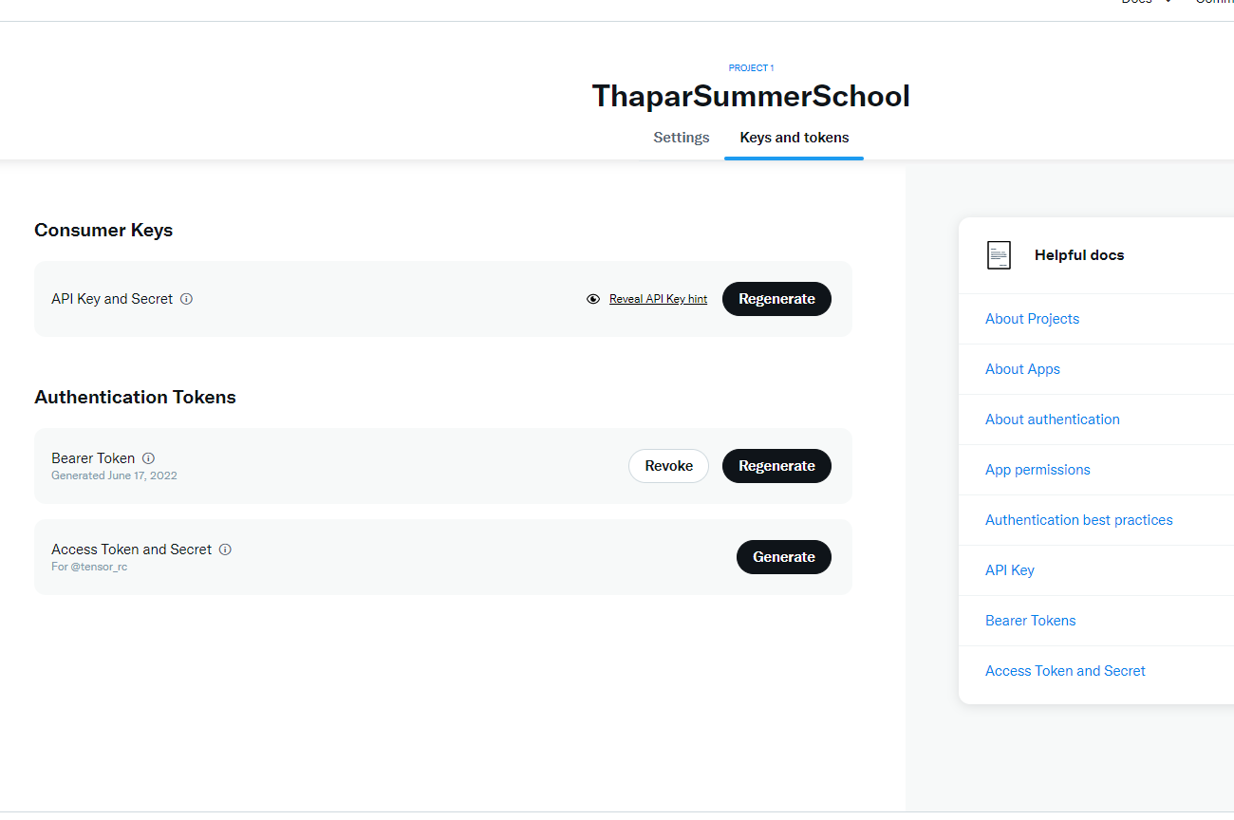

5.You get your Consumer Keys which you need to replace in the colab ipynb notebook

(API KEY)consumer_key = "xxxxxxxxxxxxx"

(API Key Secret)consumer_secret = "xxxxxxxxxxxxxxxxxxxxxxxxxxxxxxx"

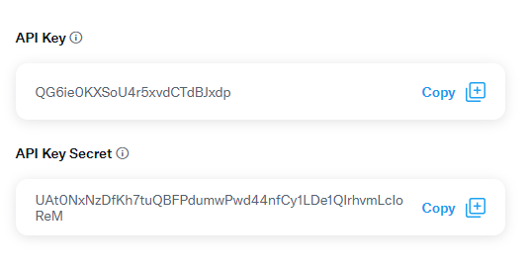

6.Similarly get the other two keys by clicking genrate under Authentication tokens ->Access Tokens and secret

Replace them in your colab notebook in place of

access_token = "xxxxxxxxxxxxxxxxxxxxxxx"

access_token_secret = "xxxxxxxxxxxxxxxxxxxxxxxxxxxxxxxxxxxxxx"

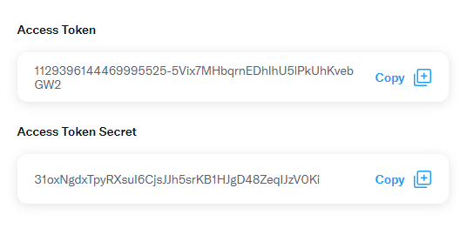

7.Apply for elevate access for developer account on <https://developer.twitter.com/en/portal/products/elevated> or else the tokens wont work the tweets your trying to fetch as it requires more access. Write your purpose and wait for response from Twitter. Be genuine as on what you want to build using this and then only it will get approved.

**ELSE USE THE KEYS ALREADY PROVIDED IN THE NOTEBOOK THEY WORK!**