# IC 152: Makerspace Laboratory

Line Follower

BATCH: B1 TEAM: H

***Names Roll nos.***

**Pathak Krish 230002049**

**Mudit Tiwari 230002044**

**Nishit 230002047**

**Nitin Mewara 230002048**

**Pranav 230002045**

**Naman Goyal 230002046**

# Overview

In this project, we built a simple line follower capable of autonomously navigating a predefined path marked by a contrasting black line on the floor. The robot had two extra features:

* It can detect and avoid an obstacle in its path.
* You can operate it from afar using a phone app connected via Bluetooth.

# Components

* IR SENSOR (2)
* ARDUINO MICRCONTROLLER
* L298N MOTOR DRIVER
* GEAR MOTOR (4)
* JUMPER WIRE
* LITHIUM BATTERIES
* BATTERY HOLDER
* WHEELS (3-D PRINTED) (4)
* SERVO MOTOR
* ACRYLIC CHASSIS (LASER CUT)
* BLUETOOTH MODULE
* SR04 ULTRASONIC SENSOR AND HOLDER
* BREADBOARD (FOR CONNECTIONS)

# Design

Line Following

The robot has a compact design with a small chassis. The underside features four motors, each driving a wheel, alongside two batteries to supply power to the system. The microcontroller, breadboard and motor driver are positioned on the top. Two IR sensors are affixed symmetrically to the front of the chassis using double-sided tape, offering flexibility in adjusting their spacing as needed.

Logic:

The IR sensors give a high output whenever they detect a black line and low otherwise. A left turn is achieved by increasing the speed of the motors controlling the right wheels and vice versa for a right turn. By using the logic shown in the image below, we ensure that the robot follows the line.

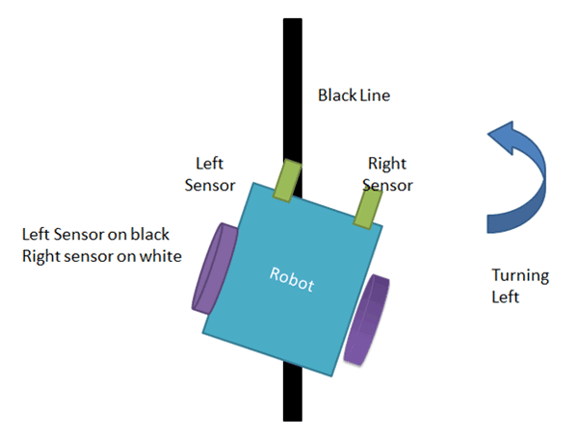 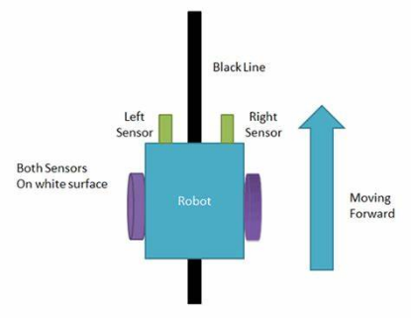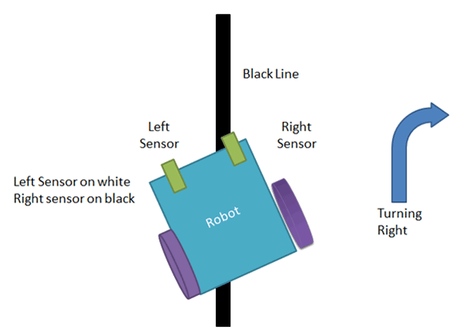

Object Detection and Avoidance

The ultrasonic sensor constantly sends pulses of sound in front and notes the time for the echo to return. Knowing the speed of sound, we can use this to calculate the distance in front of the line follower. If there is an object at a distance less than 15 cm, the line follower turns to avoid it. On detecting the line again, it continues to follow it.

Bluetooth

A mobile app that communicates with the Bluetooth module can be used to remotely control the robot. It follows a few predefined commands to change its speed(gear), move forward and back, turn left and right, etc.

# Photos

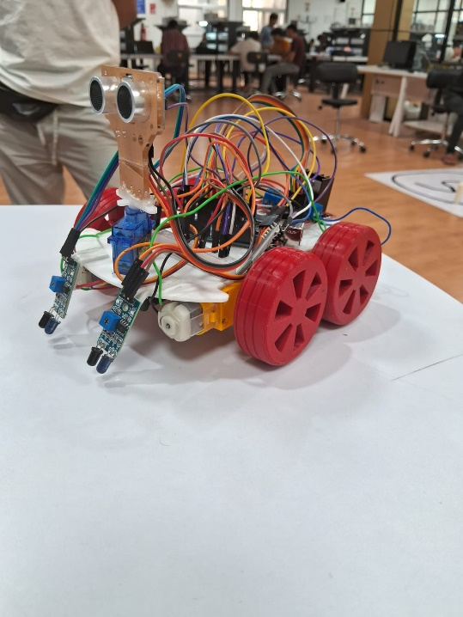 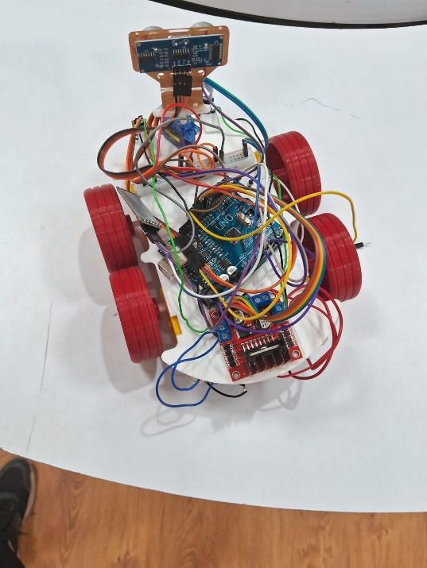

# Key Learnings

* Discovering the critical role that a robot's physical dimensions play in its manoeuvrability and effectiveness.
* Gaining insights into the design process, including crafting wheels and chassis boards.
* Exploring electronic components like Arduino, Motor Driver, and IR Sensors, understanding their functionalities and interconnections.
* Understanding how to write, upload and debug code on Arduino IDE.
* Engaging in a collaborative team effort, fostering valuable experience in teamwork.