Internal AI Sales Assistant
Internship Project Specification

Prepared for: CS / AI-ML Internship Student
Project duration: 2 months
Document version: v1.1
Last updated: 03-Jul-2026

This document defines a practical project for building an internal AI assistant for the sales, business development, and technical teams. The assistant must answer questions only from approved company documents, provide source-backed responses, flag risky claims, and generate short customer-facing replies when needed.

Version History
This page should be updated whenever the project scope, environment, tooling, security assumptions, or deliverables change.
Version | Date | Owner | Change Summary | Review Status
v1.0 | 03-Jul-2026 | Sudarshan | Initial internship specification for internal AI sales assistant, including RAG flow, guardrails, UI mockups, milestones, and acceptance criteria. | Baseline
v1.1 | 03-Jul-2026 | Sudarshan | Added recommended VS Code-based development environment, enterprise controls, repository workflow, approved extension list, AI usage rules, deployment progression, and agent runtime settings. | Current
v1.2

Item | Description
Project type | Internal AI / RAG assistant for sales knowledge support
Primary users | Sales, business development, application engineering, and management
Main output | Working web app + document ingestion + claim guardrail + evaluation report
Preferred stack | VS Code desktop, Python, Streamlit, ChromaDB / FAISS, private Git repo, company-approved LLM API, local files / SQLite for prototype.
Important rule | No customer-facing deployment in the first version. Do not use confidential chip design, customer, legal, financial, PDK, or vendor documents.

1. Project Objective
Build an internal AI sales assistant that helps the team quickly retrieve product, application, and positioning information from approved company documents.
The assistant should reduce repeated manual search through brochures, decks, notes, FAQs, and product documents.
The assistant must not invent answers. If the required information is not present in the approved knowledge base, it should clearly say that the information is not available and request human review.

2. Scope

2.1 In Scope
- Internal web app for sales and technical team use.
- Document upload / ingestion for selected approved files.
- Question-answering using retrieval-augmented generation.
- Source-backed answers with document name and section reference where possible.
- Approved-claim and restricted-claim checking.
- Short customer-facing response drafts for email or WhatsApp.
- Evaluation using a fixed set of test questions.

2.2 Out of Scope
- Public website chatbot.
- Direct customer deployment without human approval.
- Pricing, warranty, delivery commitment, or legal answers unless explicitly provided in approved documents.
- Use of confidential chip design, vendor quote, PDK, foundry, customer NDA, or financial documents.
- Any claim about certification, safety, hazardous area use, or accuracy unless supported by approved source material.

3. Example Use Cases
Use case | Example question | Expected behavior
Product positioning | What is our hydrogen detection positioning? | Answer using approved product positioning document and mention source.
Application support | Can we use this for oil and gas applications? | Answer with target application context and avoid certification overclaims.
Interface support | Do we support RS485 or 4-20 mA? | Retrieve product/interface notes and provide concise sales wording.
Restricted claim | Can we say this is ATEX certified? | Flag as risky. Do not allow external claim without approved source.
Customer reply | Draft a reply for a customer asking about hydrogen leak detection. | Generate short customer-facing response with cautious wording.
Document recommendation | Which document should I send for industrial safety? | Suggest relevant approved documents from the knowledge base.

4. System Architecture
The first version should be a simple internal RAG system. RAG means the assistant retrieves relevant document chunks first and then generates the answer from those chunks. The answer should not rely on general internet knowledge or unsupported assumptions.
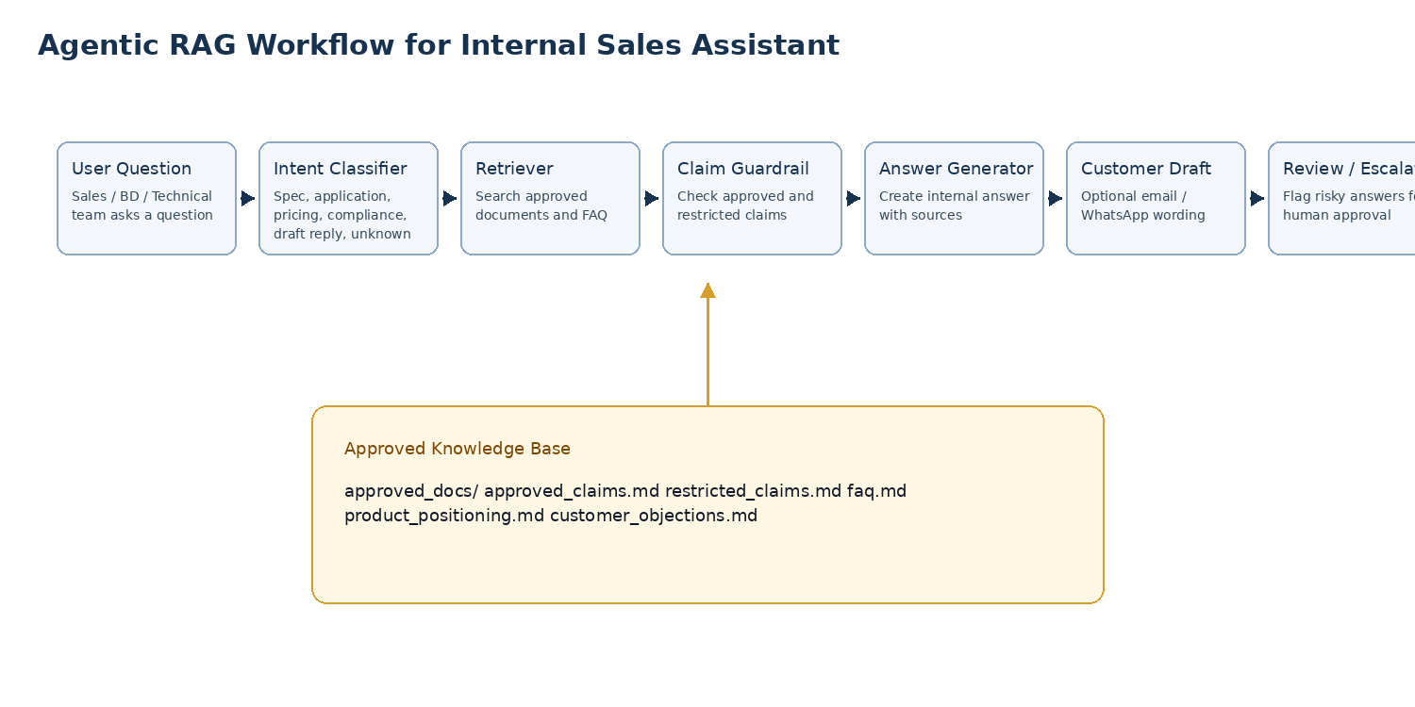
Figure 1: Proposed agentic RAG workflow.

4.1 Core Components
Component | Purpose
Web UI | Simple user interface for asking questions, viewing answer, source, confidence, and risk flags.
Document loader | Reads PDF, DOCX, PPTX, CSV, Markdown, and text files from an approved folder.
Chunker | Splits documents into small searchable pieces with metadata.
Embedding / search index | Stores document chunks for semantic search.
Intent classifier | Classifies user question into product, application, compliance, pricing, customer draft, or unknown.
Retriever | Finds the most relevant approved chunks.
Claim checker | Checks whether the answer touches restricted claims such as certification, safety, accuracy, price, warranty, or delivery.
Answer generator | Creates concise internal answer and optional customer-facing wording.
Evaluation module | Runs test questions and stores results for review.

5. Agentic Workflow
The system should behave like a controlled workflow, not like a free-form chatbot. Each query should pass through defined steps.
- Receive the user question.
- Classify the question type: product, application, compliance, pricing, document request, customer response drafting, or unknown.
- Search only the approved knowledge base.
- Retrieve the top relevant document chunks.
- Check whether the question or draft answer triggers restricted-claim categories.
- Generate the answer using only retrieved material.
- Attach source references and confidence level.
- If the question is risky or unsupported, respond with an escalation message instead of guessing.
- If requested, generate a short customer-facing version that avoids unsupported claims.

6. Environment Setup

6.1 Required Tools
Tool | Purpose | Minimum version / notes
Python | Main backend and app logic | Python 3.10 or 3.11 preferred
VS Code | Development environment / IDE | Use VS Code desktop. Prefer company-managed policies, approved extensions, and Git integration.
Git | Version control | Create feature branches and commit weekly
Streamlit | Fast internal web UI | Recommended for first version
LLM provider API | Answer generation and optional embeddings | Use only company-approved OpenAI / Azure OpenAI / equivalent enterprise API key.
Vector database | Semantic retrieval | FAISS or Chroma for local prototype
SQLite | Small local metadata store | Optional for chat logs and evaluations
Private Git repository | Version control and review | Use GitHub private repo or Azure DevOps private repo. Student must work on branches.
Dev Containers | Optional reproducible environment | Useful if laptop setup varies. Not mandatory for first version.
Managed secrets | API-key protection | Use .env locally only. Do not commit real .env or keys.
Allowed extensions list | Reduce extension risk | Allow Python, Pylance, Jupyter, GitLens, Docker, Dev Containers, YAML, Markdown. Avoid random AI extensions.

6.2 Folder Setup
sales-ai-assistant/
app/
streamlit_app.py
config.py
rag_pipeline.py
document_loader.py
chunker.py
retriever.py
claim_checker.py
response_generator.py
evaluation.py
data/
approved_docs/
approved_claims.md
restricted_claims.md
faq.md
sample_questions.xlsx
index/
vector_store/
reports/
evaluation_report.xlsx
weekly_status.md
tests/
test_claim_checker.py
test_retriever.py
.env.example
requirements.txt
README.md

6.3 Python Environment Setup
# Windows PowerShell
cd sales-ai-assistant
python -m venv .venv
.\.venv\Scripts\Activate.ps1
python -m pip install --upgrade pip
pip install -r requirements.txt
# macOS / Linux
cd sales-ai-assistant
python3 -m venv .venv
source .venv/bin/activate
python -m pip install --upgrade pip
pip install -r requirements.txt

6.4 Suggested requirements.txt
streamlit
python-dotenv
pandas
openpyxl
pypdf
python-docx
python-pptx
markdown
chromadb
sentence-transformers
openai
pydantic
pytest
ruff

6.5 .env.example
# Do not commit the real .env file.
LLM_PROVIDER=openai
OPENAI_API_KEY=replace_with_company_approved_key
EMBEDDING_MODEL=text-embedding-3-small
CHAT_MODEL=gpt-4o-mini
APP_MODE=internal
KNOWLEDGE_BASE_DIR=data/approved_docs

6.6 Running the App
# Build / refresh index
python app/rag_pipeline.py --reindex
# Run internal UI
streamlit run app/streamlit_app.py
# Run tests
pytest tests/
# Optional code quality check
ruff check app tests

6.7 Recommended Development Environment
Recommended choice for the internship: VS Code desktop + Python virtual environment + Streamlit + ChromaDB / FAISS + private Git repository. Keep the first version simple and internal-only.

6.7.1 VS Code Enterprise Clarification
There is no separate heavy IDE called "VS Code Enterprise" that is required for this project. Use VS Code desktop, but manage it like an enterprise development environment through company policies, approved extensions, repository permissions, secrets control, and AI usage rules.

6.7.2 Recommended Tooling Decision
Item | Decision
IDE | VS Code desktop
Repository | GitHub private repo or Azure DevOps private repo
Frontend | Streamlit for version 1
Backend | Python modules; FastAPI only if needed later
Deployment path | Local demo first, then internal VM / Azure App Service / company intranet deployment

6.7.3 VS Code Extensions to Allow
Keep the allowed extension list small. The intern should not install random AI, scraping, cloud-sync, or code-upload extensions.
Extension | Purpose
Python | Python language support and debugging
Pylance | Python analysis and IntelliSense
Jupyter | Notebook experiments and data exploration
GitLens | Git history and review support
Docker | Optional container support
Dev Containers | Optional reproducible development environment
YAML | Configuration file editing
Markdown All in One | README, prompts, and documentation
GitHub Copilot | Optional only with company-approved Business/Enterprise account

6.7.4 VS Code Workspace Files
Create a .vscode folder in the repository so the student gets consistent behavior.
.vscode/
extensions.json
settings.json
launch.json # optional
Example .vscode/extensions.json:
{
"recommendations": [
"ms-python.python",
"ms-python.vscode-pylance",
"ms-toolsai.jupyter",
"eamodio.gitlens",
"ms-azuretools.vscode-docker",
"ms-vscode-remote.remote-containers",
"redhat.vscode-yaml",
"yzhang.markdown-all-in-one"
]
}
Example .vscode/settings.json:
{
"python.defaultInterpreterPath": ".venv\\Scripts\\python.exe",
"python.analysis.typeCheckingMode": "basic",
"editor.formatOnSave": true,
"files.exclude": {
"**/__pycache__": true,
"**/.pytest_cache": true
}
}

6.7.5 Repository and Branch Workflow
- Create a private repository named sales-ai-assistant.
- Keep main branch protected. Student should not push directly to main.
- Use weekly feature branches such as week-02-streamlit-skeleton or week-04-rag-flow.
- Require pull request review before merging important changes.
- Commit README updates, prompt templates, test questions, and evaluation reports along with code.
- Do not commit .env, API keys, raw confidential documents, or temporary vector database files unless explicitly approved.
Suggested .gitignore:
.venv/
.env
__pycache__/
.pytest_cache/
vector_store/
data/private_docs/
*.log
*.tmp

6.7.6 Agent Runtime Configuration
Keep all agent behavior controlled through configuration rather than hardcoding it inside the UI.
Setting | Purpose
LLM_PROVIDER | Select openai, azure_openai, or offline_mock for testing
APP_MODE | development, demo, or internal
ALLOW_CUSTOMER_FACING_OUTPUT | Default false. Enable only for drafted wording, never automatic sending
ALLOW_DOCUMENT_UPLOAD | Default false for normal users; admin-only if implemented
REQUIRE_SOURCES | Default true. Blocks answers without retrieved sources
CLAIM_GUARDRAIL_MODE | warn, block, or review_required
LOG_USER_QUESTIONS | Default false unless privacy policy and review need it
VECTOR_DB_PATH | Local path for ChromaDB / FAISS index

Example expanded .env.example:
# Do not commit the real .env file.
LLM_PROVIDER=azure_openai
APP_MODE=development
ALLOW_CUSTOMER_FACING_OUTPUT=false
REQUIRE_SOURCES=true
CLAIM_GUARDRAIL_MODE=block
VECTOR_DB_PATH=./vector_store/chroma
# OpenAI option
OPENAI_API_KEY=replace_with_company_approved_key
OPENAI_MODEL=gpt-4.1-mini
EMBEDDING_MODEL=text-embedding-3-small
# Azure OpenAI option
AZURE_OPENAI_API_KEY=replace_with_company_approved_key
AZURE_OPENAI_ENDPOINT=https://your-resource.openai.azure.com/
AZURE_OPENAI_API_VERSION=2025-xx-xx
AZURE_OPENAI_DEPLOYMENT=gpt-4.1-mini

6.7.7 Enterprise Controls and Security Rules
- Use only company-approved LLM/API accounts. Do not use personal API keys for company documents.
- If Copilot is used, use only a company-approved Business/Enterprise account and approved VS Code extension.
- Disable or block unapproved AI coding extensions.
- Use allowed extension policies if the laptop is company-managed through Intune, Group Policy, or equivalent MDM.
- Keep real documents in data/approved_docs only. Keep confidential or excluded documents outside the repository.
- Use restricted_claims.md as a mandatory guardrail file, not as optional documentation.
- Do not expose the app publicly. Version 1 must remain internal-only.

6.7.8 Optional Dev Container
A Dev Container is optional. Use it only if local setup becomes inconsistent across laptops.
.devcontainer/devcontainer.json
{
"name": "sales-ai-assistant",
"image": "mcr.microsoft.com/devcontainers/python:3.11",
"customizations": {
"vscode": {
"extensions": [
"ms-python.python",
"ms-python.vscode-pylance",
"ms-toolsai.jupyter"
]
}
},
"postCreateCommand": "pip install -r requirements.txt"
}

6.7.9 Deployment Progression
Stage | Environment | Purpose
Stage 1 | Student laptop / local VS Code | Development and unit testing
Stage 2 | Local Streamlit demo | Mentor review using sanitized approved documents
Stage 3 | Internal VM or company-controlled machine | Pilot use by sales / management team
Stage 4 | Azure App Service / intranet deployment | Only after security review and management approval

6.8 Initial VS Code Setup Checklist for the Student
- Install VS Code desktop from the company-approved source.
- Install only the approved extensions listed in this document.
- Clone the private repository provided by the mentor.
- Create and activate the Python virtual environment.
- Install dependencies from requirements.txt.
- Copy .env.example to .env and get API-key values from the mentor; do not create a personal key unless approved.
- Run the Streamlit blank app before starting RAG implementation.
- Create a first pull request containing only setup documentation and the blank app skeleton.

7. Knowledge Base Preparation
The quality of the assistant depends more on clean approved documents than on the model itself. The intern should first prepare a small, controlled knowledge base before building advanced features.

7.1 Approved Documents
- Company overview / one-page profile.
- Product positioning note.
- Application areas note: hydrogen, industrial safety, green energy, oil and gas, home safety, process monitoring.
- Interface options note: RS485, 4-20 mA, HART if applicable, BLE / LoRa if applicable.
- FAQ for common customer questions.
- Approved claims and restricted claims documents.
- Any brochure or presentation that management approves for internal use.

7.2 Documents Not Allowed
- Full SoC architecture documents.
- AFE schematics, RTL, register maps, chip design files, PDK-related documents.
- Vendor quotes, commercial negotiations, legal agreements, customer confidential emails.
- Financial projections, DLI-sensitive documents, hiring or salary documents.
- Any document not explicitly approved for the project.

8. Claim Guardrail
The claim guardrail is one of the most important parts of the project. Sales assistants are useful only if they prevent unsupported claims.

8.1 approved_claims.md Example
# Approved Claims
- The company is developing gas-sensing and sensor-electronics solutions.
- Target application areas include hydrogen sensing, industrial safety, green energy, oil and gas, home safety, and process monitoring.
- The product roadmap may include industrial interfaces such as RS485 and 4-20 mA depending on product configuration.
- The company has capability in sensor electronics, embedded calibration, and low-power data acquisition.

8.2 restricted_claims.md Example
# Restricted Claims
The assistant must flag or block the following unless explicitly supported by approved documents:
- ATEX certified
- IECEx certified
- SIL-2 certified
- Life-safety certified
- Explosion-proof
- Intrinsically safe
- ppm accuracy
- Universal gas detection
- Guaranteed delivery date
- Final price or warranty commitment
- Any regulatory or legal claim

9. Agent Prompt Templates
The intern can start with the following prompt templates. These should be stored as editable files, not hardcoded inside the app.

9.1 System Prompt
You are an internal sales knowledge assistant for a gas-sensing and sensor-electronics company.
Answer only from the approved knowledge base provided to you.
Do not use general knowledge for product claims.
If the documents do not support the answer, say: "I do not have approved information for this. Please check with the technical or management team."
Flag risky topics such as certification, hazardous-area use, safety, accuracy, pricing, warranty, delivery dates, or legal commitments.
Always provide:
1. Short answer
2. Source references
3. Confidence: High / Medium / Low
4. Risk flag, if any
5. Optional customer-facing wording if requested

9.2 Answer Format
Short answer:
<2-5 sentences>
Sources:
- <document name>, <section / page if available>
Confidence:
High / Medium / Low
Risk flag:
None / Certification / Accuracy / Safety / Pricing / Legal / Delivery / Unknown
Customer-facing wording:
<Only if requested. Keep it short and cautious.>

10. Sample Screen Outputs
The first version can be a simple Streamlit app. It does not need advanced UI design. The important requirement is clarity: question, answer, sources, confidence, and risk flag should be visible.
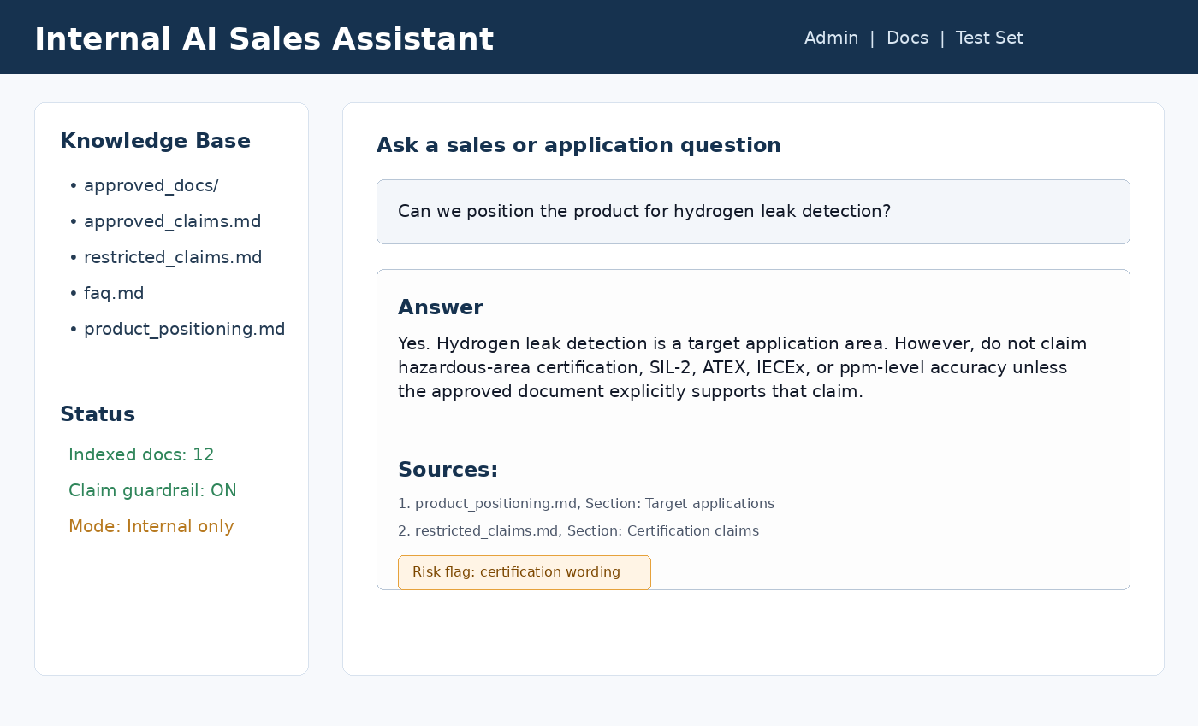
Figure 2: Example main assistant screen.
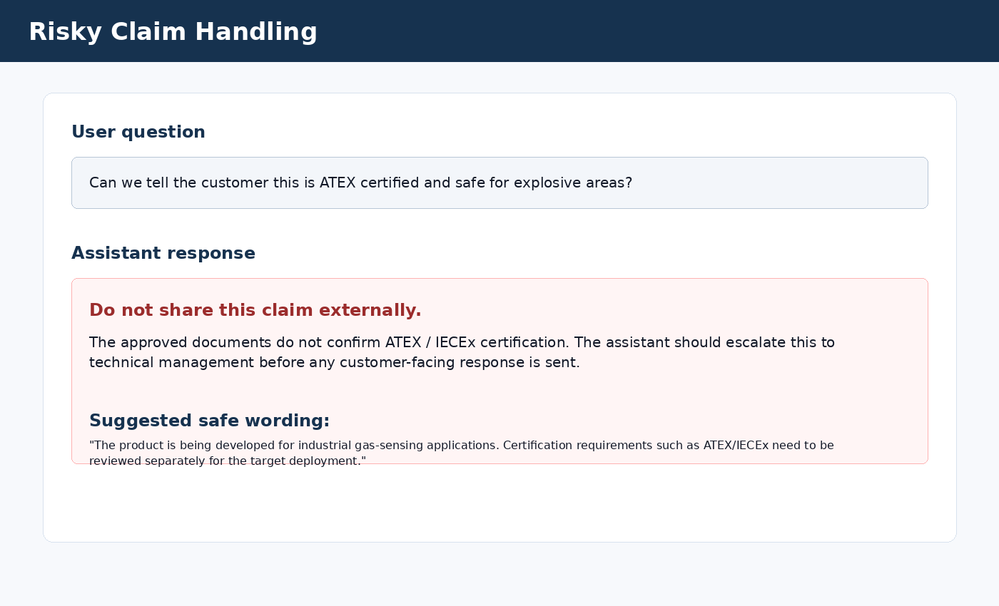
Figure 3: Example response when a user asks for an unsupported certification claim.

11. Sample Assistant Outputs

11.1 Normal Product Question
User:
Can we position the product for hydrogen leak detection?
Assistant:
Short answer:
Yes. Hydrogen leak detection is listed as a target application area. The safe positioning is that the product is being developed for hydrogen sensing and industrial safety monitoring. Do not claim hazardous-area certification unless an approved certification document supports it.
Sources:
- product_positioning.md, Target applications
- restricted_claims.md, Certification claims
Confidence:
High
Risk flag:
Certification wording
Customer-facing wording:
Our sensing platform is being developed for hydrogen sensing and industrial safety monitoring. Final suitability depends on the gas range, deployment environment, calibration requirements, and certification needs.

11.2 Unsupported Claim Question
User:
Can we say the product is ATEX certified?
Assistant:
Short answer:
I do not have approved information confirming ATEX certification. This claim should not be shared externally unless management provides an approved certification document.
Sources:
- restricted_claims.md, Certification claims
Confidence:
High
Risk flag:
Certification
Customer-facing wording:
Do not auto-generate customer-facing wording for this answer. Escalate for review.

12. Implementation Details

12.1 Document Ingestion
- Read files from data/approved_docs only.
- Extract text and metadata: file name, page number or slide number where possible, section title if available.
- Chunk text into approximately 400 to 800 words per chunk with small overlap.
- Store chunks in the vector database with metadata.
- Rebuild the index when documents change.

12.2 Retrieval
- For each question, retrieve top 3 to 5 relevant chunks.
- If retrieved chunks have low similarity or weak relevance, answer with low confidence.
- Show the sources used in the answer.
- Do not answer if no relevant source is found.

12.3 Claim Checking
- Scan the question and draft answer for restricted terms.
- If restricted terms are present, attach a risk flag.
- If the claim is unsupported, block external wording and request human review.
- Keep this simple initially using keyword rules; ML classification can be a later improvement.

12.4 UI Requirements
UI element | Requirement
Question input | Text box where user enters a question.
Answer panel | Shows concise answer in readable format.
Sources panel | Lists source document names and section/page if available.
Confidence indicator | High / Medium / Low.
Risk flag | Visible warning for restricted claim categories.
Customer draft button | Optional button to generate short external wording.
Admin upload area | Optional simple document upload or refresh index button.

13. Evaluation Plan
The intern should maintain a spreadsheet of test questions and expected behavior. Each build should be tested against the same set so progress can be measured objectively.
Metric | Target
Answer correctness | At least 80% of test answers should match approved documents.
Source citation | At least 90% of answers should show a source.
Unsupported question handling | Must say insufficient information instead of guessing.
Restricted claim handling | Must flag certification, safety, accuracy, price, warranty, and delivery claims.
Response length | Default answers should be short enough for sales team use.
UI usability | User should understand answer, source, confidence, and risk in one screen.

13.1 Sample Test Questions
- What gases are we targeting?
- Can we detect hydrogen?
- Can we claim ppm accuracy?
- Do we support RS485?
- When should I propose 4-20 mA?
- Can we say this is ATEX certified?
- What should I tell a customer asking for hazardous-area deployment?
- What documents should I send for industrial safety?
- What is our product differentiation?
- Draft a short customer reply for hydrogen leak detection enquiry.
- Can we guarantee delivery in 4 weeks?
- Can this be used as a life-safety certified detector?

14. Two-Month Execution Plan
Week | Work package | Deliverable
1 | Understand company, product areas, and sales use cases. Prepare initial project plan. | Use-case list, data boundary list, first knowledge base structure.
2 | Set up Python environment, repository, Streamlit app skeleton, and sample approved documents. | Running blank app and repo structure.
3 | Build document loader, text extraction, chunking, and index creation. | Indexed knowledge base with search results.
4 | Build basic RAG question-answering flow with source references. | Working internal Q&A prototype.
5 | Add claim checker using approved_claims.md and restricted_claims.md. | Risk flags for certification, safety, accuracy, pricing, and legal claims.
6 | Add customer-facing response drafting and improved UI. | Answer screen with internal answer, source, confidence, and customer wording.
7 | Create evaluation test set and fix observed issues. | Evaluation report with pass/fail results.
8 | Polish app, write handover guide, record demo, and final presentation. | Final code, README, demo, and handover document.

15. Final Deliverables
- Working internal web app.
- Clean Git repository with README and setup instructions.
- Knowledge base sample folder with only approved documents.
- Document ingestion and indexing script.
- RAG pipeline with source-backed answers.
- Claim checker using approved and restricted claim files.
- Sample question test set and evaluation report.
- Short demo video or live demo.
- Handover note explaining how to add documents, rebuild index, run tests, and operate the tool.

16. Acceptance Criteria
- The app should run locally with one command after environment setup.
- The assistant should answer only from approved documents.
- Each answer should include source references or clearly say that no approved source is available.
- The assistant should flag or block risky claims related to certification, safety, accuracy, pricing, warranty, delivery, and legal commitments.
- The intern should demonstrate at least 30 test questions with recorded results.
- The code should be understandable by another engineer after reading README.md.
- No confidential documents should be used in the prototype.

17. Guidance to the Student
This project is not about creating a fancy chatbot. It is about creating a controlled assistant that gives reliable, traceable, and safe answers for internal sales support. A simple working system with correct guardrails is more valuable than a complex system that gives unsupported answers.
- Start simple. Use Streamlit and local files first.
- Do not over-engineer the backend in the first month.
- Keep all prompts, approved claims, and restricted claims editable as text files.
- Show sources clearly for every answer.
- Whenever unsure, make the assistant say that approved information is not available.
- Treat claim safety as a core feature, not an optional feature.

18. Stretch Goals
- Add login or simple user role separation for admin and viewer.
- Add conversation history and export to PDF or Markdown.
- Add document freshness metadata.
- Add feedback buttons: correct, partially correct, wrong, unsafe answer.
- Add automatic weekly evaluation report.
- Add customer objection handling: price, accuracy, certification, delivery, integration, and calibration.
- Add multilingual response drafting if needed later.

Appendix A: Minimal Pseudocode
def answer_question(question):
intent = classify_intent(question)
chunks = retrieve_relevant_chunks(question, top_k=5)
if not chunks:
return unsupported_answer(question)
draft = generate_answer(question, chunks, intent)
risk = check_restricted_claims(question, draft)
if risk.is_blocked:
return escalation_answer(question, risk, chunks)
return {
"answer": draft.short_answer,
"sources": chunks.sources,
"confidence": estimate_confidence(chunks, draft),
"risk_flag": risk.category,
"customer_wording": draft.customer_wording_if_requested
}

Appendix B: Minimum README Content
# Internal AI Sales Assistant
## Purpose
Internal assistant for sales and technical teams. Answers only from approved company documents.
## Setup
1. Create Python virtual environment.
2. Install requirements.
3. Copy .env.example to .env and add approved API key.
4. Place approved documents inside data/approved_docs/.
5. Run indexing script.
6. Start Streamlit app.
## Important Rules
- Do not upload confidential chip, customer, legal, financial, or vendor documents.
- Do not use this as a public chatbot.
- Always review risky answers before sharing externally.
## Commands
python app/rag_pipeline.py --reindex
streamlit run app/streamlit_app.py
pytest tests/

Appendix C: Weekly Status Template
Week:
Completed:
Pending:
Issues / blockers:
Test questions passed:
Test questions failed:
Next week plan:
Support required:

Appendix D: Tooling and Security Reference Notes
These notes are for mentor/student awareness. They are not a substitute for company IT or legal approval.
- VS Code supports enterprise management of policies, extensions, AI settings, telemetry, updates, and network configuration.
- VS Code extension installation can be controlled using allowed-extension policies or a private marketplace in enterprise environments.
- GitHub Copilot Business/Enterprise states that business and enterprise data is not used to train GitHub models; use only company-approved accounts.
- Azure OpenAI / Azure Direct Models documentation states that customer prompts and completions are handled under Azure service data-processing rules and are not used to train models without permission/instruction; validate current tenant settings before using real company data.
- For higher-security deployment, consider private networking/private endpoint patterns for Azure services and internal-only access.

