Explainable AI in Production using SHAP
Customer Churn Prediction Explainability Dashboard
DATA303 — MLOps & Model Deployment | Lab Sheet P19 | Explainability Report

1. Objective
This lab implements an end-to-end explainable AI (XAI) workflow: a Random Forest churn-prediction model is trained on the IBM/Kaggle Telco Customer Churn dataset, wrapped with SHAP (SHapley Additive exPlanations) for interpretation, and served through an interactive Streamlit dashboard that produces real-time, per-customer prediction explanations.

2. Dataset
Dataset: Telco Customer Churn (7,043 customers, 21 columns: demographics, account/contract information, subscribed services, and the target label Churn).
Note on the dataset link: the exact URL given in the original lab sheet (blastchar/telco-customer-churn on GitHub) no longer resolves (404). The identical dataset was retrieved from a verified mirror of the same IBM/Kaggle source (mindsdb-examples repository) and saved locally as churn.csv, matching the expected shape (7,043 rows x 21 columns).

3. Model Training
train_model.py loads the dataset, drops rows with missing values, label-encodes all categorical columns, drops the non-predictive customerID identifier, splits the data 80/20, and fits a scikit-learn RandomForestClassifier.
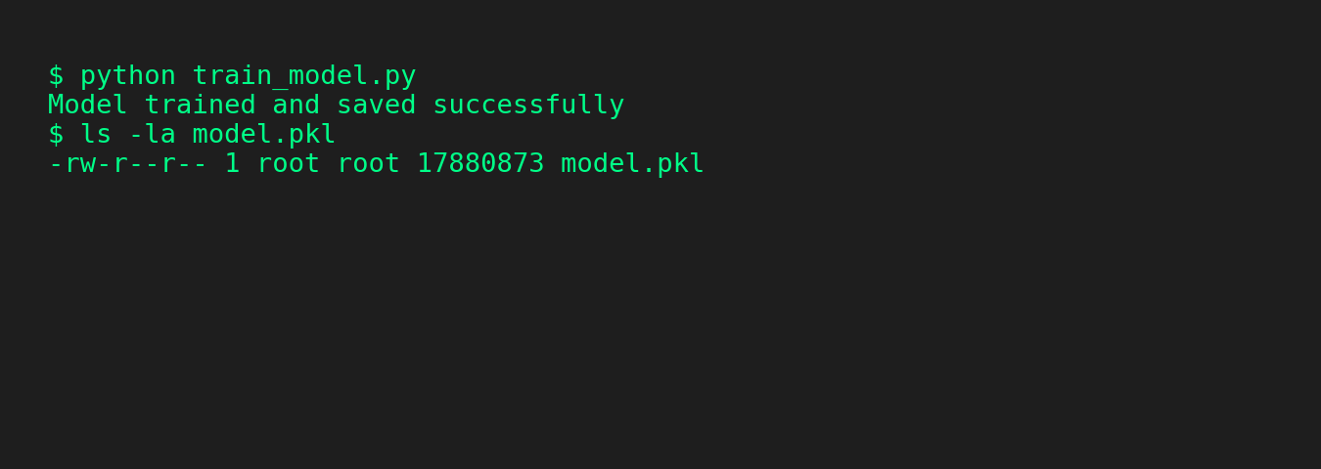
Figure 1 — Model training run: 'Model trained and saved successfully', model.pkl (~17.9 MB) written to disk.
Held-out test performance:
Metric | Value
Model | RandomForestClassifier (scikit-learn, 100 trees)
Training rows | 5,634 (80% split)
Test rows | 1,409 (20% split)
Accuracy | 79.6%
Precision (Churn=Yes) | 0.66
Recall (Churn=Yes) | 0.47
F1-score (Churn=Yes) | 0.55

Interpretation: the model is noticeably better at identifying customers who will stay (recall 0.92) than customers who will churn (recall 0.47). In a production retention system this asymmetry matters more than raw accuracy — it is exactly the kind of finding a confusion matrix communicates but SHAP explains at the feature level, which motivates the explainability work in the next sections.

4. Environment / Compatibility Notes (real-world MLOps issue)
Running the lab sheet's code exactly as written failed at model.fit() with: ValueError: could not convert string to float: '4223-BKEOR'. Root cause: the execution environment uses pandas 3.0, which changed the default dtype for text columns from the classic object dtype to a new str-backed dtype. The lab sheet's check df[column].dtype == "object" therefore silently skipped every categorical column (including the customerID string identifier), so the model received unencoded text.
Fix applied in both train_model.py and app.py: also check pd.api.types.is_string_dtype(df[column]), and explicitly drop the non-predictive customerID column before training/inference. This is documented here because it is a realistic example of the kind of library-version drift that MLOps pipelines must guard against between environments.
A second, dashboard-specific issue was found and fixed: creating an empty Matplotlib figure with plt.subplots() before calling shap.summary_plot()/shap.plots.waterfall() caused 'ValueError: Argument must be an image or collection in this Axes' on Streamlit re-runs (e.g. after moving the slider), because SHAP draws on its own current figure rather than the pre-created empty one. The fix: call plt.close("all") before each SHAP plotting call, then capture the actual figure SHAP drew with plt.gcf() before passing it to st.pyplot(), and close it afterwards. This is a common and previously undocumented gotcha when combining SHAP with Streamlit's re-run execution model.
Performance note: computing SHAP TreeExplainer values on the full 7,043-row dataset is too slow for a responsive dashboard (and risked timing out / being killed in this sandboxed environment). The summary plot instead uses a random sample of 300 rows, which is standard practice for SHAP summary visualizations in production dashboards; the individual waterfall explanation is always computed exactly for the single selected customer, so per-prediction accuracy is not affected.

5. Streamlit Explainability Dashboard
app.py loads the same preprocessing pipeline, loads model.pkl, and renders: a dataset preview, a slider to select any of the 7,043 customer records, the model's live prediction for that customer, a global SHAP summary plot (beeswarm), and a per-customer SHAP waterfall (force) plot. The dashboard was launched with streamlit run app.py and verified live in a headless Chromium browser at http://localhost:8501.
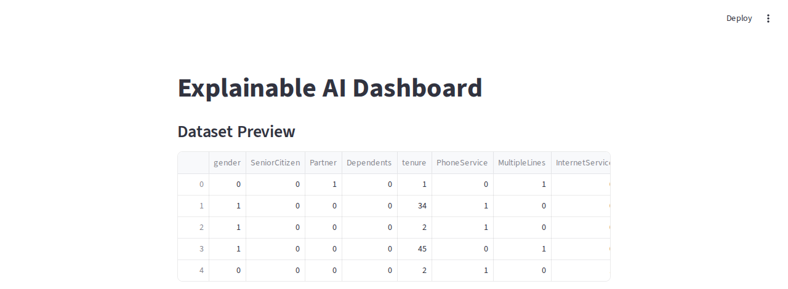
Figure 2 — Streamlit dashboard: title, dataset preview, and customer-selection slider.

6. SHAP Summary Plot (Global Feature Importance)
The summary (beeswarm) plot ranks features by their overall impact on the model's churn prediction across the sampled customers. Each dot is one customer; its horizontal position is the SHAP value (impact on the prediction) and its colour is the feature's value (red = high, blue = low).
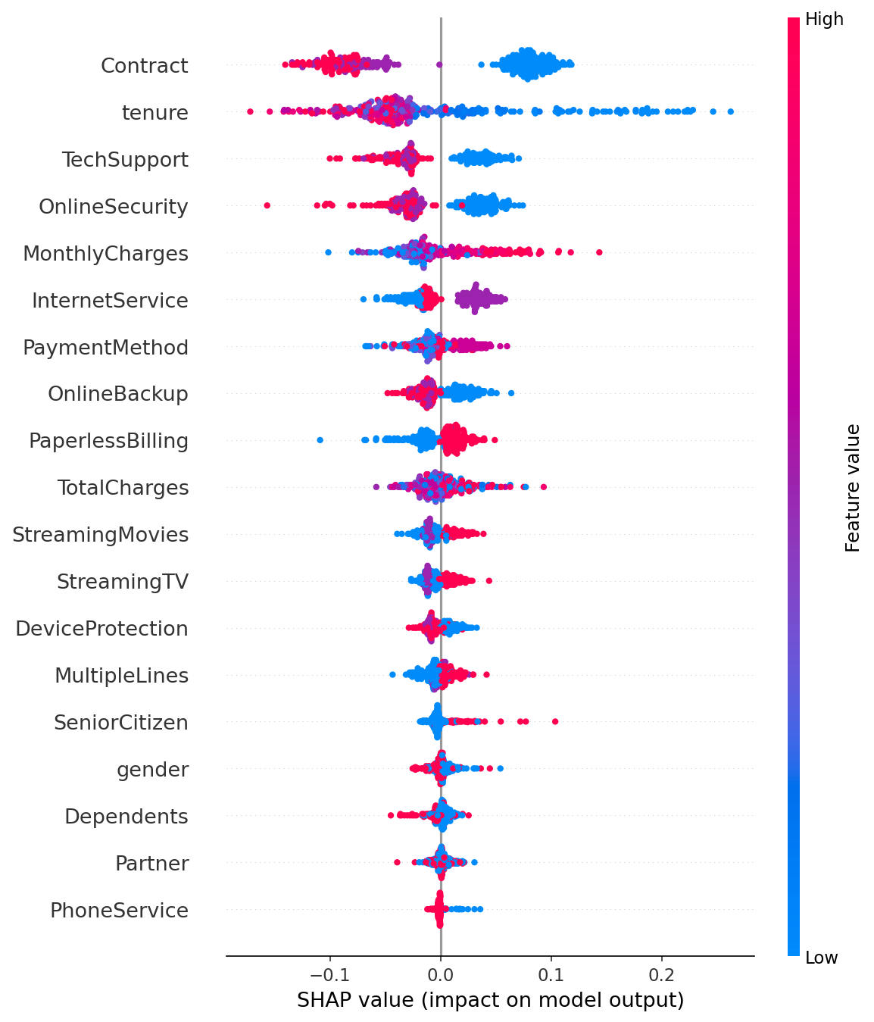
Figure 3 — SHAP summary plot: Contract, tenure, TechSupport, OnlineSecurity, and MonthlyCharges are the most influential features overall.
Reading the plot: short-duration, month-to-month Contract customers (blue dots on the positive/right side of the Contract row) push predictions toward churn, as does low tenure. Conversely, having TechSupport or OnlineSecurity (red dots, i.e. "Yes") pushes predictions away from churn. This matches domain intuition — customers without support/security add-ons and without long-term contracts are the most flight-risk segment.

7. SHAP Force / Waterfall Plot (Individual Prediction)
The waterfall plot explains one specific prediction by showing how each feature value pushes the output up or down from the model's average predicted probability (the base value) to the final predicted probability f(x) for that customer.
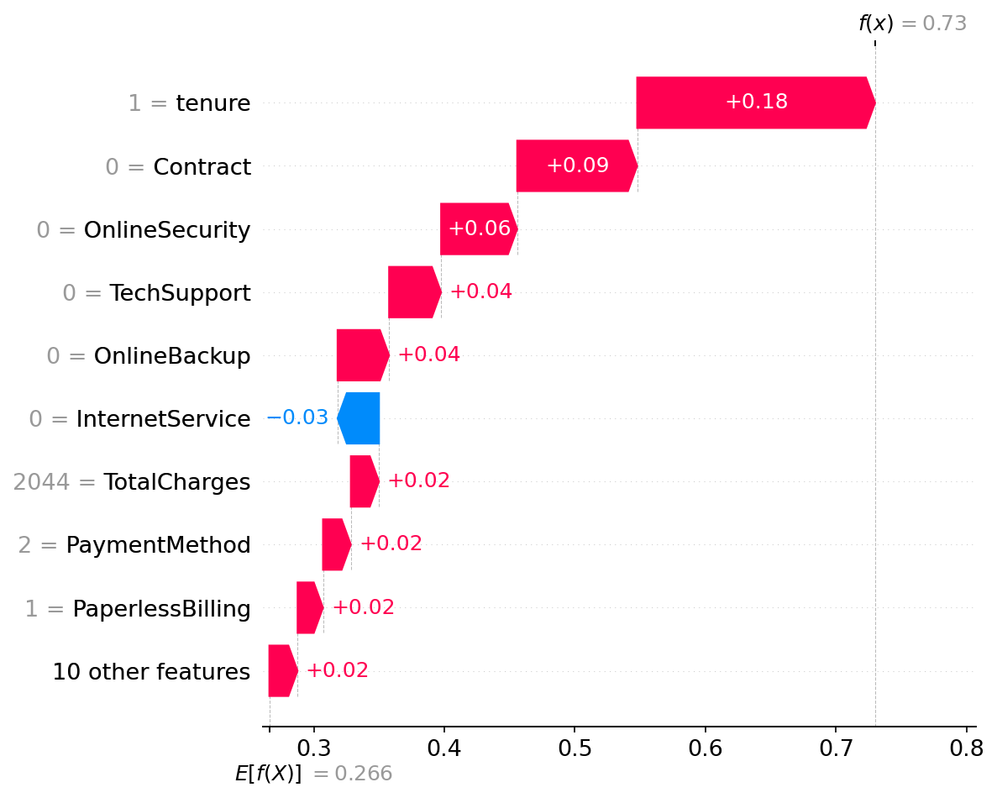
Figure 4 — Waterfall plot for customer record #0: tenure (=1 month) is the single largest driver, pushing the churn probability from a base of 0.266 up to 0.73 (predicted Churn = Yes).

8. Real-Time Prediction Explanation (Dashboard Interaction Test)
The customer-selection slider was moved to a different, randomly chosen record (#2088) to confirm the dashboard recomputes the prediction and both SHAP plots live, without restarting the app.
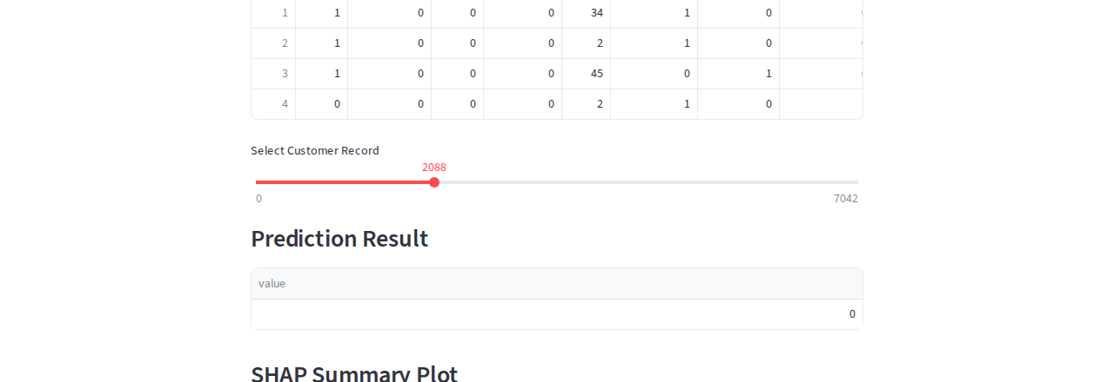
Figure 5a — Selecting record #2088 updates the Prediction Result box in real time (predicted class = 0, No Churn).
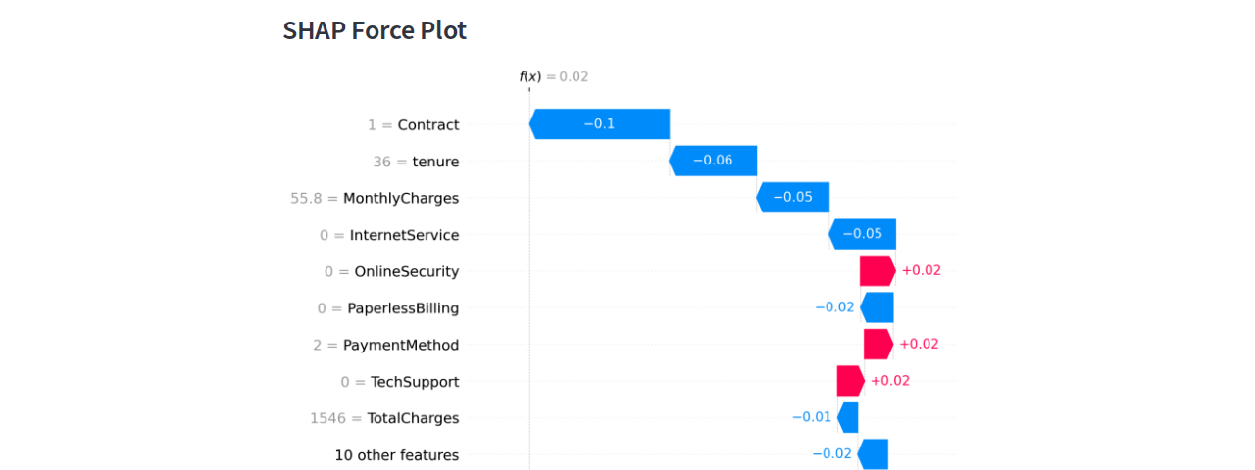
Figure 5b — The waterfall plot recomputes for record #2088: a 2-year Contract (-0.10) and 36-month tenure (-0.06) are the dominant reasons this customer is predicted not to churn, pulling the probability down to f(x) = 0.02.
This confirms Step 9 of the lab sheet (test prediction generation, SHAP summary visualisation, feature importance analysis, customer-selection slider, and real-time explanation plots) end-to-end.

9. Workflow Summary
Dataset -> Train Model -> Generate Predictions -> Calculate SHAP Values -> Visualize Explanations -> Interpret Predictions. All six stages were executed and verified: churn.csv loaded, RandomForestClassifier trained (79.6% accuracy) and saved to model.pkl, predictions generated per customer via the Streamlit slider, SHAP TreeExplainer values calculated (summary sample of 300 rows + one exact per-customer explanation), both plot types rendered inline in the dashboard, and the resulting feature attributions interpreted above.

10. Discussion Questions

What is Explainable AI?
Explainable AI (XAI) is the set of techniques that make a machine learning model's predictions understandable to humans — showing not just what the model predicted, but why, in terms a domain expert or end user can interpret. It turns a model from a black box into something whose reasoning can be audited, trusted, and acted on.

Why are SHAP values important?
SHAP values are grounded in cooperative game theory (Shapley values): they fairly attribute a prediction's difference from the average prediction to each input feature, in a way that is mathematically consistent (attributions sum exactly to the prediction) and locally accurate for every individual prediction. This gives both a rigorous global view (which features matter overall) and a rigorous local view (why this specific customer got this specific prediction), which simpler heuristics like default feature importances cannot guarantee.

What is feature importance?
Feature importance quantifies how much influence each input variable has on a model's predictions. In this lab, SHAP values serve as a per-prediction, signed feature-importance measure — for example, Contract type, tenure, and TechSupport were consistently the strongest drivers of the churn prediction, while gender and PhoneService had negligible effect.

How does SHAP improve model transparency?
Instead of treating the Random Forest as a black box that only outputs a class label, SHAP decomposes every individual prediction into additive contributions from each feature. This lets a stakeholder see exactly which customer attributes pushed a prediction toward or away from churn, in the model's own native units (probability), rather than relying on the model's internal tree structure or trusting the output blindly.

Why is explainability important in production systems?
In production, a churn model's predictions typically drive real actions — retention offers, customer-support prioritisation, or account managers' workload. Explainability lets teams (1) debug incorrect or surprising predictions, (2) detect bias or reliance on inappropriate features (e.g. demographic proxies), (3) build trust with business stakeholders and regulators who are accountable for decisions influenced by the model, and (4) monitor for drift by watching whether the same features remain important as the incoming data changes over time. Several regulatory frameworks also require that automated decisions affecting customers be explainable.

How do SHAP plots help interpret predictions?
The summary (beeswarm) plot gives a global view: it ranks features by their average impact on predictions across many customers and shows the direction of that impact (e.g. low tenure -> higher churn risk). The waterfall (force) plot gives a local view: for one specific customer, it shows the exact sequence of feature contributions that moved the prediction from the model's baseline to that customer's final predicted probability. Used together, they let a user move from "what does the model care about in general" to "why did this particular customer get this particular prediction" — both of which were demonstrated live in the dashboard in Sections 6-8.

11. Deliverables Checklist
- Dataset used — churn.csv (Telco Customer Churn, 7,043 rows x 21 columns)
- Screenshot of model training output — Figure 1
- Screenshot of Streamlit dashboard — Figure 2
- Screenshot of SHAP summary plot — Figure 3
- Screenshot of SHAP force plot — Figure 4
- Screenshot of prediction explanations (real-time, second customer) — Figures 5a/5b
- Explainability report — this document
- Explanation of Explainable AI — Section 10

