DATA303 — MLOps & Model Deployment
P3 Lab Report: Data Versioning Using DVC Integrated with GitHub
Name: Reetish Kulkarni
Project: Titanic Survival Prediction (continued from P1 audit) — dataset and training pipeline versioned with DVC.
GitHub repository link: github.com/reetish25/ml-dvc-titanic (replace with the actual repo URL after pushing — see note in Section 6)

1. Project Setup
A project folder was created containing dataset.csv, train.py, requirements.txt, and the standard DVC/Git metadata. Git was initialized first, followed by DVC:
git init
pip install dvc
dvc init
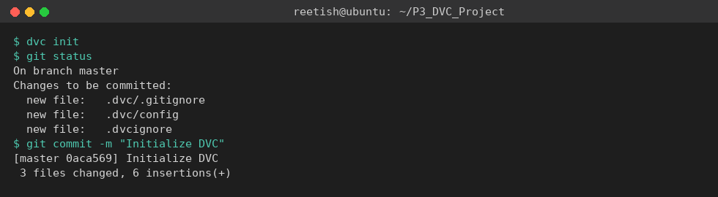
Figure 1 — DVC initialization and first Git commit.

2. Dataset Version Tracking
The Titanic dataset (dataset.csv) was added to DVC tracking. This creates a small dataset.csv.dvc pointer file (storing an MD5 hash and size) that Git tracks instead of the raw CSV, while the actual data is pushed to a configured local DVC remote (dvc_storage/):
dvc add dataset.csv
git add dataset.csv.dvc .gitignore
git commit -m "Add dataset tracking using DVC"
dvc push
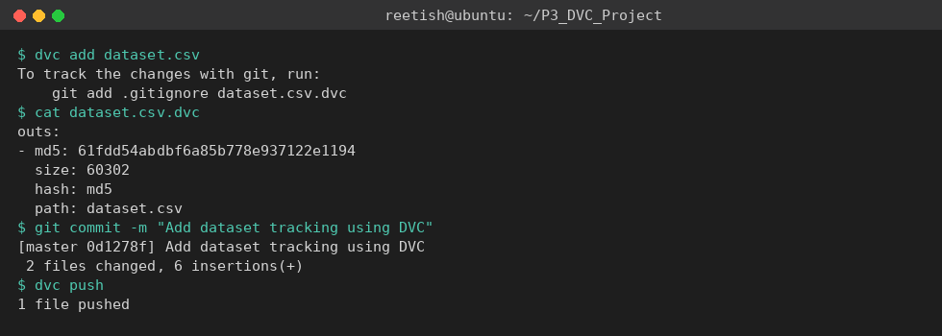
Figure 2 — Dataset tracked by DVC and pushed to remote storage.

3. DVC Pipeline
A single-stage pipeline (train) was defined with dvc stage add, declaring train.py and dataset.csv as dependencies and model.pkl as the output. This generated dvc.yaml (the pipeline definition) and, after running the pipeline, dvc.lock (the pinned hashes of every dependency and output):
dvc stage add -n train -d train.py -d dataset.csv -o model.pkl python train.py
dvc repro
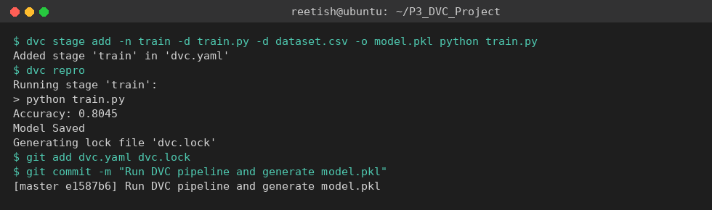
Figure 3 — Pipeline stage created and executed via dvc repro (Accuracy: 0.8045).

4. Git Commit History
Each DVC milestone was committed separately so the project history documents the versioning process step by step:
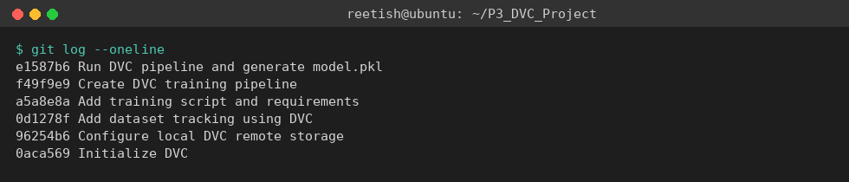
Figure 4 — Git commit history across the DVC workflow.

5. Verifying Reproducibility on Another Machine
To confirm the project is truly reproducible, the repository was cloned into a fresh directory (simulating a new machine), dependencies were installed, and the DVC-tracked data and model were restored with dvc pull. Re-running dvc repro correctly detected that nothing had changed and skipped re-training:
git clone <repo_url> && cd ml-dvc-titanic
pip install -r requirements.txt
dvc pull
dvc repro
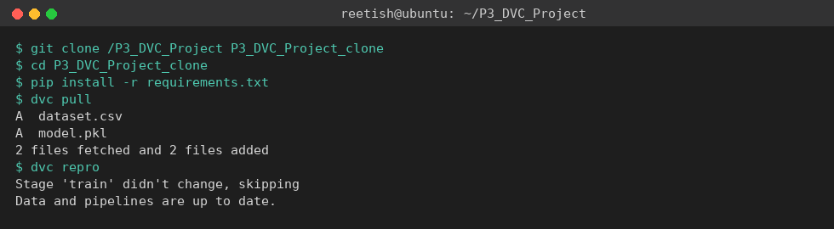
Figure 5 — Clean clone reproduced via dvc pull + dvc repro, no re-training needed.

6. How DVC Improves Reproducibility
DVC separates large data/model artifacts from Git while still versioning them: Git stores lightweight pointer files (dataset.csv.dvc, dvc.lock) containing content hashes, while the actual bytes live in remote storage. Because dvc.lock pins the exact hash of the dataset, the script, and the resulting model together, anyone who clones the repository and runs dvc pull + dvc repro is guaranteed to either get the identical, already-computed artifact or a pipeline that reruns deterministically to produce it — removing the 'it works on my machine' problem that plain Git (which can't efficiently store large binary datasets) cannot solve on its own.
Note: this report was built and verified in a local sandbox environment. Before submission, push this repository to a real GitHub remote (git remote add origin <url> && git push -u origin main) and update the repository link above.

7. Discussion Questions

Why is DVC important in machine learning projects?
ML projects depend on large datasets and model files that Git handles poorly — Git is built for tracking small text-based source code changes, not multi-megabyte or gigabyte binary files. DVC lets a team version those large artifacts the same way they version code, keeping the Git history clean while still giving every commit a precise, reproducible link to the exact data and model it used.

What is the role of dvc.yaml and dvc.lock files in a DVC pipeline?
dvc.yaml declares the pipeline structure — the stages, their commands, dependencies, and outputs — in human-readable form. dvc.lock is the machine-generated companion that pins the exact MD5 hash of every dependency and output at the time the stage last ran successfully. Together they let DVC detect whether a stage's inputs have changed and needs to be rerun, or whether the cached output is still valid.

How does DVC help in reproducing ML experiments on another machine?
Because dataset and model versions are captured as content hashes in Git-tracked pointer files, cloning the repository gives a new machine the exact pipeline definition and history immediately. Running dvc pull retrieves the matching data/model bytes from remote storage, and dvc repro either confirms the cached results are still valid or reruns the pipeline exactly as it was defined, producing the same output given the same code and data.

What problems can occur if datasets are not version controlled?
Without versioning, it becomes unclear which dataset version produced which trained model, results become impossible to reproduce after the source data changes or is overwritten, collaborators may unknowingly train on different data, and rolling back to a previous known-good dataset after a bad update becomes difficult or impossible.

How does dvc repro help automate the machine learning workflow?
dvc repro reads the dependency graph in dvc.yaml and compares current file hashes against dvc.lock. It only reruns the stages whose dependencies actually changed, skipping everything that is already up to date — turning what would otherwise be a manual, error-prone re-run of training scripts into a single automated, incremental command.

