

Department of Electronic & Telecommunication Engineering, University of Moratuwa, Sri Lanka

**Theremin**

Group Members

|  |  |
| --- | --- |
| MALSHAN K.K.R. | 220379N |
| PITIGALA P.K.N.W. | 220481U |
| RAJAKARUNA R.W.M.D.S. | 220498D |
| RAJINTHAN R. | 220502M |

Abstract

The Theremin is one of the earliest electronic music instruments which has a unique ability to produce sound without any physical contact. This project forces on designing constructing a functional theremin with oscillators to create audio signals using hand movements. There are two antennas to control the pitch and the volume which enables the user to have a great experience. This demonstrates the principles of the capacitors, oscillators and amplifiers etc. This project encourages to delve into the development of electronic musical instruments. \

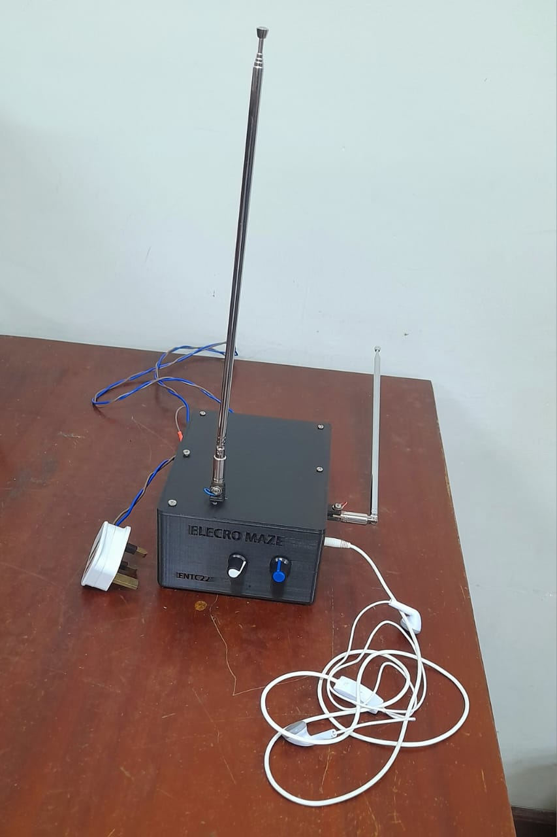

Contents

1. Introduction & Functionality
2. System Architecture
3. Component Selection
4. PCB Design
5. Enclosure Design
6. Software Simulation
7. Conclusion
8. Contribution of Group Members

**Introduction & Functionality**

**Introduction**

The theremin is an iconic electronic musical instrument that creates sound without physical contact, but rather through the movement of the player's hands near its antennas. Invented in the early 20th century by Léon Theremin, it represents a fascinating combination of science, music, and technology. Our analog theremin project extends this innovative concept by using simple, discrete analog circuitry to illustrate some of the principles of capacitive sensing and frequency modulation. It is designed to be both instructive and fun, making it a very good introduction to basic electronics, signal processing, and the physics of sound.

Functionality

Our analog theremin works by using two antennas: one for pitch control and the other for volume control. The pitch antenna senses changes in capacitance brought about by the distance of the player's hand, which modulates the frequency of an oscillator circuit to produce varying tones. The volume antenna adjusts the amplitude of the output signal according to the proximity of the player's other hand. These signals are then combined and sent to an amplifier to drive a speaker; the result is a dynamic, touch-free musical instrument.

System architecture

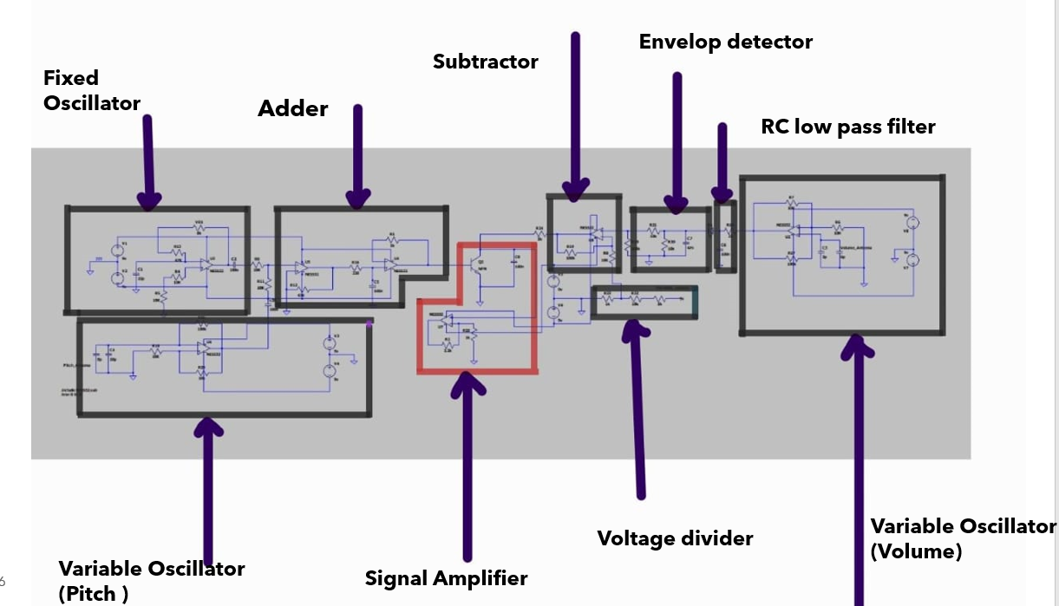

Fixed Oscillator

The Fixed Oscillator in the theremin circuit serves as a critical reference point for generating the output audio signal. Its primary function is to produce a steady, high-frequency signal that remains constant during the operation of the theremin. This signal acts as a baseline for the theremin’s pitch control mechanism. Unlike the variable oscillator, whose frequency changes depending on the proximity of the user’s hand to the pitch antenna, the fixed oscillator frequency is stable and unchanging. The interaction between the fixed oscillator and variable oscillator frequencies creates the beat frequency, which determines the pitch of the sound the theremin produces.

Variable Oscillator

The Variable Oscillator in the theremin circuit is responsible for generating a frequency that changes based on the position of the user’s hand relative to the pitch antenna. Unlike the Fixed Oscillator, whose frequency remains constant, the variable oscillator's frequency shifts dynamically as the performer moves their hand closer to or farther from the antenna. This changing frequency is what allows the theremin to produce varying pitches, enabling the performer to "play" musical notes without physical contact.

Adder

In the theremin, theAdderis used to sum signals from both the Fixed Oscillatorand Variable Oscillator before they are processed further. It prepares the signals for conditioning before being sent to the Subtractor, where the beat frequency (difference between the oscillator frequencies) is extracted.

### Variable Volume Oscillator and envelop detector

The Variable Volume Oscillator in the theremin circuit is responsible for controlling the amplitude, or loudness, of the audio signal based on the position of the performer’s hand relative to the volume antenna. Similar to the variable pitch oscillator, the variable volume oscillator produces a frequency that changes with hand proximity. As the hand moves closer to the volume antenna, the capacitance between the hand and antenna increases, which alters the oscillator's frequency. This changing frequency is then processed to adjust the amplitude of the theremin's final output signal.

The output of the variable volume oscillator is typically sent to an envelope detector or similar circuit, which converts the oscillator’s high-frequency signal into a control voltage. This control voltage determines the amplitude (volume) of the theremin’s audio signal. When the hand is far from the antenna, the control voltage allows the audio signal to have maximum volume**.** Conversely, as the hand moves closer to the antenna, the control voltage reduces the amplitude, lowering the volume until the sound becomes nearly silent. This dynamic relationship between hand movement and volume enables the performer to control the loudness of the sound smoothly and expressively.

**Component Selection**

Although there are several op-amp available in the local market like TL072, LM741, LM358, but we choose NE5532P as best op-amp for our project. Because  
  
 (1) Low Noise

(2) Moderate Slew Rate

(3) Low Cost

(4) Availability

We choose 2N2222 NPN general purpose transistor for amplify output sound because, it is small and inexpensive & commonly used for low-power amplification.

**Circuit Simulation**

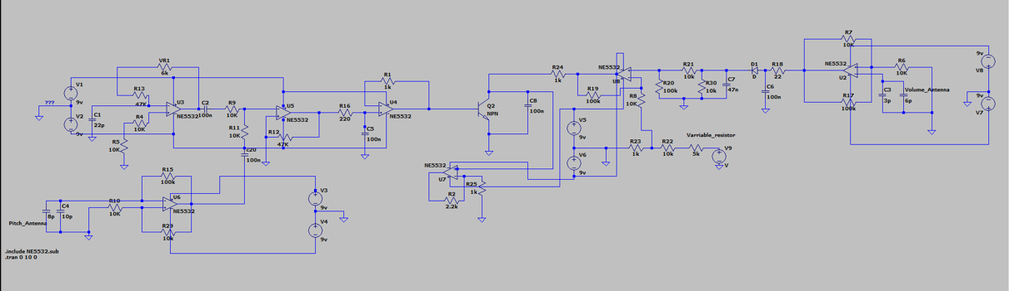

**PCB Design**

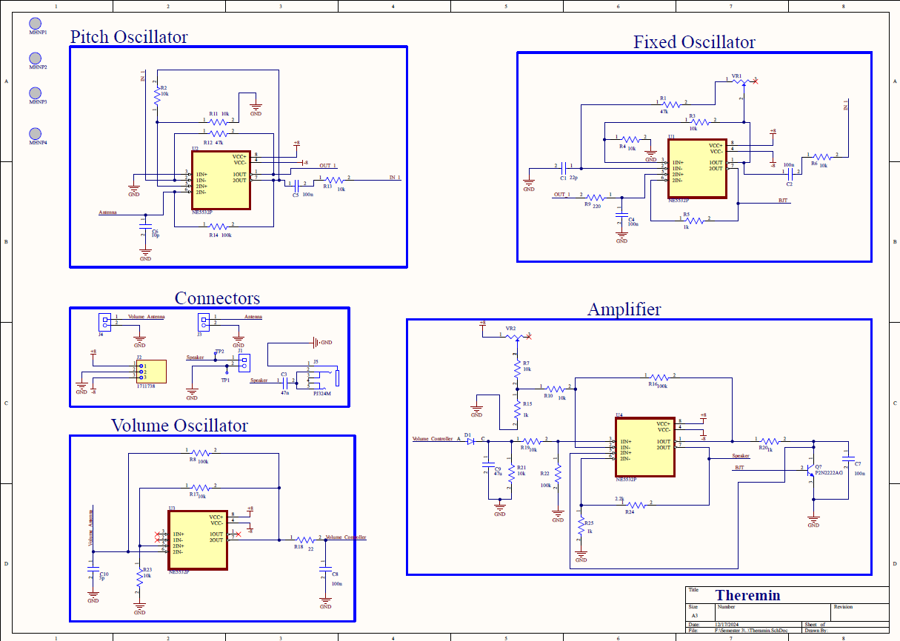

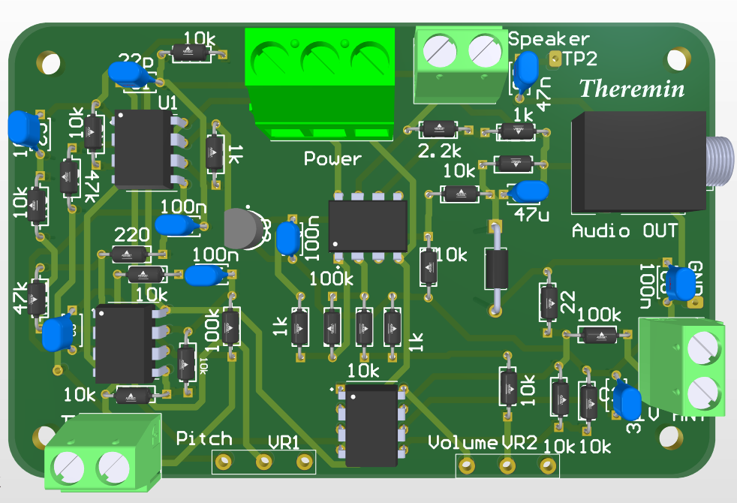

**Enclosure Design**

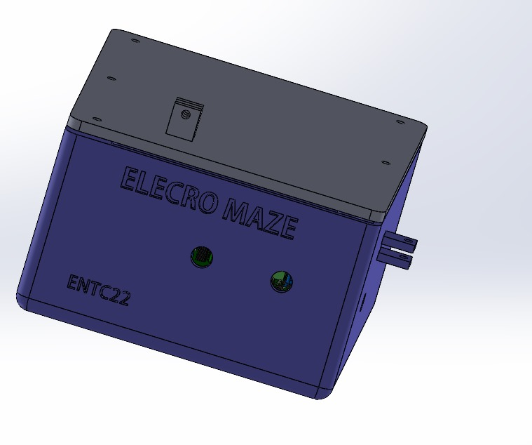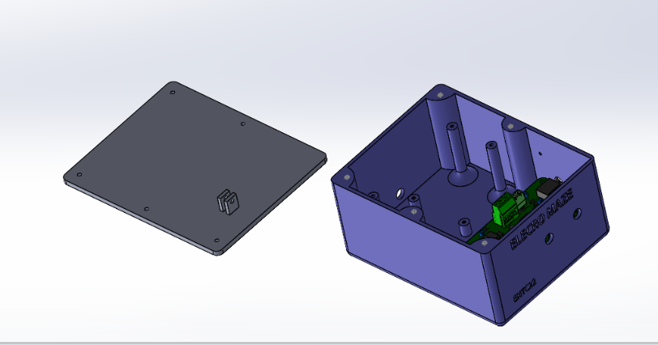

We designed an enclosure using Solidworks .It’s 11.1cm*14.6 cm*6.8cm in size. It has one audio output and two controllers, one for volume controlling and other one for pitch controlling which are used to calibrate in beginning.

**Power Supply**

We need 12V dual power supply to power up the PCB. This circuit include 9-0-9,1000mA transformer for step down 220 VAC to 12V, four 1N4001 diode for rectification, two 2200uF capacitors for reduce ripple, LM7809 IC for stabilize +9V & LM7909 IC for stabilize –9V and two 0.1uF & 0.33uF ceramic capacitors to block high frequency noise & smooth the output voltage.

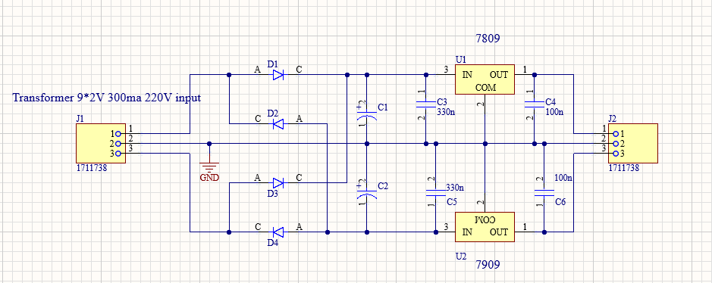

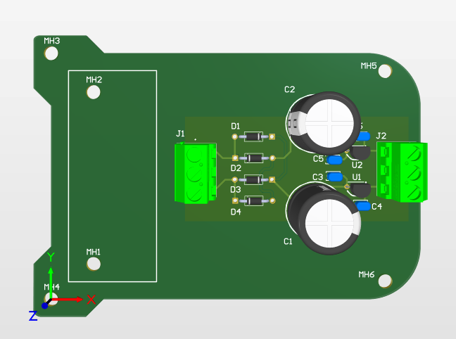

**Conclusion**

Actual Theremin is contained with digital parts, not only with analogy parts. We hope to implement this project furthermore using digital parts also to get more quality output sound.

Our PCB has THT component, we hope to implement new PCB using SMD component which reduce the size of the PCB.

**Contribution of Group Members**

|  |  |
| --- | --- |
| Circuit Design & Simulation | Rajinthan,Ravindu, Dhawala |
| PCB Design | Nishitha, Rajinthan |
| Enclosure Design | Ravindu, Nishitha |
| Troubleshooting | Ravindu, Dhawala |