
- Internship ID:SWPAAM1028
- Intern Name: Chunchu Nichitha Sree
- Organization: Saredufy Web Plus Academy
- Domain: AI/ML Internship
- Project Title: Startup Success Probability Estimator – AI Web App using Machine Learning and Flask
- Brief tagline: "An AI-powered web tool to instantly estimate a startup’s success probability based on key business factors."
- Key Features :
  - Interactive Web Interface for entering startup details.
  - Rule-Based AI Scoring System to estimate success probability.
  - Instant Result Display with percentage score.
  - Simple User-Friendly Design for easy navigation.
  - Customizable Logic for future ML model integration.
  - Lightweight Flask Backend for fast performance.
  - Responsive Frontend built with HTML & CSS.
- Date : August 2025
- Tech Partner: WebNexZ Solutions

2. Project Abstract
The Startup Success Probability Estimator is a web-based application built using Python Flask
to help aspiring entrepreneurs evaluate their startup's potential success rate. The system takes
user inputs such as idea innovation, team strength, funding status, and market potential, and
applies a rule-based scoring algorithm to estimate a probability percentage. The project solves
the problem of early-stage entrepreneurs lacking a quick, interactive tool for feasibility analysis.
Technologies used include Python, Flask, HTML, CSS, and basic AI logic. The final output is an
interactive web application that displays an estimated success probability instantly based on user input.
3. Internship Organization Profile
- Name: SAREDUFY – Web Plus Academy Pvt. Ltd.
- Department: AI/ML Internship Program
- Mentor:Pranathi
- Tech Partner: WebNexZ Solutions

4. Project Description
a. Objective:
To develop a lightweight, accessible web tool that estimates a startup’s success probability using rule-based AI logic, providing entrepreneurs with instant feasibility insights.
b. Target Users:
Aspiring entrepreneurs, startup incubators, business mentors, investors, and innovation hubs.
c. Problem Statement:
Many early-stage entrepreneurs lack quick access to tools for evaluating their startup’s viability. This project bridges the gap by providing an easy-to-use, instant estimation platform that helps guide decision-making before major investments are made.

5. Key Features Implemented
- Data preprocessing & cleaning
- Feature engineering
- Model selection and training
- Model evaluation metrics
- Deployment strategy
- Automation or optimization features

6. Tech Stack Used
- Programming: Python / R
- Libraries: Pandas, NumPy, Scikit-learn, TensorFlow, PyTorch
- Version Control: Git, GitHub
- Deployment: Flask
- Tools: Jupyter Notebook, VS Code, Google Colab
7.ML Workflow & Data Preprocessing
- Dataset sources
- Data cleaning steps
- Handling missing values
- Feature scaling/normalization
- Data splitting (train/test/validation)

8.Model Architecture & Pipeline
- Model type (e.g., Decision Tree, Neural Network, Random Forest)
- Training pipeline stages
- Hyperparameter tuning strategy

9. Challenges Faced
- Data imbalance
- Overfitting / underfitting
- Limited computational resources
- Model interpretability

10. Screenshots of the Website
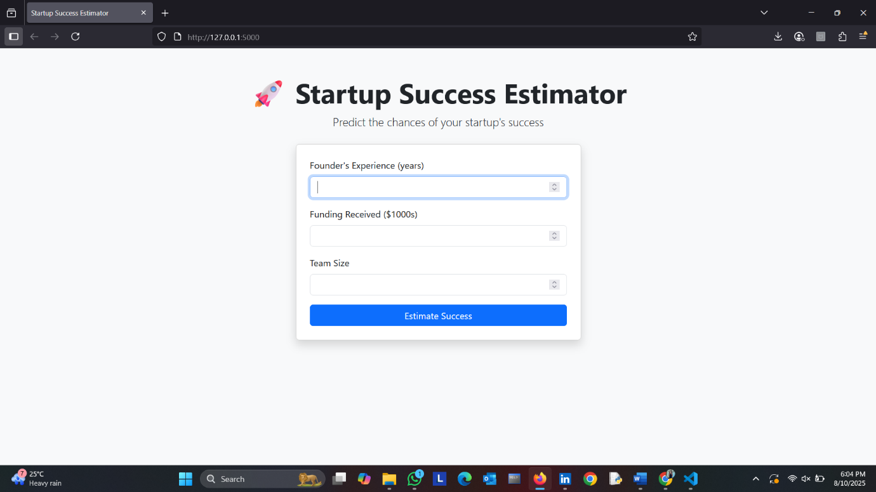
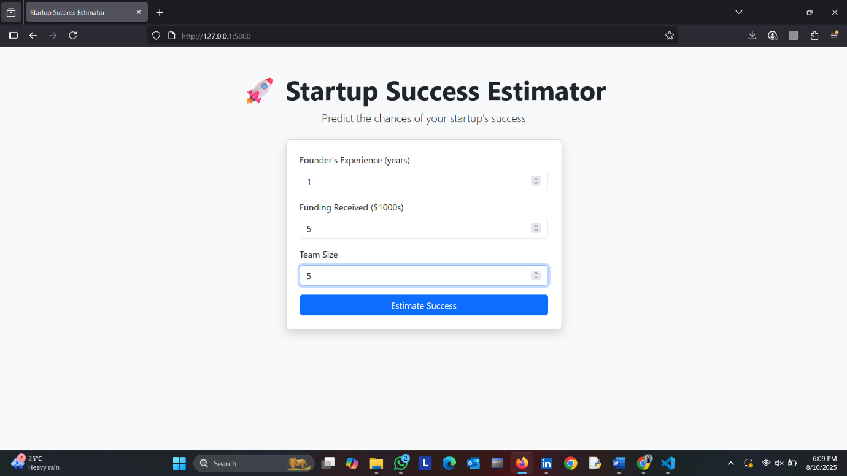
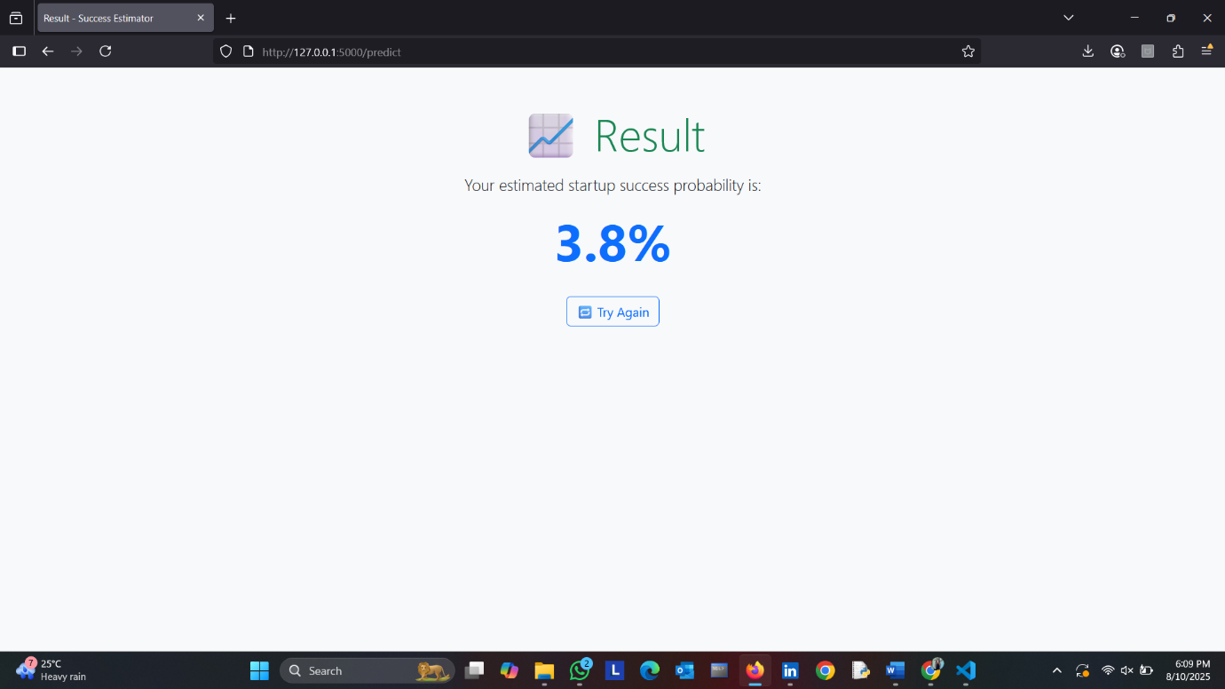
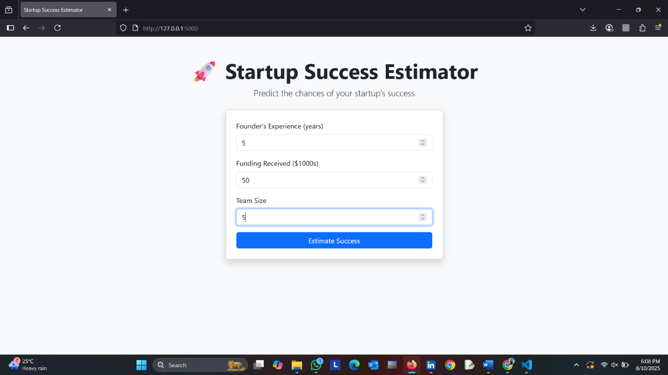
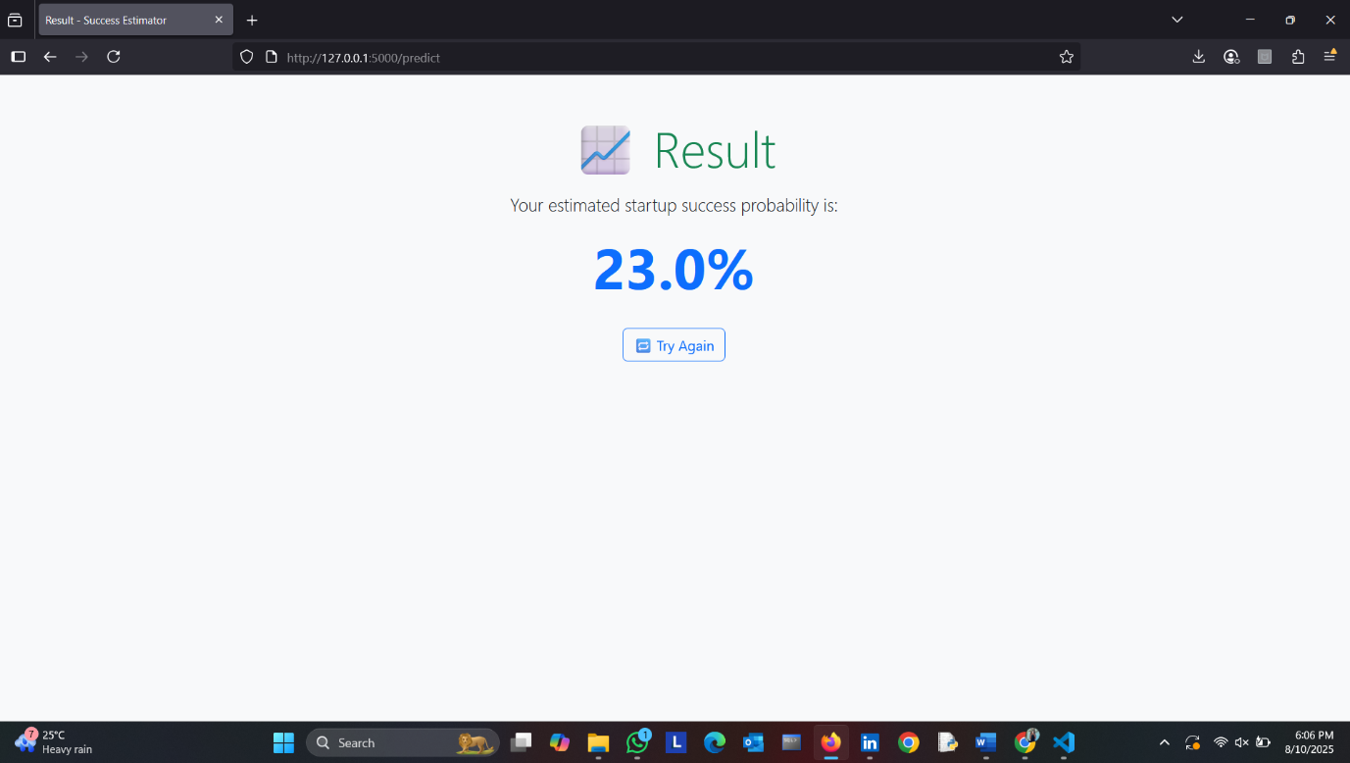
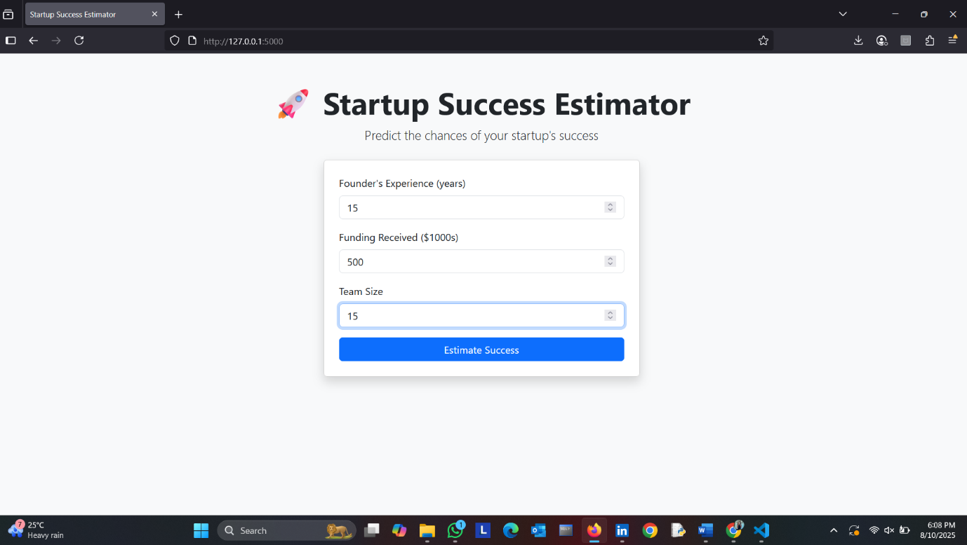
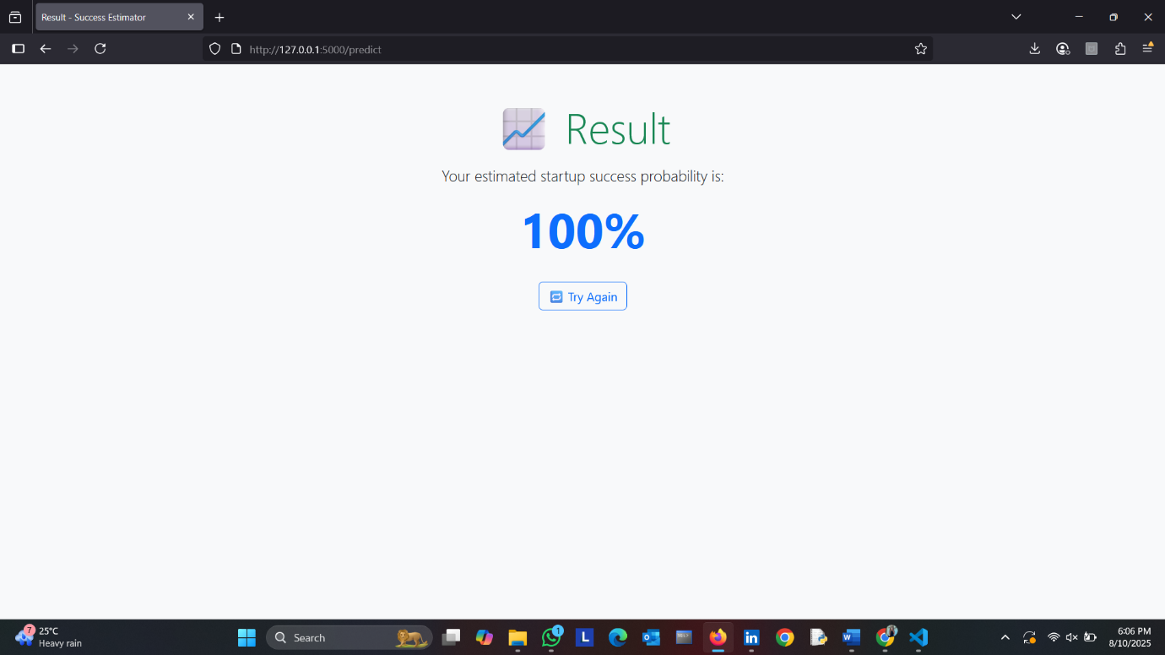
11. Results & Output
- Fully functional web application for startup success probability estimation.
- Linkedin post link:View my post
12. Learnings & Takeaways
- Understanding ML workflows
- Working with datasets
- Model optimization techniques
- Deployment best practices

13. Conclusion and Future Scope
- Summary of achievements
- Future improvements (e.g., larger datasets, new algorithms, production deployment)

14. References
- Research papers
- ML documentation (Scikit-learn, TensorFlow, PyTorch)
- Online tutorials and datasets

