

**Group Assignment**

**Optimization Techniques – using Excel Solver**

**Post-Graduate programme in Data Science & Business Analytics**

**Batch-October 2019.**

**By: Group 4**

**Indu Mohan**

**Nishitha Ramesh**

**Ashish Nath Km**

**Athul Aravind PM**

**Cost Optimization for a Production Company for the next 6 Months**

**Problem Statement:**

In the next six months a company must, in each month, operate either a normal shift or an extended shift (if it produces at all). A normal shift costs 100,000 per month and can produce up to 5,000 units per month. An extended shift costs 180,000 per month and can produce up to 7,500 units per month.

It is estimated that changing from a normal shift in one month to an extended shift next month costs an extra £15,000. No extra cost is incurred in changing from an extended shift in one month to a normal shift in the next month.

Carrying cost is estimated to be 2 per unit per month (based on the stock held at the end of each month) and the initial stock is 3,000 units (produced by a normal shift). At the end of month 6, at least 2000 units should be in stock. The demand for the company's product is shown below:

|  |  |
| --- | --- |
| Month | Demand |
| 1 | 6000 |
| 2 | 6500 |
| 3 | 7500 |
| 4 | 7000 |
| 5 | 6000 |
| 6 | 6000 |

If the company produces anything in a particular month it must produce at least 2,000 units. If the company wants a production plan for the next six months that avoids stockouts, formulate their problem as an integer program.

Few important terminologies from the point of view of analyzing this case study are as follows.

Optimization problems:

[Optimization problem](https://en.wikipedia.org/wiki/Optimization_problem) consists of [maximizing or minimizing](https://en.wikipedia.org/wiki/Maxima_and_minima) a [real function](https://en.wikipedia.org/wiki/Function_of_a_real_variable) by systematically choosing [input](https://en.wikipedia.org/wiki/Argument_of_a_function) values from within an allowed set and computing the [value](https://en.wikipedia.org/wiki/Value_(mathematics)) of the function. The generalization of optimization theory and techniques to other formulations constitutes a large area of [applied mathematics](https://en.wikipedia.org/wiki/Applied_mathematics). More generally, optimization includes finding "best available" values of some objective function given a defined [domain](https://en.wikipedia.org/wiki/Domain_of_a_function) (or input), including a variety of different types of objective functions and different types of domains.

Numerical Optimization Techniques

Linear Programming:

Linear programming studies the case in which the objective function is linear and the constraints are specified using only linear equalities and inequalities

Integer Programming:

An integer programming issue is a mathematical optimization or feasibility program in which some or all of the variables are integers. The phrase is frequently used in conjunction with integer linear programming (ILP), which has a linear objective function and restrictions (other than integer constraints). Integer programming has the property of being NP-complete. The specific situation of 0-1 integer linear programming, in which the unknowns are binary and only the constraints must be satisfied, is one of Karp's 21 NP-complete problems. A mixed-integer programming challenge occurs when some decision variables are not discrete.

Goal Programming:

Goal programming studies the case in which there are multiple goals to be satisfied using linear equalities and inequalities

Non-Linear Programming:

Non-Linear programming studies the general case in which the objective function or the constraints or both contain nonlinear parts

1. **Formulating the Constraints and the objective function along with the detailed explanation**

The decisions that must be made concern:

* Each month, whether to operate a regular shift or an extended shift;
* How much should be produced per month to meet the demand

Variables

* xt = 1 if we operate a normal shift in month t (t=1,2,...,6) and 0 otherwise
* yt = 1 if we operate an extended shift in month t (t=1,2,...,6) and 0 otherwise
* pt (>= 0) be the amount produced in month t (t=1,2,...,6)
* zt = 1 if we switch from a normal shift in month t-1 to an extended shift in month t (t=1,2,...,6) and 0 otherwise
* It be the closing inventory (amount of stock left) at the end of month t (t=1,2,...,6)
* wt = 1 if we produce in month t, and hence from the production constraints Pt >= 2000 (t=1,2,...,6) and 0 otherwise

Constraints

* Only operate (at most) one shift each month, xt + yt <= 1 t=1,2,...,6
* Production limits not exceeded, pt <= 5000xt + 7500yt t=1,2,...,6
* No stockouts, It >= 0 t=1,2,...,6
* Closing stock = opening stock + production – demand

where I0 = 3000. Hence letting Dt = demand in month t (t=1,2,...,6) (a known constant) and assuming

* that opening stock in period t = closing stock in period t-1 and
* that production in period t is available to meet demand in period t
* It = It-1 + pt – dt t=1,2,...,6
* The amount in stock at the end of month 6 should be at least 2000 units, I6 >= 2000
* Production constraints of the form "either Pt = 0 or Pt >= 2,000".
* pt <= Mwt t=1,2,...,6
* pt >= 2000wt t=1,2,...,6

Where M is a positive constant and represents the most we can produce in any period t (t=1,2,...,6). A convenient value for M for this example is M = 7500

* Relate the shift change variable zt to the shifts being operated

zt = xt-1yt t=1,2,...,6

Objective

The objective is to minimize SUM{t=1,...,6} (100000xt + 180000yt + 15000zt + 2It)

1. **Excel Solver Calculations along with detailed explanations step by step**

Now, that the problem is formulated. Let’s formulate it step by step in excel.

First, let’s formulate the variables.

x1, x2…x6 are binary variables

x =1 if we operate the company in normal shift in a month, x=0, otherwise

From the problem statement provided, it is clear that the previous month company was operated on a normal shift. Hence xt-1 = 1

Initially, for all the other months are set to zero (0)

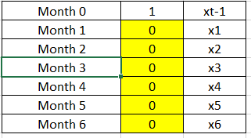

y1, y2…y6 are binary variables

y =1 if we operate the company in extended shift in a month, x=0, otherwise

Initially, all the months are set to zero (0)

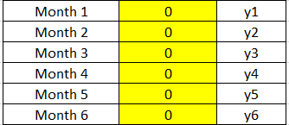

p1, p2…p6 are Integer variables

p is the amount produced in each month.

Initially, all the months are set to zero (0)

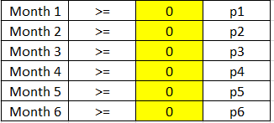

z1, z2…z6 are binary variables

z =1 if we switch from a normal shift in month t-1 to an extended

shift in month t, z=0, otherwise

Initially, all the months are set to zero (0)

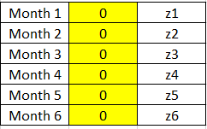

I1, I2…I6 are Integer variables

I is the Closing Inventory.

From the problem statement provided, it is clear that the Initial stock is 3000. Hence It-1 = 3000

Initially, for all the other months are set to zero (0)

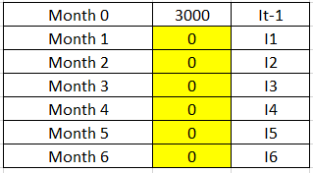

w1, w2…w6 are binary variables

w =1 if we produce in month t, z=0, otherwise

Initially, all the months are set to zero (0)

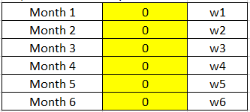

Now, let’s formulate the Objective function.

We need to minimize the total cost.

Objective Function = Minimize 100000xt + 180000yt + 15000zt + 2It

Calculate it for each of the month as shown below in the excel i.e., 100000x1 + 180000y1+15000z1+2I1, 100000x2 + 180000y2 + 15000z2+2I2 ……….. 100000x6 + 180000y6+15000z6+2I6

and then take a summation of all the months together.

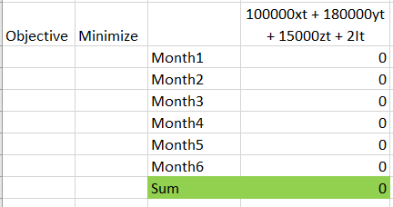

Now, let’s formulate the constraints.

1. Only operate (at most) one shift each month  
   xt + yt <= 1 t=1,2,...,6

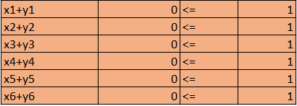

1. Production limits not exceeded

Pt <= 5000xt + 7500yt t=1,2,...,6

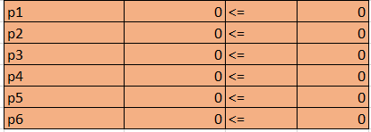

1. No stockouts

It >= 0 t=1,2,...,6

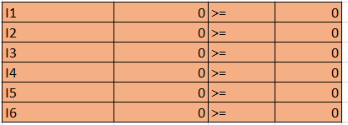

1. Inventory continuity equation of the form

closing stock = opening stock + production – demand

It = It-1 + Pt - Dt t=1,2,...,6

t-1 is for Month 0

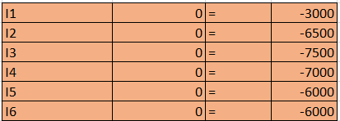

1. The amount in stock at the end of month 6 should be at least 2000 units

I6 >= 2000



1. Production constraints of the form "either Pt = 0 or Pt >= 2,000"

Pt <= Mwt t=1,2,...,6

Pt >= 2000wt t=1,2,...,6

Here M is a positive constant and represents the most we can produce in any period t (t=1,2,...,6). A convenient value for M for this example is M = 7500

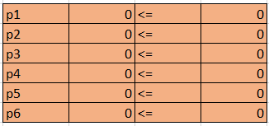

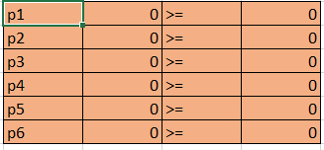

1. We also need to relate the shift change variable zt to the shifts being operated

zt = xt-1*yt  t=1,2,...,6

t-1 is for the Month 0

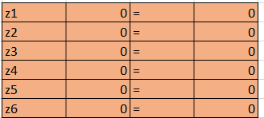

1. x1…..x6 are binary
2. y1…..y6 are binary
3. z1…..z6 are binary
4. w1…..w6 are binary
5. p1….p6 are Integers
6. I1…..I6 are integers

Now, let’s set the Objective, Variables and Constraints on the Excel solver and Solve it.

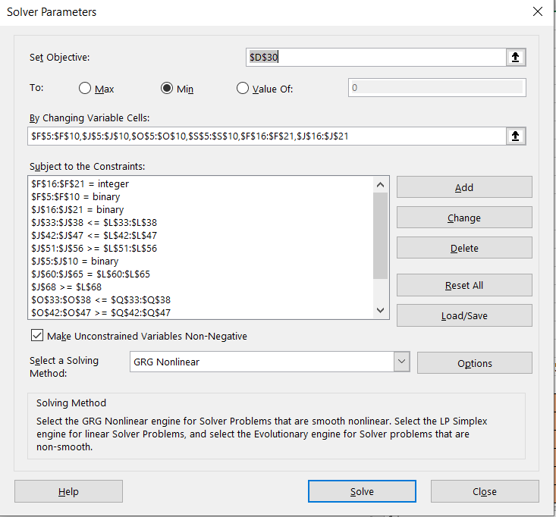

Now, let’s look at the Variables, Constraints and Objective function values.

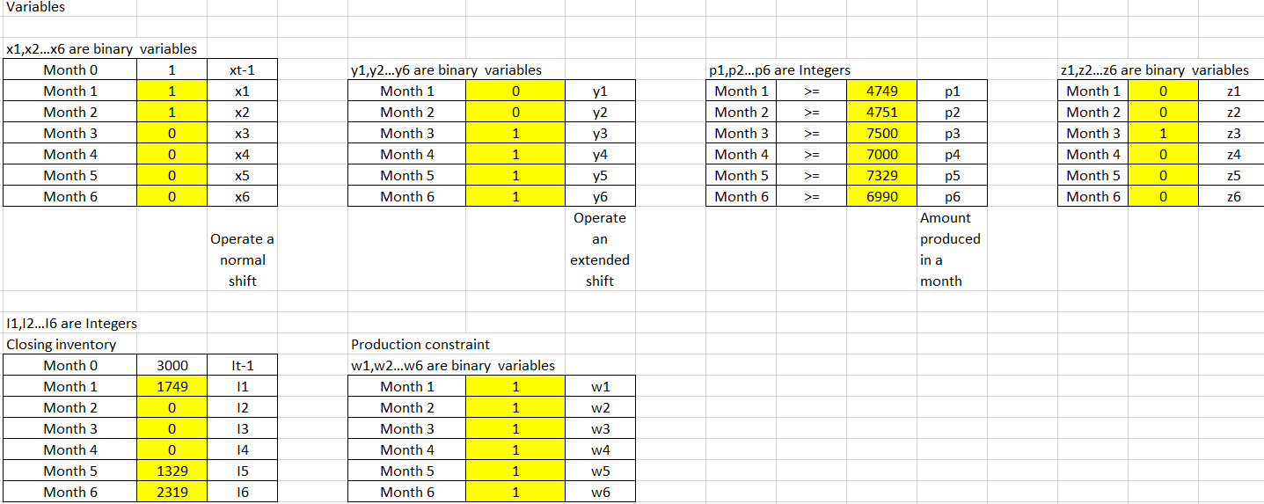

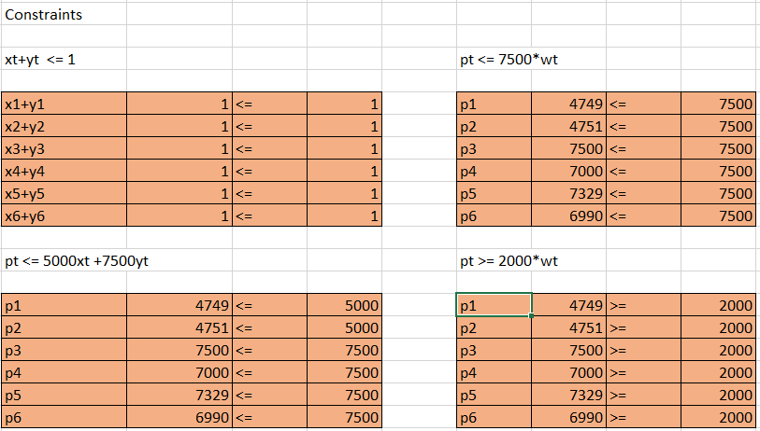

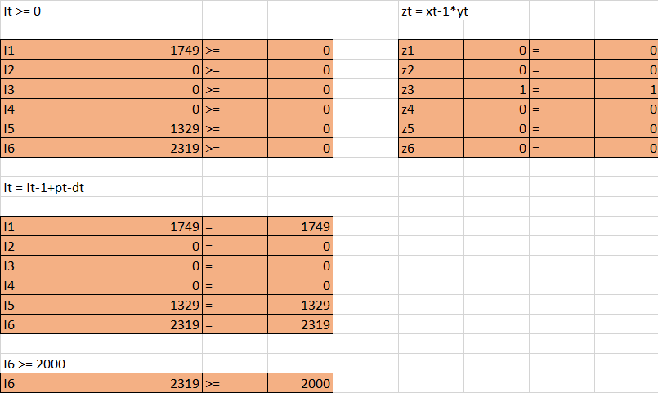

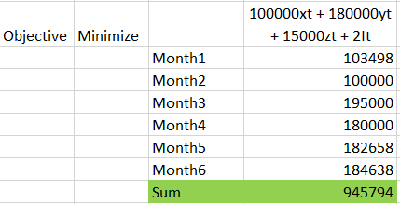

1. **Insights from the Solution**
2. The total optimized cost that the company would incur for the 6 months is £945,794.
3. Month 1 and Month 2, the company is operated on a Normal shift and from Month 3 to Month 6 it is operated on an extended shift to meet the Demand.
4. Our solution is formed in such a way as to reduce the cost of switching from the Normal shift to extended switch multiple times, an extra cost of £15,000 is incurred only once i.e., in the Month 3 for a switch from normal to extended.
5. For Months 2, 3 and 4 the closing inventory is zero.