The provided dataset

1. Yearwise sales

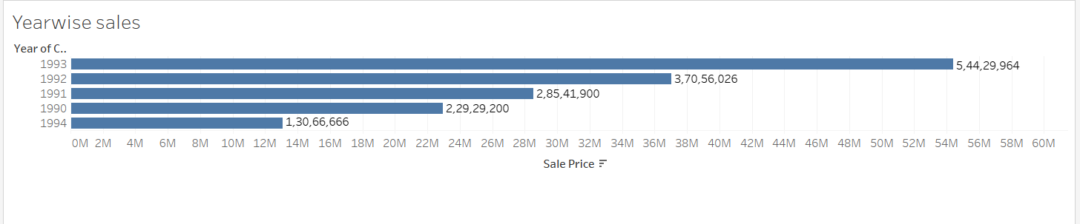

This graph shows how the sales price are for different years. As we can see the sales price is increasing every year.

1. Sales price Vs Month

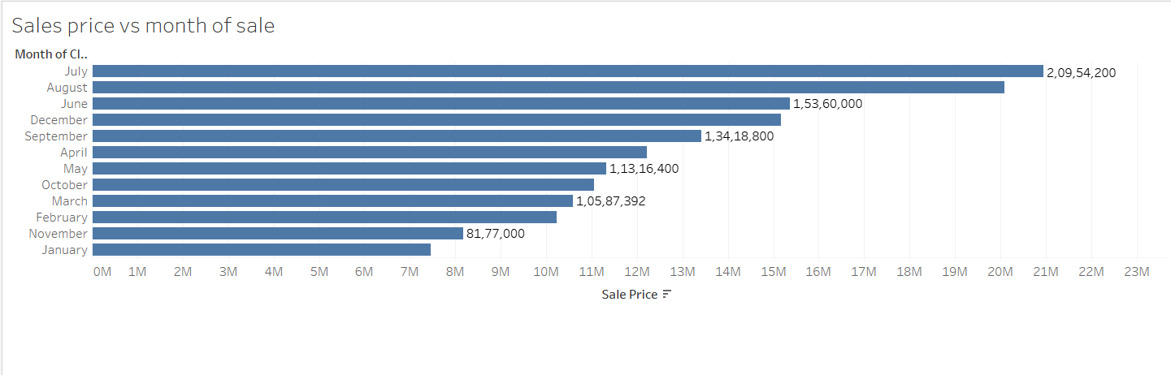

This graph shows the monthly trend for sales price. As we can see the sales prices are high during the months for June till August.

1. Sales price Vs Area

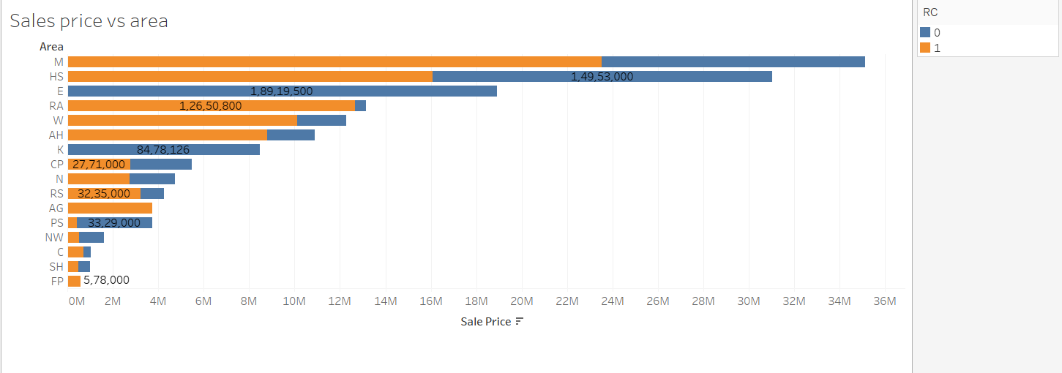

This graph is to show how the sales is in different areas for Boston. The ratio between the commercial and residential condos can be seen via the colour.

1. Sales Vs RC

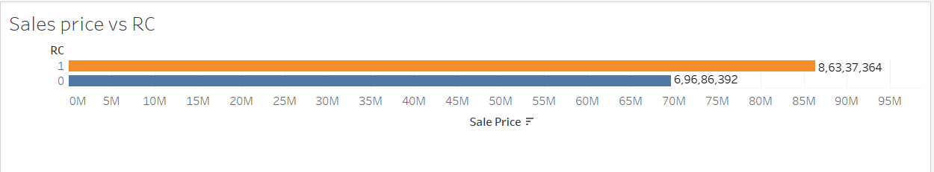

This graph shows that the commercial condos(RC = 1) have higher sales price when compared to residential condos (RC = 0).

1. Sales price Vs continuous month

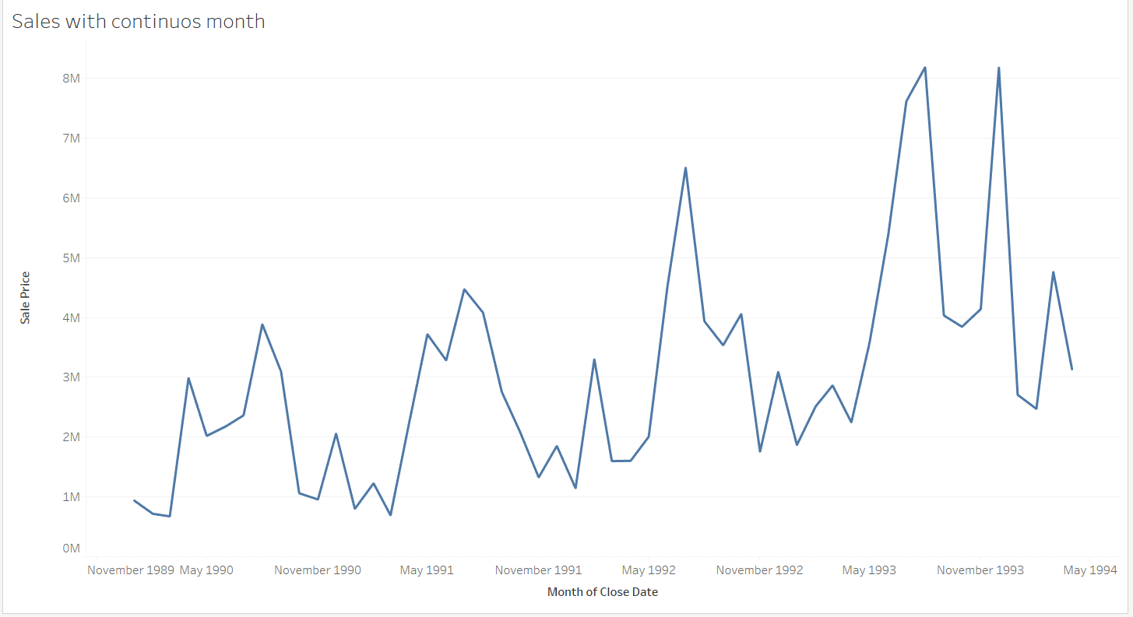

This graph shows the trend over the years for the sales price. As we can see the sales price is increasing every year with slight dips in few months.

1. # of Bed Vs Sales price

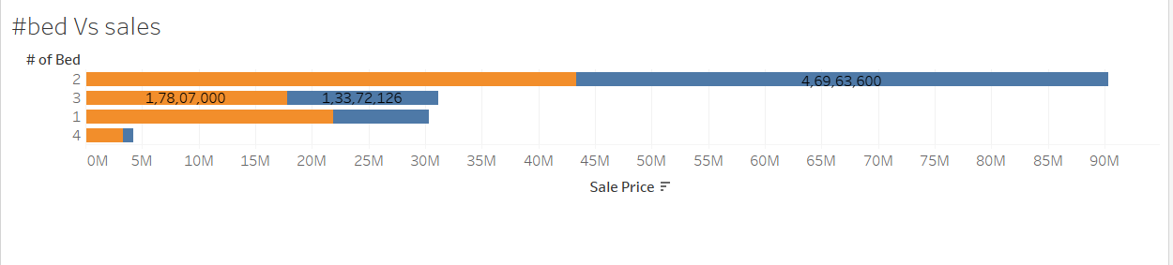

From the above graph we can see that 2 bed condos have the highest sales price.

1. # of rooms Vs Sales price

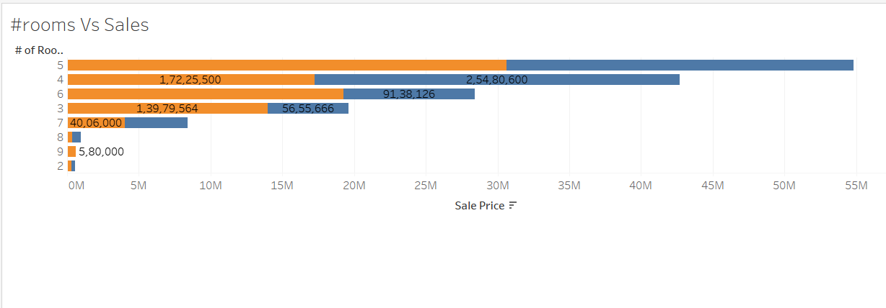

From the above graph we can see that the condos with 5 rooms have most sales price.

1. Tree map for # of rooms and Sq ft area

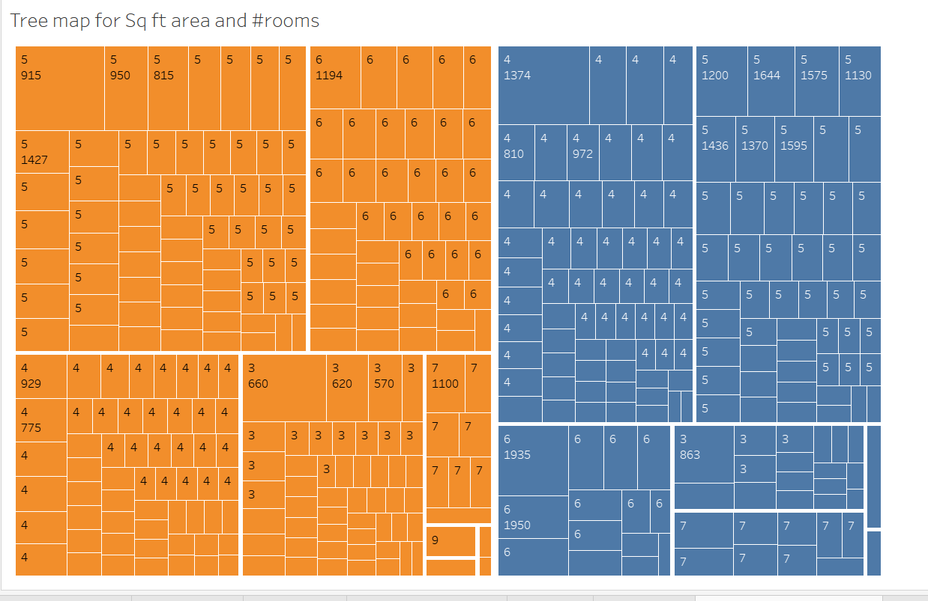

The above tree map represents the division of different condos based on the Type, area and the number of rooms in it.

1. Yearly trend of sales price

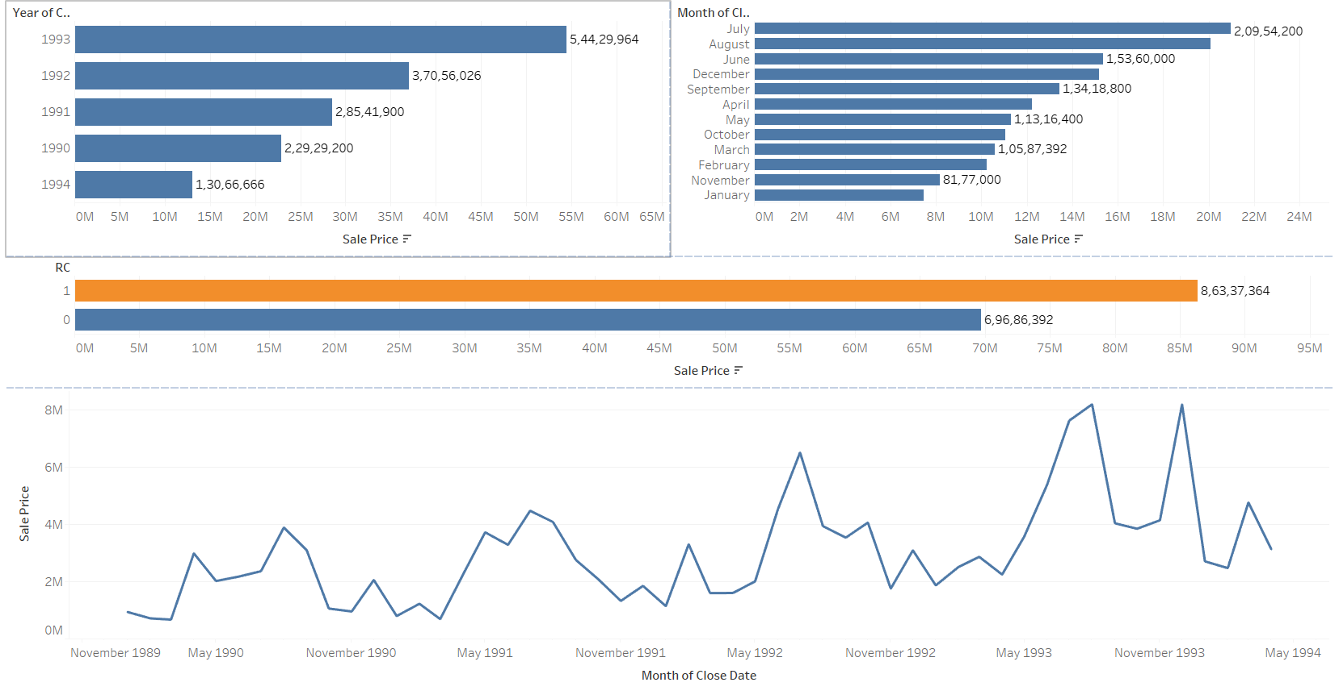

This dashboard can be used to view the trend of sales price based on the type of condo as filter.

1. Dashboard for types of condo.

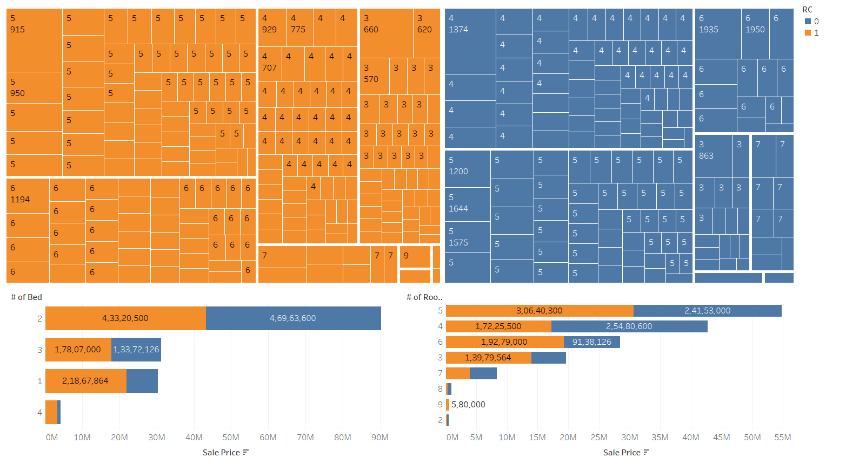

This dashboard is to represent how the sales price is based on the type of condo.

The theme of story is to show which is the ideal features of condos to get maximum sales price. We can see that the sales price is increasing every year and June – august being the hot season with high sales price. Ideal rooms is 5 – 7 and ideal sq ft area is around 1000 sq ft for commercial condos to get max sales price.

Link to story: <https://public.tableau.com/profile/nishitha.ramesh#!/vizhome/storybookforbostoncondo/Story1?publish=yes>