 **PROJECT REPORT TEMPLATE**

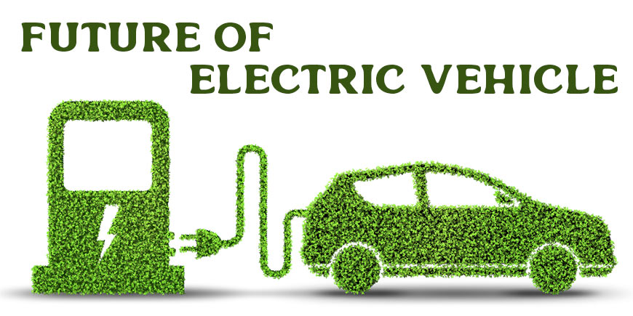

**1.INTRODUCTION :**

|  |
| --- |
| TOPIC: Visualization tool for electric vehicle charge and range analysis |

.

**OVERVIEW**:  Unlike internal combustion technology—which uses combustion and pressure to propel a vehicle—electric vehicles, or EVs, are propelled by electromagnetism. These vehicles use electricity, typically stored in a battery, to power an electric motor. EV technology is used in hybrid electric vehicles, or HEVs; plug-in hybrid electric vehicles, or PHEVs; and battery electric vehicles, or BEVs. a battery electric vehicle has the simplest and most efficient drivetrain with a typical battery range of 150 to 300 miles. BEVs can be charged overnight using standard residential Level 2 EVSE. The “EV Now” mode relies entirely on the battery and electric drivetrain, which results in zero tailpipe emissions, similar to a battery electric vehicle. The vehicles themselves also often display energy consumption or vehicle efficiency on their physical dashboard. Some vehicle models show lifetime energy consumption, so federal fleet managers will need to check the kilowatt-hours consumed annually to complete their FAST reports. However, if the vehicle displays the lifetime efficiency in miles per kilowatt-hour, fleet managers will need to divide the annual vehicle miles traveled by the vehicle efficiency to determine annual energy consumed.

|  |
| --- |
| (Annual miles)/(miles/kWh) = annual kWh |

If all else fails, the U.S. Department of Energy's Federal Energy Management Program has a simple way to estimate vehicle energy consumption: Take the vehicle's annual mileage reading and multiply it by the vehicle's fuel economy, listed in kilowatt-hours per mile on Fueleconomy.gov.

|  |
| --- |
| Annual miles x kWh/mile = annual kWh |

**PURPOSE**: Electric vehicles use electricity to charge their batteries instead of using fossil fuels like petrol or diesel. Electric vehicles are more efficient, and that combined with the electricity cost means that charging an electric vehicle is cheaper than filling petrol or diesel for your travel requirements. Vehicle power electronics primarily process and control the flow of electrical energy in hybrid and plug-in electric vehicles, including plug-in electric vehicles. They also control the speed of the motor, and the torque it produces.

**PROBLEM DEFINITION & DESIGN THINKING:**

**EMPATHY MAP**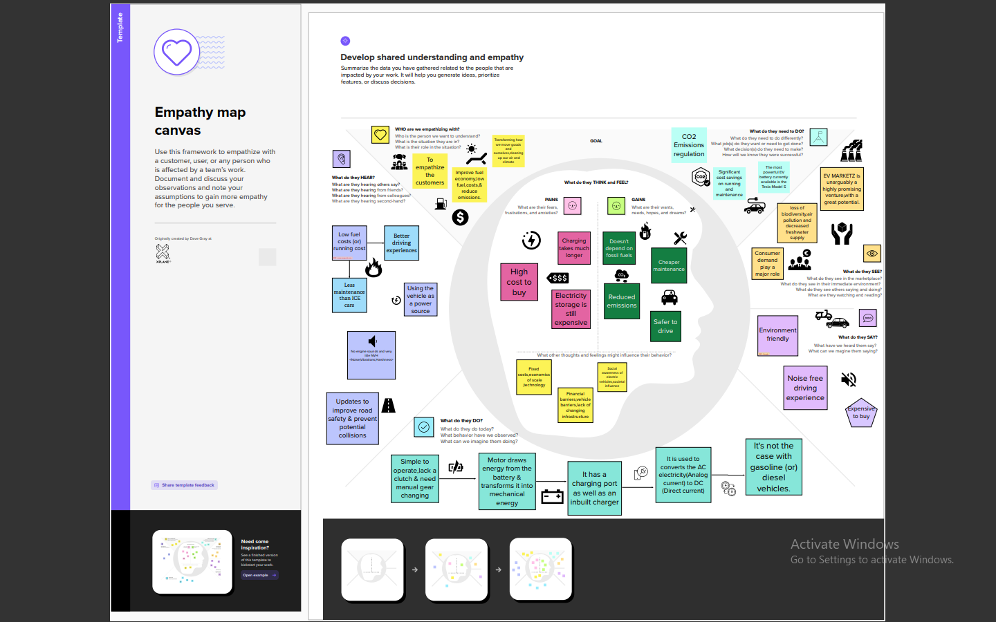

**IDEATION & BRAINSTORMING MAP:**

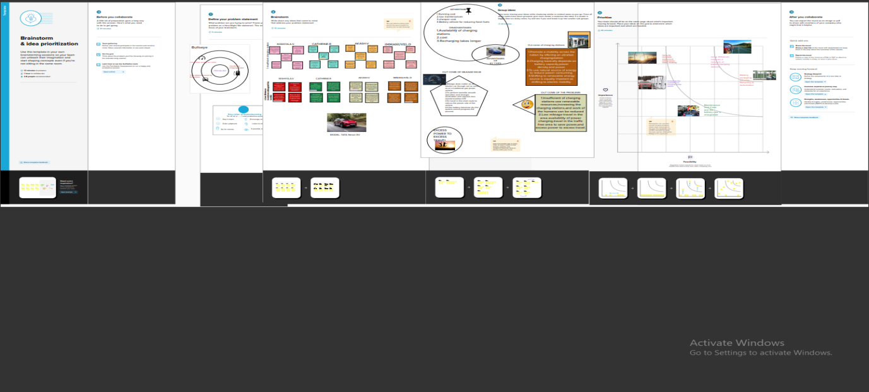

**RESULT:**

**DASHBOARD:**

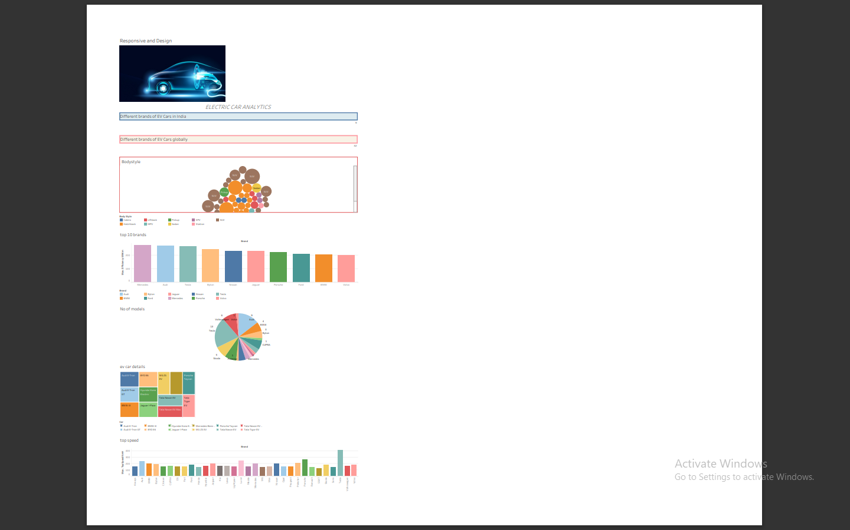

**STORY:**

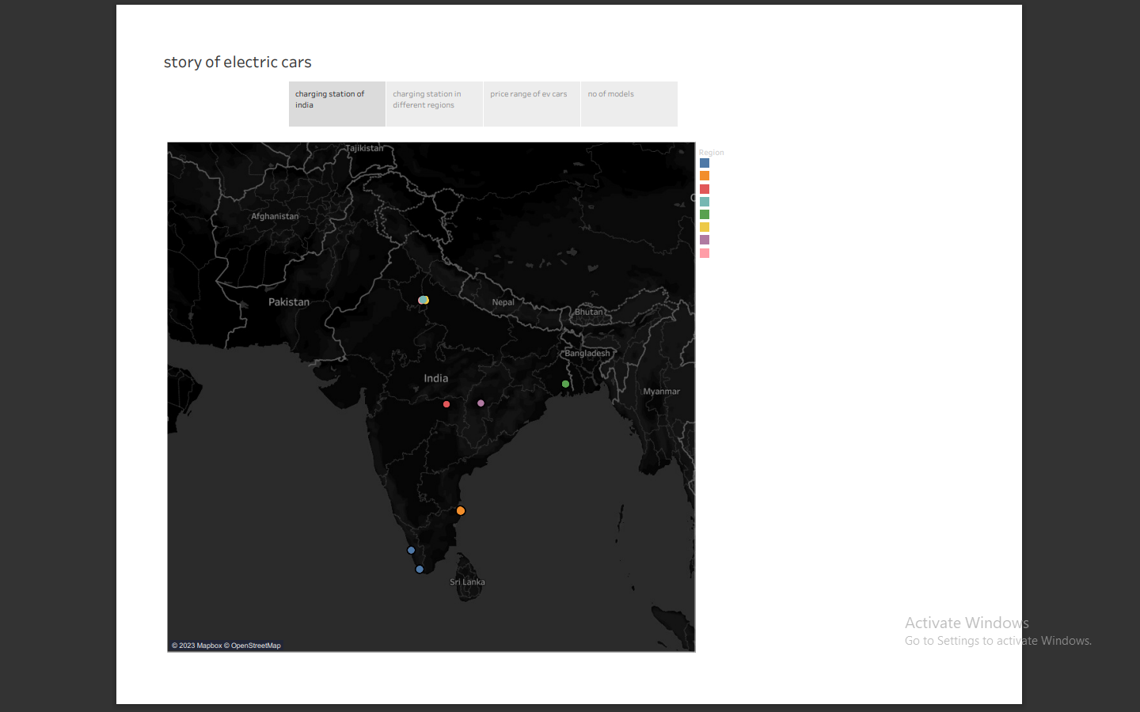

**ADVANTAGES & DISADVANTAGES:**

|  |  |
| --- | --- |
| **Pros** | **Cons** |
| Electric cars are powered by batteries, thus they emit no emissions, which helps to keep pollution under control in the environment. | Electric vehicles have a high initial purchase cost, and many consumers cannot afford them in their budgets, thus they are hesitant to move from regular vehicles to electric vehicles. |
| Although electric cars rely on renewable energy, they assist to protect nonrenewable energy supplies, which are fast depleting owing to broad use. | Due to the lack of electric car models accessible to the market, buyers have few alternatives in terms of design, appearance, or customized variants. |
| The moving components in electric vehicles are less numerous than those in traditional automobiles, which means they last longer. Repairing EVs is also less expensive than regular automobiles. | People who travel long distances are concerned about becoming stuck because there are fewer charging outlets accessible. |
| Driving an electric car is significantly smoother and quieter since there are no fast-moving pistons. | The charging time of an electric car is around four to six hours. |
| Governments all across the globe have provided tax breaks to encourage people to buy electric vehicles. | The electric vehicle gets less mileage than gasoline-powered vehicles and is only appropriate for short journeys. |
|  |  |

**APPLICATIONS:**

* Zero Tailpipe Emissions
* Tax and financial benefits
* Petrol and diesel use is destroying our planet
* Electric Vehicles are easy to drive and quiet
* Convenience of charging at home
* No noise pollution

**CONCLUSION:**

TASK1 – EMPATHY MAP:

Collection of ideas grouped together in a particular map .Each team member ideas and opinion are pointed together. what we hear? Who are we empathizing with? Are the some of the topics we have discussed. Expressing everything in a picture and symbol representation.

TASK2 –IDEATION & BRAINSTORMING MAP:

It is a group problem-solving method that involves the spontaneous contribution of creative ideas and solutions. This technique requires intensive, freewheeling discussion in which every member of the group is encouraged to think aloud and suggest as many ideas as possible based on their diverse knowledge.

TASK3- COMPLETION OF COURSE VIDEOS:

They were 23 videos and we have learnt and completed all the videos and we attended the quiz asked in each videos.

TASK4- WORKING ON THE TABLEAU:

Working on the tableau platform is used to create the dashboard and story for the project. some of the screenshot of working are displayed below;

|  |  |
| --- | --- |
| WhatsApp Image 2023-04-10 at 3.50.28 PM.jpeg | WhatsApp Image 2023-04-10 at 3.50.28 PM (1).jpeg |
| WhatsApp Image 2023-04-10 at 3.50.28 PM (2).jpeg | WhatsApp Image 2023-04-10 at 3.50.28 PM (3).jpeg |
| WhatsApp Image 2023-04-10 at 3.50.28 PM (5).jpeg | WhatsApp Image 2023-04-10 at 3.50.28 PM (4).jpeg |
| WhatsApp Image 2023-04-10 at 3.50.28 PM (6).jpeg | WhatsApp Image 2023-04-10 at 3.50.31 PM.jpeg |

We were using My SQL work bench for the data manipulation and the visual code for output confirmation of the program. In the dashboard we were representing the data and parameters in a pictorial representation of pie chart and graph.

**FUTURE SCOPE:**

**There are no emissions:**

Electric automobiles are being developed primarily because they do not emit any pollution when driving. An electric vehicle is propelled by a battery-powered electric motor. There is no burning of fuel. An electric vehicle does not have an exhaust system. It's the best road transportation solution at a time when global CO2 emissions and air pollution must be drastically cut.

**Access to city centres is unrestricted:**

Aside from the fact that more cities are implementing LEZs, these zones are also growing in size and strictness with time. With an electric car, you have limitless access to low-emission zones, now and in the future, wherever and whenever you want.

**Electricity is less expensive than gasoline:**

Electricity is less expensive than gasoline and fuel. In this regard, an electric automobile is less expensive than a car with a combustion engine. The most cost-effective solution is to charge at home.

**Comfortable and quiet:**

Unlike a combustion engine, an electric motor produces very little noise. As a result, the silence inside an electric vehicle is unmistakable. Additionally, unlike a combustion engine, an electric motor does not produce any vibrations or resonance. The vibration-free and silent drivetrain adds to the relaxation.

**There's no need to switch gears:**

An electric automobile does not have a traditional gearbox, which is another key distinction from a car with a combustion engine. An electric car always works like a car with an automatic transmission, which eliminates the need to shift gears. You also don't have to pay more for it. Driving in busy start-stop traffic in the city or traffic congestion has never been more comfortable, thanks to the quietness of an electric motor.

**Torque on the fly:**

The incredibly high torque of an electric motor is a distinct feature. Much more powerful than a typical internal combustion engine. Furthermore, an electric motor responds rapidly to throttle motions and generates peak torque right from a standstill. Internal combustion engines have an unavoidable response time and can only generate maximum torque in a specific speed range. All of this assures enticing performance thanks to the smooth and powerful acceleration, as well as a great deal of driving pleasure.

**Extremely effective:**

At the moment, the most efficient combustion engines have an efficiency of around 40%. That means they only put 40% of the energy in the fuel into motion. Heat and friction account for the remaining 60%.

An electric motor has a 90 per cent efficiency, which means it uses the battery's energy far more efficiently. Furthermore, because an electric motor can be transformed into a generator in the blink of an eye, an electric car can swiftly recover kinetic energy.

**Requires less maintenance:**

Electric drivetrain technology is much simpler than that of a combustion engine. Because only a few sections need to be lubricated, it has far fewer (spinning) parts and fluids. So, as you may have guessed, an electric vehicle requires less maintenance.

**Generate your power:**

Having your oil refinery in your garden to make your auto fuel is impossible. It's hardly unexpected, though, that you can create your electricity. For example, solar panels on the top of your home or office building can provide energy. You may further lower your kilometre cost by charging your battery with this renewable energy.

**APPENDIX:**

**<div class='tableauPlaceholder' id='viz1681194155677' style='position: relative'><noscript><a href='#'><img alt='Responsive and Design ' src='https:&#47;&#47;public.tableau.com&#47;static&#47;images&#47;el&#47;electriccardashboard&#47;ResponsiveandDesign&#47;1_rss.png' style='border: none' /></a></noscript><object class='tableauViz' style='display:none;'><param name='host_url' value='https%3A%2F%2Fpublic.tableau.com%2F' /> <param name='embed_code_version' value='3' /> <param name='site_root' value='' /><param name='name' value='electriccardashboard&#47;ResponsiveandDesign' /><param name='tabs' value='no' /><param name='toolbar' value='yes' /><param name='static_image' value='https:&#47;&#47;public.tableau.com&#47;static&#47;images&#47;el&#47;electriccardashboard&#47;ResponsiveandDesign&#47;1.png' /> <param name='animate_transition' value='yes' /><param name='display_static_image' value='yes' /><param name='display_spinner' value='yes' /><param name='display_overlay' value='yes' /><param name='display_count' value='yes' /><param name='language' value='en-US' /></object></div> <script type='text/javascript'> var divElement = document.getElementById('viz1681194155677'); var vizElement = divElement.getElementsByTagName('object')[0]; if ( divElement.offsetWidth > 800 ) { vizElement.style.width='1320px';vizElement.style.height='2027px';} else if ( divElement.offsetWidth > 500 ) { vizElement.style.width='1320px';vizElement.style.height='2027px';} else { vizElement.style.width='100%';vizElement.style.height='2327px';} var scriptElement = document.createElement('script'); scriptElement.src = 'https://public.tableau.com/javascripts/api/viz_v1.js'; vizElement.parentNode.insertBefore(scriptElement, vizElement); </script>**