**FP5.0 Module-1**

**Project-1**

**Batch Name:**

Infosys FP5.0 Summer 2018

**Enrollment Number:** R171217041

**SAPID:** 500060720

**Name:** Nishkarsh Raj Khare

**Sem:** Semester-III

**Branch:** CSE-DevOps-Xebia

**Project Objectives**

After completing this project, a learner should be able to understand and implement the following fundamental concepts of Python Programming in solving a real world problem.

* Variables
* Data Structures
  + String Lists
* Control Structures
  + If / else statements, For loop
* Functions
* File Handling and Operations

**Specifications**

The project is to write a Python program that reads a text file, scrambles the words in the file on following rules and writes the output to a new text file:

* Words less than or equal to 3 characters need not be scrambled
* Don't scramble first and last char, so Scrambling can become Srbmnacilg or Srbmnailcg or Snmbracilg , i.e. letters except first and last can be scrambled in any order
* Punctuation at the end of the word to be maintained as is i.e. "Surprising," could become "Spsirnirug," but not "Spsirn,irug"
* Following punctuation marks are to be supported - Comma Question mark, Full stop, Semicolon, Exclamation
* Do this for a file and maintain sequences of lines
* Hint: use random module of Python for scrambling

**Expected Output**

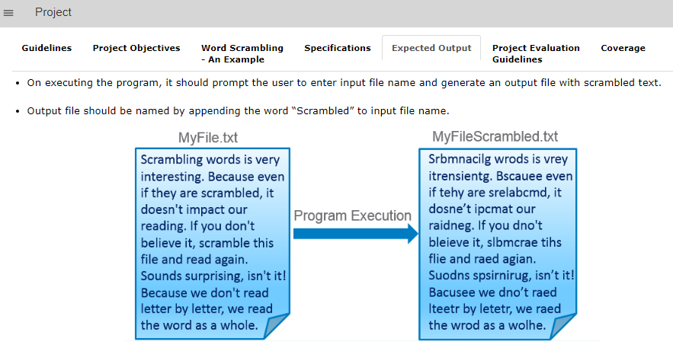

**Coding**

**#Step 1) Import all the libraries required**

**import random**

**import string**

**#Step 2) Create function of Scrambling of word where input argument will be a single word.**

**def scramble(word):**

**if len(word) <= 3: #if length of word is less than 3, it remains unchanged**

**return word**

**elif word[-1] == "?" or word[-1] == "." or word[-1] == ";" or word[-1] == "," or word[-1] == "!":**

**k=list(word[1:-2])**

**random.shuffle(k)**

**return word[0]+''.join(k)+word[-2]+word[-1]**

**else:**

**k=list(word[1:-1])**

**random.shuffle(k)**

**return word[0]+''.join(k)+word[-1]**

**#Step 3) Create a file from which you want to read the content**

**print("Welcome to the Project 1 in Python Course")**

**print("Lets Scramble a complete file!!!")**

**filename = input("Enter name of the file: ") #Using Input we can prompt user to enter the filename**

**filename = filename+".txt" #Creating Text file as specified**

**file = open(filename,"w",1) #File name is a string basically and thus can be pre-specified**

**num = int(input("Enter lines of content you want to write in the file: "))**

**print("Enter the content now!!!")**

**for i in range (0,num):**

**str1 = input()**

**file.write(str1)**

**file.write("\n")**

**file.close()**

**'''If you have already created the File and don't want to create it again comment or delete everything written above'''**

**#Step 4) Read The file content and store it as a list of lines**

**nish = open(filename,"r+")**

**lines = nish.readlines()**

**i=0**

**list1 = [None]*len(lines)**

**for line in lines:**

**list1[i] = line.split()**

**i = i+1**

**nish.close()**

**#Now we have a list containing elements: One line of a file as a list of all words in line**

**''' Create a file to write the contents into!!!! '''**

**#Step 5) Create new file with appened file name as 'Scrambled'**

**filename = filename.split(".") # Splitting File name by comma delimiter**

**filename1 = filename[0]+"Scrambled."+filename[1] #Appending Scrambled to the filename before .ext**

**file1 = open(filename1,"w",1)**

**#Step 6) Write content into scrambled file by randomizing each word by calling function 'scramble' and maintain the spaces and linefeeds**

**for k in range (0,len(list1)):**

**for j in range (0,len(list1[k])):**

**file1.write(scramble(list1[k][j]))**

**file1.write(" ")**

**file1.write("\n")**

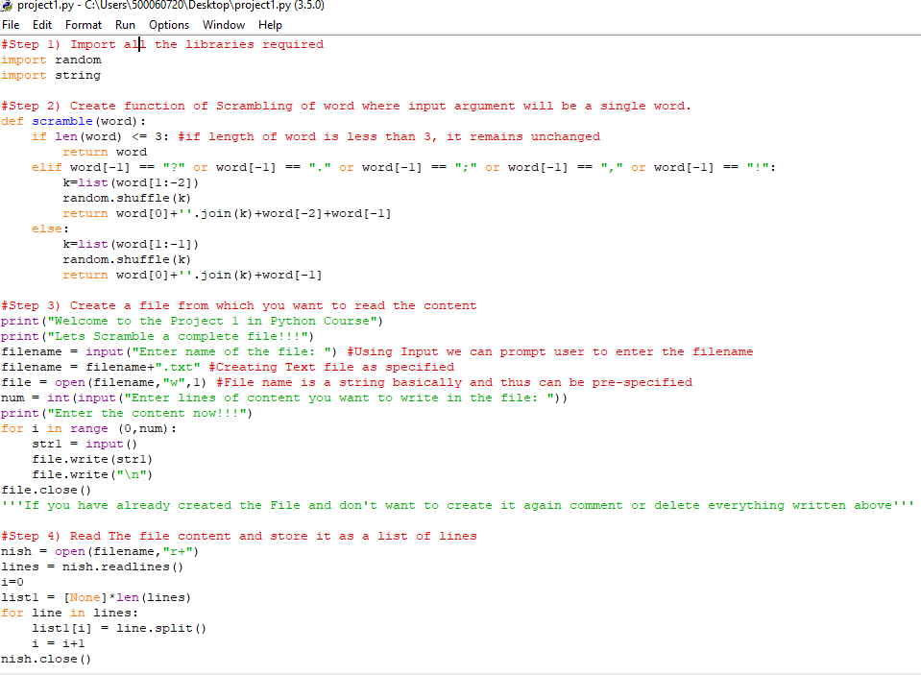**Screenshot of coding**

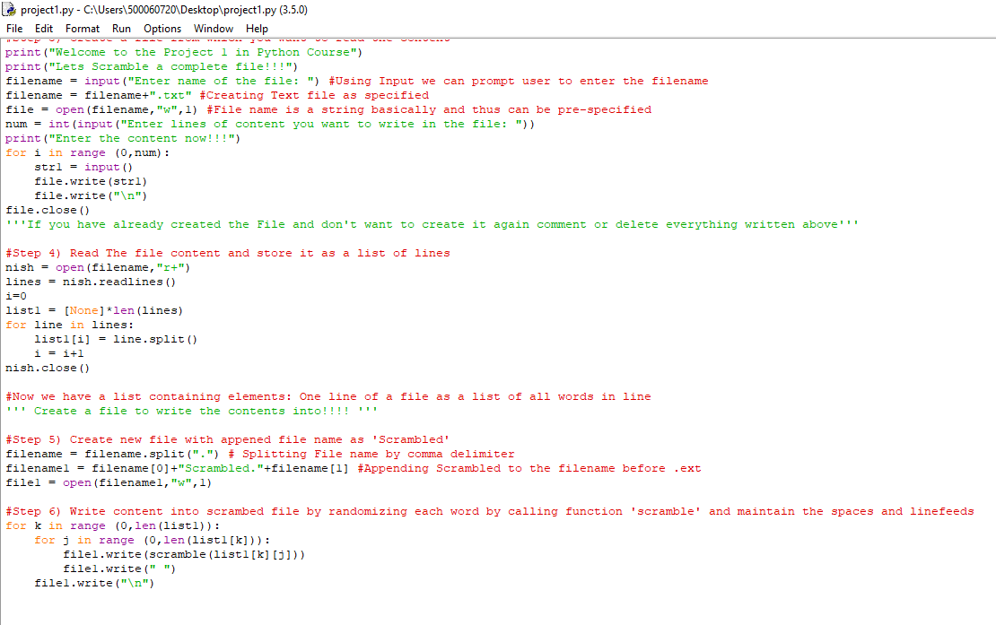

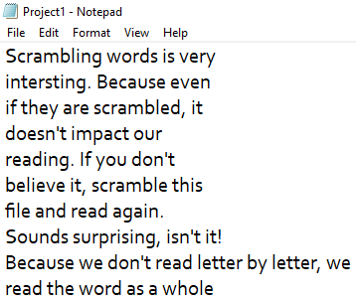**Screenshot of Text File**

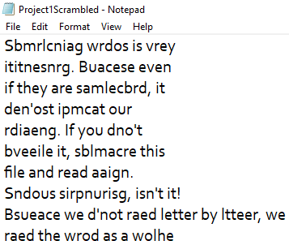

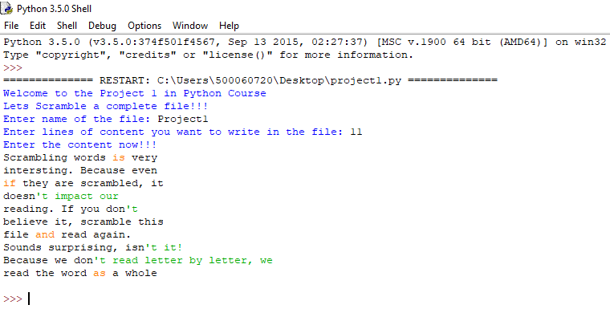**Screenshot of Shell output**