AI LAB 1
EXPERIMENT 1 - BFS for Emergency Facility Navigation
AIM: To find a route through a hospital or emergency facility.
QUESTION:
Develop a Python-based navigation system for an emergency response team operating inside a hospital represented as an unweighted graph. Rooms and junctions are vertices, while accessible corridors are edges. Implement Breadth-First Search (BFS) to identify the route from the emergency entrance to a designated critical-care unit.
The program must:
- Represent the hospital layout as an adjacency list.
- Accept the source and destination nodes.
- Find and display the shortest route in terms of the number of corridors traversed.
- Report the number of nodes explored and explain how BFS guarantees a shortest path in an unweighted graph.
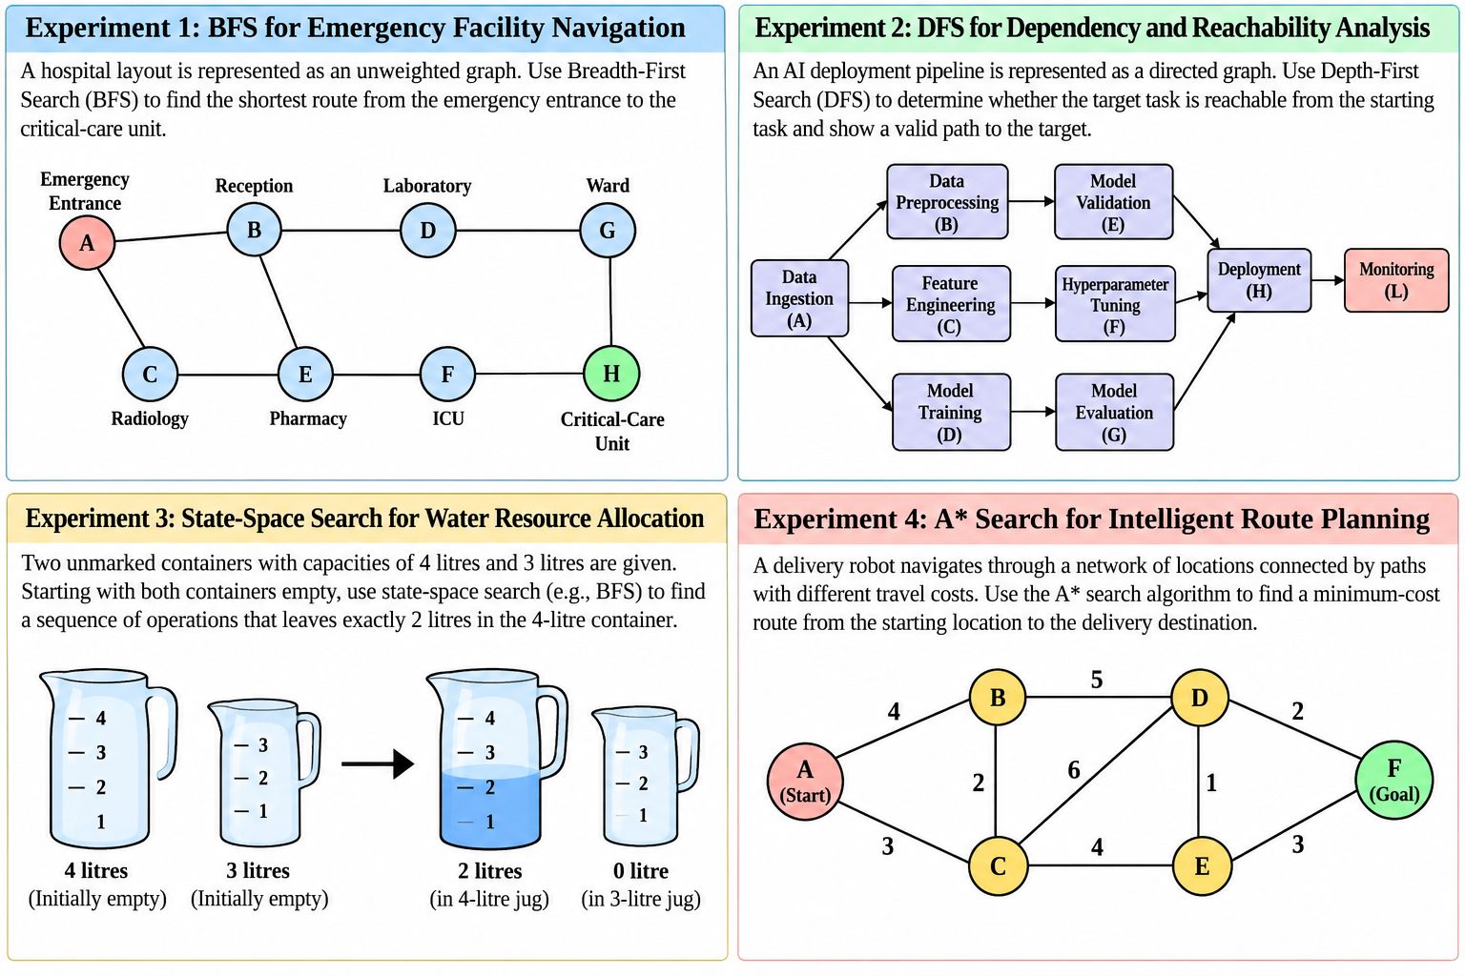

CODE:

from collections import deque
hospital = {
'A': ['B', 'C'],
'B': ['A', 'D', 'E'],
'C': ['A', 'E'],
'D': ['B', 'G'],
'E': ['B', 'C', 'F'],
'F': ['E', 'H'],
'G': ['D', 'H'],
'H': ['F', 'G']
}

def bfs(graph, source, destination):
queue = deque([source])
visited = {source}
parent = {source: None}
nodes_explored = 0

while queue:
current = queue.popleft()
nodes_explored += 1

if current == destination:
break

for neighbor in graph[current]:
if neighbor not in visited:
visited.add(neighbor)
parent[neighbor] = current
queue.append(neighbor)

if destination not in parent:
print("No route exists between the given locations.")
return

path = []
node = destination

while node is not None:
path.append(node)
node = parent[node]

path.reverse()

print("\nShortest Route:", " -> ".join(path))
print("Number of Corridors:", len(path) - 1)
print("Number of Nodes Explored:", nodes_explored)

print("Hospital Navigation System")
print("A - Emergency Entrance")
print("B - Reception")
print("C - Radiology")
print("D - Laboratory")
print("E - Pharmacy")
print("F - ICU")
print("G - Ward")
print("H - Critical-Care Unit")

source = input("\nEnter source node: ").strip().upper()
destination = input("Enter destination node: ").strip().upper()

if source not in hospital or destination not in hospital:
print("Invalid node! Please enter a node from A to H.")
else:
bfs(hospital, source, destination)

OUTPUT:
Hospital Navigation System
A - Emergency Entrance
B - Reception
C - Radiology
D - Laboratory
E - Pharmacy
F - ICU
G - Ward
H - Critical-Care Unit

Enter source node: A
Enter destination node: H

Shortest Route: A -> B -> D -> G -> H
Number of Corridors: 4
Number of Nodes Explored: 8

EXPERIMENT 2 - DFS for Dependency and Reachability Analysis
AIM: To analyse dependencies in an AI software pipeline.
QUESTION:
An AI deployment pipeline consists of interconnected processing tasks, where each task depends on one or more downstream tasks. Model the pipeline as a directed graph and implement Depth-First Search (DFS) in Python to determine whether a specified target task is reachable from a given starting task.
The program must:
- Represent the pipeline using a directed adjacency list.
- Accept a starting task and a target task.
- Display the DFS traversal order and determine whether the target is reachable.
- Reconstruct a valid path to the target, if one exists.
- Explain how visited-node tracking prevents repeated exploration and how DFS behaves when the graph contains cycles.

CODE:
pipeline = {
'A': ['B', 'C', 'D'], # Data Ingestion
'B': ['E'],
'C': ['F'],
'D': ['G'],
'E': ['H'],
'F': ['H'],
'G': ['H'],
'H': ['L'],
'L': []
}

def dfs(graph, start, target):
visited = set()
traversal = []
parent = {start: None}
stack = [start]

while stack:
current = stack.pop()

if current in visited:
continue

visited.add(current)
traversal.append(current)

if current == target:
break

for neighbor in reversed(graph[current]):
if neighbor not in visited and neighbor not in parent:
parent[neighbor] = current
stack.append(neighbor)

print("\nDFS Traversal Order:", " -> ".join(traversal))

if target in visited:
path = []
node = target

while node is not None:
path.append(node)
node = parent[node]

path.reverse()

print("Target is reachable.")
print("Valid Path:", " -> ".join(path))
else:
print("Target is not reachable from the starting task.")

print("AI Deployment Pipeline")
print("A - Data Ingestion")
print("B - Data Preprocessing")
print("C - Feature Engineering")
print("D - Model Training")
print("E - Model Validation")
print("F - Hyperparameter Tuning")
print("G - Model Evaluation")
print("H - Deployment")
print("L - Monitoring")

start = input("\nEnter starting task: ").strip().upper()
target = input("Enter target task: ").strip().upper()

if start not in pipeline or target not in pipeline:
print("Invalid task! Please enter a valid task label.")
else:
dfs(pipeline, start, target)

OUTPUT:
AI Deployment Pipeline
A - Data Ingestion
B - Data Preprocessing
C - Feature Engineering
D - Model Training
E - Model Validation
F - Hyperparameter Tuning
G - Model Evaluation
H - Deployment
L - Monitoring
Enter starting task: A
Enter target task: L
DFS Traversal Order: A -> B -> E -> H -> L
Target is reachable.
Valid Path: A -> B -> E -> H -> L

EXPERIMENT 3 - State-Space Search for Water Resource Allocation
AIM: To Measure a target quantity using containers with fixed capacities.
QUESTION:
Design a Python-based state-space search solution for a water allocation problem involving two unmarked containers with capacities of 4 litres and 3 litres. Starting with both containers empty, determine a sequence of valid operations that leaves exactly 2 litres in the 4-litre container.
The program must:
- Represent each state as the quantities of water in both containers.
- Define the legal actions: fill, empty and transfer water between containers.
- Search the state space using BFS and identify a valid solution.
- Display the sequence of states and actions from the initial state to the goal.
- Explain how state representation, goal testing and repeated-state detection affect the search.
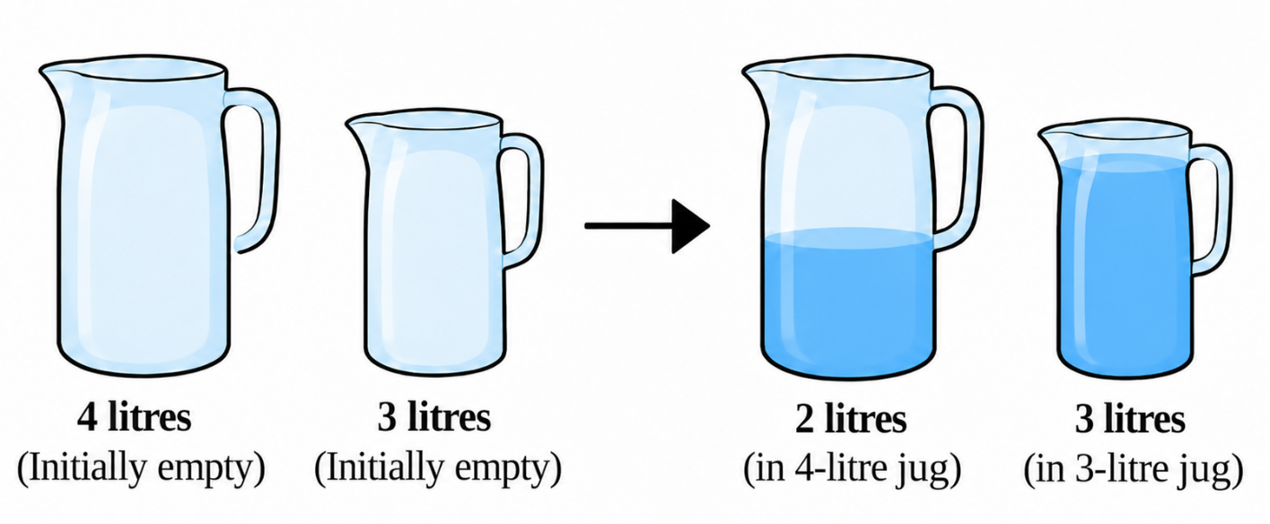

CODE:

from collections import deque
CAPACITY_A = 4
CAPACITY_B = 3
GOAL = 2

def get_next_states(state):
a, b = state
next_states = []

if a < CAPACITY_A:
next_states.append(((CAPACITY_A, b), "Fill 4L container"))

if b < CAPACITY_B:
next_states.append(((a, CAPACITY_B), "Fill 3L container"))

if a > 0:
next_states.append(((0, b), "Empty 4L container"))

if b > 0:
next_states.append(((a, 0), "Empty 3L container"))

if a > 0 and b < CAPACITY_B:
transfer = min(a, CAPACITY_B - b)
next_states.append(
((a - transfer, b + transfer), "Pour 4L -> 3L")
)
if b > 0 and a < CAPACITY_A:
transfer = min(b, CAPACITY_A - a)
next_states.append(
((a + transfer, b - transfer), "Pour 3L -> 4L")
)

return next_states
def water_jug_bfs():
initial_state = (0, 0)
queue = deque([(initial_state, [])])
visited = {initial_state}

while queue:
current_state, path = queue.popleft()
a, b = current_state

if a == GOAL:
return path + [(current_state, "Goal reached")]
for next_state, action in get_next_states(current_state):
if next_state not in visited:
visited.add(next_state)
new_path = path + [(current_state, action)]
queue.append((next_state, new_path))

return None
solution = water_jug_bfs()

if solution:
print("Water Jug Problem using BFS")
print("Initial State: (0, 0)")
print("State format: (water in 4L, water in 3L)\n")

for i, (state, action) in enumerate(solution):
if i == 0:
print(f"State: {state}")

if action == "Goal reached":
print(f"Goal State: {state}")
else:
next_state = solution[i + 1][0]
print(f"Action: {action}")
print(f"Next State: {next_state}\n")
else:
print("No solution found.")

OUTPUT:
Water Jug Problem using BFS
Initial State: (0, 0)
State format: (water in 4L, water in 3L)

State: (0, 0)
Action: Fill 4L container
Next State: (4, 0)

Action: Pour 4L -> 3L
Next State: (1, 3)

Action: Empty 3L container
Next State: (1, 0)

Action: Pour 4L -> 3L
Next State: (0, 1)

Action: Fill 4L container
Next State: (4, 1)

Action: Pour 4L -> 3L
Next State: (2, 3)

Goal State: (2, 3)

EXPERIMENT 4 - A* Search for Intelligent Route Planning
APPLICATION: To route planning for an autonomous delivery robot.
QUESTION
Develop an intelligent route-planning system for an autonomous delivery robot navigating a network of locations connected by paths with different travel costs. Implement the A* search algorithm in Python to find a minimum-cost route from a specified starting location to a delivery destination.
The program must:
- Represent the environment as a weighted graph.
- Assign a heuristic estimate \(h(n)\) to each node and calculate the accumulated path cost \(g(n)\).
- Use \(f(n)=g(n)+h(n)\) to determine which node to explore next.
- Display the selected route, total path cost and node expansion order.
- Explain how heuristic quality affects search efficiency and why an admissible heuristic matters for optimality.
Heuristic values.
Node | h(n)
A | 6
B | 4
C | 5
D | 2
E | 3
F | 0

CODE:

import heapq

graph = {
'A': {'B': 4, 'C': 3},
'B': {'A': 4, 'C': 2, 'D': 5},
'C': {'A': 3, 'B': 2, 'D': 6, 'E': 4},
'D': {'B': 5, 'C': 6, 'E': 1, 'F': 2},
'E': {'C': 4, 'D': 1, 'F': 3},
'F': {'D': 2, 'E': 3}
}

h = {
'A': 6,
'B': 4,
'C': 5,
'D': 2,
'E': 3,
'F': 0
}

def astar(start, goal):
open_list = [(h[start], start)]

g_cost = {start: 0}
parent = {start: None}
expanded = []

while open_list:
f_value, current = heapq.heappop(open_list)
if f_value != g_cost[current] + h[current]:
continue

if current in expanded:
continue

expanded.append(current)

if current == goal:
break

for neighbor, cost in graph[current].items():
new_g = g_cost[current] + cost

if neighbor not in g_cost or new_g < g_cost[neighbor]:
g_cost[neighbor] = new_g
parent[neighbor] = current

f = new_g + h[neighbor]
heapq.heappush(open_list, (f, neighbor))
if goal not in parent:
print("No route found.")
return

path = []
node = goal

while node is not None:
path.append(node)
node = parent[node]

path.reverse()

print("\nA* Search Results")
print("-----------------")
print("Selected Route:", " -> ".join(path))
print("Total Path Cost:", g_cost[goal])
print("Node Expansion Order:", " -> ".join(expanded))

print("\nNode Cost Details:")
print("Node\tg(n)\th(n)\tf(n)")

for node in expanded:
print(f"{node}\t{g_cost[node]}\t{h[node]}\t"
f"{g_cost[node] + h[node]}")

print("Intelligent Route Planning")
print("Available nodes: A, B, C, D, E, F")

start = input("Enter starting node: ").strip().upper()
goal = input("Enter goal node: ").strip().upper()

if start not in graph or goal not in graph:
print("Invalid node! Please enter a node from A to F.")
else:
astar(start, goal)

OUTPUT:
Intelligent Route Planning
Available nodes: A, B, C, D, E, F
Enter starting node: A
Enter goal node: F

A* Search Results
-----------------
Selected Route: A -> C -> E -> F
Total Path Cost: 10
Node Expansion Order: A -> B -> C -> E -> D -> F

Node Cost Details:
Node g(n) h(n) f(n)
A 0 6 6
B 4 4 8
C 3 5 8
E 7 3 10
D 8 2 10
F 10 0 10

