AI LAB 2
EXPERIMENT 5: Solving the 8-Queens Problem Using Backtracking
AIM: To find the collision-free placement of components on a grid.
QUESTION:
An automated placement system must position eight components on an 8 × 8 grid such that no two components interfere with one another. Model this as the 8-Queens problem, where each queen represents a component and can attack another queen along the same row, column, or diagonal.
Develop a Python program using the backtracking algorithm to find a valid arrangement of eight queens on the chessboard.
The program must:
- Represent the chessboard as an 8 × 8 grid and track the positions of the queens.
- Place one queen at a time while ensuring that no two queens share the same row, column, or diagonal.
- Use recursive backtracking to undo an invalid placement and explore alternative positions.
- Display the final chessboard arrangement and the positions of all eight queens.
- Report the number of placement attempts and explain how constraint checking and backtracking help find a valid solution.
CODE:
N = 8
board = [-1] * N
attempts = 0
def is_safe(row, col):
for prev_row in range(row):
prev_col = board[prev_row]
# Check same column
if prev_col == col:
return False

# Check diagonals
if abs(prev_col - col) == abs(prev_row - row):
return False

return True

def solve(row):
global attempts
# All 8 queens have been placed
if row == N:
return True
# Try each column in the current row
for col in range(N):
attempts += 1

if is_safe(row, col):
board[row] = col

# Place the next queen
if solve(row + 1):
return True

# Backtrack if no solution is found
board[row] = -1

return False
def display_board():
print("\nChessboard Arrangement:\n")

for row in range(N):
for col in range(N):
if board[row] == col:
print(" Q ", end="")
else:
print(" . ", end="")
print()

print("\nQueen Positions (Row, Column):")
for row in range(N):
print(f"Queen {row + 1}: ({row + 1}, {board[row] + 1})")
if solve(0):
display_board()
print("\nTotal Placement Attempts:", attempts)
print("Solution found successfully!")
else:
print("No solution exists.")
OUTPUT:
Chessboard Arrangement:

Q . . . . . . .
. . . . Q . . .
. . . . . . . Q
. . . . . Q . .
. . Q . . . . .
. . . . . . Q .
. Q . . . . . .
. . . Q . . . .

Queen Positions (Row, Column):
Queen 1: (1, 1)
Queen 2: (2, 5)
Queen 3: (3, 8)
Queen 4: (4, 6)
Queen 5: (5, 3)
Queen 6: (6, 7)
Queen 7: (7, 2)
Queen 8: (8, 4)

Total Placement Attempts: 876
Solution found successfully!

EXPERIMENT 6: Solving the Map Colouring Problem Using CSP
AIM: To make frequency allocation for neighbouring cellular network regions.
QUESTION:
A telecommunications network is divided into interconnected regions. To reduce interference, neighbouring regions must be assigned different frequency bands. Model the network as a Constraint Satisfaction Problem (CSP), where each region is a variable, the available frequency bands form its domain, and neighbouring regions must receive different assignments.
Develop a Python program to solve the map-colouring problem using CSP techniques.
The program must:
- Represent each region as a variable and define its available colours as a domain.
- Specify adjacency constraints requiring neighbouring regions to have different colours.
- Use backtracking search to find a valid colour assignment.
- Display the final map-colouring assignment and verify that all adjacency constraints are satisfied.
- Report the number of assignments attempted and explain how CSP variables, domains, and constraints guide the search.

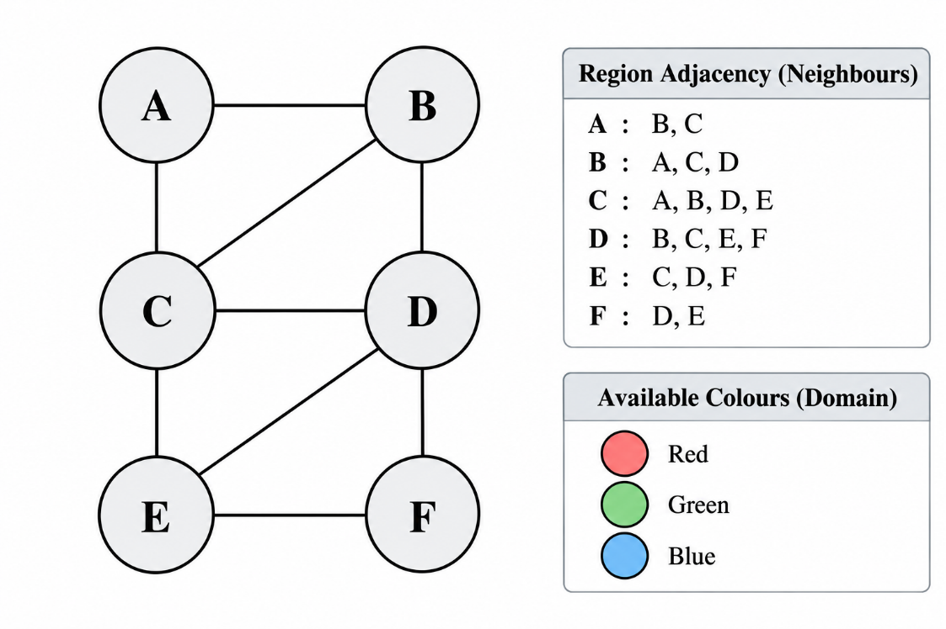
CODE:

OUTPUT:
Map Colouring Problem Using CSP
--------------------------------

Final Colour Assignment:
Region A: Red
Region B: Green
Region C: Blue
Region D: Red
Region E: Green
Region F: Blue

Adjacency Constraint Verification:
All constraints satisfied.

Total Assignment Attempts: 12
Valid solution found!

EXPERIMENT 7 - Implementing the Minimax Algorithm
AIM: To demonstrate decision-making in a two-player strategy game.
QUESTION:
A game-playing AI must select its best move in a two-player game where one player tries to maximize the score while the opponent tries to minimize it.
Develop a Python program to implement the Minimax algorithm for a game represented as a binary game tree. The program must:
- Represent the game tree with terminal utility values.
- Treat the AI as the maximizing player and the opponent as the minimizing player.
- Recursively evaluate the game tree using the Minimax algorithm.
- Display the evaluated values and the best move selected by the AI.
- Explain how the algorithm assumes that both players choose optimal moves.

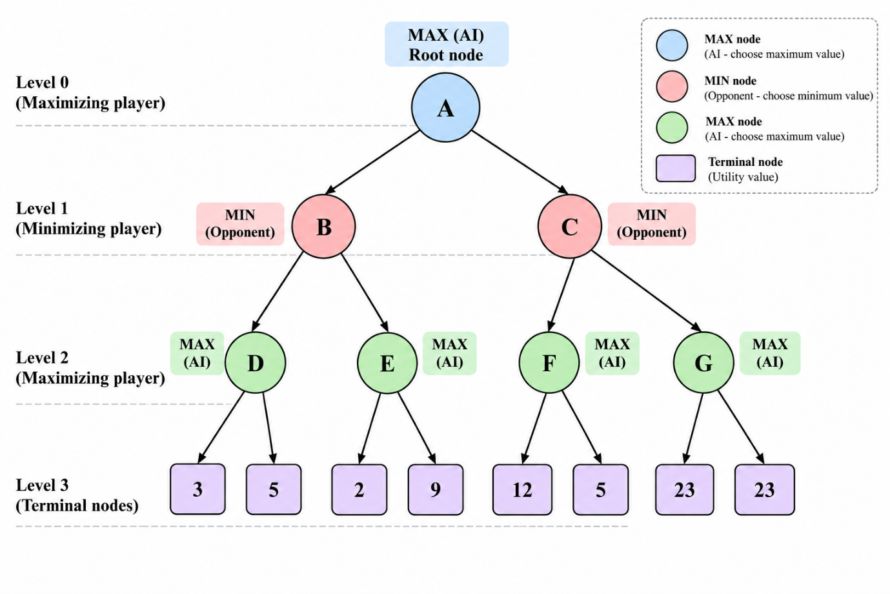
CODE:

OUTPUT:
Minimax Algorithm
-----------------

Evaluated Node Values:
Node D: 5
Node E: 9
Node F: 12
Node G: 23
Node B: 5
Node C: 12
Node A: 12

Best Move for AI: C
Optimal Utility Value: 12
Terminal Nodes Evaluated: 8

EXPERIMENT 8 - Implementing Alpha-Beta Pruning
AIM: To optimize decision-making in a two-player strategy game.
QUESTION:
A chess-playing AI evaluates possible moves by exploring a game tree. Since evaluating every possible move is computationally expensive, the AI uses Alpha-Beta Pruning to eliminate branches that cannot influence the final decision.
Develop a Python program to implement the Alpha-Beta Pruning algorithm for a chess-inspired game tree with multiple possible moves and terminal utility values.
The program must:
- Represent the game tree with multiple candidate moves and terminal utility values.
- Implement Alpha-Beta Pruning using alpha and beta bounds.
- Identify and skip branches that cannot affect the final decision.
- Display the selected move, its utility value, the number of nodes evaluated, and the number of branches pruned.
- Explain how Alpha-Beta Pruning reduces the search effort while preserving the optimal decision.

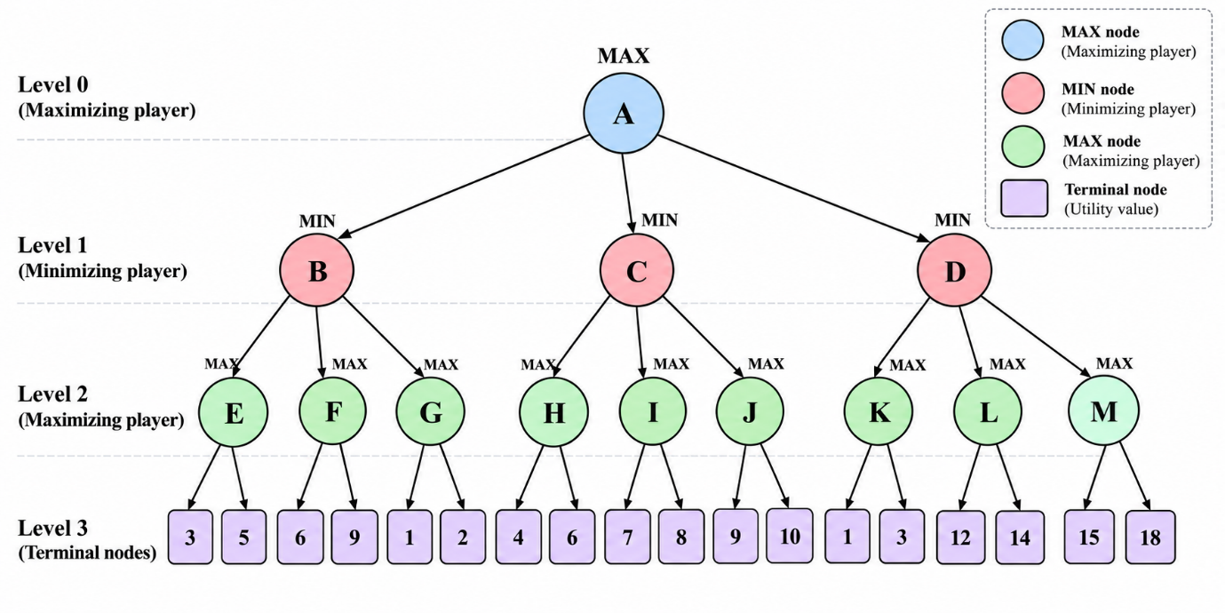
CODE:

OUTPUT:
ALPHA-BETA PRUNING RESULTS
--------------------------
Selected Move: C
Optimal Utility Value: 6
Terminal Nodes Evaluated: 11
Branches Pruned: 5

