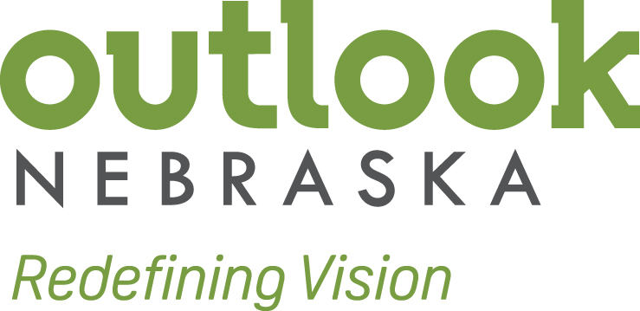September 8, 2017

We are writing on behalf of all the associates at Outlook Nebraska, plus the nearly 35,000 Nebraskans who are dealing with vision loss and their families, to express our strong opposition to Vocational Rehabilitation rules enacted by the Department of Education in August of 2016. We must insure that people who are blind continue to receive federal support for critical services and meaningful training and employment. I invite anyone to visit Outlook Nebraska in Omaha, NE to see first-hand how people who are blind are employed in competitive integrated employment under the Ability One Program.

Outlook Nebraska currently employs 87 associates. The 51 blind and visually impaired associates work among their sighted counterparts in all departments of our organization including manufacturing, human resources, IT, and marketing. They participate in all aspects of work life, utilize the same facilities, and receive the same benefits and advancement opportunities. Blind associates in marketing, HR, and IT routinely interact with partners and contractors in addition to their sighted co-workers to perform their daily responsibilities. Just like our sighted associates, our blind associates have access to benefits such as healthcare coverage and a retirement plan. The jobs our associates have under the AbilityOne program allow them to purchase homes, provide for their families, and, in many cases, eliminate the need for social security benefits.

Our jobs are often not deemed a "closure" by Vocational Rehabilitation agencies, even though they enable our associates to enjoy the rewards of a successful career. The blanket statements in the WIOA VR rule pre-judge the AbilityOne program and make it harder for organizations like Outlook Nebraska to receive referrals from VR agencies. Right now, we still have a strong relationship with the Nebraska Commission for the Blind and Visually Impaired, but referrals from the Iowa Department for the Blind have decreased.

**Harmful Statements Regarding AbilityOne**

The following are examples of statements found in the VR rule that pre-judge our program:

* “When the criteria are properly applied by DSUs, group and enclave employment settings operated by businesses formed for employing individuals with disabilities will not satisfy the definition of “competitive integrated employment.”
* “Therefore, the Secretary maintains the long-standing Departmental policy that settings established by community rehabilitation programs specifically for the purpose of employing individuals with disabilities (e.g., sheltered workshops) **do not** constitute integrated settings because these settings are **not** typically found in the competitive labor market – the first of two criteria that must be satisfied if a DSU is to determine that a work setting is an integrated location under final 361.5 (c) (9)."
* “The factors that generally would result in a business being considered “not typically found in the community,” include: (1) the funding of positions through **Javits-Wagner-O’Day Act (JWOD) contracts**; (2) allowances under the FLSA for compensatory subminimum wages; and (3) compliance with a **mandated direct labor-hour ratio of persons with disabilities.”**

In the same rule, the DoED reminds agencies that they still must examine each job and make a determination on a case-by-case basis.

* “We emphasize that it is the DSU’s responsibility to apply final 361.5 (c) (9) (ii) in a manner consistent with long-standing Departmental policy. The DSU must apply the criteria equally to any position, whether it involves the management or administration of, or the production and delivery of goods and services by, the organization, and without regard to the type of business operation, such as, butlimited to, a call center within a community rehabilitation program, the manufacture of office supplies by a State industries program for individuals who are blind, or a contract for landscaping services. The criteria contained in final 361.5 (c) (9) (ii) and 361.5 (c) (32) (ii) provide important clarifications that are necessary to better enable a **DSU to determine, on a case-by-case basis, whether or a particular position in an organization’s specific work unit is in an integrated location.”**

These harmful statements put everyone in the same category. Assuming that all AbilityOne affiliated non-profit agencies operate like a sheltered workshop creates a misconception of our jobs and takes away an individual’s right to choose when it comes to their own employment.

**We respectfully ask Congress to direct the Department of Education to issue a new communication to state VR agencies and remind them of their obligation under existing regulations to investigate and make case-by-case integrated work setting determinations.**

The livelihoods of thousands of Americans who are blind have been placed at risk by an agency that engaged in regulatory overreach and went beyond the will of Congress in 2016, and it is imperative that we correct these wrongs.

Sincerely,

Eric Stueckrath, CEO

Outlook Nebraska