**Experiment Procedure Documentation**

**Introduction**

This document captures the instructions to perform the experiment.

**Instructions**

1. First run the header.html and click start the experiment. After this, select the molecule from the navigation tab.

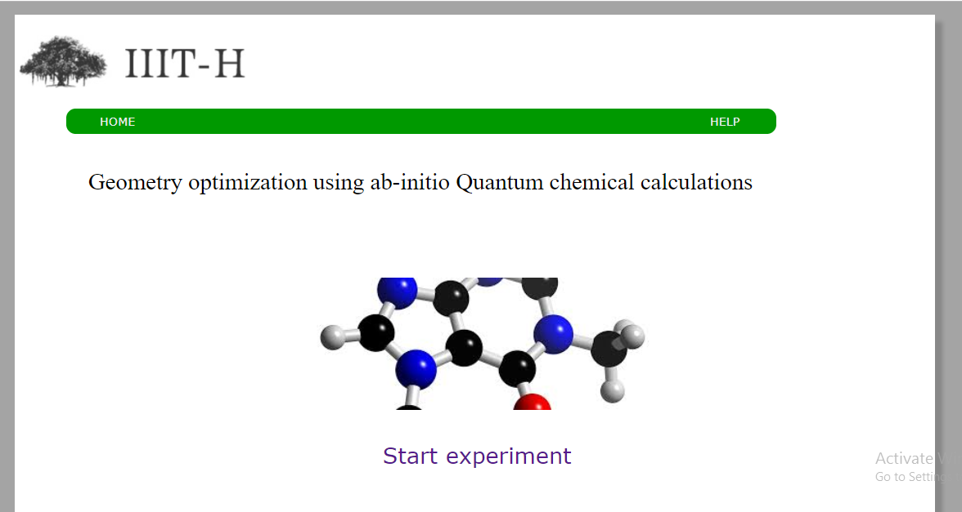

1. After that, start calculating z-matrix by selecting the appropriate atoms from the drop-down lists and click ‘render’ button. See the simulation for each step.
2. While doing this, change the control options to see the changes in the simulation.

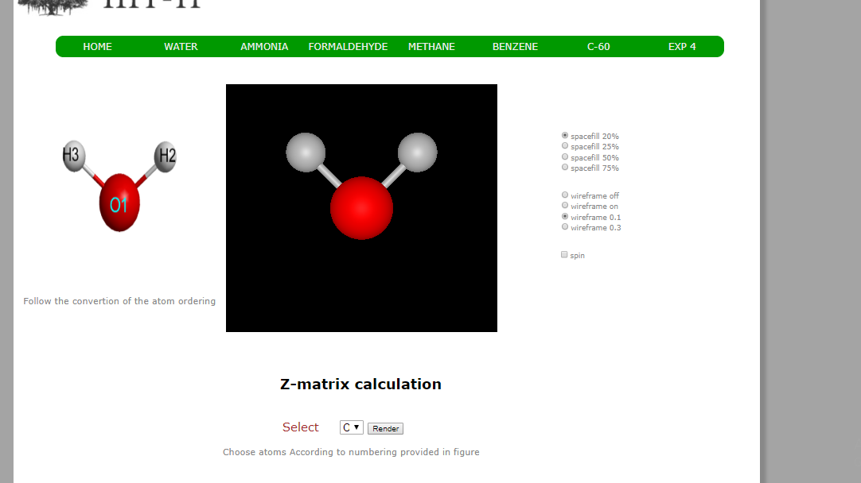

4.Click the “Go to next step” button to see method, procedure, basis set used for GAMESS calculation.

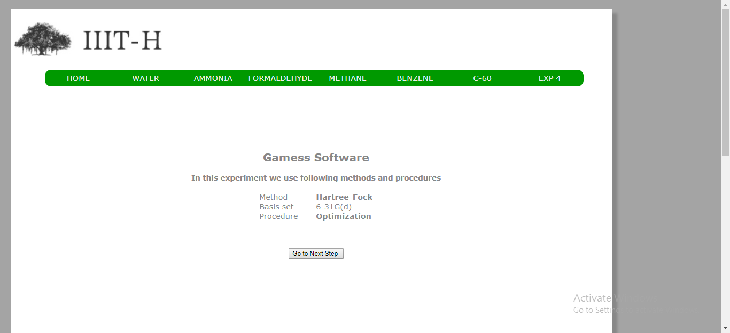

5.After this, Click “Go to next step” button. The page displays input file for GAMESS software. Click on “RUN GAMESS”.

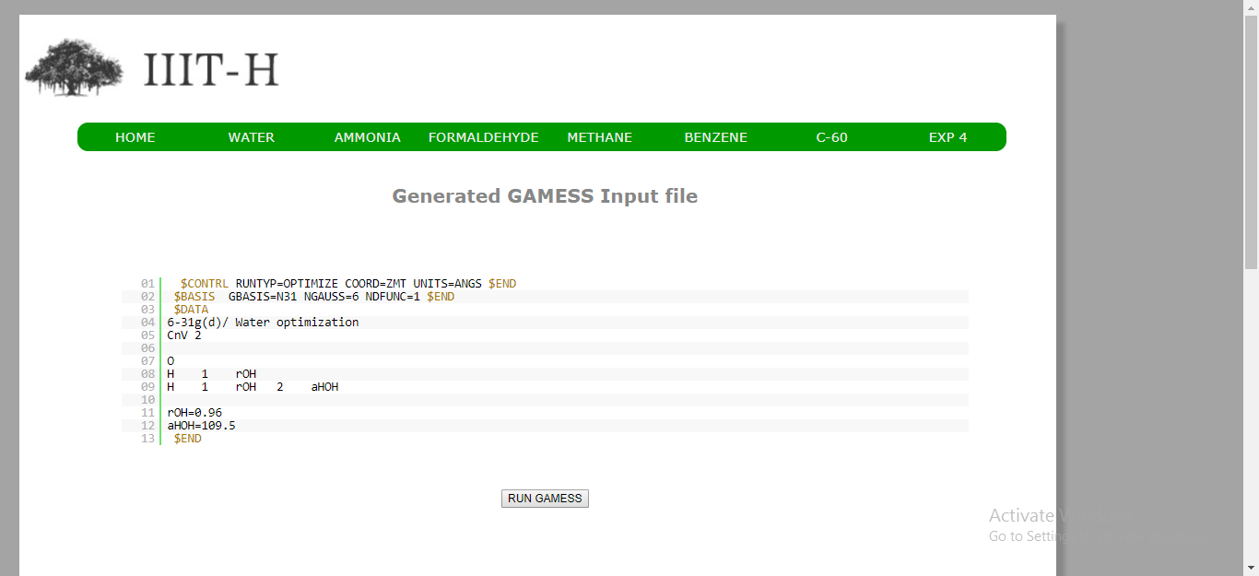

6. Next, the page displays output of the calculations. Click “next” button.

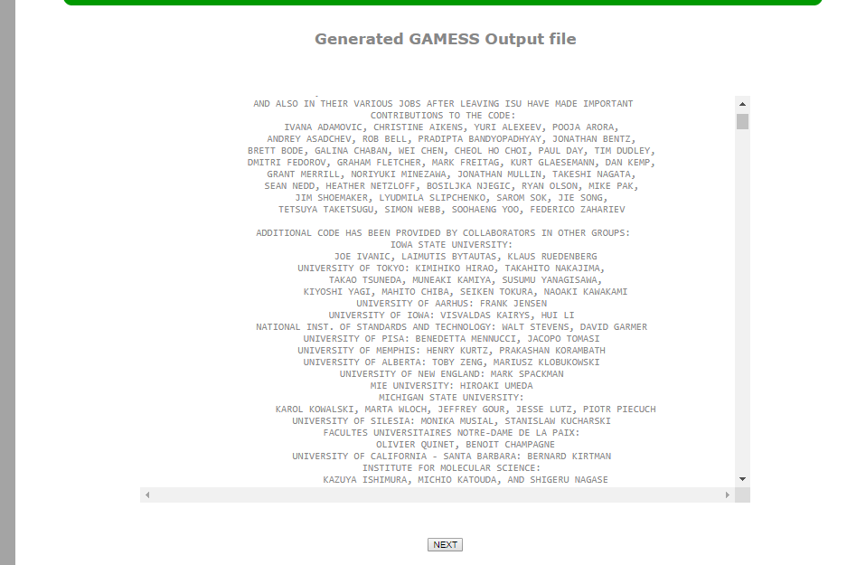

7. This final page displays the simulator along with the graph plotted as energy difference vs optimization step number.

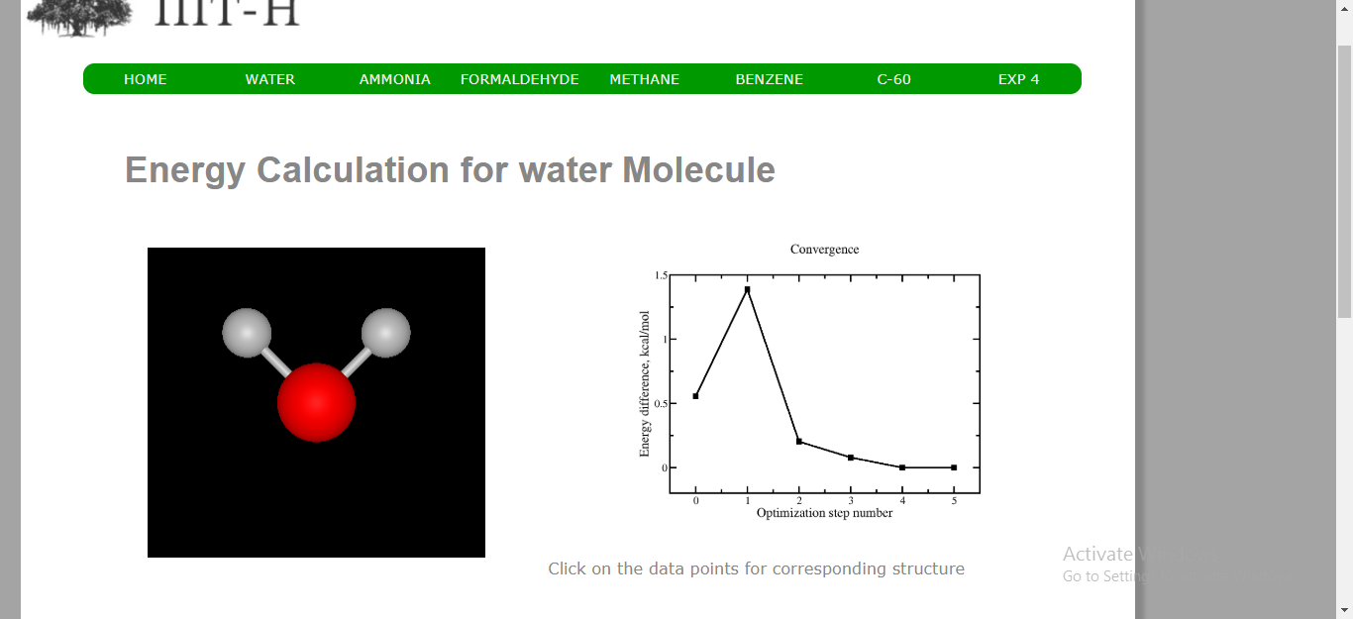

You can continue the experiment with another molecule by selecting that from the navigation bar.