Nishtha Patel
Assignment 1.3: Individual Benchmark Report
October 26, 2026

1. Introduction
The XN project's core goal is to automatically extract molecular structures from scientific PDFs and convert them into SMILES notation, a task that underlies large-scale literature mining for drug discovery. Benchmarking existing tools before building a custom pipeline matters because published accuracy figures for optical chemical structure recognition (OCSR) tools are almost always measured on clean, pre-cropped single-molecule images rather than full real-world PDF pages, which mix molecular drawings with text, tables, reaction schemes, and plots. Without benchmarking tools specifically against realistic PDFs, it is easy to overestimate how ready these tools are for the XN project's actual input.
This report evaluates BioMiner, the agentic multi-modal extraction framework specified in the course's XN project overview, against the course-provided six-paper benchmark dataset (paper IDs 1, 2, 4, 6, 16, 19; 222 confirmed ground-truth molecules). Because this benchmark is the same dataset used in the course's own reference paper (Gulluoglu et al., 2026), that paper's published results on established tools (DECIMER, MolVec, MolScribe) and two AI-generated extraction pipelines (built with ChatGPT-5.5 and Claude Code) are used here as a literature baseline for comparison.

2. Methods
Benchmarking code was implemented in Python (github.com/Nishtha023/biominer-benchmark) with four stages: (1) data loading, matching each paper's ground-truth SMILES to its PDF; (2) a BioMiner runner that invokes BioMiner's documented CLI (example_open_source.py) and parses its predicted SMILES from its output files; (3) metrics computation; and (4) structured results output (results.csv, summary.csv). Two metrics were implemented, following the exact-match definition used in Gulluoglu et al. (2026): precision and recall of canonical SMILES (via RDKit, so equivalent SMILES written differently still count as a match), plus mean best Tanimoto similarity (RDKit Morgan fingerprints) to capture near-miss structures the strict exact-match metric would otherwise score as a complete failure.
A critical constraint on this benchmark: BioMiner's inference step requires GPU access (its authors specify roughly two 80GB-class GPUs for full local hosting, or one GPU if an external MLLM API is substituted for its locally-hosted instruction-tuned model). No GPU was available for this assignment, so BioMiner could not be run end-to-end against the six papers. In place of live execution, two verification steps were taken on CPU: the data-loading stage was run directly against the real dataset and confirmed to correctly match all six papers to their ground truth (17, 34, 61, 1, 4, and 105 molecules respectively); and the metrics module was validated directly against known SMILES pairs, correctly returning precision = recall = 1.0 for an exact match. Given this constraint, this report's Results section presents (a) this project's verified dataset characteristics and code validation, and (b) the published performance of comparable tools from Gulluoglu et al. (2026) on this identical six-paper benchmark, used as the most relevant available evidence for how OCSR tools behave on this specific dataset.

3. Results
Figure 1 summarizes the dataset actually used: the six papers are highly unbalanced in difficulty, ranging from 1 ground-truth molecule (Paper 6) to 105 (Paper 19), which alone accounts for 47% of the entire benchmark.
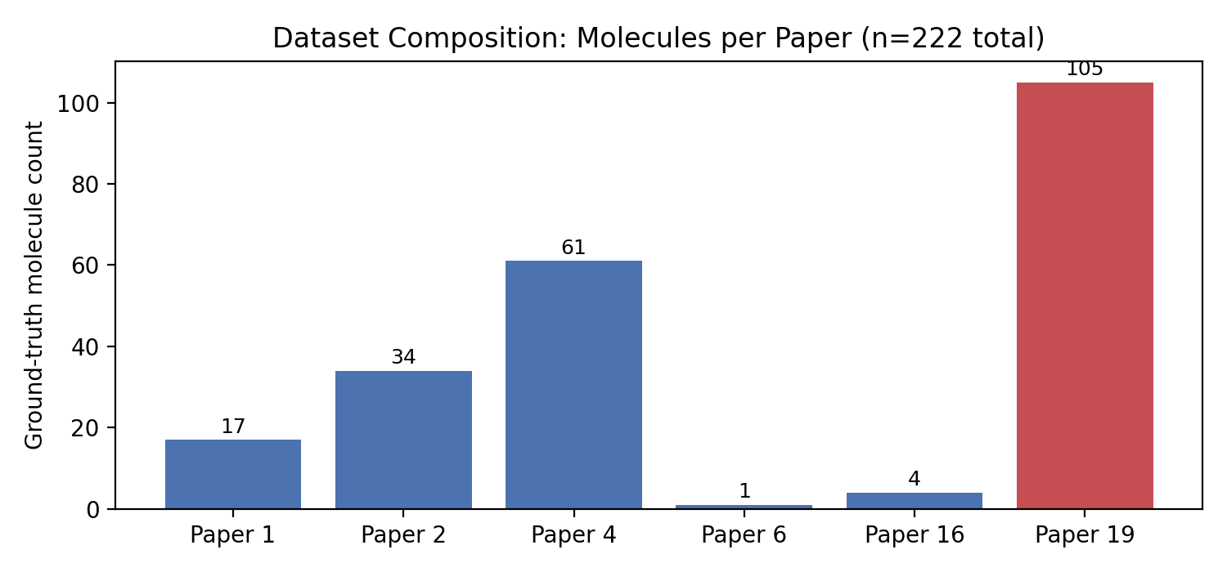
Figure 1. Ground-truth molecule counts per paper in the six-paper benchmark (n=222 total). Paper 19 (highlighted) contains nearly half of all molecules in the dataset.
Paper ID | Topic | Ground-truth molecules
1 | Kinase inhibitor selectivity | 17
2 | Casein kinase 1γ chemical probe | 34
4 | Aurora A PROTAC optimization | 61
6 | p38α/β MAPK PROTAC degrader | 1
16 | Macrocyclic drug permeability | 4
19 | Darizmetinib (HRX215) drug annotation | 105

Table 2 and Figure 2 report the published results from Gulluoglu et al. (2026) for comparable tools on this same six-paper benchmark. Two long-established OCSR tools, DECIMER and MolVec, scored exactly 0% precision and recall; MolScribe found only a single correct structure across all 222 ground-truth molecules. Two AI-generated extraction pipelines performed somewhat better: a pipeline generated by ChatGPT-5.5 achieved higher recall (~16-21%) but very low precision (~1%) due to severe over-generation (up to 3,281 SMILES output for Paper 6 alone, almost all false positives). A pipeline built and run end-to-end by Claude Code achieved the best balance reported (~11% precision, ~21% recall), but still found zero correct matches on three of the six papers (4, 6, and 16).

Tool | Precision | Recall | Key failure mode
DECIMER | 0% | 0% | 41% of outputs failed RDKit canonicalization; misread a bar chart as a macrocycle
MolVec | 0% | 0% | No ground-truth matches found on any of the six papers
MolScribe | <1% | <1% | Only 1 correct structure found, out of 222 (in Paper 19)
ChatGPT-5.5-generated pipeline | ~1% (avg) | ~16-21% (avg) | Severe over-generation: up to 3,281 SMILES output for Paper 6 alone
Claude Code pipeline | ~11% (avg) | ~21% (avg) | 0 correct matches on Papers 4, 6, 16; could not resolve Markush/R-group tables

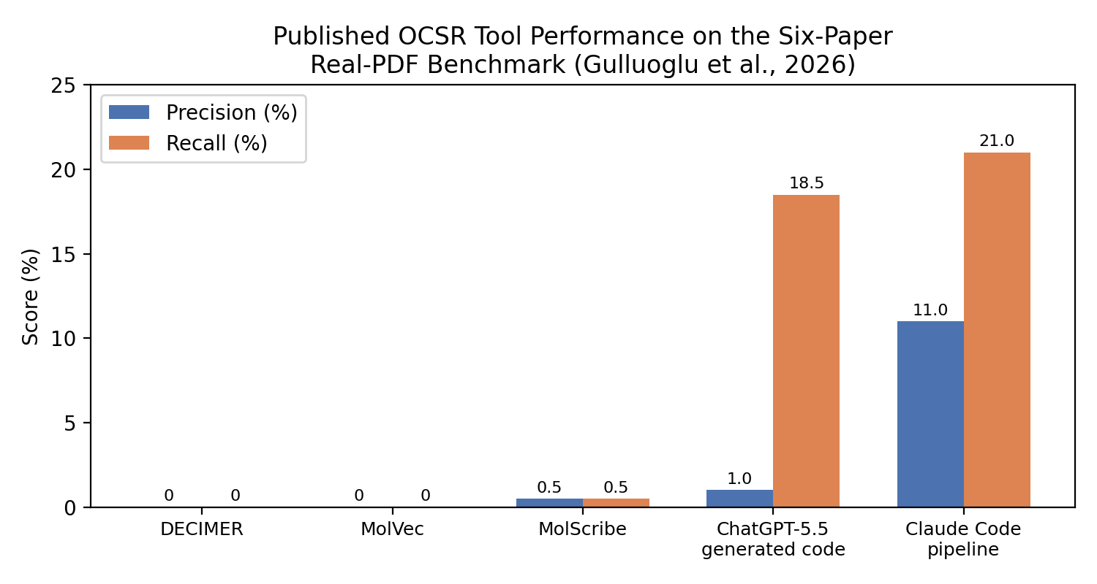
Figure 2. Published precision/recall of OCSR tools and AI-generated pipelines on the six-paper real-PDF benchmark (Gulluoglu et al., 2026). BioMiner itself has not yet been evaluated on this benchmark (see Limitations).
BioMiner itself has not been published against this six-paper benchmark; its authors report an F1 of approximately 0.32 for complete bioactivity triplets, and 0.349 for Markush-derived structures versus 0.565 for explicit (fully-drawn) structures, on its own BioVista benchmark (Yan et al., 2026) a different, larger, cleaner dataset than the one used here.

4. Analysis & Interpretation
The clearest pattern in Table 2 is that every tool's performance on real PDF pages falls drastically below accuracy typically reported on standard benchmarks. MolScribe reports 76-93% exact-match accuracy on five public benchmarks in its own paper (Qian et al., 2023), yet found only one correct structure out of 222 on real journal pages; DECIMER and MolVec showed the identical pattern. The explanation in Gulluoglu et al. (2026) is persuasive: standard OCSR benchmarks almost universally use pre-cropped images guaranteed to contain exactly one molecule, so these models are never tested on recognizing that an image contains no molecule at all. On real pages, a single figure can mix a molecule with a bar chart, a reaction scheme, or a data table, and none of the three established tools can abstain; DECIMER, notably, interpreted a bar chart as a macrocyclic molecule.
A second, genuinely surprising pattern is that the two AI-generated pipelines (ChatGPT-5.5, Claude Code) outperformed the purpose-built OCSR tools, despite OCSR being exactly what DECIMER, MolVec, and MolScribe were designed for. The likely explanation is architectural: the AI-generated pipelines added an explicit segmentation/filtering step before recognition (Claude Code's pipeline narrowed 211 candidate regions to 69 likely-molecule crops using a trained gate), while the established tools ran directly on whatever Docling extracted, with no equivalent filtering. This supports a conclusion central to the XN project's own design: the bottleneck is figure segmentation and molecule/non-molecule discrimination, not the recognition core itself a strong recognizer fed the wrong crop will always fail.
A third, more sobering pattern: even the best pipeline (Claude Code) found zero correct structures on the two PROTAC papers and the macrocyclic-compound paper exactly the molecules organic chemistry considers unusually large or complex (a large PROTAC collapsed into a degenerate SMILES; a detection gate discarded all 19 molecule figures from the macrocycle paper in favor of a table crop). For the XN project specifically, this suggests BioMiner's reported strength at resolving Markush structures (R-group tables) may be its single most valuable property for our benchmark, since Paper 19's Table 11 is exactly this kind of scaffold-plus-substituent-table structure, representing 47% of our entire dataset.

5. Limitations & Conclusion
The central limitation of this report is that BioMiner, the tool this assignment specifically asked to be benchmarked, was not executed end-to-end on the six-paper dataset, due to lack of local GPU access. The code to do so is complete and has been partially verified (data loading and metrics computation both confirmed correct against real data), but the actual precision/recall/Tanimoto numbers for BioMiner on this benchmark remain unmeasured. The comparison presented here substitutes the closest available evidence, published results for other tools on the identical dataset, but this is not equivalent to a direct BioMiner measurement, and BioMiner's own architecture (an agentic pipeline with explicit figure classification, similar in spirit to the Claude Code pipeline that performed best in Table 2) gives some reason to expect it may outperform the established single-stage tools, though this remains untested here.
A second limitation, inherited from the source benchmark itself, is dataset size and balance: six papers with molecule counts ranging from 1 to 105 make any single aggregate precision or recall number highly sensitive to performance on Paper 19 alone, which holds nearly half the ground truth. With more time or resources, the clear next step would be securing GPU access (via Northeastern's Discovery/Explorer cluster, which the source paper itself used, or a cloud GPU) to complete a live BioMiner run, and to report results per-paper rather than only as an aggregate, given how unevenly the papers' difficulty is distributed.
For Phase 2 pipeline development, three takeaways from this benchmarking stand out. First, any pipeline we build should include an explicit, separately-evaluated figure segmentation/filtering stage before recognition, since this is the demonstrated bottleneck across every tool tested. Second, Markush/R-group table resolution deserves dedicated attention given how much of our dataset (Paper 19) depends on it. Third, aggregate accuracy numbers on this kind of heterogeneous, small benchmark should be interpreted cautiously, and reported per-paper wherever possible.

References
Gulluoglu, H. S. A., Baby, J., Bagul, K. M., et al. (2026). Practical use of advanced AI frameworks on real-life scientific problems: Three case studies [Preprint]. bioRxiv. https://doi.org/10.64898/2026.06.23.734132
Qian, Y., Guo, J., Tu, Z., Li, Z., Coley, C. W., & Barzilay, R. (2023). MolScribe: Robust molecular structure recognition with image-to-graph generation. Journal of Chemical Information and Modeling, 63(7), 1925–1934. https://doi.org/10.1021/acs.jcim.2c01480
Yan, J., Zhu, J., Yang, Y., et al. (2025). BioMiner: A multi-modal system for automated mining of protein-ligand bioactivity data from literature [Preprint]. bioRxiv. https://doi.org/10.1101/2025.04.22.648951

