**Accenture**

1.About Company

2.Detailed Syllabus

3.YouTube Playlists

1. **About Company**

**Accenture plc** is an Irish-American [professional services](https://en.wikipedia.org/wiki/Professional_services) company [based in Dublin](https://en.wikipedia.org/wiki/Corporation_tax_in_the_Republic_of_Ireland), specializing in [information technology](https://en.wikipedia.org/wiki/Information_technology) (IT) services and [consulting](https://en.wikipedia.org/wiki/Management_consulting). A [*Fortune* Global 500](https://en.wikipedia.org/wiki/Fortune_Global_500) company, it reported revenues of $64.1 billion in 2023. Accenture's current clients include 91 of the *Fortune* Global 100 and more than three-quarters of the *Fortune* Global 500. As of 2022, Accenture is considered the largest consulting firm in the world by number of employees.

**REVELATION**

[Julie Sweet](https://en.wikipedia.org/wiki/Julie_Sweet) has served as CEO of Accenture since 1 September 2019.

**2.Detaileds Syllabus**

**Accenture Selection Process 2023-2024**

1. Cognitive and Technical Assessment
2. Coding Round
3. Communication Assessment
4. Interview Round

**Accenture Exam Pattern 2023-2024**

1. English Ability (17 Que)
2. Critical Reasoning & Problem Solving (18 Que)
3. Abstract Reasoning (15 Que)
4. Common Applications & MS Office (12 Que)
5. Pseudocode (18 Que)
6. Networking Security& Cloud (10 Que)

**Accenture Abstract Reasoning Syllabus**

* Number & Letter series
* Odd man out
* Analogies
* Coding-Decoding
* Visual reasoning

**Accenture Critical Reasoning & Problem Solving Syllabus**

* Data arrangement
* Flow charts
* Data sufficiency
* Argument & Assumption
* Syllogism
* Statement-Conclusion

**Accenture  English Ability Syllabus**

* Synonyms & Antonyms
* Error detection
* Para jumbles
* Reading comprehension
* Sentence completion/ Fill in the blanks
* Sentence improvement

**Accenture Common Applications & MS Office Syllabus**

* MS Office (Word, PowerPoint, Excel, Outlook)
* Browsers' fundamentals
* Shortcut keys
* Command prompt
* Working flow of keys

**Accenture Network Security Syllabus**

* Basics of Networking
* Network Security
* Encryption standards & Algorithms
* Network security devices
* Attack types
* Firwalls

**Accenture Cloud Syllabus**

* Fundamentals of Cloud Computing
* Client server architecture
* Cloud data centers
* Cloud service providers
* Cloud Service Platforms

**Accenture Pseudocode Syllabus**

* Programming Fundamentals
* Looping
* Arrays
* Recursion
* Function
* Bitwise Operators
* Increment & Decrement Operators
* Conditional statements
* Basics of Data Structures

**Accenture Coding Syllabus**

* Basics of Programming
* Input & Output Concepts
* Flow Control
* Conditional Looping
* Arrays
* Functions
* Strings
* Data types & Operators

**3.Youtube Playlists**

A. Quantitative

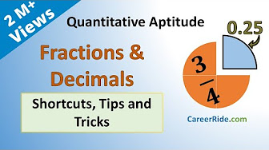

<https://youtube.com/playlist?list=PLpyc33gOcbVA4qXMoQ5vmhefTruk5t9lt&si=Ij26zlPJ_DewVcvk>

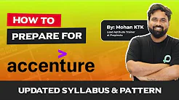

<https://youtube.com/playlist?list=PLKtofb3HgEywU2xZZFsBroiwuBhTWxUtb&si=GmXu1z9IDDy-KJaI>

B. Reasoning

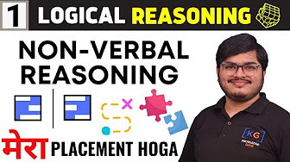

<https://youtube.com/playlist?list=PLMufDeLh5x2Dx9Ob6if7OEy8EzDxUXMTc&si=0e6VojeSO-S8jJgk>

C. English

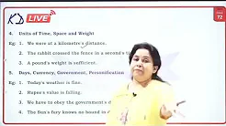

<https://youtube.com/playlist?list=PLPl36nwl5AljN7fkhGsr-7RnsA5lJq33S&si=MuvMzDb34zD8tA4N>