**WIPRO**

1.About Company

2.Detailed Syllabus

3.YouTube Playlists

1. **About Company**

**Wipro** (stylized in lower case as, **wipro**) is an [Indian multinational corporation](https://en.wikipedia.org/wiki/Multinational_corporation) that provides [information technology](https://en.wikipedia.org/wiki/Information_technology), [consultant](https://en.wikipedia.org/wiki/Consultant) and [business process](https://en.wikipedia.org/wiki/Business_process) services. It is one of the leading [Big Tech](https://en.wikipedia.org/wiki/Big_Tech_(India)) companies.[[5]](https://en.wikipedia.org/wiki/Wipro#cite_note-5) Wipro's capabilities range across [cloud computing](https://en.wikipedia.org/wiki/Cloud_computing), [computer security](https://en.wikipedia.org/wiki/Computer_security), [digital transformation](https://en.wikipedia.org/wiki/Digital_transformation), [artificial intelligence](https://en.wikipedia.org/wiki/Artificial_intelligence), [robotics](https://en.wikipedia.org/wiki/Robotics), [data analytics](https://en.wikipedia.org/wiki/Data_analytics), and other technology consulting services to customers in 167 countries.[[6]](https://en.wikipedia.org/wiki/Wipro#cite_note-6)

**REVELATION**

**2.Detailed Syllabus**

|  |  |  |  |
| --- | --- | --- | --- |
| **Rounds** | **Sections** | **Number of Questions** | **Time Limit** |
| Online Test | Quantitative Aptitude | 16 | 16 mins |
| Logical Reasoning | 14 | 14 mins |
| Verbal Ability | 18 | 18 mins |
| Written Communication Test | Essay Writing | 1 | 20 mins |
| Online Programming Test | Coding | 2 | 60 mins for PE role 45 mins for GET role |

Logical Reasoning

* Number Series
* Verbal Classification,
* Analogies
* Logical Games
* Logical Problems
* Missing Letters
* Matching Definitions
* Clock Puzzles
* Calendars
* Non-Verb reasoning Series
* The Embedded Figure
* Classification
* Water Images
* Mirror Images
* Completion of Incomplete Pattern
* Analytical Reasoning
* Verbal Reasoning
* Data Sufficiency
* Data Interpretation.

Aptitude

In addition to this, the Aptitude consists of questions on various topics such as

* Time and Work
* Time and Distance
* Problems on L.C.M and H.C.F
* Simple Interest
* Areas
* Problems on Trains
* Boats and Streams
* Partnership
* Ratio and Proportion
* Averages
* Pipes and Cistern
* Simple Equations
* Quadratic Equations
* Mixtures and Allegations
* Percentages
* Problems on Numbers
* Compound Interest
* Volumes
* Profit and Loss
* Odd Man Out
* Races and Games
* Numbers and Ages
* Simplification and Approximation
* Indices and Surds
* Mensuration
* Permutations and Combinations
* Probability

General English

* Articles
* Adjectives
* Gerunds
* Homophones
* Identify the Errors
* Identify the Sentences
* Plural Forms
* Nouns
* Odd Words
* Prefix
* Prepositions
* Sentence Pattern
* Suffix
* Tag Questions
* Tense
* Synonyms
* Antonyms
* Prepositions
* Sentence Completion
* Active and Passive Voice
* Spelling Test
* Spotting Errors
* Passage Completion
* Substitution
* Sentence Arrangement
* Transformation
* Idioms and Phrases
* Sentence Improvement
* Para Completion
* Joining Sentences
* Error Correction (Underlined Part)
* Error Correction (Phrase in Bold)
* Fill in the blanks

Technical/ Coding

Likely, the Technical Session consists of questions on the topics of core subjects like

* C++
* C
* Linux
* DBMS
* PHP
* Java
* Operating System
* Computer Networks
* .Net
* Cloud Computing
* Data Structure
* HTML
* Javascript
* Database
* Networks etc.

**3.Youtube Playlists**

A. Quantitative

[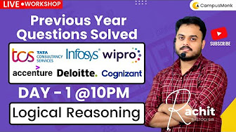](https://youtube.com/playlist?list=PL3JmT-xgOMNy5r3QBTRzv32LFUTXBmKf2&si=X4dOO30DA9wqdzkR)

<https://youtube.com/playlist?list=PL3JmT-xgOMNy5r3QBTRzv32LFUTXBmKf2&si=X4dOO30DA9wqdzkR>

B. Reasoning

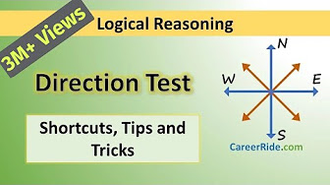

<https://youtube.com/playlist?list=PLpyc33gOcbVADMKqylI__O_O_RMeHTyNK&si=hYGHMMv62Q2dsgRi>

C. English

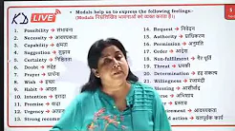

<https://youtube.com/playlist?list=PLPl36nwl5AljN7fkhGsr-7RnsA5lJq33S&si=MuvMzDb34zD8tA4N>