**Name: Nishtha Agarwal**

**BITS ID: 2022MT93178**

**Problem Statement: In this assignment, you will create a Flutter app that connects to Back4App, a Backend-as-a-Service (BaaS) platform, to manage tasks. You will be responsible for setting up the Back4App backend, creating the Flutter app, and implementing the necessary functionality to interact with the backend.**

Solution:

1. Ensure that Flutter is installed without any error

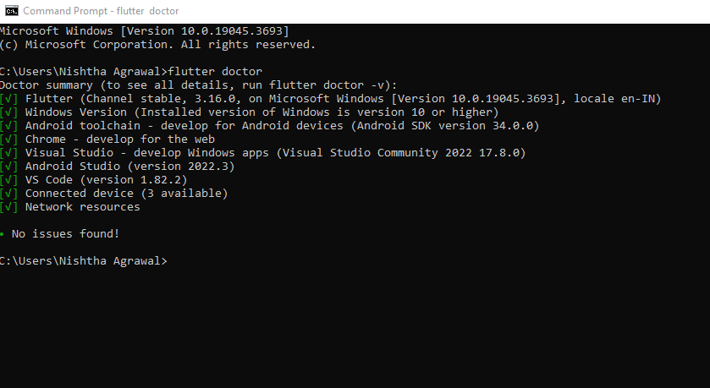

1. Ensure that Parse-server-sdk version is same in your flutter application(pubsec.yaml) file and back4app as shown below.

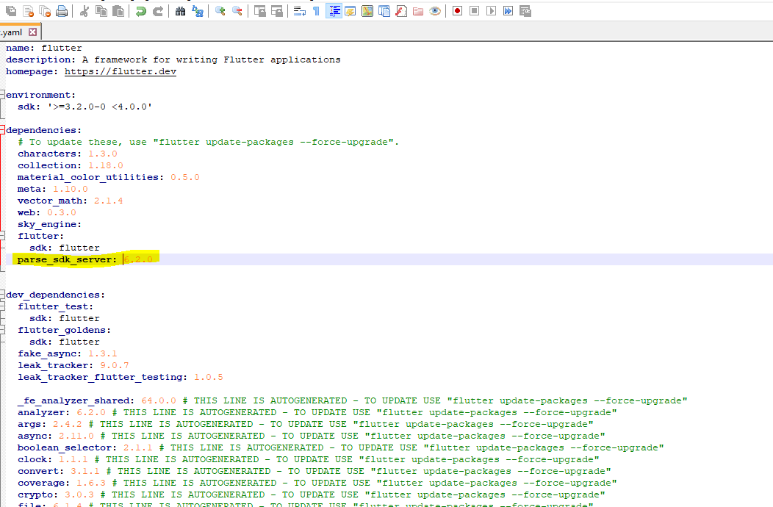

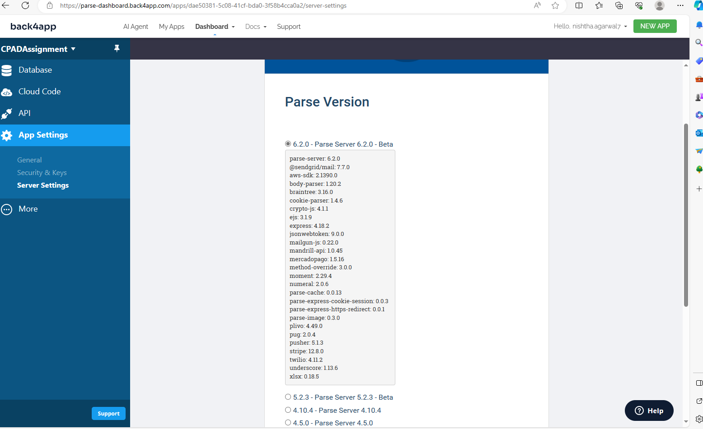

1. Update keyApplicationID, final keyClientKey and final keyParseServerUrl in main.dart file. This is done so as to connect between Flutter application and Back4app.

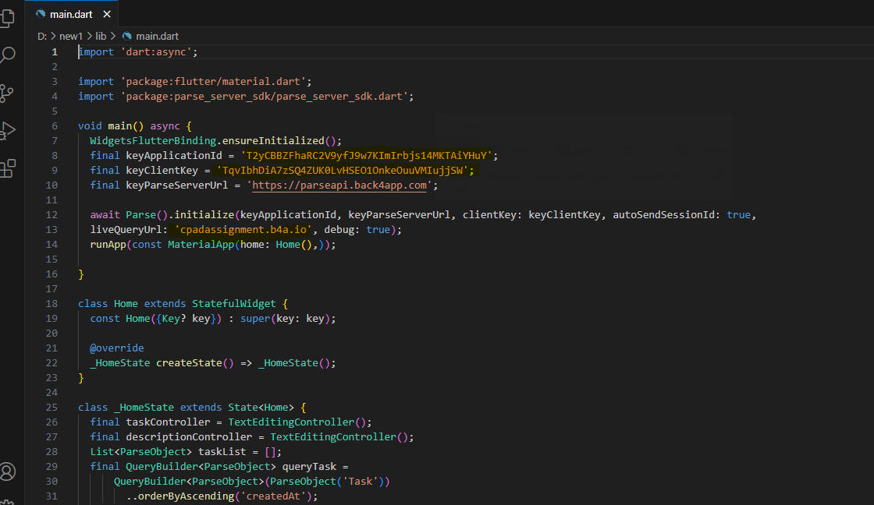

These details can be fetched from Back4app (AppSettings>>Security & Keys and App Settings>>General)

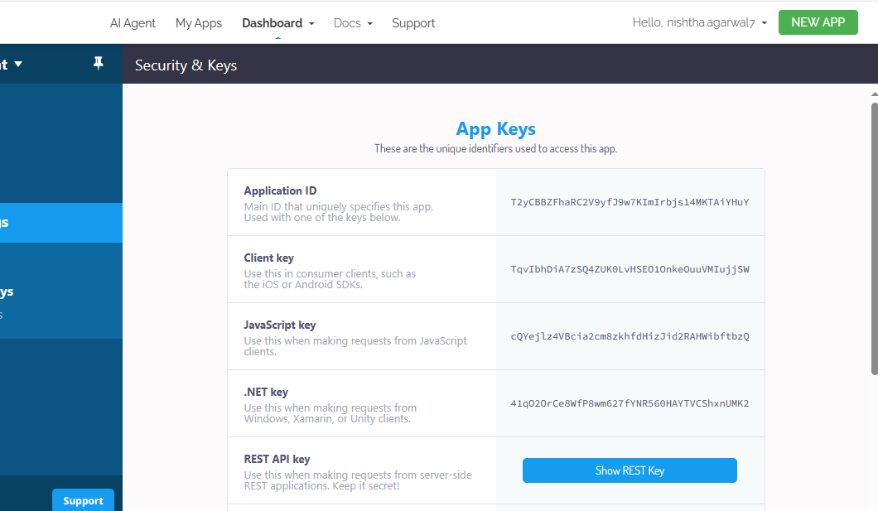

1. Update the Parse API as shown below is same for all the Back4app.

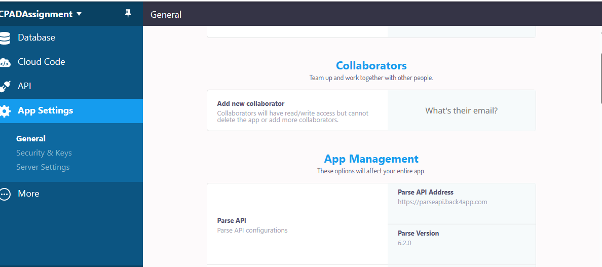

1. As we are creating Interactive/Live Application therefore, we need to make sure that Back4app subdomain is activated with Live Query. This can be done from Server URL and Live Query(AppSettings>>Server Settings>>Server URL and Live Query). The Live liveQueryURL is updated in main.dart file. This is unique for a dashboard.

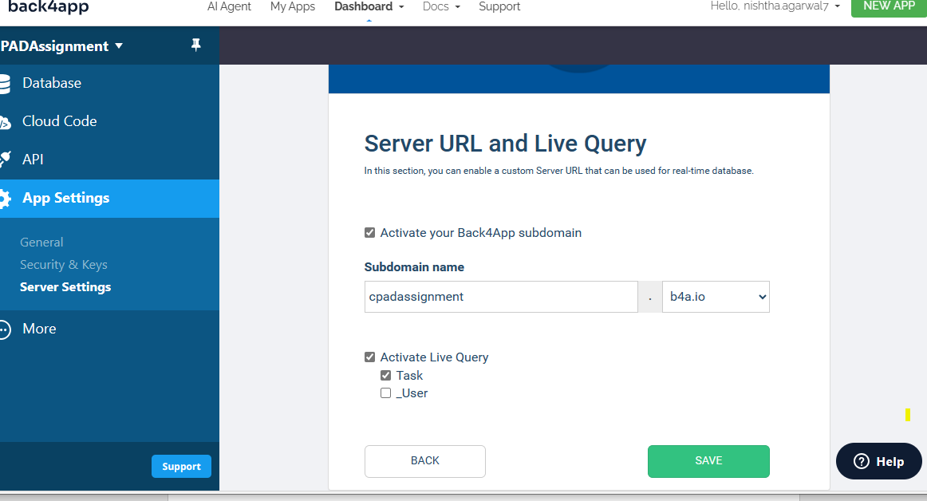

We need to startLiveQuery with CREATE, UPDATE and DELETE. This is to ensure that we can make changes while application is running.

1. Execute the code by running “flutter run” command.

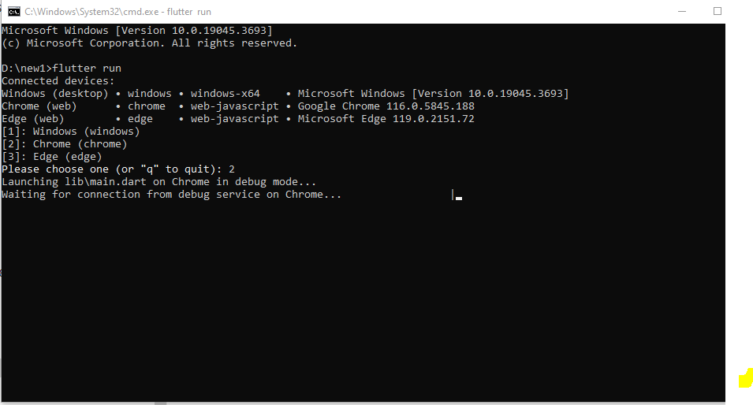

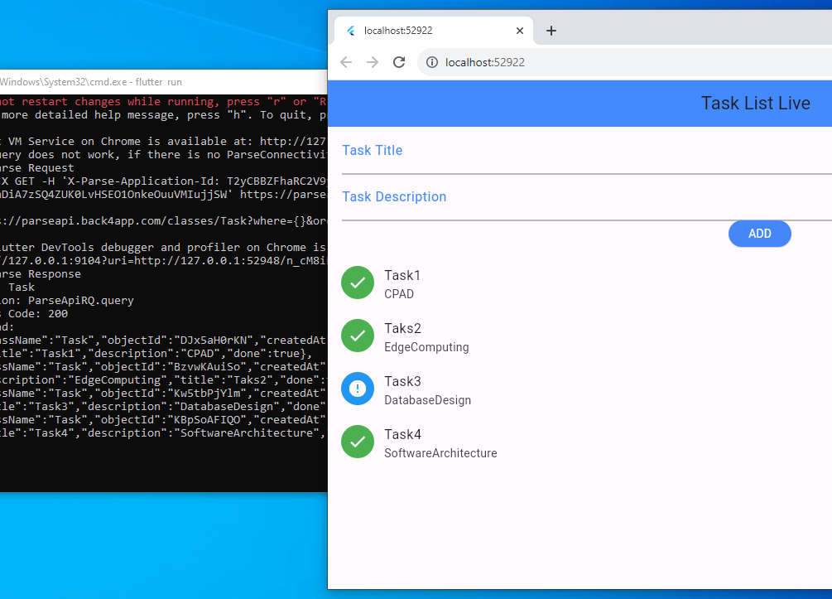

1. Adding a task in Back4App will update in Flutter Application

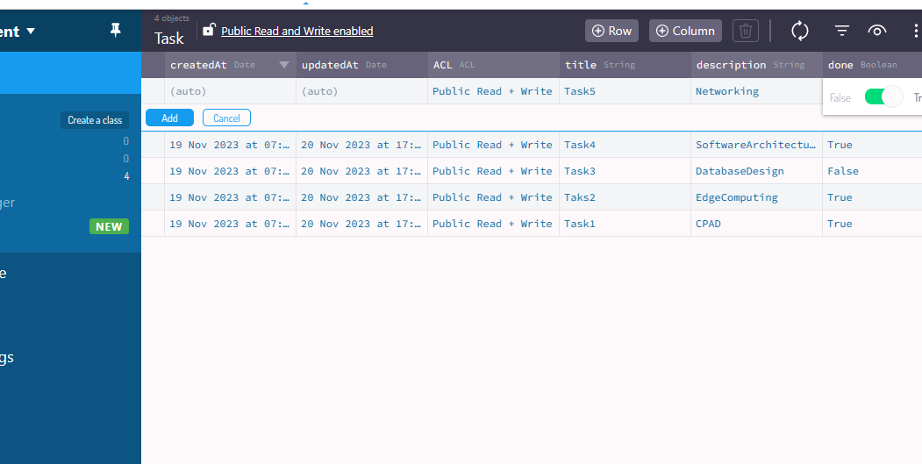

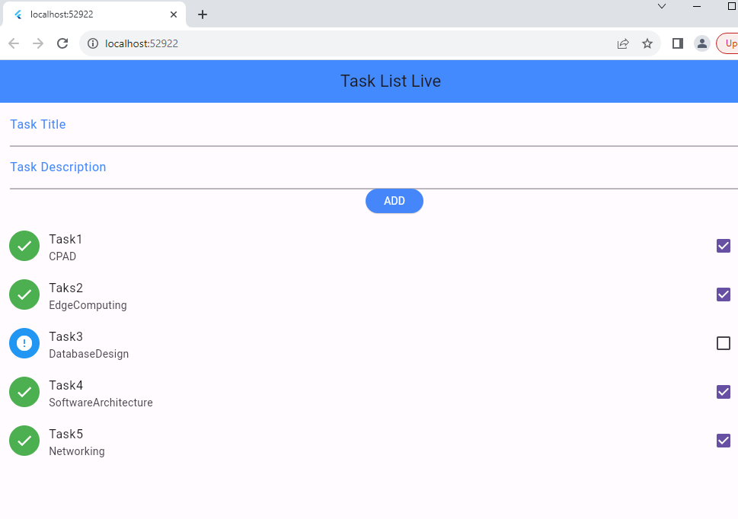

1. Updating a task in flutter application will be updated in Back4app. As I set value of field Done to false for Edge Computing on my Flutter Application it is set to done in Back4App as shown below.

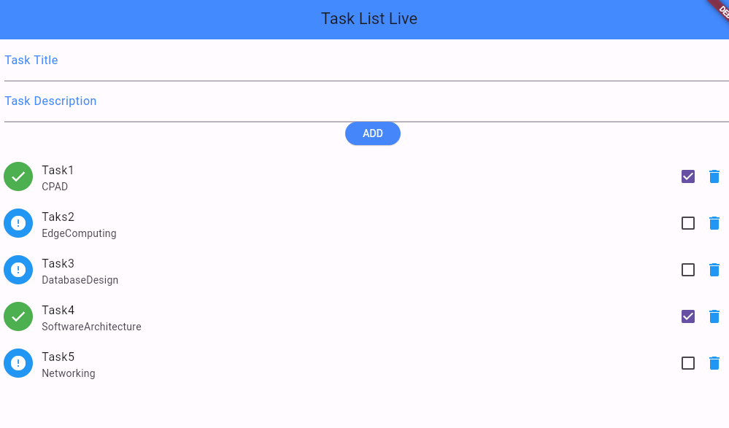

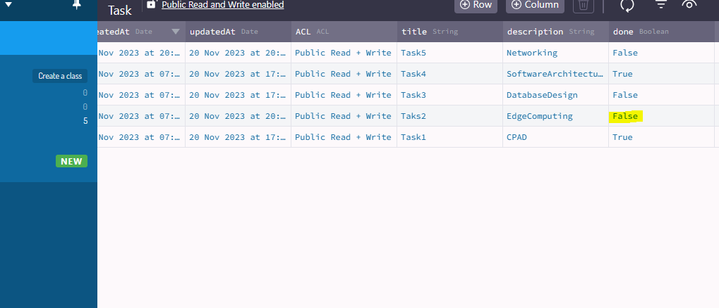

1. Deleting a task in flutter Application will delete a task in Back4App.

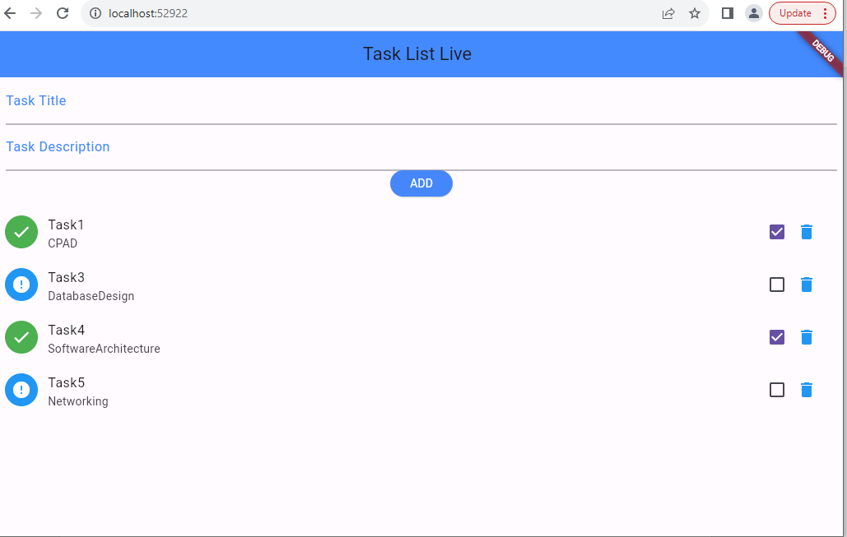

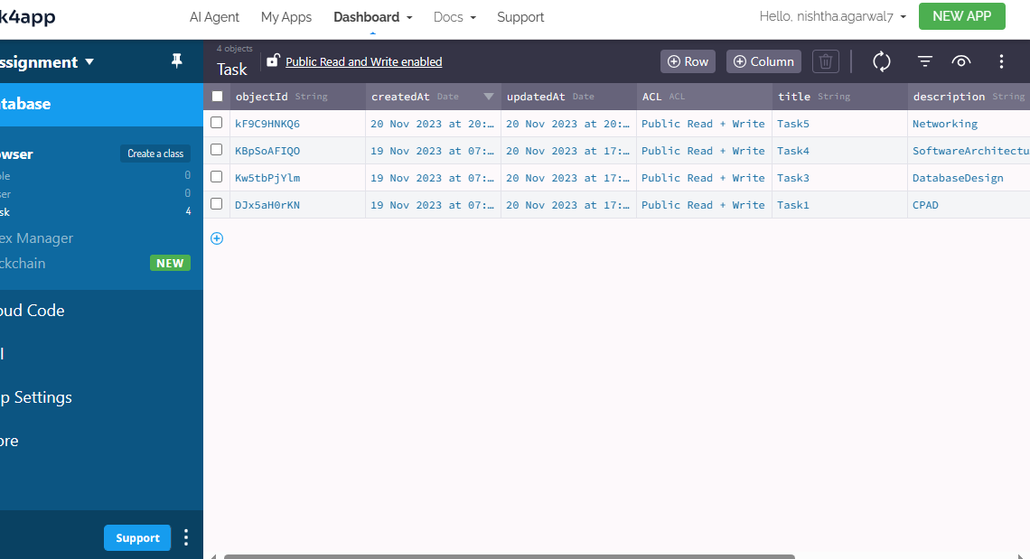

1. The query execution can be seen as shown below in the logs:

