Database Management System
PROJECT REPORT

On

Game Management System

Submitted by
Group No.

Disha Paliwal (240451)
Muskan Yadav (240436)
Gyanesh Nayak (240462)
Falak Rathee (240890)

CSE 2 ( Batch 2024–2028)

Submitted to

Dr. Nishtha Phutela
(Assistant Professor, School of Engineering and Technology)

April 2026

Certificate

This is to certify that the work presented in this Project entitled "Game Management System" has been carried out by the students mentioned below under my supervision. The work is genuine, original, and suitable for submission to BML Munjal University for the award of Bachelor of Technology in the School of Engineering and Technology.

Disha Paliwal
Muskan Yadav
Gyanesh Nayak
Falak Rathee

______________________________
Supervisor
Dr. Nishtha Phutela
Assistant Professor, School of Engineering and Technology
BML Munjal University

TABLE OF CONTENTS
i. Certificate
ii. Acknowledgement
iii. Abstract
iv. Abbreviations
v. List of Tables

1. Introduction
1.1 Background
1.2 Problem Statement
1.3 Objectives

2. Methodology / System Design
2.1 System Architecture
2.2 ER Diagram
2.3 Database Schema
2.4 Normalization (Up to 3NF)
2.5 Implementation

3. Discussion
4. Concluding Remarks
5. Societal Relevance
6. Future Scope
7. Team Details and Contribution
8. References

Acknowledgement
We would like to express our sincere gratitude to our faculty guide, Dr. Nishtha Phutela, for providing valuable guidance and continuous support throughout the development of this project. Her feedback at every stage helped us remain focused and on the right track.
We are also thankful to BML Munjal University for providing us with the necessary infrastructure and resources to complete this work.
We extend our appreciation to our classmates and peers who offered constructive suggestions during the development and testing phases.
Finally, we thank our families for their constant encouragement and moral support.

Abstract
This project, a Game Management System, is a desktop application developed using C# with Windows Forms for the interface and MySQL as the database. It is inspired by real-world game distribution platforms and brings together three types of users—Players, Developers, and Admins—each with their own dashboard and functionality. Players can sign up, explore a list of approved games, purchase them using a virtual wallet, and even enjoy built-in mini-games like FakeGame 1, FakeGame 2, and Pong. They can also keep track of their gameplay history, view leaderboards, manage friends, and monitor their wallet transactions. Developers, on the other hand, can upload games for approval, analyze sales performance, and track user engagement. Admins handle approvals, manage submissions, and earn a small commission on each approved game, all while maintaining a transparent transaction record.
The system is backed by a well-structured relational database consisting of 12 tables designed in Third Normal Form (3NF), ensuring efficiency and data integrity. It incorporates key database concepts such as joins, aggregate functions, subqueries, views, stored procedures. Security is also a priority, with parameterized queries used throughout to prevent SQL injection. Overall, the project highlights how a carefully designed database combined with a user-friendly interface can create a reliable, interactive, and data-driven application that supports multiple roles and real-time operations.

Abbreviations

Table: List of Abbreviations
Short Form | Full Form
DBMS | Database Management System
SQL | Structured Query Language
DDL | Data Definition Language
DML | Data Manipulation Language
DQL | Data Query Language
TCL | Transaction Control Language
ACID | Atomicity, Consistency, Isolation, Durability
ER | Entity-Relationship
PK | Primary Key
FK | Foreign Key
1NF / 2NF / 3NF | First / Second / Third Normal Form
CRUD | Create, Read, Update, Delete

List of Tables:-
Table No. | Title
Table 1 | users
Table 2 | player
Table 3 | developer
Table 4 | admin
Table 5 | wallet
Table 6 | game
Table 7 | purchase
Table 8 | match_session
Table 9 | participation
Table 10 | player_game_stats
Table 11 | social
Table 12 | transaction

1. Introduction

1.1 Background
The gaming industry has quietly become one of the biggest entertainment businesses in the world, and a huge part of what makes platforms like Steam, Epic Games Store, and GOG work so smoothly is the database sitting behind them. Every time a player buys a game, checks a leaderboard, or sends a friend request, there is a relational database handling it, tracking users, games, transactions, match histories, and social connections all at once.
We built this project, the Game Management System, because we wanted to actually understand how that works at the database level, not just draw an ER diagram on paper, but connect a real application to a real MySQL database and watch things happen. Every button click in our UI runs actual SQL. The application has three types of users, Players, Developers, and Admins, each with their own dashboard and a completely different set of things they can do.

1.2 Problem Statement
As the gaming industry keeps growing, so does the complexity of managing everything behind the scenes. User accounts, game libraries, purchases, player stats, and admin workflows all need to stay in sync, and real platforms solve this with carefully designed backend systems. Understanding how those systems actually work, though, is not straightforward.
What we set out to do was design and build a centralised system that handles multiple user roles cleanly, keeps data consistent, and supports real operations like registration, authentication, game purchases, and role based access control, all tied together through a relational database. That is the core problem this project addresses.

1.3 Objectives
Going into this, we had five things we actually wanted to achieve, not just demonstrate on paper:
- Design a properly normalised relational database up to 3NF with 12 interconnected tables covering users, roles, games, purchases, matches, statistics, wallets, transactions, and friendships.
- Get every major DBMS concept working inside a real application, DDL, DML, DQL, TCL, all join types, Group By, Having, subqueries, views, stored procedures, transactions, and indexing.
- Build three separate dashboards for three separate roles, where each role actually does different things in the database and not just sees a different screen.
- Implement a virtual economy with wallets, deposits that go through a simulated bank delay, purchases, admin commissions, and a full transaction history that never gets erased.
- Build playable mini games that are not just cosmetic. After every session, match results get saved, player stats get updated, and leaderboard rankings get recalculated live in the database.

2. Methodology / System Design
2.1 System Architecture
The system is built on a straightforward two tier setup. On one side you have the client, a C# Windows Forms application that handles everything the user sees and interacts with. It connects to MySQL through the MySql.Data NuGet package. On the other side sits the database, a MySQL instance named trial_1 running locally with 12 tables underneath it. There is no middle layer, the application talks directly to the database, which kept things simple and let us focus on the SQL rather than the plumbing.

2.2 ER Diagram

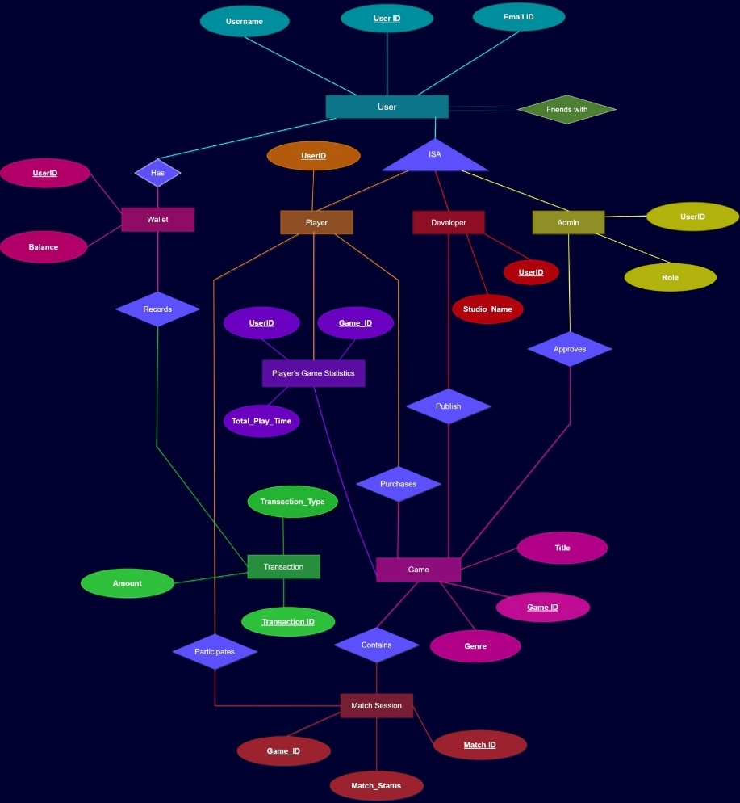

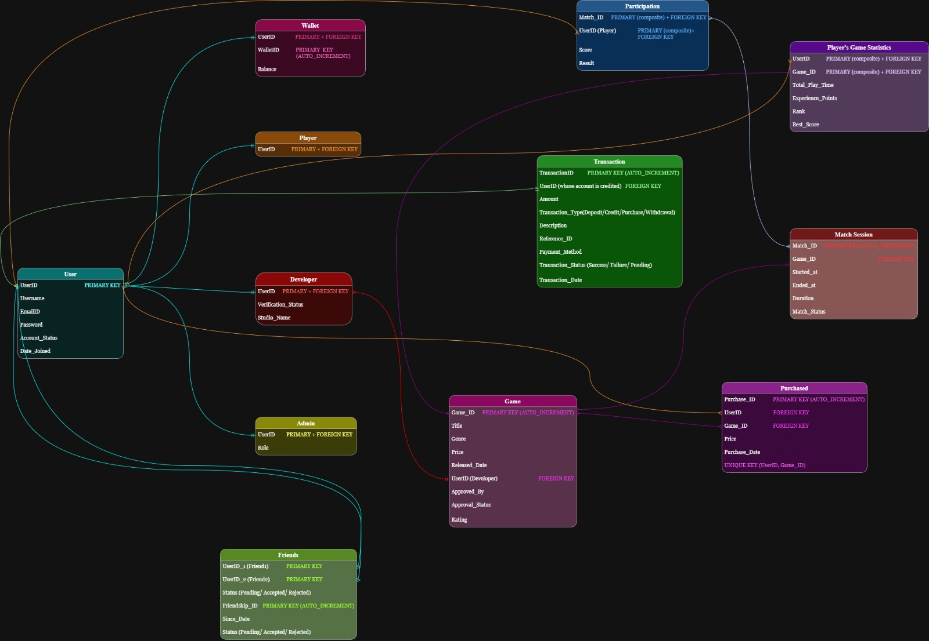

2.3 Database Schema
Below is the complete schema for all 12 tables in the trial_1 database.

Table 1: users
Column | Data Type | Constraints
user_id | VARCHAR(50) | PRIMARY KEY
username | VARCHAR(100) | NOT NULL, UNIQUE
email | VARCHAR(150) | NOT NULL, UNIQUE
password | VARCHAR(255) | NOT NULL
account_status | ENUM('active','suspended','banned') | DEFAULT 'active'
created_at | TIMESTAMP | DEFAULT CURRENT_TIMESTAMP

Table 2: player
Column | Data Type | Constraints
user_id | VARCHAR(50) | PRIMARY KEY, FK → users(user_id) ON DELETE CASCADE

Table 3: developer
Column | Data Type | Constraints
user_id | VARCHAR(50) | PRIMARY KEY, FK → users(user_id) ON DELETE CASCADE
studio_name | VARCHAR(100) | DEFAULT 'New Studio'
verification_status | ENUM('pending','verified','rejected') | DEFAULT 'pending'

Table 4: admin
Column | Data Type | Constraints
user_id | VARCHAR(50) | PRIMARY KEY, FK → users(user_id) ON DELETE CASCADE
role | VARCHAR(50) | DEFAULT 'admin'

Table 5: wallet
Column | Data Type | Constraints
wallet_id | INT | PRIMARY KEY, AUTO_INCREMENT
user_id | VARCHAR(50) | NOT NULL, UNIQUE, FK → users(user_id) ON DELETE CASCADE
balance | DECIMAL(12,2) | DEFAULT 0.00, CHECK (balance >= 0)

Table 6: game
Column | Data Type | Constraints
game_id | INT | PRIMARY KEY, AUTO_INCREMENT
title | VARCHAR(150) | NOT NULL
genre | VARCHAR(50) | NOT NULL
price | DECIMAL(10,2) | NOT NULL, CHECK (price >= 0)
release_date | DATE | —
developer_id | VARCHAR(50) | NOT NULL, FK → developer(user_id) ON DELETE CASCADE
approval_status | ENUM('pending','approved','rejected') | DEFAULT 'pending'
approved_by | VARCHAR(50) | DEFAULT NULL
rating | DECIMAL(3,2) | DEFAULT 0.00

Table 7: purchase (Bridge table — users ↔ game M:N)
Column | Data Type | Constraints
purchase_id | INT | PRIMARY KEY, AUTO_INCREMENT
user_id | VARCHAR(50) | NOT NULL, FK → users(user_id)
game_id | INT | NOT NULL, FK → game(game_id)
price | DECIMAL(10,2) | NOT NULL
purchase_date | DATETIME | DEFAULT CURRENT_TIMESTAMP
— | — | UNIQUE KEY (user_id, game_id) — Composite UNIQUE

Table 8: match_session
Column | Data Type | Constraints
match_id | INT | PRIMARY KEY, AUTO_INCREMENT
game_id | INT | NOT NULL, FK → game(game_id)
started_at | DATETIME | —
ended_at | DATETIME | —
duration | INT | DEFAULT 0
match_status | ENUM('in_progress','completed','cancelled') | DEFAULT 'completed'

Table 9: participation (Bridge table — match_session ↔ users M:N)
Column | Data Type | Constraints
match_id | INT | PK (Composite), FK → match_session(match_id)
user_id | VARCHAR(50) | PK (Composite), FK → users(user_id)
score | INT | DEFAULT 0
result | ENUM('win','loss','draw') | NOT NULL

Table 10: player_game_stats (Bridge table — player ↔ game M:N)
Column | Data Type | Constraints
user_id | VARCHAR(50) | PK (Composite), FK → users(user_id)
game_id | INT | PK (Composite), FK → game(game_id)
total_play_time | INT | DEFAULT 0
experience | INT | DEFAULT 0
rank_level | INT | DEFAULT 1
best_score | INT | DEFAULT 0

Table 11: friendship (Self-referencing M:N on users)
Column | Data Type | Constraints
friendship_id | INT | PRIMARY KEY, AUTO_INCREMENT
user_id_1 | VARCHAR(50) | NOT NULL, FK → users(user_id)
user_id_2 | VARCHAR(50) | NOT NULL, FK → users(user_id)
status | ENUM('pending','accepted','declined') | DEFAULT 'pending'
created_at | TIMESTAMP | DEFAULT CURRENT_TIMESTAMP

Table 12: transaction
Column | Data Type | Constraints
transaction_id | INT | PRIMARY KEY, AUTO_INCREMENT
user_id | VARCHAR(50) | NOT NULL, FK → users(user_id)
amount | DECIMAL(10,2) | NOT NULL
transaction_type | ENUM('deposit','purchase','credit','withdrawal') | NOT NULL
description | VARCHAR(200) | —
reference_id | VARCHAR(100) | —
payment_method | VARCHAR(50) | DEFAULT 'Wallet'
transaction_status | ENUM('pending','completed','failed') | DEFAULT 'pending'
created_at | DATETIME | DEFAULT CURRENT_TIMESTAMP

2.4 Normalization (Up to 3NF)
First Normal Form (1NF):-
The basic idea behind 1NF is that every cell in your table should hold exactly one value, nothing more. All our tables follow this. There are no columns stuffed with lists or multiple values crammed together. Take match results as an example. Instead of storing all of a player's match outcomes in one column, we give each match its own row in the participation table. One row, one match, one player. Every table also has a clearly defined primary key, so there is never any ambiguity about what uniquely identifies a record.

Second Normal Form (2NF):-
2NF only becomes relevant when you have a composite primary key, meaning a key made up of two or more columns. The rule is that every other column in that table must depend on the whole key, not just one part of it.
In our participation table, the primary key is the combination of match_id and user_id together. The score and result columns only make sense when you know both which match it was and which player played it. A score on its own, without knowing who played or in what match, means nothing. Same logic applies to player_game_stats, where the key is user_id and game_id together. Stats like best_score, experience, and rank_level are specific to a particular player playing a particular game. Neither column alone tells you enough.

Third Normal Form (3NF):-
3NF goes one step further and says that non-key columns should not depend on other non-key columns, only on the primary key itself. This is about cutting out what are called transitive dependencies.
A clean example from our schema is the game table. It stores a developer_id as a foreign key, but it does not store the developer's studio_name. That lives in the developer table where it belongs. If we had put studio_name in the game table, you would have a chain: game_id points to developer_id, and developer_id points to studio_name. That chain is exactly what 3NF tells you to break. Another simple example is the wallet table. It stores balance against a user_id, but it does not store the username. If you need the username alongside the balance, you join to the users table. The wallet table stays clean and focused on what it actually owns.
2.5 Implementation

Tools and Technologies
Table 16: Tools and Technologies Used
Component | Technology | Version | Purpose
Programming Language | C# | .NET 8.0 | Application logic and UI
UI Framework | Windows Forms | .NET 8.0 | Graphical user interface
Database | MySQL | 8.0 | Back-end data storage
DB Connector | MySql.Data (NuGet) | 9.6.0 | C# ↔ MySQL communication
IDE | Visual Studio | 2022+ | Development environment
DB Tool | MySQL Workbench | 8.0 | Schema design and query testing
OS | Windows | 10/11 | Deployment platform

Database Connection
The application connects to the database using a centralised connection string stored in a static class DB.cs. All forms in the application reference DB.connStr to establish connections, ensuring a single point of configuration.

class DB
{
public static string connStr =
"server=localhost;database=trial_1;uid=root;pwd=****;";
}

DDL — CREATE TABLE (with Constraints)

CREATE TABLE users (
user_id VARCHAR(50) PRIMARY KEY,
username VARCHAR(100) NOT NULL UNIQUE,
email VARCHAR(150) NOT NULL UNIQUE,
password VARCHAR(255) NOT NULL,
account_status ENUM('active','suspended','banned') DEFAULT 'active',
created_at TIMESTAMP DEFAULT CURRENT_TIMESTAMP
);

CREATE TABLE wallet (
wallet_id INT AUTO_INCREMENT PRIMARY KEY,
user_id VARCHAR(50) NOT NULL UNIQUE,
balance DECIMAL(12,2) DEFAULT 0.00 CHECK (balance >= 0),
FOREIGN KEY (user_id) REFERENCES users(user_id) ON DELETE CASCADE
);

CREATE TABLE IF NOT EXISTS participation (
match_id INT NOT NULL,
user_id VARCHAR(50) NOT NULL,
score INT DEFAULT 0,
result ENUM('win','loss','draw') NOT NULL,
PRIMARY KEY (match_id, user_id),
FOREIGN KEY (match_id) REFERENCES match_session(match_id),
FOREIGN KEY (user_id) REFERENCES users(user_id)
);

DML — INSERT, UPDATE, DELETE

-- INSERT via stored procedure call (Sign Up form)
CALL sp_register_user('p_999', 'test_player', 'test@email.com', 'pass123');

-- INSERT with subquery (ensure all users have wallets)
INSERT IGNORE INTO wallet(user_id, balance)
SELECT user_id, 0 FROM users
WHERE user_id NOT IN (SELECT user_id FROM wallet);

-- UPDATE with JOIN
UPDATE game g
JOIN developer d ON g.developer_id = d.user_id
SET g.rating = 4.5
WHERE d.studio_name = 'New Studio' AND g.approval_status = 'approved';

-- DELETE
DELETE FROM game WHERE game_id = @g AND developer_id = @d;

DQL — SELECT with Joins, Group By, Having, Subqueries

-- INNER JOIN: Players with purchased games
SELECT u.username, g.title, p.price, p.purchase_date
FROM purchase p
INNER JOIN users u ON p.user_id = u.user_id
INNER JOIN game g ON p.game_id = g.game_id;

-- LEFT JOIN: All games with purchase count
SELECT g.title, g.price, COUNT(p.purchase_id) AS times_bought
FROM game g
LEFT JOIN purchase p ON g.game_id = p.game_id
WHERE g.approval_status = 'approved'
GROUP BY g.game_id;

-- SELF JOIN: Mutual friendships
SELECT u1.username AS player1, u2.username AS player2, f.status
FROM friendship f
JOIN users u1 ON f.user_id_1 = u1.user_id
JOIN users u2 ON f.user_id_2 = u2.user_id
WHERE f.status = 'accepted';

-- GROUP BY with HAVING: Developers earning more than ₹100
SELECT u.username AS developer, SUM(p.price) AS revenue
FROM purchase p
JOIN game g ON p.game_id = g.game_id
JOIN users u ON g.developer_id = u.user_id
GROUP BY g.developer_id
HAVING revenue > 100
ORDER BY revenue DESC;

-- Correlated Subquery: Each player's best score
SELECT u.username,
(SELECT MAX(s.best_score)
FROM player_game_stats s
WHERE s.user_id = u.user_id) AS overall_best
FROM users u WHERE u.user_id LIKE 'p_%';

-- SUM with CASE WHEN: Win/Loss breakdown
SELECT u.username,
SUM(CASE WHEN pt.result='win' THEN 1 ELSE 0 END) AS wins,
SUM(CASE WHEN pt.result='loss' THEN 1 ELSE 0 END) AS losses,
COUNT(*) AS total_matches
FROM participation pt
JOIN users u ON pt.user_id = u.user_id
GROUP BY pt.user_id ORDER BY wins DESC;

Views (5 Views)

-- VIEW 1: Game Catalog (Player Dashboard → Available Games tab)
CREATE OR REPLACE VIEW vw_game_catalog AS
SELECT g.game_id, g.title, g.genre, g.price, g.release_date,
d.studio_name AS developer_studio,
u.username AS developer_name
FROM game g
JOIN developer d ON g.developer_id = d.user_id
JOIN users u ON d.user_id = u.user_id
WHERE g.approval_status = 'approved';

-- VIEW 2: Leaderboard (Player Dashboard → Stats tab)
CREATE OR REPLACE VIEW vw_leaderboard AS
SELECT u.username, g.title AS game_title,
s.best_score, s.experience AS xp,
s.rank_level, s.total_play_time, s.user_id, s.game_id
FROM player_game_stats s
JOIN users u ON s.user_id = u.user_id
JOIN game g ON s.game_id = g.game_id
ORDER BY s.game_id, s.rank_level ASC;

-- VIEW 3: Developer Revenue (Developer Dashboard → Summary)
CREATE OR REPLACE VIEW vw_developer_revenue AS
SELECT d.user_id AS developer_id, u.username AS developer_name,
d.studio_name,
COUNT(DISTINCT g.game_id) AS total_games,
COUNT(DISTINCT p.purchase_id) AS total_sales,
IFNULL(SUM(p.price), 0) AS total_revenue
FROM developer d
JOIN users u ON d.user_id = u.user_id
LEFT JOIN game g ON g.developer_id = d.user_id
AND g.approval_status = 'approved'
LEFT JOIN purchase p ON p.game_id = g.game_id
GROUP BY d.user_id, u.username, d.studio_name;

-- VIEW 4: Transaction History (Admin Dashboard → Wallet)
CREATE OR REPLACE VIEW vw_transaction_history AS
SELECT t.transaction_id, u.username, t.amount,
t.transaction_type, t.description,
t.transaction_status, t.payment_method, t.created_at
FROM transaction t
JOIN users u ON t.user_id = u.user_id;

-- VIEW 5: Active Players (last 30 days)
CREATE OR REPLACE VIEW vw_active_players AS
SELECT DISTINCT u.user_id, u.username, u.email,
MAX(m.ended_at) AS last_played
FROM users u
JOIN participation p ON u.user_id = p.user_id
JOIN match_session m ON p.match_id = m.match_id
WHERE m.ended_at >= DATE_SUB(NOW(), INTERVAL 30 DAY)
GROUP BY u.user_id, u.username, u.email;

Stored Procedures (4 Procedures)

-- PROCEDURE 1: Register User (Transaction + Role Detection)
CREATE PROCEDURE sp_register_user(
IN p_user_id VARCHAR(50), IN p_username VARCHAR(100),
IN p_email VARCHAR(150), IN p_password VARCHAR(255))
BEGIN
DECLARE EXIT HANDLER FOR SQLEXCEPTION
BEGIN ROLLBACK;
SIGNAL SQLSTATE '45000' SET MESSAGE_TEXT = 'Registration failed';
END;
START TRANSACTION;
INSERT INTO users(user_id, username, email, password)
VALUES(p_user_id, p_username, p_email, p_password);
INSERT INTO wallet(user_id, balance) VALUES(p_user_id, 0);
IF p_user_id LIKE 'p_%' THEN
INSERT INTO player(user_id) VALUES(p_user_id);
ELSEIF p_user_id LIKE 'd_%' THEN
INSERT INTO developer(user_id, studio_name) VALUES(p_user_id, 'New Studio');
ELSEIF p_user_id LIKE 'a_%' THEN
INSERT INTO admin(user_id, role) VALUES(p_user_id, 'admin');
END IF;
COMMIT;
END;

-- PROCEDURE 2: Purchase Game (Balance Check + Transaction Log)
CREATE PROCEDURE sp_purchase_game(
IN p_user_id VARCHAR(50), IN p_game_id INT)
BEGIN
DECLARE v_price DECIMAL(10,2);
DECLARE v_balance DECIMAL(10,2);
DECLARE EXIT HANDLER FOR SQLEXCEPTION
BEGIN ROLLBACK;
SIGNAL SQLSTATE '45000' SET MESSAGE_TEXT = 'Purchase failed.';
END;
SELECT price INTO v_price FROM game WHERE game_id = p_game_id;
SELECT balance INTO v_balance FROM wallet WHERE user_id = p_user_id;
IF v_balance < v_price THEN
SIGNAL SQLSTATE '45000' SET MESSAGE_TEXT = 'Insufficient balance';
END IF;
START TRANSACTION;
UPDATE wallet SET balance = balance - v_price WHERE user_id = p_user_id;
INSERT INTO purchase(user_id, game_id, price)
VALUES(p_user_id, p_game_id, v_price);
INSERT INTO transaction(user_id, amount, transaction_type,
description, reference_id, payment_method, transaction_status)
VALUES(p_user_id, v_price, 'purchase',
CONCAT('Purchased: ', v_title),
CONCAT('GAME-', p_game_id), 'Gameverse Wallet', 'completed');
COMMIT;
END;

-- PROCEDURE 3: Recalculate Rankings (Window Function ROW_NUMBER)
CREATE PROCEDURE sp_recalculate_ranks(IN p_game_id INT)
BEGIN
UPDATE player_game_stats pgs
JOIN (
SELECT user_id, game_id,
ROW_NUMBER() OVER (
PARTITION BY game_id
ORDER BY best_score DESC) AS rn
FROM player_game_stats WHERE game_id = p_game_id
) ranked
ON pgs.user_id = ranked.user_id
AND pgs.game_id = ranked.game_id
SET pgs.rank_level = ranked.rn;
END;

-- PROCEDURE 4: Get Player Stats (OUT parameters)
CREATE PROCEDURE sp_get_player_stats(
IN p_user_id VARCHAR(50),
OUT p_total_games INT,
OUT p_total_matches INT,
OUT p_win_rate DECIMAL(5,2))
BEGIN
SELECT COUNT(DISTINCT game_id) INTO p_total_games
FROM purchase WHERE user_id = p_user_id;

SELECT COUNT(*) INTO p_total_matches
FROM participation WHERE user_id = p_user_id;

SELECT IFNULL(ROUND(
SUM(CASE WHEN result='win' THEN 1 ELSE 0 END)*100.0
/ NULLIF(COUNT(*),0), 2), 0) INTO p_win_rate
FROM participation WHERE user_id = p_user_id;
END;

Transactions (TCL — ACID Demonstration)

-- Transaction with COMMIT
START TRANSACTION;
UPDATE wallet SET balance = balance - 50 WHERE user_id = 'p_102';
INSERT INTO transaction(user_id, amount, transaction_type,
description, transaction_status)
VALUES('p_102', 50, 'purchase', 'Demo purchase', 'completed');
COMMIT;

-- Transaction with ROLLBACK
START TRANSACTION;
UPDATE wallet SET balance = balance - 99999 WHERE user_id = 'p_102';
ROLLBACK; -- Undo: insufficient funds

-- Transaction with SAVEPOINT
START TRANSACTION;
UPDATE wallet SET balance = balance + 100 WHERE user_id = 'p_102';
SAVEPOINT after_deposit;
UPDATE wallet SET balance = balance - 200 WHERE user_id = 'p_102';
ROLLBACK TO SAVEPOINT after_deposit;
COMMIT; -- Only the +100 deposit is applied

Indexing

CREATE INDEX idx_users_login ON users(username, password);
CREATE INDEX idx_game_status ON game(approval_status);
CREATE INDEX idx_purchase_user ON purchase(user_id);
CREATE INDEX idx_purchase_game ON purchase(game_id);
CREATE INDEX idx_participation_user ON participation(user_id);
CREATE INDEX idx_transaction_user ON transaction(user_id);
CREATE INDEX idx_friendship_user1 ON friendship(user_id_1);
CREATE INDEX idx_friendship_user2 ON friendship(user_id_2);

Application Navigation Flow

Program.cs (Entry Point)
└── Form1 (Login Screen — "GAMEVERSE")
├── [Login] → Checks users table → Routes by user_id prefix:
│ ├── p_ → PlayerDashboard (6 tabs)
│ ├── d_ → DeveloperDashBoard (4 sections)
│ └── a_ → AdminDashBoard (3 sections)
└── [Sign Up] → FormSignUp
└── CALL sp_register_user()
→ Inserts into users + wallet + role table

Step-by-Step Working of the System
Step 1 :- Application Launch: Program.cs initialises the Windows Forms application and opens Form1
Step 2 :- User Registration (Sign Up): User clicks "Don't have an account? Create one" → opens FormSignUp. User enters a User ID (must start with p_, d_, or a_ to indicate role), username, email, and password. On submit, the form calls CALL sp_register_user(...) which inserts into users, wallet, and the appropriate role table (player/developer/admin) inside a single transaction.
Step 3 :- Login: User enters username and password on Form1. The system runs SELECT user_id FROM users WHERE username=@u AND password=@p. Based on the user_id prefix, it opens the correct dashboard.

Step 4 :- Player Dashboard:
- Games Tab: Shows available games from vw_game_catalog view. Player can buy a game (wallet deduction + purchase insert + transaction log , all in one transaction with rollback on failure).
- My Games Tab: Shows purchased games. Player selects a game and clicks "Play" to launch FakeGame1, FakeGame2, or PongGame.
- Wallet Tab: Shows balance and transaction history. Player can add money (simulates 5-second bank server delay, shows "pending" then "completed" status).
- Stats Tab: Shows per-game stats (PlayTime, XP, Rank, Best Score) from vw_leaderboard view.
- History Tab: Shows all match sessions with scores, results, timestamps.
- Social Tab: Send/accept/decline friend requests. Uses the friendship table with status management.
Step 5 :- Playing a Game: When a player launches a game (e.g., PongGame), after the game ends, the following database operations execute:
- INSERT into match_session (creates match record with timestamps and duration).
- INSERT into participation (records player's score and win/loss result).
- INSERT or UPDATE player_game_stats (updates play time, XP, and best score using GREATEST()).
- CALL sp_recalculate_ranks(@gameId) (recalculates all player ranks for that game using ROW_NUMBER() OVER (PARTITION BY game_id ORDER BY best_score DESC)).
Step 6 :- Developer Dashboard:
- View profile, studio name, total games, total sales, total revenue (from vw_developer_revenue view).
- Submit new games (INSERT into game with status 'pending').
- Delete own games. View buyer list (JOIN of purchase + game + users).
- View match history across all own games. Social features (friends).
Step 7 :- Admin Dashboard:
- View pending game requests (SELECT from game WHERE status='pending').
- Approve a game: within a single transaction — updates game status to 'approved', credits developer wallet with 95% of price, credits admin wallet with 5% commission, logs both transactions. Uses approved_by column to track which admin approved.
- Reject a game: updates status to 'rejected'.
- View own wallet and transaction history using vw_transaction_history view.

3. Discussion

When this project began, the goal was straightforward: build something that actually works rather than writing queries on paper. The Game Management System connects a real MySQL database to a real Windows Forms application, and every button click in the UI executes actual SQL , no fake data, no hardcoded values.
Considerable time was invested in the transaction logic. The game purchase flow, for instance, must check the wallet balance, deduct the amount, record the purchase, and log the transaction — all four together or not at all. This was implemented inside a stored procedure with a DECLARE EXIT HANDLER FOR SQLEXCEPTION, so if anything fails mid-execution, the entire operation rolls back automatically. That is ACID in practice, not merely in theory.
For optimisation, eight indexes were added on columns frequently used in WHERE clauses and JOINs. For example, idx_users_login on (username, password) prevents a full table scan at login, and idx_game_status on approval_status ensures the game catalogue query filters efficiently. Additionally, ROW_NUMBER() OVER (PARTITION BY game_id ORDER BY best_score DESC) is used inside sp_recalculate_ranks rather than recalculating ranks row-by-row from the application layer. A single SQL call handles the entire leaderboard update for a game, regardless of how many players have participated.
The five views also contribute to optimisation. Instead of writing lengthy multi-table JOINs directly in C# every time a dashboard loads, these are encapsulated once at the database level. vw_game_catalog, vw_leaderboard, and vw_developer_revenue are simply selected by the dashboards. Should the underlying schema change, only the view definition needs updating , not every form in the project.
The wallet deposit feature incorporates a realistic touch: the transaction first appears as pending in the transaction grid, then updates to completed after a 5-second simulated delay. This reflects how real payment systems operate, with intermediate transaction states before final confirmation.
One limitation acknowledged by the team is that passwords are stored as plain text. While this was understood to be a security concern, it fell outside the scope of the project's DBMS focus. Password hashing using bcrypt would be the first fix in any real deployment.
Overall, this project demonstrated that good database design reduces application complexity. When the database enforces rules through CHECK constraints, UNIQUE keys, and foreign key cascades, the application code does not need to. That is a principle worth carrying forward into professional work.

4. Concluding Remarks
This project began as a DBMS assignment and concluded as a working application the team is genuinely proud of. It covers DDL, DML, DQL, TCL, all five join types, subqueries, aggregate functions, views, stored procedures, indexing, and ACID transactions. None of these concepts exist in isolation , every one is connected to a real, functioning feature in the user interface.
The team built three working dashboards for three distinct roles, three playable mini-games that persist results to the database, and a virtual economy complete with wallets, commissions, and full transaction audit trails. After every Pong game ends, four database operations fire in sequence: match insert, participation insert, stats update, and rank recalculation , with the leaderboard refreshing immediately afterwards. That kind of end-to-end flow is what made this project meaningful to build.
The optimisation work through indexes, views, and stored procedures with window functions demonstrated clearly that writing SQL that works and writing SQL that performs well are two different objectives. Both matter in a production environment.
The most important takeaway is that the database should do the heavy lifting. When constraints, transactions, and procedures are designed properly, the application code stays clean and the data stays consistent. That is something one only truly understands by building something real.

5. Societal Relevance
At first glance, a game management system may seem like a purely academic exercise. However, the concepts underpinning it appear across nearly every domain of modern software.
Platforms such as Steam and Epic Games operate on databases that manage millions of users, transactions, and game libraries , at a scale far beyond this project, but following the same fundamental design. The 95–5 percent revenue split implemented in this system mirrors how real digital marketplaces handle creator payouts. Understanding how that works atomically, with audit trails, is directly relevant to anyone building fintech or e-commerce systems.
The wallet and transaction system follows the same pattern as UPI and other digital payment platforms. Every operation is logged, every status is tracked, and failures roll back cleanly. India's Digital Personal Data Protection Act 2023 (DPDPA) makes it a legal requirement for companies to protect user financial data. The transaction audit trail implemented here is a tangible, small-scale example of that kind of accountability.
The consistent use of parameterised queries for SQL injection prevention addresses a real and widespread security concern. Data breaches affect real people, and building that habit early , even in a student project , establishes sound professional practice.
On a broader level, the skills built through this project , relational database design, transaction management, and role-based access control , are foundational to software in healthcare, banking, government, and education. The more developers understand how these systems work at the architectural level, the better those systems will be for everyone who depends on them.

6. Future Scope
- Password Hashing: This is the most urgent fix. Passwords are currently stored as plain text; implementing bcrypt would be the first step before any real-world deployment.
- Web Version: Migrating to ASP.NET Core or React with a REST API would make the application browser-accessible without requiring local installation.
- Real Payment Integration: The simulated 5-second wallet top-up would be replaced with an actual payment gateway such as Razorpay or Stripe.
- Game Reviews and Ratings: Players would be able to rate purchased games, with averages displayed in the game catalogue.
- Two-Player Multiplayer: Extending match_session and participation to support real-time matches between two players over a network.
- Cloud Deployment: Hosting the MySQL database on AWS RDS or Azure to remove the localhost constraint and enable broader access.
- Admin Analytics Dashboard: Adding visual charts for revenue trends, genre popularity, and active player counts, built on top of the aggregate queries already present in the system.
- Query Caching with Redis: Caching vw_game_catalog and vw_leaderboard results to reduce database load, since these views are read frequently but change less often.

7. Team Details and Contribution

Sr. | Name | Enrolment No. | Role
1 | Gyanesh Nayak | 240462 | Database Design & Developer dashboard
2 | Disha Paliwal | 240436 | Database Design, ER Diagram & Player Dashboard
3 | Muskan Yadav | 240436 | ER Diagram & Admin Dashboard
4 | Falak Rathee | 240890 | Demonstration, Database Design & ER Diagram

Disha Paliwal co-designed the full database schema and worked on normalisation to 3NF alongside Gyanesh. She also co-designed the ER diagram with Muskan and built the Player Dashboard across all 6 tabs covering the game catalogue using vw_game_catalog, the purchase flow with transaction rollback, the wallet with pending and completed states, the leaderboard stats using vw_leaderboard, match history, and the friend request system using the self referencing friendship table.
Muskan Yadav co-designed the ER diagram with Disha and built the Admin Dashboard. This included the pending game approval queue, the 95 to 5 commission transaction workflow with six operations in one atomic transaction, game history filtered by approving admin, and the wallet and transaction view using vw_transaction_history.
Gyanesh Nayak co-designed the full database schema and worked on normalisation to 3NF alongside Disha. He wrote the stored procedures, views, and indexes for the backend and built the Developer Dashboard including the summary section pulling from vw_developer_revenue, the buyers grid using a multi table JOIN across purchase, game and users, game submission and deletion, and match history filtered by developer.
Falak Rathee contributed to the database design and ER diagram alongside the team and handled the complete project demonstration. He wrote the project script, prepared all flowcharts for registration and approval workflows, documented the working flow, tested all CRUD operations and rollback scenarios, prepared sample data SQL scripts, and compiled the final report.

All four team members were involved in code reviews, bug fixing, and viva rehearsal. The roles above reflect primary ownership but there was significant overlap and collaboration throughout the project.

8. References
It looks like you are organizing a bibliography or reference list focused on database systems and software development. I have standardized the formatting to ensure consistency in indentation, spacing, and punctuation across all entries.

Revised Reference List
1). Elmasri, R. and Navathe, S.B. (2016). Fundamentals of Database Systems. 7th ed. Pearson.
2). Silberschatz, A., Korth, H.F. and Sudarshan, S. (2019). Database System Concepts. 7th ed. McGraw-Hill.
3). Oracle Corporation. (2024). MySQL 8.0 Reference Manual. Available at:
https://dev.mysql.com/doc/refman/8.0/en/
4). Oracle Corporation. (2024). MySQL Connector/J Developer Guide. Available at: https://dev.mysql.com/doc/connector-j/en/
5). Oracle Corporation. (2024). Java Platform, Standard Edition Documentation, Release 21. Available at: https://docs.oracle.com/en/java/javase/21/
6). Bloch, J. (2018). Effective Java. 3rd ed. Addison-Wesley.
7). Connolly, T. and Begg, C. (2015). Database Systems: A Practical Approach to Design, Implementation, and Management. 6th ed. Pearson.
8). Date, C.J. (2003). An Introduction to Database Systems. 8th ed. Addison-Wesley.

AI Usage Declaration
We want to be transparent about where we used AI assistance in this project.
When our professor informed us that UI/UX design would not be marked, we used AI to help build the frontend interface so we could focus our time on the database side of the project, which was the actual scope of evaluation.
We also ran into a specific issue while connecting our database tables to the frontend. The data was showing up in the wrong places, wrong tables were being populated on wrong dashboards, and the binding logic was getting messy. We took help from AI to debug and fix this mapping so each dashboard correctly displayed the data it was supposed to.
Everything else, including the database schema design, ER diagram, normalization, stored procedures, views, indexes, transaction logic, and the overall system architecture, was done entirely by us. The core database work which is what this project is actually about was our own.
We believe in being honest about this rather than hiding it, and we used AI as a tool to resolve specific blockers, not to do the project for us.

