Kayalaya Mobile Yoga Application – Frontend Plan
This document summarizes the proposed Kayalaya application flow and the frontend/UI development plan. The project is currently focused only on React Native + Expo frontend development. Yoga poses, dataset, reference angles, backend, database, MediaPipe implementation, and ML model will be finalized later.

1. Complete Kayalaya Idea
Kayalaya will be a mobile beginner-yoga application that teaches users yoga through a structured 7-day program, provides real-time posture correction during practice, tracks improvement, and finally tests whether the user has learned the poses.
During the 7-day program, Computer Vision, MediaPipe Pose, and joint-angle analysis will be used for posture correction. ML will be reserved for the final assessment, where the system identifies the pose the user performs without a demonstration or corrective feedback.

2. Overall Application Flow
Kayalaya → Opening/Splash → Login → Create Account/Google Sign-in → Survey → Profile Setup → Home → 7-Day Beginner Program → Select Day → 5–8 Yoga Poses → Select Pose → Demonstration → Camera Practice → MediaPipe Pose → Joint Landmarks → Joint-Angle Calculation → Compare with Reference → Correct/Incorrect Feedback → Accuracy Result → Next Pose → Complete Day → Progress Tracking → Complete Day 7 → Final Assessment → Random 5–8 Poses → User performs without demo/correction → ML detects pose → Score → Overall Assessment → Motivation and Progress Summary.

3. Planned Screens

Splash / Opening Page
Kayalaya fades in/out with a yoga outline illustration. An illustration can be usedwith KAYALAYA logo..

Login
Email/password login and a Google sign-in. Users can navigate to Create Account.

Create Account
Name, email, password, confirm password, and Google sign-in.

Survey / Profile Setup
Age, height, weight, BMI-related information, yoga experience, goals, and other beginner-oriented preferences.

Home Dashboard
Shows the 7-day beginner journey, current day, completion status, and progress. Day names and poses remain.

Day Screen
Shows 5–8 poses for the selected day. Each pose has a placeholder demo clip, pose name, difficulty/description placeholder, and Practice button.

Pose Practice
Camera placeholder with future MediaPipe skeleton overlay, posture accuracy, correct/incorrect status, and actionable feedback such as raising an arm or bending a knee.

Pose Navigation
A filter/selector or previous/next control allows users to move through all poses in the selected day.

Day Completion
Shows that all poses were completed, the day's accuracy, practice time, and a Continue button.

Progress Dashboard
Tracks day completion, posture accuracy, and improvement over time. Example: Day 2 accuracy can be compared with Day 1.

Profile
Displays user information, goal, beginner status, completed days, average accuracy, sessions, and edit/settings options.

Final Assessment Introduction
Explains that the user will perform 5–8 poses without demonstrations or correction.

Final Assessment
Shows the camera, target pose name, timer, pose-detection status, and assessment controls.

Assessment Result
Shows detected poses, correct/incorrect results, marks, overall score, strengths, areas for improvement, motivation, and progress over time.

4. Seven-Day Beginner Program
The program will contain approximately 5–8 poses per day. The poses do not need to be completely different every day. Essential beginner poses can be repeated, while a few new poses can be introduced progressively.
For the current frontend prototype, use placeholders such as Pose 01, Pose 02, Pose 03, etc. Actual poses, sequence, demonstrations, and difficulty levels will be inserted after the project decisions are finalized.

5. Everyday Pose-Correction Concept
The user selects a predefined pose from the day's routine. The app provides a short demonstration and then opens the camera. MediaPipe Pose will later extract body landmarks. Joint angles will be calculated and compared against reference ranges. The system can then display a posture accuracy percentage and specific corrections.
Example correct feedback: “✓ Accurate! Good posture.”
Example incorrect feedback: “⚠ Bend your left knee.”
Example incorrect feedback: “⚠ Raise your right arm.”
The frontend should already contain the visual areas for camera output, accuracy, status, and feedback, even though the computer-vision functionality will be integrated later.

6. Final Assessment Concept
After completing all seven days, the user unlocks a final assessment. The system presents 5–8 poses from the selected pose set. The user performs each pose without a demonstration and without corrective feedback. A future trained ML classifier detects the pose being performed. Correct detection/completion receives marks, while incorrect performance or detection results in marks being deducted or not awarded, according to the finalized scoring design.
The assessment will have a time limit; the current concept is approximately 3–4 minutes for the overall test. The exact timing and scoring rules will be finalized later.

7. Progress Tracking
The profile/progress area should show completed days, posture accuracy, practice sessions, and improvement over time. For example, Day 1 may show 76% accuracy while Day 2 shows 81%, allowing the user to see improvement.
After the final assessment, the application can show the overall score, number of correctly identified poses, strongest areas, areas for improvement, motivation, and a progress-over-time summary.
Selected poses
Mountain pose
Tree pose
Downward dog pose
Warrior 2
Triangle pose
Cobra pose
Child’s pose
Chair pose
How the UI design should look like follow these, If can make some adjustments needed.(Dark mode and Light mode toggle)
After slash page for first new users
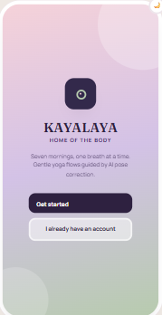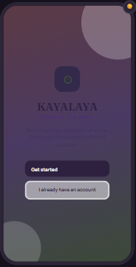
Create account
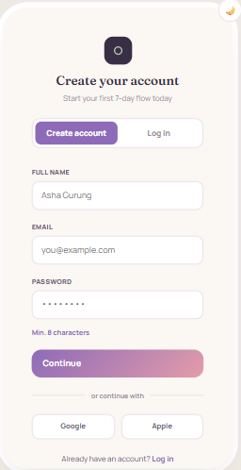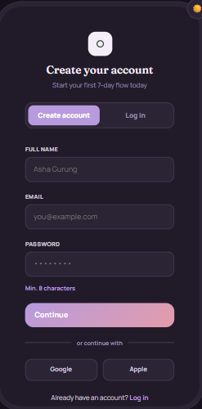
Login if already created acc
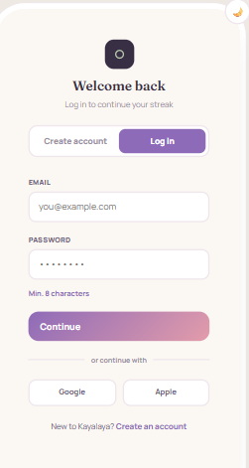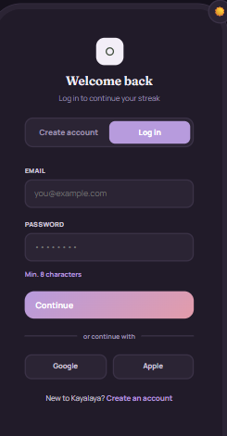
Home page dashboard
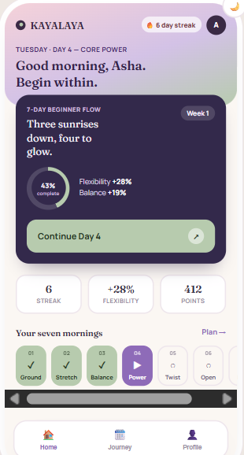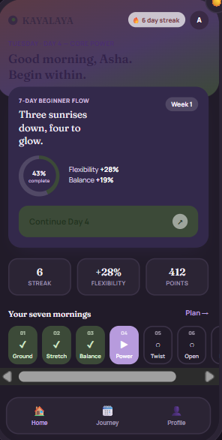
Or for the display program u can do this format aswell howver match the colouyrs
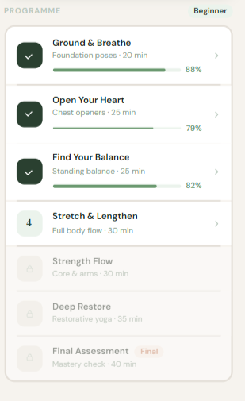I don’t have the final assessment page right now but it’s the same as the pose correction page
After clicking day 1 page poses page
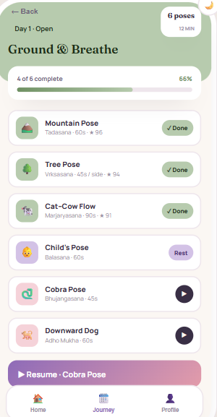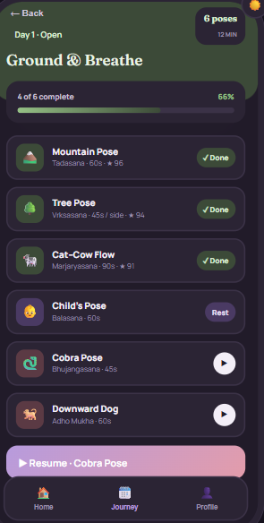
After clicking the pose demo and correction page
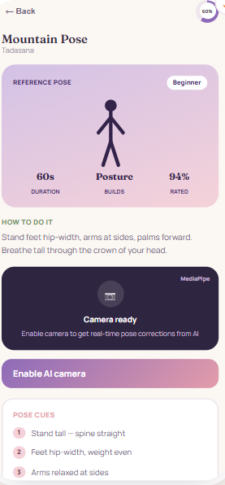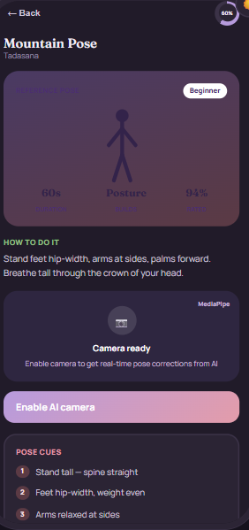
Profile
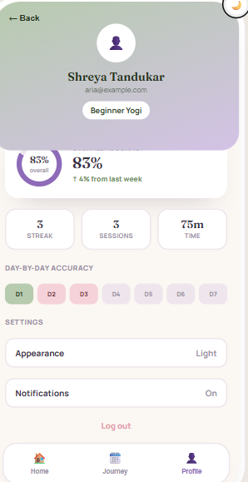
Put personal information, improvement, streaks, duration

8. What We Should NOT Finalize Yet
- Actual yoga demonstration videos
- Final dataset
- Exact reference joint-angle values/ranges
- ML model and training code
- MediaPipe implementation details
- FastAPI endpoints
- PostgreSQL database structure
- Real Google authentication
- JWT implementation
- Final assessment scoring formula

9. Frontend Development Plan

Phase 1 – UI Foundation
Expo project → theme/fonts → reusable components → splash → login → create account → survey → profile setup

Phase 2 – Main Application
Home → 7-day program → day screen → pose cards → pose details → practice screen

Phase 3 – Progress
Day completion → progress dashboard → accuracy charts → profile

Phase 4 – Assessment UI
Assessment introduction → assessment camera placeholder → pose-detection placeholder → score screen → final result

Phase 5 – Technology Integration
Camera → MediaPipe → landmarks → joint angles → correction → FastAPI → PostgreSQL → final ML assessment

10. Current Expo Status
The Expo project has been created successfully in Desktop/Kayalaya and the default Expo Starter screen is running. The current screen shows “Welcome to Expo,” which confirms that the basic Expo frontend is working.

11. Recommended Next Step
The next frontend task is to replace the default Expo Starter screen with the Kayalaya splash screen. The splash should contain a placeholder yoga outline illustration and the Kayalaya name, followed by a fade-out transition to the Login screen. Do not install MediaPipe, camera, FastAPI, PostgreSQL, or ML packages yet.

