## Front End Engineering-II

Project Report

Semester-IV (Batch-2022)

**Weather Prediction App**

**Supervised By: Submitted By:**

Ms. Parul Gehlot Kashish Verma (2210990498)

Nishtha (2210990619)

Nishtha Bansal (2210990620)

Nitya Gautam (2210990626)

(Group 7)

**Department of Computer Science and Engineering**

**Chitkara University Institute of Engineering & Technology,**

**Chitkara University, Punjab**

## Table of Contents

|  |  |  |
| --- | --- | --- |
| S.NO | PROGRAM TITLE | PAGE NO. |
|  | Abstract |  |
| 1. | Introduction |  |
| 1.1 | Background of the Project |  |
| 1.2 | Objectives |  |
| 1.3 | Significance |  |
|  |  |  |
| 2. | Problem Definition and Requirements |  |
| 2.1 | Problem Definition |  |
| 2.2 | Software Requirements |  |
| 2.3 | Hardware Requirements |  |
|  |  |  |
| 3 | Technologies Used |  |
| 3.2 |  |  |
|  | Results |  |
| 4. | Home Page |  |
| 4.1 | Pet Shope |  |
| 4.2 | Services |  |
| 4.3 | Contact Us |  |
| 4.4 |  |  |
|  |  |  |
|  |  |  |

## 

## 

## ABSTRACT

Weather is the state of the atmosphere at a given place and time in regards to heat, cloudiness, dryness, sunshine, wind, and rain. Of all the geophysical phenomena weather is the most significant one that influences us. Weather can vary greatly and largely depends on climate, seasons and various other factors. The chief goal of this work is to get the weather forecast of any city throughout the world through an application. Operational weather forecasting systems use observations to optimize the initial state of a forecast without considering possible model deficiencies. For precipitation assimilation, this could be an issue since precipitation observations, unlike conventional data, do not directly provide information on the atmospheric state but are related to the state variables through parameterized moist physics with simplifying assumptions. Precipitation observation operators are comparatively less accurate than those for conventional data or observables in clear-sky regions, which can limit data usage not because of issues with observations but with the model. The challenge lies in exploring new ways to make effective use of precipitation data in the presence of model errors. This study continues the investigation of variational algorithms for precipitation assimilation using column model physics as a weak constraint. The strategy is to develop techniques to make online estimation and correction of model errors to improve the precipitation observation operator during the assimilation cycle. Earlier studies have shown that variational continuous assimilation (VCA) of tropical rainfall using moisture tendency correction can improve GEOS-3 global analyses and forecasts. Here we present results from a four-year GEOS-3 reanalysis assimilating TMI and SSM/I tropical rainfall using the VCA scheme. Comparisons with NCEP operational analysis and ERA-40 reanalysis show that the GEOS-3 reanalysis is significantly better at replicating the intensity and variability of tropical precipitation systems ranging from a few days to interannual time scales. As a further refinement of rainfall assimilation using the VCA scheme, we describe a variational algorithm for assimilating TMI latent heating retrievals using semi-empirical parameters in the model moist physics as control variables **INTRODUCTION**

The Weather App project is a web application that leverages HTML, CSS, and JavaScript to fetch weather data from a weather API and display current weather conditions and forecasts for a specific location. It provides users with real-time weather information, allowing them to stay informed about the weather conditions in their desired location.

The Weather App utilizes an API (in this example, the WeatherAPI) to retrieve weather data based on the user’s input location. The application dynamically fetches the current weather information and the forecast for the upcoming days. It then presents this data in a user-friendly format, making it easy for users to understand and interpret.

* 1. **BACKGROUND OF THE PROJECT:**

The first ever daily weather forecasts were published in The Times on August 1, 1861, and the first weather maps were produced later in the same year.[28] In 1911, the Met Office began issuing the first marine weather forecasts via radio transmission. These included gale and storm warnings for areas around Great Britain.[29] In the United States, the first public radio forecasts were made in 1925 by Edward B. "E.B." Rideout, on WEEI, the Edison Electric Illuminating station in Boston.[30] Rideout came from the U.S. Weather Bureau, as did WBZ weather forecaster G. Harold Noyes in 1931.

The world's first televised weather forecasts, including the use of weather maps, were experimentally broadcast by the BBC in November 1936.[31] This was brought into practice in 1949, after World War II.[31] George Cowling gave the first weather forecast while being televised in front of the map in 1954.[32][33] In America, experimental television forecasts were made by James C. Fidler in Cincinnati in either 1940 or 1947[clarification needed] on the DuMont Television Network.[30][34] In the late 1970s and early 1980s, John Coleman, the first weatherman for the American Broadcasting Company (ABC)'s Good Morning America, pioneered the use of on-screen weather satellite data and computer graphics for television forecasts.[35] In 1982, Coleman partnered with Landmark Communications CEO Frank Batten to launch The Weather Channel (TWC), a 24-hour cable network devoted to national and local weather reports.

* 1. **OBJECTIVES**

**1. Air Traffic: Because the aviation industry is especially sensitive to the weather, accurate weather forecasting is essential. Fog or exceptionally low ceilings can prevent many aircraft from landing and taking off.[91] Turbulence and icing are also significant in-flight hazards.[92] Thunderstorms are a problem for all aircraft because of severe turbulence due to their updrafts and outflow boundaries,[93] icing due to the heavy precipitation, as well as large hail, strong winds, and lightning, all of which can cause severe damage to an aircraft in flight.**

**2.Agriculture:** **Farmers rely on weather forecasts to decide what work to do on any particular day. For example, drying hay is only feasible in dry weather. Prolonged periods of dryness can ruin cotton, wheat,[100] and corn crops. While corn crops can be ruined by drought, their dried remains can be used as a cattle feed substitute in the form of silage.[101] Frosts and freezes play havoc with crops both during the spring and fall. For example, peach trees in full bloom can have their potential peach crop decimated by a spring freeze.[102] Orange groves can suffer significant damage during frosts and freezes, regardless of their timing.[103].**

**3.Forestry: Forecasting of wind, precipitation and humidity is essential for preventing and controlling wildfires. Indices such as the Forest fire weather index and the Haines Index, have been developed to predict the areas more at risk of fire from natural or human causes. Conditions for the development of harmful insects can also be predicted by forecasting the weather..**

**4.Ultility Companies:** private companies pay for weather forecasts tailored to their needs so that they can increase their profits or avoid large losses.[[108]](https://en.wikipedia.org/wiki/Weather_forecasting#cite_note-108) For example, supermarket chains may change the stocks on their shelves in anticipation of different [consumer spending](https://en.wikipedia.org/wiki/Consumer_spending) habits in different weather conditions. Weather forecasts can be used to invest in the commodity market, such as futures in oranges, corn, soybeans, and oil.[[109]](https://en.wikipedia.org/wiki/Weather_forecasting#cite_note-109)

**5.Marine: Commercial and recreational use of waterways can be limited significantly by wind direction and speed, wave periodicity and heights, tides, and precipitation. These factors can each influence the safety of marine transit. Consequently, a variety of codes have been established to efficiently transmit detailed marine weather forecasts to vessel pilots via radio, for example the MAFOR (marine forecast).[99] Typical weather forecasts can be received at sea through the use of RTTY, Navtex and Radiofax.**

**SIGNIFICANCE**

**1. Real-Time Weather Updates**

**One of the most obvious yet vital benefits of weather apps is providing real-time weather updates. Users get instant access to current weather conditions, which is crucial for planning daily activities. Whether it’s about deciding what to wear or determining if an outdoor event can go ahead, real-time updates are invaluable.**

**2. Advanced Weather Forecasting**

**Modern weather apps offer advanced forecasting, using sophisticated algorithms and data analysis. This feature allows users to view weather predictions for days, or even weeks ahead, aiding in long-term planning and decision-making for both personal and professional activities.**

**3. Severe Weather Alerts: Safety is a paramount concern, and weather apps contribute significantly by providing severe weather alerts. Understanding the weather app development cost is essential as it impacts the range and quality of features such apps can offer ,including the ability to warn users about incoming storms, hurricanes, or other extreme weather conditions. Investing appropriately in the development process ensures that these apps are equipped with accurate and timely alert systems, enabling users to take necessary precautions well in time.**

**4. Agricultural and Environmental Benefits: Weather apps are incredibly beneficial for agriculture. Farmers can plan sowing, irrigation, and harvesting activities based on accurate weather predictions. Moreover, these apps contribute to environmental conservation by facilitating better water resource management and predicting natural disasters.**

**5. Business and Economic Advantages: Weather apps hold significant benefits for businesses. Industries such as agriculture, aviation, and tourism rely heavily on weather forecasts for operational planning. Accurate weather information helps in minimizing risks, optimizing operations, and saving costs.**

**6. Enhancing Outdoor Activities: Finally, for outdoor enthusiasts, weather apps are essential. They provide the necessary information to plan activities such as hiking, fishing, or photography, ensuring that the weather doesn’t spoil the fun.**

**2. PROBLEM DEFINITION AND REQUIREMENTS**

**2.1 PROBLEM DEFINITION:**

**Users can get too busy at work or at home to check the current weather condition for sever weather. Many of the free weather software programs have too many pop ups or unwanted software tied to them like weather bug. Getting confusing information on weather warnings and watches from inaccurate sources. Problems concern availability, timeliness, and quality of observational data; time constraints on forecast preparation; the nature and reliability of communication systems available for forecast dissemination; and the makeup and requirements of the user community.**

**2.2 SOFTWARE REQUIREMENTS:**

**Software Requirements specifies the logical characteristics of each interface and software components of the system. The following are some software requirements:**

**1. HTML, CSS, JavaScript, and React: The project will be implemented using these technologies, providing a robust and dynamic front-end interface for user interaction and engagement.**

**2. Code Editor:**  **Visual Studio Code (VSCode): A versatile and widely-used code editor that supports HTML, CSS, JavaScript, and React development, offering features such as syntax highlighting, code completion, and debugging capabilities.**

**3. Front-end Libraries and Frameworks:**

# • **React: A popular JavaScript library for building user interfaces, facilitating the creation of interactive and responsive web applications.**

# • **Bootstrap: A front-end framework for building responsive and mobile-first websites, providing pre-designed components and layouts for rapid development.**

# • **Styled-components: For styling React components with dynamic and scoped CSS.**

**4. Version Control System:**

# • **Git: A distributed version control system widely used for tracking changes in source code and collaborating on projects. Git provides features such as branching, merging, and version history tracking, ensuring efficient code management and collaboration among team members.**

**5. Package Manager:**

# • **npm (Node Package Manager): A package manager for JavaScript, used for installing, managing, and updating dependencies required for the project. npm facilitates the integration of third-party libraries and tools, enhancing the development process and productivity.**

**By leveraging these software requirements, the project aims to deliver a modern and feature-rich web application that meets the needs and expectations of users, while ensuring maintainability, scalability, and efficiency in development and deployment processes.**

**2.3 HARDWARE REQUIREMENTS:**

Hardware interfaces specify the logical characteristics of each interface between the software product and the hardware components of the system. The following are some hardware requirements.

• System : Intel Core i5.

• Hard Disk : 1 TB.

• Monitor : 15 ’’LED

• Input Devices : Keyboard, Mouse

• Ram : 4 GB

**3. TECHNOLOGIES USED:**

**1. REACT:**

React is a JavaScript library designed for creating interactive user interfaces, primarily for single-page applications. It revolves around a component-based architecture, where UIs are broken down into reusable and encapsulated components. React's virtual DOM efficiently updates only the necessary parts of the actual DOM, enhancing performance.

One of React's standout features is its declarative syntax, allowing developers to describe the desired UI state, leaving React to handle the underlying DOM updates. This simplifies development and enhances code maintainability.

Moreover, React promotes unidirectional data flow, making state management predictable and debugging easier. JSX, a JavaScript extension, enables the embedding of HTML-like syntax within JavaScript files, streamlining the creation of UI components.

In summary, React provides a robust framework for building modern web applications, emphasizing component reusability, performance optimization, and a straightforward approach to UI development.



Here are some of the commands of react js that we have used in this project:

**1. npx create-react-app my-app:** This command is used to create a new React application with a predefined project structure. npx is a tool that allows you to execute npm packages without installing them globally. create-react-app is a package provided by Facebook that sets up a new React project for you. my-app is the name of the directory that will be created for your new React application.

**2. cd my-app:** After running the create-react-app command and specifying a name for your project (in this case, my-app), you need to navigate into the newly created project directory. cd stands for "change directory", and my-app is the name of the directory created by create-react-app. This command moves your terminal session into the project directory so that you can start working on your React application.

**3. code .:** This command opens the current directory in Visual Studio Code, assuming you have it installed and configured as your default code editor. code is a command-line tool provided by Visual Studio Code, and . represents the current directory. This command opens the project directory in Visual Studio Code, allowing you to edit the files and work on your React application using the code editor.

**4. npm run start:** This command is used to start the development server for your React application. In a typical React project setup, the start script is defined in the package.json file and is configured to run the development server provided by react-scripts. This server compiles your React code, starts a local web server, and opens your application in a web browser. You can then view and interact with your React application in real-time while making changes to the code.

**5. npm run build:** This command is used to build a production-ready bundle of your React application. When you're ready to deploy your application to a production environment, you use the build script to generate optimized and minified files for better performance and smaller file sizes. The output of the build script is typically a set of static files that can be served by a web server.

**6. npm run dev:** This command is not a standard script in React projects by default. However, it might be used in some projects as a custom script to start a development server or perform other development-related tasks. The exact behavior of the dev script would depend on how it's defined in the package.json file of the project.

**2. REACT ROUTER DOM:**

React Router DOM provides a set of components that enable declarative routing in React applications. These components allow you to define routes, nested routes, and handle navigation between different views. Some key components provided by

React Router DOM include:

**1. BrowserRouter:** This component is used to wrap the entire application and provides the routing context for all other routing components. It utilizes HTML5 history API for navigation and rendering the appropriate components based on the current URL.

**2. Route:** The Route component is used to define a route within the application. It renders a specific component when the URL matches the specified path. You can also use additional props like exact, path, and component to configure the behavior of the route.

**3. Switch:** The Switch component is used to render the first Route or Redirect that matches the current URL. It helps in rendering a single route exclusively.

**4. Link:** The Link component is used to create navigation links within the application. It renders an anchor tag (<a>) with an href attribute that updates the URL and triggers the appropriate route rendering when clicked.

**5. NavLink:** Similar to Link, NavLink is used to create navigation links. It provides additional styling capabilities by applying an active class name to the link when its to prop matches the current URL.

**4. RESULTS:**

In the presentation of the results, visual representations of "Weather Prediction App" to showcase its interface and features.

**4.1 HOMEPAGE**

The homepage of “Weather Prediction App” welcomes visitors with a captivating visual layout designed to inspire and engage

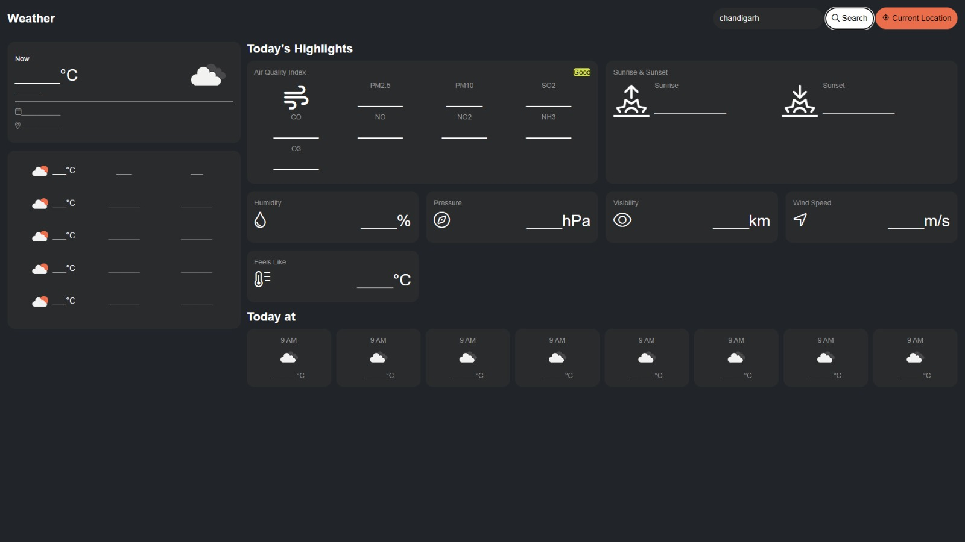

**4.7 REFERENCES**

<https://www.mrnmrspet.com/dogs-for-adoption>

**https://www.youtube.com/watch?v=Xe8CkYZvCig&t=4237s**

**W3Schools 🡪** [**www.w3schools.com**](http://www.w3schools.com/)