**ANUDIP FOUNDATION POWER BI ASSIGNMENT TASK 1**

**Part 1 . 3a)Represent the data, which includes the total count of account numbers against the country, in a tabular format**

1.In the Visualizations pane on the right, click on the "Table" visual icon to add a table to your report canvas.

2.In the Fields pane, find the "Country" field and drag it to the "Values" section of the Table visual.

3.Find the "Account Number" field and drag it to the "Values" section of the Table visual as well.

4.By default, Power BI might list all account numbers individually. To count the account numbers, click the dropdown arrow next to the "Account Number" field in the "Values" section of the Visualizations pane.

5.Select "Count" from the dropdown menu. This will aggregate the account numbers and show the total count for each country.

6.Adjust the formatting of the table as needed. For example, you can change the column headers, font size, and colors by selecting the table and using the Format pane (the paint roller icon) in the Visualizations pane.

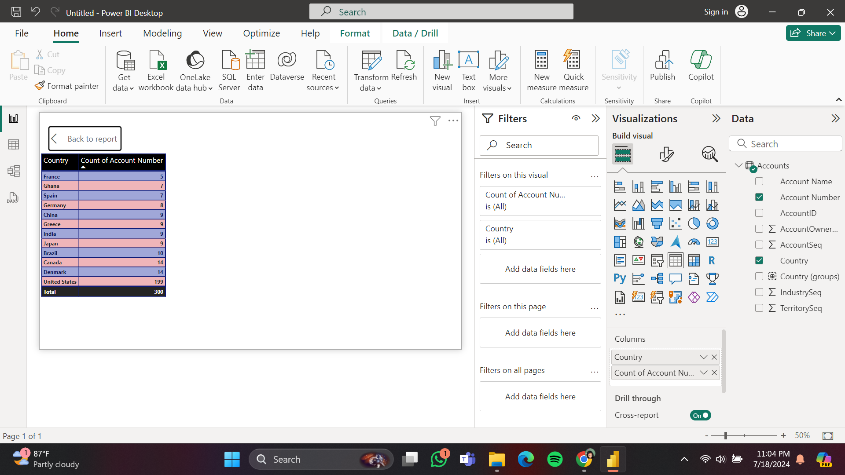

**Part 1.3b)Insert another table and represent the data on the country-wise Account holder's name.**

1.In the Visualizations pane on the right side, click on the "Table" visual icon to add a new table to your report canvas.

2.In the Fields pane, find the "Country" field and drag it to the "Values" section of the new Table visual.

3.Find the "Account Holder's Name" field and drag it to the "Values" section of the Table visual as well.The table will automatically display the account holder's names categorized by country.

Ensure that the table is set to display the data in a readable format. By default, Power BI will list the names under each country.

4.In the Visualizations pane, click on the Format (paint roller) icon to adjust the appearance of the table.

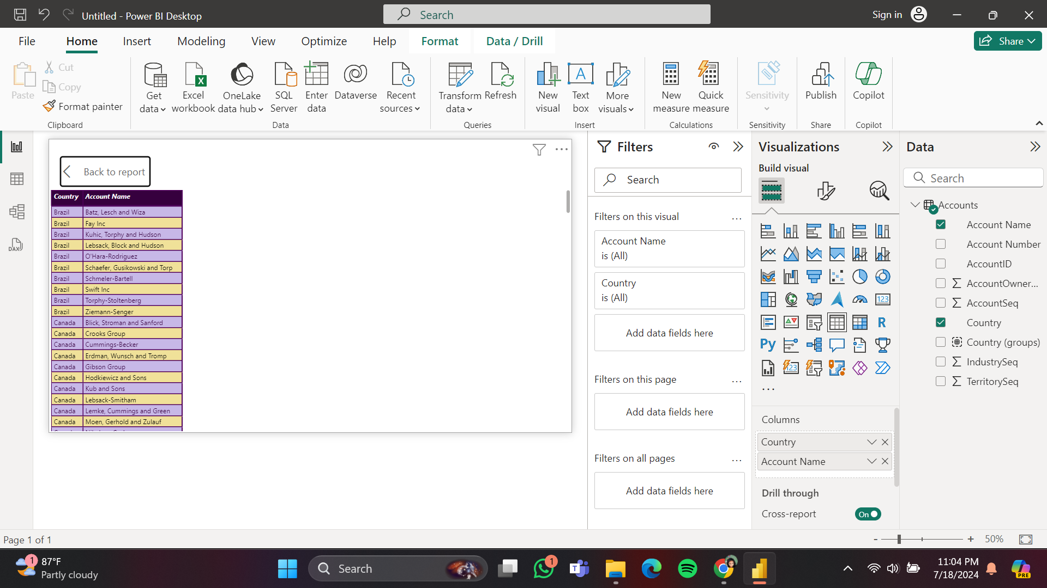

**Part 1.3c)Insert a slicer from the visualisation section and add a country-wise filter.**

1.In the Visualizations pane on the right side, click on the "Slicer" visual icon to add a slicer to your report canvas.

2.In the Fields pane, find the "Country" field.Drag the "Country" field to the "Field" section of the Slicer visual.The slicer will automatically display a list of countries.

By default, the slicer will be a list. If you want to change it to a dropdown, click on the slicer visual, then click the dropdown arrow in the top-right corner of the slicer, and select "Dropdown".

3.Select the slicer visual on the canvas.In the Visualizations pane, click on the Format (paint roller) icon to adjust the appearance of the slicer.

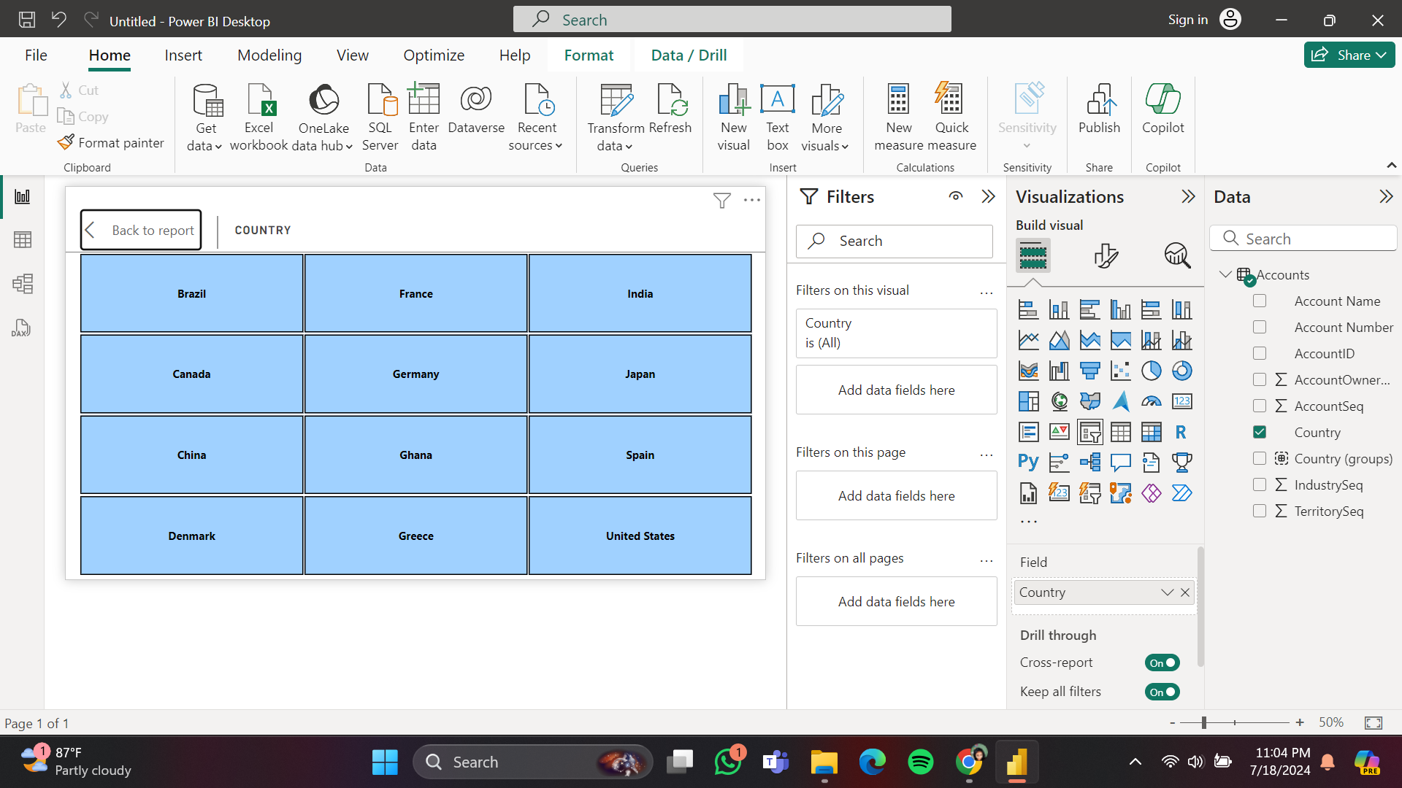

**Part 1. 3d)Represent the data of India, Brazil, Greece, and France together.**

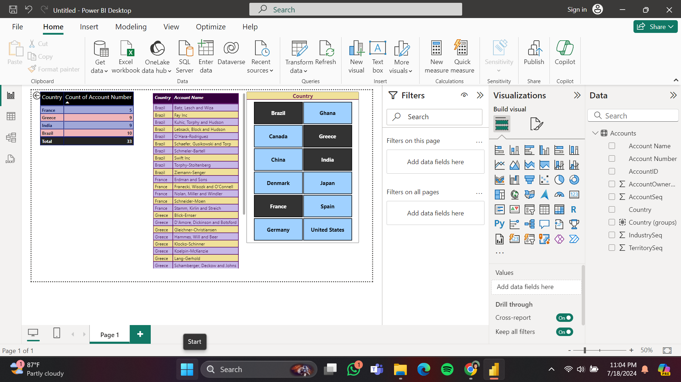

**Part 2.2a). Represent the data as per the given criteria: Country-wise industry and average profitability margin (in Percentage %)**

1.In the Visualizations pane on the right, click on the "Table" or "Matrix" visual icon to add it to your report canvas.

2.In the Fields pane, drag the "Country" field to the "Rows" section of the visual.Drag the "Industry" field to the "Rows" section of the visual.Drag the "Profitability Margin" field to the "Values" section of the visual.

3.By default, Power BI might sum the Profitability Margin. Change this to an average:Click the dropdown arrow next to the "Profitability Margin" field in the "Values" section of the Visualizations pane.Select "Average" from the dropdown menu. This will calculate the average profitability margin for each industry within each country.

4. Format the Profitability Margin(Ensure that the Profitability Margin is displayed as a percentage)

* + Click on the "Profitability Margin" field in the Fields pane.
  + Go to the "Modeling" tab in the ribbon.
  + In the "Data Type" dropdown, select "Percentage".
  + Set the number of decimal places as needed.

5.Select the visual on the canvas.In the Visualizations pane, click on the Format (paint roller) icon to adjust the appearance of the visual.

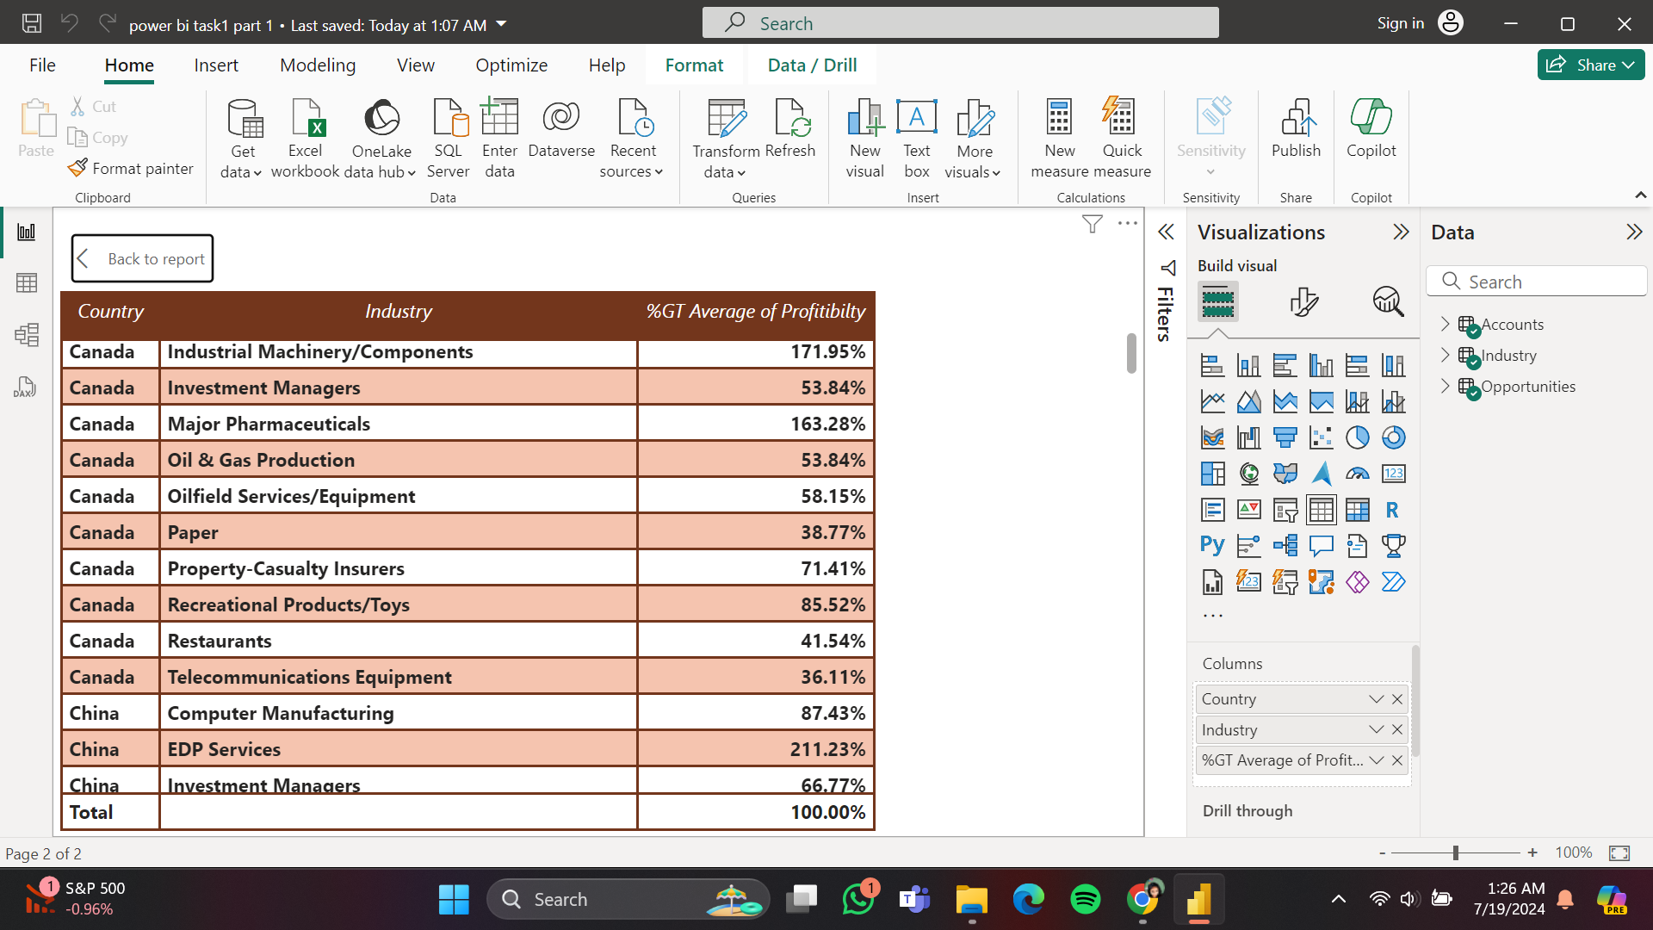

**Part 2.2b)Represent the data as per the given criteria: Add a separate filter so that country-wise industry and profitability margins can be shown based on the selective countries (There is no bar on country selection).**

1.In the Visualizations pane, click on the "Slicer" visual icon to add a slicer to your report canvas.

2.In the Fields pane, drag the "Country" field to the "Field" section of the Slicer visual.By default, the slicer will display a list of countries. The slicer will now allow you to select one or multiple countries.

3.Click on the slicer visual on the canvas, then go to the Format (paint roller) icon in the Visualizations pane to adjust the slicer's appearance as needed.

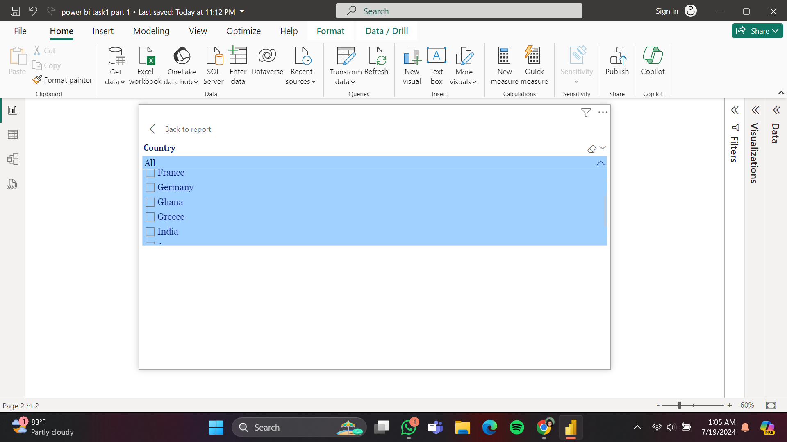

**Part2 .3)Represent the following data using a pie chart: a. Industry-wise profitability percentage b. The data should be visualised in single or multiple country-wise**

1.In the Visualizations pane on the right, click on the "Pie chart" visual icon to add it to your report canvas.

2.In the Fields pane, drag the "Industry" field to the "Legend" section of the pie chart.

Drag the "Profitability Margin" field to the "Values" section of the pie chart.

3.By default, Power BI might sum the Profitability Margin.

4. Format the Profitability Margin

(Ensure that the Profitability Margin is displayed as a percentage)

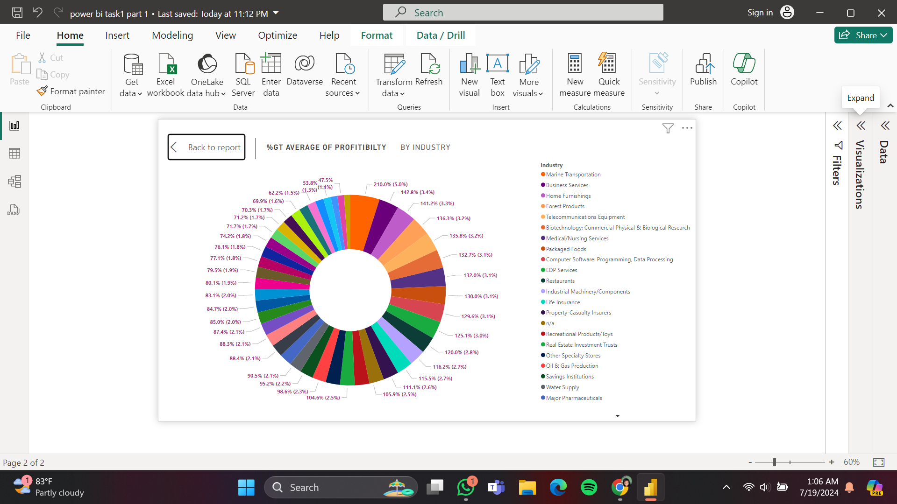

**Part 2.4) Present the data that shows industry-wise profitability trends by taking the Line & stacked column chart from the visualisation section**

1.In the Visualizations pane on the right, click on the "Line and stacked column chart" visual icon to add it to your report canvas.

2. Add Fields to the Chart:

In the Fields pane, drag the "Date" (or Time) field to the "Shared axis" section of the chart.

Drag the "Industry" field to the "Column values" section of the chart.

Drag the "Profitability Margin" field to the "Line values" section of the chart.

3. Configure the Aggregation:

(Ensure the Profitability Margin is set to an average)

4. Format the Profitability Margin:

(Ensure that the Profitability Margin is displayed as a percentage)

5. Format the Chart:

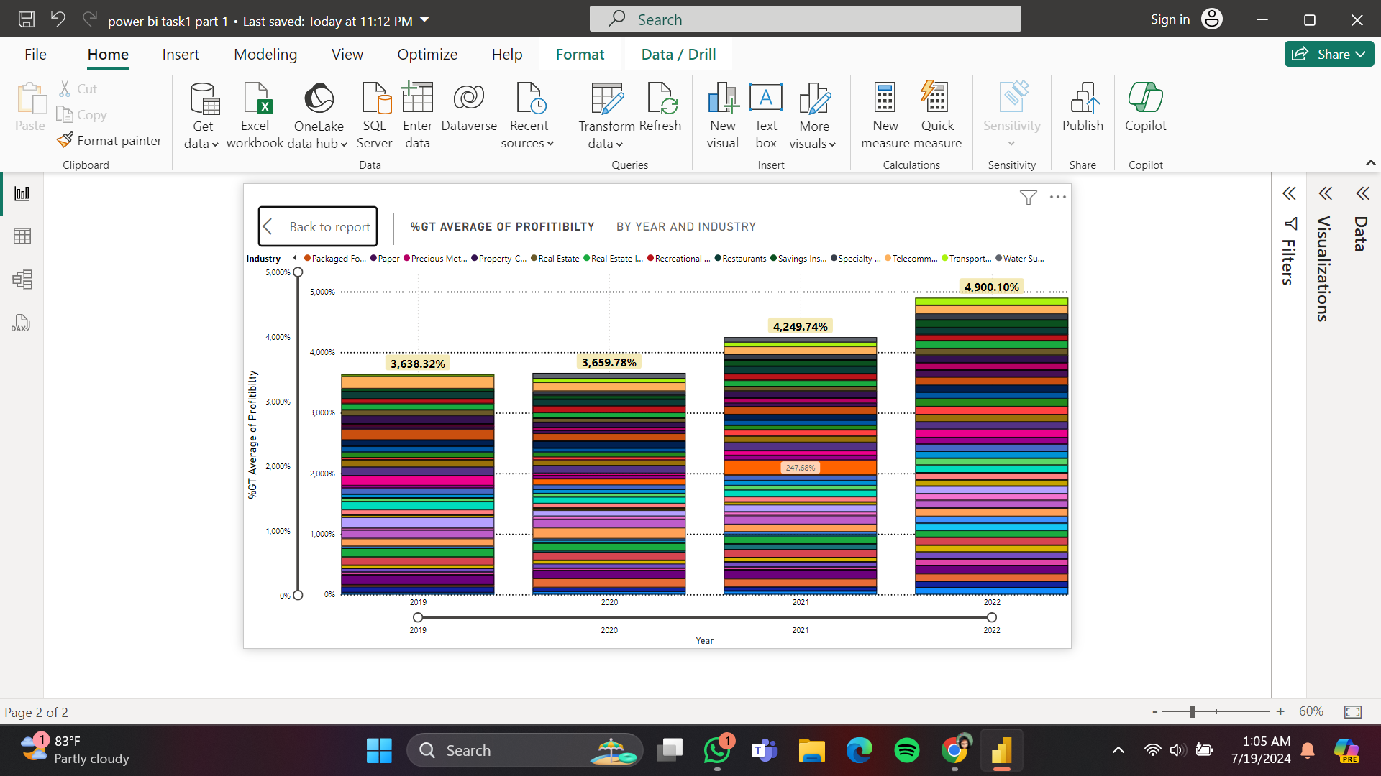

**Part 2.5)Present the data to show country-wise industry market values and industrywise presence by taking the map chart.**

1.In the Visualizations pane on the right, click on the "Map" visual icon to add it to your report canvas.

2. Add Fields to the Map Chart:

In the Fields pane, drag the "Country" field to the "Location" section of the map chart.

Drag the "Industry" field to the "Legend" section of the map chart.

Drag the "Market Values" field to the "Size" section of the map chart.

3. Configure the Data:

4. Format the Map Chart:

