RaDix

S V SAI VATHSAL | – | 22BD1A663W
T NISHANTH REDDY | – | 22BD1A663Y
PHANI | – | 22BD1A6614
G ROHITH | – | 23BD5A6601

Problem Statement:
Healthcare professionals often face challenges in diagnosing diseases accurately and efficiently due to high patient volumes and reliance on manual processes. Analyzing medical images, such as X-rays, requires significant expertise and time, which can lead to delays and potential errors. The problem is compounded by the lack of systems that integrate image analysis with detailed, actionable diagnostic reporting. There is a need for a robust, automated system that leverages deep learning to detect diseases, classify severity, and generate structured reports, improving efficiency, accuracy, and patient outcomes.

Software Requirement Specification for
RaDix
Version 2.0 approved

Prepared by:

1.S V SAI VATHSAL | – | 22BD1A663W
2.T NISHANTH REDDY | – | 22BD1A663Y
3.PHANI | – | 22BD1A6614
4.G ROHITH | – | 23BD5A6601

Keshav Memorial Institute of Technology
18-11-2024

Table of Contents
- Introduction
1.1 Purpose ................................................................................................................... 5
1.2 Document Conventions ...........................................................................................5
1.3 Intended Audience and Reading Suggestions ........................................................ 6
1.4 Product Scope .........................................................................................................6
1.5 References ..............................................................................................................6
- Overall Description
2.1 Product Perspective ................................................................................................7
2.2 Product Functions ...................................................................................................7
2.3 Operating Environment ..........................................................................................7
2.4 User Characteristics ...............................................................................................7
2.5 Design and Implementation Constraints ................................................................8
2.6 User Documentation ..............................................................................................8
2.7 Assumptions and Dependencies ............................................................................9
- External Interface Requirements
3.1 User Interfaces .......................................................................................................10
3.2 Hardware Interfaces ...............................................................................................10
3.3 Software Interfaces ................................................................................................10
3.4 Communication Interfaces .....................................................................................10
- System Overview
4.1 System Objectives ..................................................................................................11
4.2 System Architecture ...............................................................................................11
4.3 Major Features .......................................................................................................11
- Functional Requirements
5.1 Data Input ............................................................................................................12
5.2 Data Processing ...................................................................................................12
5.3 Report Generation ...............................................................................................12
5.4 User Interface (UI) ..............................................................................................12
5.5 Integration with HIS ...........................................................................................12
- Non-Functional Requirements
6.1 Performance ........................................................................................................13
6.2 Reliability ............................................................................................................13
6.3 Security ...............................................................................................................13
6.4 Usability ..............................................................................................................13
6.5 Scalability ...........................................................................................................13
- Appendices
Appendix A: Disease Detection System Glossary ...................................................14
Appendix B: Use Case Template .............................................................................15
Appendix C: To Be Determined List .......................................................................19

Revision History

Name | Date | Reasons for Changes | Version
Week-1 | 18-11-2024 | SRS Template Creation  (Introduction) | 1.0
Week-2 | 19-11-2024 | SRS Documentation – Use Case and Class Diagram | 2.0

1.Introduction

1.1 purpose

The purpose of the system is to assist healthcare professionals by automating disease detection and diagnostic report generation. It analyzes X-ray images using deep learning models to identify diseases, determine severity, and generate structured, actionable medical reports. The system aims to enhance diagnostic accuracy, streamline workflows, and support timely decision-making while ensuring compliance with data privacy regulations like HIPAA and GDPR. By integrating advanced AI techniques, it reduces diagnostic errors and improves patient outcomes.

1.2 Document Convention

Heading:
Font-Size:16
Font-Style: Bold
Font: Times New Roman
Subheading:
Font-Size:14
Font-Style: Bold
Font: Times New Roman Content:
Font-Size:12
Font: Times New Roman.

1.3 Intended Audience and Reading Suggestions

Intended Audience

Healthcare Professionals: Radiologists and doctors using the system for diagnostics.

Developers: Engineers and data scientists building and maintaining the system.

System Administrators: IT personnel managing deployment, security, and updates.

Regulatory Teams: Ensuring compliance with healthcare data privacy laws.

Reading Suggestions

For an overview, read Section 1 (Introduction) and Section 2.1 (Product Perspective).

For system functionality, see Section 3 (Features and Requirements).

For technical integration, refer to Section 4 (Interfaces).

For performance and security, refer to Section 5 (Non-Functional Requirements).

1.4 Product Scope
The system focuses on generating diagnostic reports for various medical conditions based on the input data. It can be integrated into a hospital information system (HIS) or used as a standalone application. It supports disease detection, severity assessment, and recommendations for further medical action.
By streamlining diagnostic workflows, the system aims to enhance efficiency, reduce diagnostic errors, and improve overall patient outcomes.

1.5 References
- Smith, J., & Doe, A. (2020). Advances in Medical Imaging and Radiology AI. Journal of Medical Technology.
- Encoder-decoder models for chest X-ray report generation.
- HIPAA and GDPR guidelines.
- TensorFlow and PyTorch documentation.

2.Overall Description

2.1 Product Perspective
The Medical Report Generator is designed to streamline the process of generating medical reports based on patient data. It integrates with existing healthcare systems or functions as a standalone application. The system processes structured and unstructured medical data (such as symptoms, test results, and X-ray images), providing healthcare professionals with detailed diagnostic reports. By automating this process, the system aims to reduce diagnostic errors, improve accuracy, and enhance operational efficiency in healthcare environments.

2.2 Product Functions
    - Input: Medical images (JPEG, PNG, DICOM) and structured health data (CSV, JSON).
    - Processing: Employs advanced deep learning (e.g., CNNs for image analysis, NLP for report generation).
    - Output: Reports with disease details, affected areas, severity, and treatment suggestions.

2.3 Operating Environment

The system will operate on Linux, Windows, or macOS, using frameworks like TensorFlow and PyTorch for model processing. It will be hosted on cloud platforms (AWS, Google Cloud) or local servers, with high-performance GPUs for deep learning tasks. Secure, high-speed networks will handle data transfer, ensuring compliance with healthcare regulations (HIPAA, GDPR).

2.4 User Characteristics

Healthcare Professionals: Radiologists, doctors, and technicians.

Patients: Indirect beneficiaries through improved and faster diagnostics.

System Administrators: Responsible for model maintenance and data security.

2.5 Design and Implementation Constraints

1. Model Accuracy:

The accuracy of disease detection heavily relies on the quality of input data. High-resolution X-ray images and complete, accurate numerical health data (such as vital signs or lab results) are crucial for generating precise diagnostic reports. Any deficiencies in data quality can affect the performance of the underlying models.

2. Compliance with Healthcare Regulations:

The system must adhere to healthcare data privacy standards, including HIPAA (Health Insurance Portability and Accountability Act) and GDPR (General Data Protection Regulation). This ensures that all patient data is securely stored and handled, with strict access controls and encryption mechanisms in place.

3.Optimal Processing Time:

The system must maintain optimal processing times for both X-ray image analysis and numerical data processing. While ensuring accuracy, the system should avoid excessive delays, providing timely reports to healthcare professionals to support rapid decision-making.

2.6 User Documentation

The User Documentation provides clear instructions for various stakeholders:
- Healthcare Professionals: Learn to upload X-ray images, input numerical data, and generate diagnostic reports.
- Interpretation: Understand the generated reports for disease identification, location, and severity.
- System Administrators: Instructions for system installation, configuration, and user management.
- Maintenance: Guidelines for regular updates, backups, and troubleshooting common issues.
- Technical Support Staff: Detailed system requirements and installation steps for cloud or on-premise deployment.
- Integration: Instructions for connecting the system to Hospital Information Systems (HIS).
- Data Handling: Ensure input data is preprocessed to match model requirements.
- Troubleshooting: Solutions for common technical issues users may encounter.
- Security: Instructions for managing access and ensuring data privacy.
- Updates: Information on how to update the system as new features and improvements are added.

2.7 Assumptions and Dependencies
- Availability of labeled medical datasets for training the models.
- Input data (X-rays and numerical data) will be preprocessed to match model requirements.
- NLP models will handle medical terminology accurately.

3. External Interface Requirements
This section defines the interfaces between the Medical Report Generator system and external systems or components.
3.1 User Interfaces
- Healthcare Providers: Web-based or desktop interface for inputting data, viewing reports, and interacting with the system.
3.2 Hardware Interfaces
- The system shall be compatible with standard healthcare hardware like computers, X-ray machines, and diagnostic tools.
3.3 Software Interfaces
- HIS Integration: The system shall support standard APIs for communication with HIS and other hospital management software.
- Medical Databases: The system shall query external medical databases for disease information and classification.
3.4 Communication Interfaces
- Network Protocols: Secure data transmission using protocols like HTTPS for encrypted communication.
- Email/Notification System: Optional integration for sending alerts or updates about diagnostic results and system status.

4. System Overview
4.1 System Objectives
- Automation: Automatically generate diagnostic reports from structured patient data (such as test results, symptoms, and historical records).
- Accuracy: Improve diagnostic accuracy and assist healthcare providers in making timely decisions.
- Scalability: Capable of handling large volumes of patient data from various sources.
- Usability: Provide an intuitive user interface for healthcare professionals and support integration with existing HIS systems.
4.2 System Architecture
The Medical Report Generator will be developed with a modular architecture, including the following components:
- Data Input Interface: For entering patient data such as symptoms, medical tests, and images.
- Data Processing Module: To analyze the input data and generate reports.
- Report Generation Engine: To convert processed data into structured and readable diagnostic reports.
- Database: A central repository for storing patient data, reports, and system logs.
- User Interface: For interacting with the system (for inputting data, viewing reports, etc.).
4.3 Major Features
- Data Entry: Healthcare providers or patients can input various forms of data.
- Report Generation: Automatic generation of a report detailing disease detection, severity, and recommendations.
- Real-time Updates: Report updates can be accessed instantly when new patient data is added.
- Integration: Can be integrated with HIS for data sharing and consistency across systems.

5.Functional Requirements
5.1 Data Input
- The system shall allow users to input patient symptoms, medical test results, and X-ray images.
- The system shall accept structured data formats (e.g., CSV, JSON) and unstructured data (e.g., images, PDFs).
5.2 Data Processing
- The system shall process the patient data using machine learning models for disease detection and severity assessment.
- The system shall analyze X-ray images using image recognition algorithms to detect abnormalities like fractures or pneumonia.
- The system shall cross-reference patient data with medical databases (e.g., ICD-10 codes) for accurate diagnoses.
5.3 Report Generation
- The system shall automatically generate medical reports that include:
  - Patient Details: Basic demographic and medical information.
  - Disease Detection: Identification of potential conditions (e.g., pneumonia, fractures).
  - Severity Assessment: Evaluation of the severity of the condition(s).
  - Recommendations: Suggestions for further testing or treatment.
5.4 User Interface (UI)
- The system shall provide an intuitive and user-friendly interface for healthcare professionals to input data and view reports.
- The UI shall allow the user to modify or update reports before finalizing them.
5.5 Integration with HIS
- The system shall support integration with hospital information systems to synchronize patient data and report generation.

6. Nonfunctional Requirements
6.1 Performance
- The system shall process and generate medical reports within 5 seconds for standard patient data.
- The system shall support the processing of large volumes of patient data with minimal latency.
6.2 Reliability
- The system shall be available 99.9% of the time, excluding scheduled maintenance.
- The system shall have automated backup procedures to prevent data loss.
6.3 Security
- The system shall ensure data encryption both in transit and at rest to protect patient information.
- The system shall adhere to HIPAA and GDPR standards for data security and privacy.
- The system shall provide role-based access control to restrict access to sensitive patient data.
6.4 Usability
- The system shall provide an easy-to-use interface, requiring minimal training for healthcare providers.
- The system shall provide clear error messages and user prompts to guide users.
6.5 Scalability
- The system shall scale to handle an increasing number of patient records as the user base grows.

Appendix A: Disease Detection System Glossary
1. Disease Detection System: Software that analyzes medical data to detect diseases and generate reports.
2. X-ray Image Analysis: Using machine learning to identify diseases from X-ray images.
3. Numerical Health Data: Quantitative data (e.g., lab results, vital signs) used for diagnosis.
4. Diagnostic Report: A structured summary of disease detection findings and recommendations.
5. Preprocessing: Formatting and cleaning data for analysis.
6. Machine Learning Models: Algorithms that detect patterns in medical data.
7. Hospital Information System (HIS): Software for managing patient records in healthcare facilities.
8. Encryption: Protecting patient data by converting it into a secure format.
8. Role-Based Access Control (RBAC): Security method that grants system access based on user roles.
9. Integration: Connecting the system with other healthcare tools or databases.
10. HIPAA: U.S. law protecting patient health information.

Appendix B:
Use Case template:

Use Case ID | UC_001
Use Case Name | Medical Report Generator
End Objective | This use case describes how a healthcare professional uploads patient data and generates a diagnostic report
Created by | - S V Sai Vathsal  - T Nishanth  - Phani  - Rohith | On (date): | November 18, 2024
User/Actor | ADMIN,USER,SYSTEM,AIMODEL

Trigger | User or administrator initiates a system action, such as Logging into the website,  Giving an image as input to AImodel
Basic/Normal Flows

User Actions |  | Admin Actions | System Actions
where the user logs into the system by entering their credentials and clicks "Login". After successful login, the user uploads patient data, which includes X-ray images and numerical health data such as lab results and vital signs. The system validates the data format and ensures it's ready for processing. The user then clicks on "Process" to initiate disease detection, after which the system processes the data and generates a detailed diagnostic report, including disease identification, severity, and recommendations for treatment. The user reviews the report and, once satisfied, logs out. |  | the admin starts by logging into the admin portal with their credentials. They can manage user accounts, including creating, updating, or deactivating healthcare professional accounts, with the system updating user details accordingly. The admin also configures system settings, including data processing parameters and HIS integration, which the system then applies. The admin can monitor system health by checking performance metrics and logs, and once all tasks are complete, they log out of the system. | The System Actions are primarily automated. After data upload, the system first validates and preprocesses the X-ray images and numerical data, resizing the images and normalizing the data for analysis. The system then uses machine learning models to detect diseases such as pneumonia or fractures. Once the detection is complete, the system generates a structured diagnostic report, stores it in the database, and associates it with the patient's record. Finally, the system sends a notification to the healthcare professional once the report is ready for review.
Exception Flows
User Actions |  | Admin Actions | System Actions
if the user enters invalid credentials during login, the system will display an error message prompting the user to retry with the correct login details. If the uploaded X-ray images or numerical health data are in an incorrect format or missing required fields, the system will notify the user of the issue and prompt for correction. If the data processing fails due to technical issues (e.g., server overload or model failure), the system will display an error message and recommend that the user try again later. Similarly, if the system encounters issues generating the diagnostic report, the user will be informed, and they can attempt to reprocess the data. |  | if the admin enters incorrect credentials during login, the system will prompt for the correct credentials with an error message. If an admin attempts to deactivate a user account that is associated with ongoing processes, the system will notify them of potential consequences, preventing accidental deactivation. When configuring the system, if invalid parameters are entered (e.g., incorrect data sources for integration), the system will display an error message and allow the admin to correct the settings before proceeding. | if the system encounters a failure during data validation or preprocessing (e.g., corrupted data or unsupported file formats), it will notify the user with a specific error message and prompt them to upload valid data. If the disease detection model encounters an error (e.g., failure in prediction due to insufficient data), the system will display a failure message and may offer an option to retry or contact support. In case of issues during report generation, the system will halt the process, inform the user of the error, and allow the user to reattempt the generation process. If there's a failure in storing the report (e.g., database issues), the system will notify the user and retry the storage operation. If the notification process fails, the system will attempt to resend the alert to the healthcare professional once it’s back online.

Use Case Diagram:
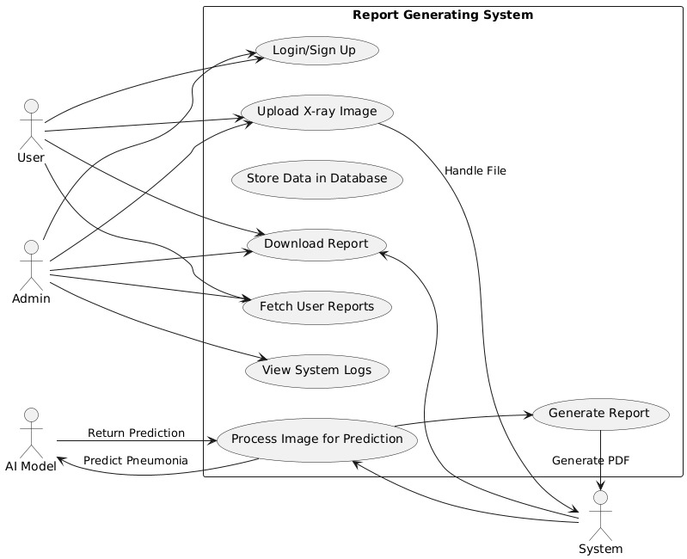
Class Diagram:
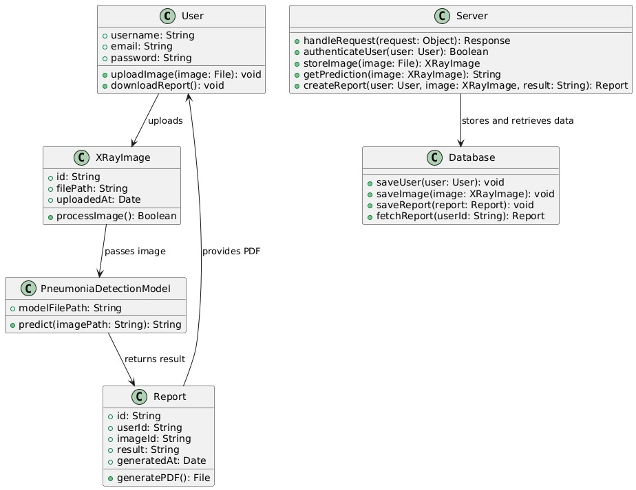

Appendix C: To Be Determined List
- Disease Types to Be Prioritized: Specific diseases or conditions that the detection model will focus on initially.
- Model Accuracy Thresholds: The minimum acceptable accuracy for disease detection across various input types.
- User Roles and Permissions: Defined access levels for different users (e.g., healthcare professionals, administrators) and their permissions for system interaction.
- System Integration Points: Detailed integration with existing healthcare systems like EHR or HIS that still need to be finalized.
- Report Format Customization: Decisions regarding the customization of the NLP-generated report format for different healthcare needs.
- Real-Time Processing Limitations: Maximum image processing time and performance criteria for real-time diagnostics.
This list tracks key decisions that need to be finalized as the project progresses.

