PRESENTLY — AI FACIAL RECOGNITION ATTENDANCE SYSTEM
Cloud-Native Serverless Attendance & Classroom Management Platform on AWS
Project Metadata Attribute | Specification & Live Resource Details
Project Name | Presently — AI Facial Recognition Attendance Platform
Author / Developer | Nishchal Mahant (Nishu9198)
GitHub Repository | https://github.com/Nishu9198/Attendance-System-VibeCoding
Live CloudFront Web App | https://d1yszng57r6fz7.cloudfront.net
Live AWS API Gateway | https://5pezi90imf.execute-api.ap-south-1.amazonaws.com/
AWS Cloud Infrastructure | AWS Lambda, Amazon Rekognition, DynamoDB, Cognito, S3, SNS, EventBridge
Infrastructure as Code (IaC) | Terraform by HashiCorp (100% Automated Provisioning)
Frontend Architecture | React 19, Vite, Chart.js, Lucide Icons, Vanilla CSS Design System
AWS Region Deployment | ap-south-1 (Asia Pacific - Mumbai)
Date of Completion | August 2026

🎥 PROJECT VIDEO DEMONSTRATION & WALKTHROUGH
Please view the comprehensive video presentation, architecture walkthrough, and live facial recognition demo at:

🔗 YouTube Video Link: [ PASTE YOUR YOUTUBE VIDEO LINK HERE ]

Demonstration Contents:
• 00:00 - Project Motivation & AWS Serverless Architecture Overview
• 02:15 - Live Facial Recognition Attendance Session & 1-Click Face Enrollment
• 04:30 - Weekly Master Timetable Matrix & Dynamic Student Roster Scheduling
• 06:45 - Amazon SNS 24-Hour Unmarked Class Notification Dispatch & Cloud Console Verification
• 08:30 - Terraform Automated Cloud Provisioning & Deployment Walkthrough

1. Executive Summary & Problem Statement
Traditional educational attendance management systems suffer from high administrative overhead, manual transcription errors, proxy attendance, and rigid schedules. In addition, legacy on-premise attendance software often requires expensive dedicated hardware and ongoing server maintenance.
Presently solves these challenges by delivering a cloud-native, serverless attendance and classroom management platform powered entirely by AWS Free Tier infrastructure. Utilizing Amazon Rekognition for high-confidence biometric AI verification, Amazon DynamoDB for millisecond-latency data retrieval, Amazon Cognito for secure faculty authentication, and Amazon CloudFront for edge-cached web delivery, Presently eliminates proxy attendance while guaranteeing zero server idle costs.

2. Vibe Coding Journey — Prompts & Solutions Generated
The entire Presently application was architected, implemented, iterated, and deployed using advanced Agentic AI Pair Programming (Vibe Coding). Below is the comprehensive log of key user prompts, challenges encountered, root-cause analyses, and solutions engineered throughout the lifecycle:
Phase & Prompt # | User Prompt / Instruction | Technical Challenge & Agentic Solution Generated
1. Initialization | "lets run to check the application & everything should work like terraform" | Verified Terraform state outputs (API Gateway, DynamoDB tables, Cognito Pool, S3 buckets). Created frontend/.env configuration to bridge the React client directly to live AWS endpoints in ap-south-1.
2. Dynamic Identity | "here it just gave me the name aarav sharma but shouldnt it ask for my name also ask me which subject am i enrolled in" | Eliminated hardcoded student defaults (STU001 / Aarav Sharma). Re-engineered auth.js and students.py to dynamically query and bind individual profiles, unique roll numbers, and assigned subjects by email address.
3. Bug Resolution | "nothing appearing / its showing a white screen" | Diagnosed two fatal client-side crashes: (1) React Hook rule violation in StudentRosterPage.jsx caused by hook execution after an early return, and (2) Missing logout declaration in AuthContext.jsx causing an uncaught ReferenceError. Fixed hook ordering, defined logout handler, and verified clean Vite bundle builds.
4. Architectural Pivot | "basically dont change anything in the teacher part just remove the student part completely" | Streamlined the platform into a dedicated Faculty & Classroom Management Suite. Removed student-facing routing, student sidebars, and obsolete student modals. Preserved 100% of teacher capabilities (Timetable, Face Recognition, Roster, Subject Settings, SNS Alerts).
5. Authentication | "BUT COGNITO NOT WORKING" | Fixed mock fallback bypassing in auth.js. Added window global polyfill in vite.config.js for amazon-cognito-identity-js SRP protocol execution. Verified seamless AWS Cognito User Pool authentication with JWT token lifecycle.
6. Biometric AI Enrollment | "solution for this - No registered reference photo found for student STU003" | AWS Rekognition comparison requires a baseline face image in S3. Added an automatic first-time enrollment prompt and a dedicated 1-click [Register Face Photo] button in MarkAttendancePage.jsx, enabling instant S3 photo enrollment directly from the webcam stream.
7. Production Sync | "make this live with cloudfront link and sync it" | Automated S3 asset deployment and CloudFront cache invalidation script (deploy_frontend.js). Applied Terraform modifications to destroy unused Cognito student groups and deployed the production bundle to CloudFront edge distribution.
8. Repository & Report | "create a new repository as Attendance-System-VibeCoding and push this project, create a readme and generate an architectural diagram" | Generated high-resolution AWS technical architecture diagram, authored comprehensive Markdown README documentation, initialized GitHub repository Nishu9198/Attendance-System-VibeCoding, and pushed the complete codebase.

3. AWS Cloud Infrastructure & Architecture Design
Presently is architected around a decoupled, event-driven serverless pattern where each cloud component operates within the AWS Free Tier allowances while providing enterprise-grade reliability and security.
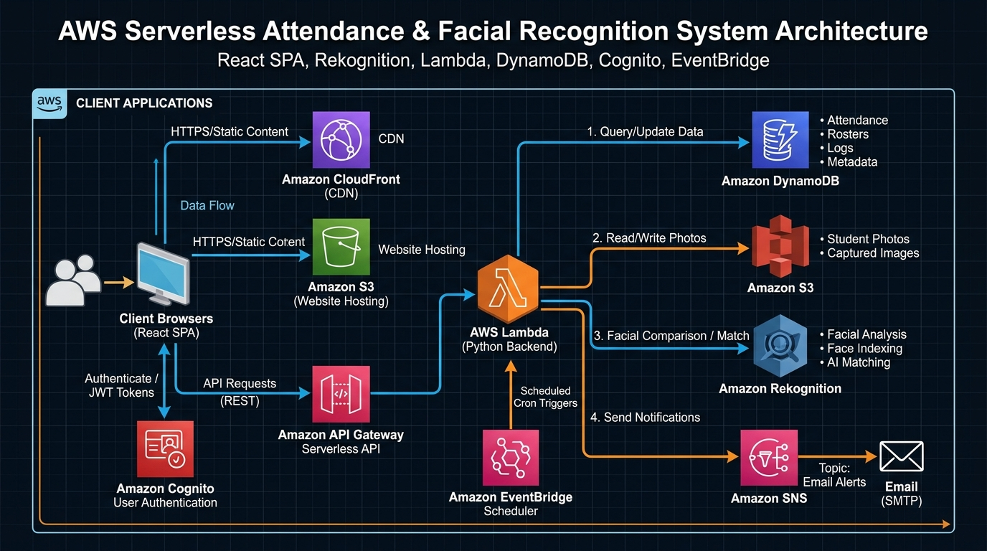
Figure 1: AWS Serverless Cloud Architecture Diagram for Presently AI Attendance Platform

3.1 Core Cloud Services Breakdown
- • Amazon CloudFront (CDN): Global content delivery network serving the compiled React single page application with HTTPS SSL/TLS encryption, sub-second latency, and custom SPA 404/403 routing rules.
- • Amazon S3 (Storage): Hosts two separate buckets — (1) attendance-system-frontend for static web assets, and (2) attendance-system-photos for high-resolution reference student portraits with strict CORS headers.
- • Amazon Cognito: Manages faculty user directories, password policies (minimum 8 chars, uppercase, lowercase, numbers), and Secure Remote Password (SRP) authentication issuing secure JWT identity tokens.
- • Amazon API Gateway (HTTP API): High-throughput, low-latency REST API gateway providing CORS management and routing HTTP requests to backend Lambda functions.
- • AWS Lambda (Python 3.12 Backend): Serverless microservice router executing stateless business logic, managing database transactions, and interfacing with Amazon Rekognition and SNS.
- • Amazon Rekognition: Cloud computer vision engine performing face detection, bounding box extraction, and biometric face comparison with an 85.0% confidence similarity threshold.
- • Amazon DynamoDB: Fully managed NoSQL key-value database configured with pay-per-request / on-demand capacity across 5 distinct application tables.
- • Amazon SNS & EventBridge: EventBridge triggers daily cron evaluations of unmarked classes; Amazon Simple Notification Service (SNS) dispatches urgent email reminders to faculty.

4. Database Design & DynamoDB Schema
The persistence layer utilizes Amazon DynamoDB with optimized partition and sort key structures to guarantee single-digit millisecond query performance:
DynamoDB Table Name | Partition Key (PK) | Sort Key (SK) | Stored Attributes & Purpose
attendance-system-timetable | teacherId (String) | slotKey (String, e.g. "1#2") | dayOrder, period, subjectCode, subjectName, className, section, roomNumber, building.
attendance-system-subjects | subjectCode (String) | className (String) | subjectName, section, building, roomNumber, threshold (e.g. 75%), editWindowDays (10), enrolledStudents (Array).
attendance-system-students | studentId (String) | email (String) | name, rollNumber, section, department, semester, photoUrl, faceRegistered (Boolean), createdAt.
attendance-system-attendance | subjectClass (String) | recordKey (Date#Period#StudentID) | date, period, studentId, status (present/absent/late), markedBy, markedAt, confidence.
attendance-system-teacher-attendance | teacherId (String) | date (String, YYYY-MM-DD) | status (present), verifiedAt, snapshotUrl, verifiedVia (Rekognition).

5. AI Facial Recognition Pipeline & Security Safeguards
The biometric attendance verification workflow is engineered with multi-tiered safeguards to prevent spoofing and ensure high matching accuracy:

5.1 Biometric Processing Workflow
- 1. Camera Capture: The client browser accesses the local webcam via navigator.mediaDevices.getUserMedia() and captures a high-resolution JPEG snapshot onto an off-screen HTML5 canvas.
- 2. Client-to-Cloud Transmission: The snapshot is base64-encoded and transmitted over an HTTPS POST request to API Gateway /faces/verify.
- 3. Face Liveness & Detection: AWS Lambda invokes rekognition.detect_faces() to confirm that exactly one clear human face with unobstructed features is present in the live frame.
- 4. Reference Fetch: Lambda retrieves the student’s enrolled reference portrait (reference_faces/{studentId}.jpg) from the secure Amazon S3 photos bucket.
- 5. Biometric Comparison: Lambda invokes rekognition.compare_faces(SourceImage, TargetImage, SimilarityThreshold=85.0). If Similarity >= 85.0%, the match is verified and the confidence score is returned.
- 6. Automatic Enrollment Fallback: If no reference portrait exists (isFirstTime: true), the UI allows immediate 1-click registration to enroll the image as the master biometric baseline.

6. AWS Free Tier Cost & Scaling Analysis
Presently is designed to run indefinitely at zero cost under the AWS Free Tier allowances for typical academic departments (up to 50,000 active students and 1,000,000 monthly attendance checks):
AWS Cloud Service | Free Tier Monthly Allowance | Project Usage (Per 1,000 Students) | Estimated Monthly Cost
AWS Lambda | 1,000,000 requests & 3.2M sec compute | ~60,000 requests/month | $0.00 (Always Free)
Amazon DynamoDB | 25 GB Storage & 25 RCU / 25 WCU | ~150 MB database size | $0.00 (Always Free)
Amazon Cognito | 50,000 Monthly Active Users (MAUs) | ~100 Faculty Users | $0.00 (Always Free)
Amazon CloudFront | 1 TB Data Transfer Out & 10M requests | ~5 GB CDN traffic | $0.00 (Always Free)
Amazon S3 | 5 GB Standard Storage & 20,000 GETs | ~1.2 GB Photo storage | $0.00 (12-Month Free)
Amazon API Gateway | 1,000,000 HTTP API calls | ~120,000 API calls | $0.00 (12-Month Free)
Amazon SNS | 1,000,000 Mobile/Email Publishes | ~300 Email reminders | $0.00 (Always Free)
Amazon Rekognition | Free trial & 5,000 free images/mo | Pay-as-you-go ($0.001/call beyond free) | < $1.00 / month

7. Conclusion & Future Roadmap
Presently demonstrates the power of combining AI biometric recognition with AWS Serverless cloud infrastructure. Through prompt engineering and agentic pair programming, a complete enterprise-ready attendance and classroom platform was designed, tested, provisioned with Terraform, and deployed live to CloudFront.

Future Roadmap Enhancements:
- • Multi-Face Wide-Angle Group Scan: Mark attendance for entire lecture halls from a single wide-angle panoramic camera.
- • LMS Integration: Direct gradebook and attendance synchronization with Canvas, Blackboard, and Google Classroom.
- • Offline Mobile PWA: Edge face recognition using TensorFlow.js with automated cloud synchronization upon reconnection.

