OptiDesk — Technical Architecture Report
MERN · Clerk · Gemini RAG · Socket.io generated from ARCHITECTURE.md
Contents
0. Tech Stack — deep
0.1 Server — helpdesk-server ("type": "commonjs")
0.2 Client — helpdesk-client ("type": "module")
0.3 External managed services
1. High-Level System Architecture
1.1 The load-bearing rule: URL prefix ⇒ credential
1.2 Middleware pipeline, in mount order (app.js)
1.3 Customer identity: Clerk ⇄ MongoDB mirroring
2. Core Backend Logic & AI Data Flow
2.1 Pipeline A — AI Triage & Ticket Creation, step by step
2.2 Pipeline B — RAG assistant, step by step
2.3 Sequence — message in, RAG context, LLM, decision, DB write, response out
2.4 Ticket lifecycle — a 3-step resolution handshake, enforced server-side
2.5 Degradation matrix — what breaks when a key is missing
3. Database Schema
3.1 Indexes and schema-level constraints
3.2 Ticket virtuals — one source of truth for UI and API
3.3 Referential integrity notes
4. API & Routing Contract
4.1 Error contract
4.2 Realtime contract — Socket.io
5. Codebase Structure
5.1 Provider nesting, and why the order is fixed
5.2 Why GET /api/me exists at all
6. Security Model
7. Configuration Reference
7.1 helpdesk-server/.env — all secret, never committed
7.2 helpdesk-client — public by definition
7.3 Key-pair discipline
8. Operational Runbook
8.1 npm scripts
8.2 First-run order (order matters)
8.3 Boot banner — the four lines to read
8.4 Failure → cause
9. Known Gaps & Upgrade Path
10. Reusable Project Briefing
OptiDesk is an AI-assisted customer-support ticketing system. Every ticket is auto-triaged offline (category, priority, sentiment) by a locally-trained Naive Bayes model; repetitive questions are deflected by a Gemini RAG assistant grounded in an embedded knowledge base; everything else is routed to human agents over a live Socket.io board. It runs a dual-authentication architecture: customers are owned end-to-end by Clerk, staff by a self-hosted JWT + bcrypt + Resend stack. The two credential systems never meet inside one request.
Deployment topology — three independently deployed parts:
Part | Folder | Runtime | Host | Entry point
REST API + WebSocket | helpdesk-server | Node ≥18, CommonJS | Render | server.js
SPA | helpdesk-client | React 18 / Vite | Vercel | src/main.jsx
Database + vector store | — | MongoDB | MongoDB Atlas | config/db.js

Roles — one enum on one collection (User.role), no separate tables:
Role | Credential | May reach | Created by
customer | Clerk session token | /api/me, /api/tickets/*, /api/chat/* | Clerk sign-up → webhook, or lazy mirror on first request
agent | custom JWT | all of /api/admin/* except DELETE | npm run seed:admin
admin | custom JWT | all of /api/admin/* including DELETE /tickets/:id | seed:admin, or POST /api/auth/register + ADMIN_SIGNUP_CODE

0. Tech Stack — deep

0.1 Server — helpdesk-server ("type": "commonjs")
Package | Ver | Exact role in OptiDesk | Why this, not the obvious alternative
express | 4.19.2 | HTTP pipeline; app.js mounts 5 routers + 2 terminal handlers | 4.x, not 5.x: the Svix route depends on 4.x express.raw() mount-order semantics and the 4-arg error handler
mongoose | 8.6.0 | ODM for 4 schemas; populate() joins, virtuals, aggregate() | the raw driver would mean hand-rolling the populate() that fills the admin board's Customer column
socket.io | 4.7.5 | live ticket board; io.use() handshake gate; rooms admins and ticket:<id> | raw ws has no rooms, no ack, no polling fallback — all three are used
@clerk/express | ^2.1.66 | customer session verification: clerkMiddleware(), getAuth(), verifyToken() | requireAuth() is deprecated and 302-redirects on failure — fatal for XHR, so the guard is hand-rolled
svix | ^2.3.0 | HMAC verification of Clerk webhook deliveries | Clerk signs with Svix; verifying by hand means reimplementing timestamp-replay defence
jsonwebtoken | 9.0.2 | staff session token {id, role} (7 d) and the email-verification token | stateless → no session store; the verify token is signed with a derived secret (§6)
bcryptjs | 2.4.3 | staff password hashing, cost 10 | pure JS → no node-gyp toolchain on Render's build image
natural | 6.12.0 | two BayesClassifiers serialised to ml/category.json + ml/priority.json | triage must work with no API key and no network; an LLM call per ticket is slow and billable
sentiment | 5.0.2 | AFINN-165 score → priority escalation | returns a comparable integer, so escalate() is a two-line rule
@google/generative-ai | 0.21.0 | gemini-embedding-001 embeddings + text generation | one SDK covers both halves of RAG
pdf-parse | 1.1.1 | PDF → text during npm run ingest | only needed by the ingest script, never at request time
resend | 6.26.0 (pinned) | staff verification email over the HTTPS API | Render blocks outbound TCP 25/465/587 → nodemailer SMTP dies with ETIMEDOUT
cors | 2.8.5 | origin allow-list, re-exported to Socket.io | one list, two servers — see app.js:74
dotenv | 16.4.5 | loaded on line 2 of server.js, before anything reads process.env | key-presence checks run at boot, not at first request
multer | 1.4.5-lts.1 | multipart handling — dependency present, no upload route mounted yet | reserved for ticket attachments
nodemon | 3.1.4 (dev) | npm run dev reload | picks up route and .env changes

0.2 Client — helpdesk-client ("type": "module")
Package | Ver | Exact role | Notes
react / react-dom | 18.3.1 | SPA; state in two Contexts (AuthContext staff, CustomerContext customer) | StrictMode double-mount is load-bearing in ClerkGate (§5.3)
react-router-dom | 6.26.2 | route table in App.jsx | splat routes /login/*, /signup/* are required — Clerk's routing="path" navigates to /login/factor-one, /login/sso-callback, …
@clerk/clerk-react | ^5.61.9 | ClerkProvider, SignIn, SignUp, UserButton, useAuth, useUser | ESM-only dist; routerPush/routerReplace must be supplied as a pair
axios | 1.7.7 | one instance; request interceptor picks the credential from the URL path | src/api/axios.js — the single most important 20 lines on the client
socket.io-client | 4.7.5 | live board subscription | currently used only by AdminDashboard.jsx
vite | 5.4.8 | dev server on :5173, production bundler | VITE_* vars are inlined into the public bundle — never secrets
@vitejs/plugin-react | 4.3.1 | JSX + HMR
tailwindcss + @tailwindcss/vite | 4.3.3 | styling | Tailwind v4: no tailwind.config.js, no postcss.config.js; the theme lives in the @theme block at the top of src/index.css (918 lines)

0.3 External managed services
Service | Responsibility | Server-side secret | Client-side public value
Clerk | customer identity: sign-up, sign-in, MFA, email verification, session lifetime | CLERK_SECRET_KEY, CLERK_WEBHOOK_SECRET | VITE_CLERK_PUBLISHABLE_KEY (pk_test_… / pk_live_…)
MongoDB Atlas | documents and embedding vectors, one cluster | MONGO_URI | —
Google Gemini (AI Studio) | embeddings + grounded generation | GEMINI_API_KEY | —
Resend | staff verification mail over HTTPS | RESEND_API_KEY, MAIL_FROM | —
Render | API + WebSocket host | — | —
Vercel | static SPA host | — | vercel.json rewrites every path to index.html

1. High-Level System Architecture
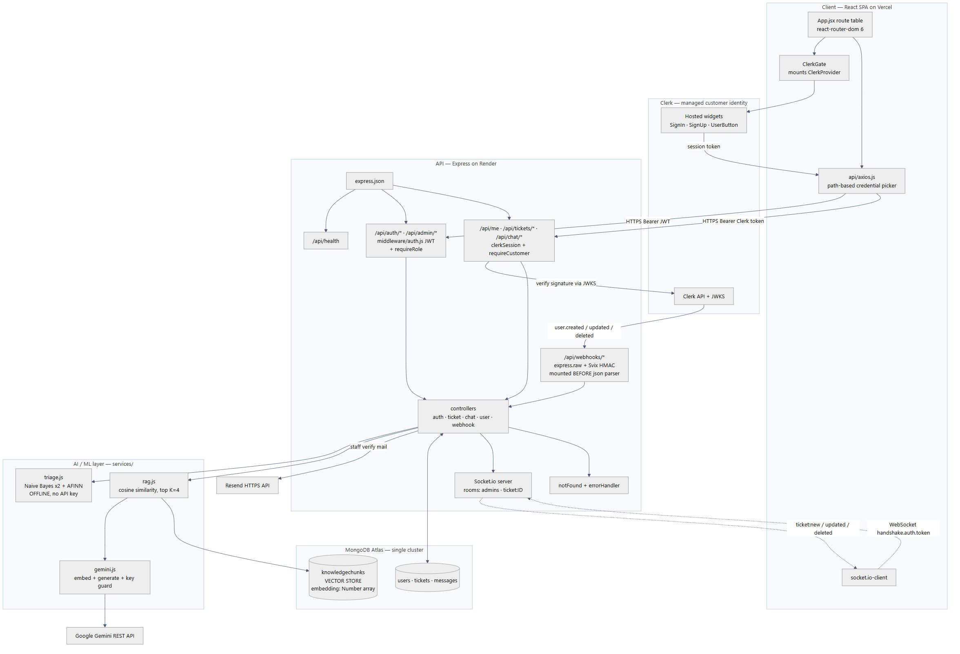
Diagram 1 — 1. High-Level System Architecture

1.1 The load-bearing rule: URL prefix ⇒ credential
There is no per-request flag deciding which token to attach. The URL space is deliberately partitioned so both the browser and the server can decide from the path alone. Moving a staff endpoint out from under /api/admin would silently start sending it a customer's Clerk token.
URL prefix | Caller | Credential | Verified by | Populates
/api/webhooks/* | Clerk's servers | Svix HMAC over the raw body | svix.Webhook.verify() | —
/api/health | anyone / uptime probe | none | — | —
/api/auth/* | staff browser | e-mail + password → JWT | bcrypt.compare then jwt.sign | req.user on /me only
/api/admin/* | staff browser | Bearer <custom JWT> | middleware/auth.js + requireRole('agent','admin') | req.user = {id, role} from the token payload
/api/me, /api/tickets/*, /api/chat/* | customer browser | Bearer <Clerk session token> | clerkSession → getAuth(req) → resolveCustomer() | req.user = {id, role:'customer', clerkId, email}, req.customer = full doc

Client mirror — src/api/axios.js: const STAFF_PATH = /^\/(admin|auth)(\/|$)/. Match ⇒ localStorage.token; otherwise ⇒ await clerkTokenGetter(). A 401 clears localStorage only on a staff path, so a failed customer request can never sign an admin out of their own board.

1.2 Middleware pipeline, in mount order (app.js)
1. cors({ origin }) — allow-list built from CLIENT_URL + CORS_ORIGINS; empty list ⇒ allow all (local only); a missing Origin header (curl, server-to-server) is never blocked.
2. `app.use('/api/webhooks', webhookRoutes)` — before any body parser. The router applies express.raw({ type: 'application/json' }) to its own path only. Once express.json() consumes the stream the original bytes are unrecoverable and the HMAC can never match again.
3. express.json()
4. GET /api/health → { ok, service, customerAuth: 'clerk' | 'off' } — the fastest way to prove which auth mode the deployed API booted in.
5. /api/auth → authRoutes (staff password + Resend verification)
6. /api/admin → adminRoutes, which begins router.use(auth, requireRole('agent','admin'))
7. GET /api/me → clerkSession, requireCustomer, myProfile
8. /api/tickets → clerkSession + ticketRoutes (which begins router.use(requireCustomer))
9. /api/chat → clerkSession + chatRoutes (same)
10. notFound → 404 { error: "Not found: <METHOD> <url>" }
11. errorHandler → CastError ⇒ 400 Invalid id; ValidationError ⇒ 400 with the Mongoose message; otherwise err.status || 500
clerkSession is created lazily and degrades to a passthrough when CLERK_SECRET_KEY/CLERK_PUBLISHABLE_KEY are absent — an unkeyed clerkMiddleware() calls next(err) and would turn every request it touches into a 500, taking the staff half of the app down with it.

1.3 Customer identity: Clerk ⇄ MongoDB mirroring
Ticket.user is a Mongoose ObjectId ref and the admin board's Customer column is a populate() of it, so a Clerk id string (user_2ab…) stored there would fail schema validation and destroy every join. Each Clerk account therefore gets exactly one local User document, linked by clerkId.
The mirror is created by two independent paths, so neither is a single point of failure:
Path | When | Code
Webhook (preferred) | Clerk POSTs user.created / user.updated / user.deleted | controllers/webhookController.js
Lazy resolver (fallback) | first authenticated request from an unseen clerkId | resolveCustomer() in middleware/clerkAuth.js

Without the fallback, signing up would appear to work and then every ticket call would fail with "customer not found" whenever the webhook is unconfigured — which is the normal state in local development. Two concurrent first-requests can both miss and both insert; the loser gets Mongo E11000 and simply re-reads the row that now exists.
Two hard rules inside the mirror (`upsertCustomerFromClerk`):
- role is hard-coded to 'customer' and is never read from a token claim, so no Clerk JWT claim can widen permissions.
- A Clerk email matching an existing non-customer row is refused with 409 staff_email_conflict — otherwise anyone able to receive mail at the admin address could sign up through Clerk and inherit that row's admin role.
- user.deleted is a soft delete (deletedAt = new Date()), because tickets and messages still reference the row; a hard delete would leave the admin board with unresolvable owners.

2. Core Backend Logic & AI Data Flow
OptiDesk runs two independent AI subsystems. They share no code path and fail independently:
 | Pipeline A — Triage | Pipeline B — RAG assistant
Trigger | POST /api/tickets (ticket creation) | POST /api/chat (customer question)
Engine | natural Naive Bayes ×2 + sentiment AFINN | Gemini embeddings + Gemini generation
Network | none — 100 % offline | Google Gemini REST, per request
Needs a key | no | yes (GEMINI_API_KEY)
Latency | sub-millisecond, synchronous | one embedding call + one generation call
Failure mode | falls back to general / normal | 503 GEMINI_NOT_CONFIGURED, or an honest "a human agent will follow up"
Writes | Ticket.category, .priority, .sentimentScore | two Message docs (customer, ai) + citations

2.1 Pipeline A — AI Triage & Ticket Creation, step by step
1. Browser — Tickets.jsx submits { subject, body }; axios matches no staff prefix, so it awaits Clerk's getToken() and attaches Authorization: Bearer <clerk session token>. getToken() is awaited per request, not cached at sign-in, because it silently refreshes a session about to expire.
2. `clerkSession` — clerkMiddleware() parses the token and populates req.auth.
3. `requireCustomer` — getAuth(req).userId → resolveCustomer() → local User doc → req.user = { id, role:'customer', clerkId, email }. Controllers never learn which auth system the caller used.
4. `createTicket` — rejects a missing subject/body with 400.
5. `triage(`subject + ' ' + body`)` (services/triage.js):
- categoryClf.classify(text) → billing | technical | account | general
- priorityClf.classify(text) → urgent | high | normal | low
- sentiment.analyze(text).score → signed integer (negative = unhappy)
- `escalate()` — when sentimentScore <= -3, priority moves one step more urgent (PRIORITIES[max(0, i-1)]), so an angry "this is broken and I'm furious" never sits at normal.
- Both classifiers are loaded once, asynchronously, at module load from ml/category.json and ml/priority.json. If those files are missing (npm run train never ran) or a label falls outside the enum, safeClassify() returns the safe default instead of throwing — a ticket is never lost to a missing model.
6. `Ticket.create({ user: req.user.id, subject, body, category, priority, sentimentScore })`
7. `await ticket.populate('user', 'name email role')` — done before broadcasting, otherwise the row that appears live on the admin board would have a blank Customer column.
8. `emit('ticket:new')` to room admins and room ticket:<id>.
9. `201` with the full ticket JSON, including the canDelete / awaitingConfirmation virtuals.
Training the classifiers — npm run train (ml/train.js) fits both models on 92 hand-labelled support tickets (billing 24, technical 24, account 22, general 22), each carrying both a category and a priority label, then serialises them with BayesClassifier.save(). ml/*.json is git-ignored: it is a build artefact, so npm run train is a required step on any fresh clone or deploy.

2.2 Pipeline B — RAG assistant, step by step
1. Ingest, offline — npm run ingest (scripts/ingestKnowledge.js) reads helpdesk-server/knowledge/*.{md,txt,pdf} (currently support-faq.md), splits on blank lines first so FAQ sections stay whole, then packs paragraphs into ≤500-word chunks, embeds each with gemini-embedding-001, and stores { source, text, embedding }. The collection is wiped first (deleteMany({})) so re-running never duplicates.
2. Question arrives — POST /api/chat { question, ticketId? }. If ticketId is present, ownership is enforced before any AI work: staff pass, otherwise String(ticket.user) !== req.user.id ⇒ 403.
3. Embed the query — embed(question) → query vector (input truncated to 8 000 chars).
4. Retrieve — KnowledgeChunk.find().lean() loads every chunk and ranks by in-memory cosine similarity; the top K = 4 become context. This is the deliberate trade-off documented in rag.js: exact and dependency-free for a few hundred chunks, and swappable for an Atlas Vector Search index behind the USE_ATLAS_VECTOR flag when the KB outgrows it.
5. Build the grounded prompt — chunks are numbered [1] (source: …); the system instruction constrains the model to answer only from the context, to admit ignorance rather than invent, and to cite inline.
6. Generate — generate(prompt) on GEMINI_CHAT_MODEL (default gemini-3.6-flash).
7. Persist — two Message docs (sender:'customer', then sender:'ai' with citations). Wrapped in its own try/catch: a save hiccup logs a warning and never fails the reply the customer is waiting for.
8. Respond — { text, citations: [{ source, snippet }] }; TicketChat.jsx renders [1] source-name chips under the bubble.

2.3 Sequence — message in, RAG context, LLM, decision, DB write, response out
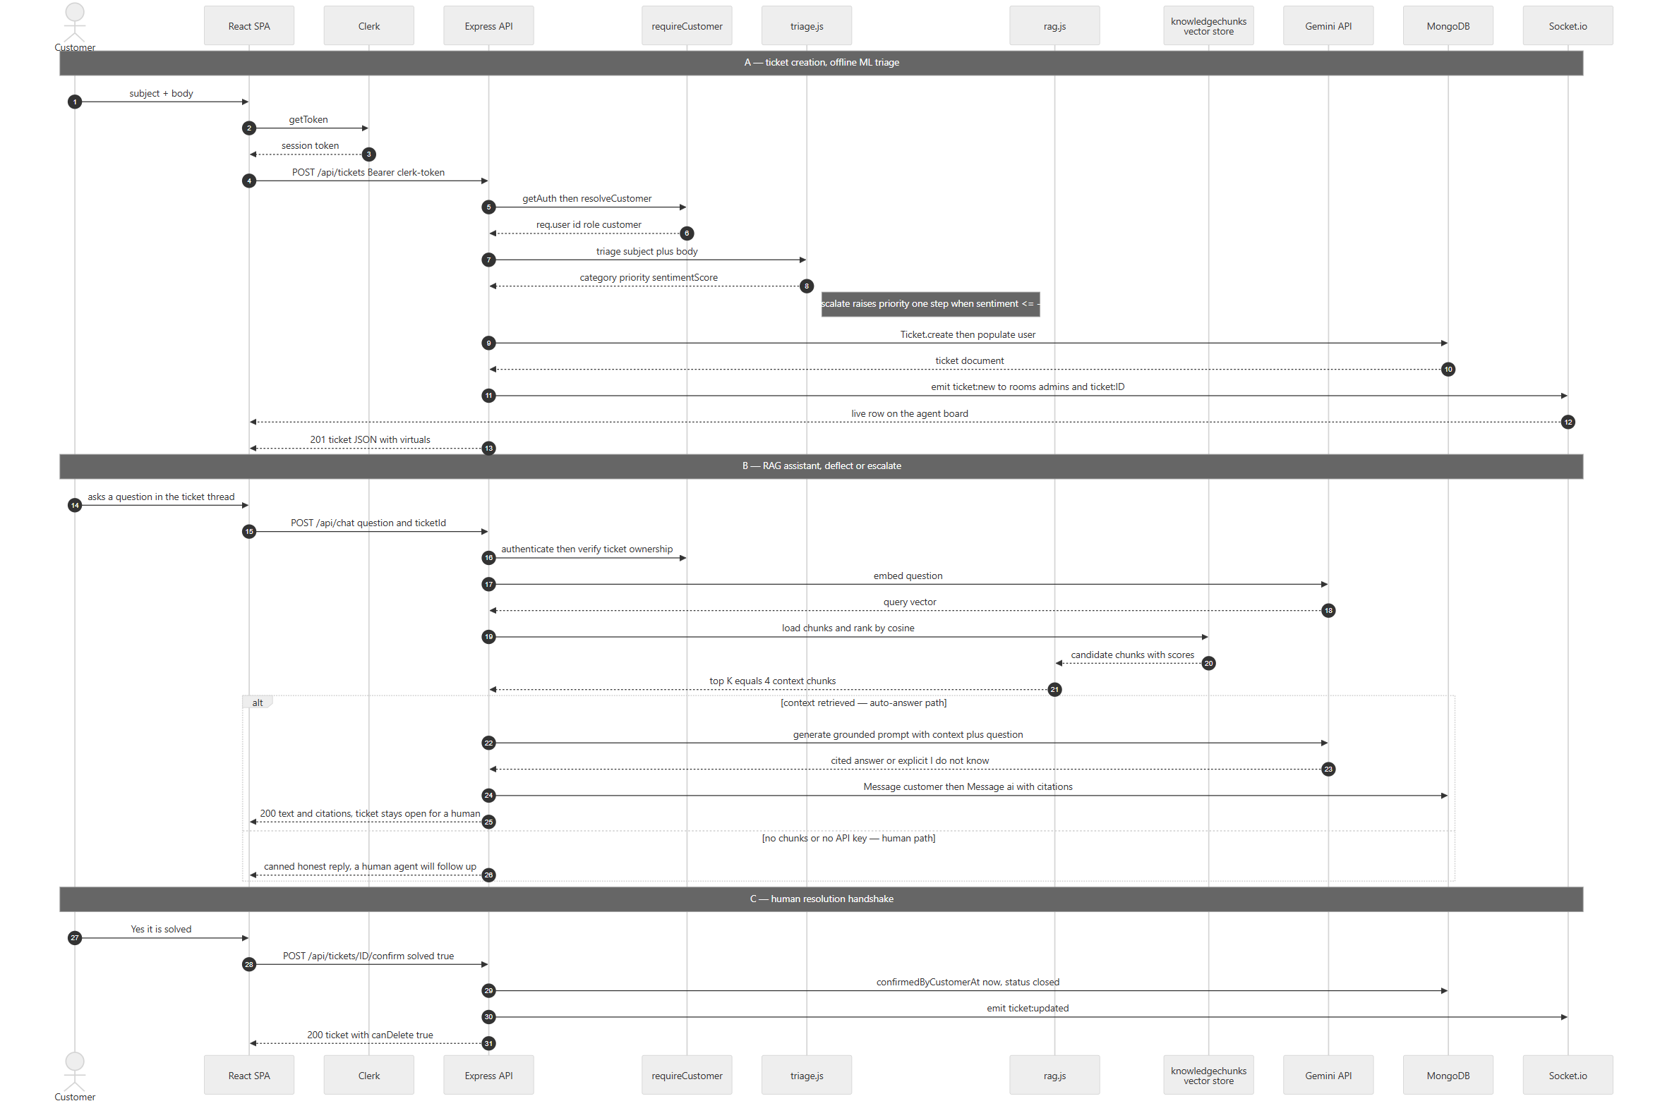
Diagram 2 — 2.3 Sequence — message in, RAG context, LLM, decision, DB write, response out
Deviation from the generic "LLM decides auto-resolve vs create ticket" pattern — stated plainly: in OptiDesk the ticket is created first, by the customer, and the escalate/deflect decision is not an LLM tool call. It is (a) a retrieval-confidence branch in rag.js — zero chunks ⇒ refuse to answer and hand off to a human — plus (b) the model's own instruction to say "I don't have that information" rather than invent one, plus (c) the human confirmation gate in §2.4. Nothing the LLM outputs can close a ticket. That is a security property, not an omission: an LLM that could set status would be a prompt-injection path straight into the ticket lifecycle.

2.4 Ticket lifecycle — a 3-step resolution handshake, enforced server-side
Neither an agent nor an admin can close or delete a ticket on the customer's behalf. status is not freely writable: updateTicket accepts only MANUAL_STATUSES = ['open','in_progress'] and answers 400 for anything else, naming the correct endpoint.
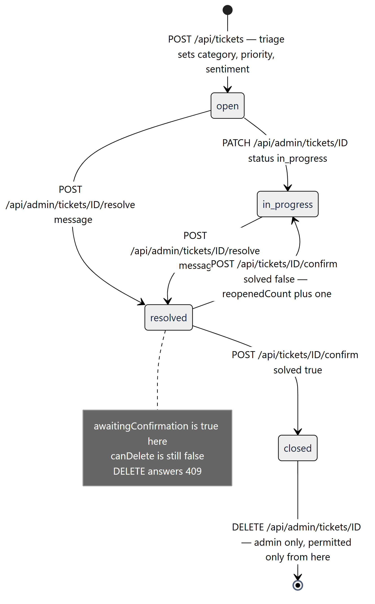
Diagram 3 — 2.4 Ticket lifecycle — a 3-step resolution handshake, enforced server-side
Step | Endpoint | Who | Side effects
1 — propose | POST /api/admin/tickets/:id/resolve { message } | agent / admin | status='resolved', resolutionRequestedAt=now, resolutionMessage, auto-assigns assignedTo to the responder if unset, writes a Message{sender:'agent'}, emits ticket:updated. Refuses 409 if already confirmed. Does not close the ticket and does not unlock deletion.
2 — confirm | POST /api/tickets/:id/confirm { solved, note? } | only the customer who raised it — staff are rejected 403 | solved:true ⇒ confirmedByCustomerAt=now, status='closed'; solved:false ⇒ clears the proposal, status='in_progress', reopenedCount++. Either way a Message{sender:'customer'} is written. 409 if no proposal exists yet.
3 — delete | DELETE /api/admin/tickets/:id | admin only | Refuses 409 until confirmedByCustomerAt is set, with a different message depending on whether a proposal is outstanding. On success: Message.deleteMany({ticket}) first (no orphaned chat rows), then ticket.deleteOne(), then emits ticket:deleted to admins.

2.5 Degradation matrix — what breaks when a key is missing
The app is designed to boot and stay useful with any subset of its integrations configured. server.js prints the state of each at startup so a misconfiguration never has to be diagnosed from a browser error.
Missing | Symptom | Still works
VITE_CLERK_PUBLISHABLE_KEY | clerkEnabled === false ⇒ ClerkProvider is not mounted; /login and /signup render a self-explaining card | the whole staff app, /admin/login included
CLERK_SECRET_KEY / CLERK_PUBLISHABLE_KEY (server) | 503 clerk_not_configured on /api/me, /api/tickets/*, /api/chat/*; boot log 🔐 Customer sign-in (Clerk): OFF | /api/health, /api/auth/*, /api/admin/*
CLERK_WEBHOOK_SECRET | 503 webhook_not_configured on the webhook; profile edits and deletions in Clerk stop propagating | sign-up — the mirror row is created lazily on first request
GEMINI_API_KEY | 503 GEMINI_NOT_CONFIGURED from /api/chat; the UI shows a specific "AI assistant is not configured" bubble | ticket creation, triage, the whole staff board — triage is offline
ml/*.json (never trained) | every ticket lands as general / normal, one warning per classifier at boot | everything else
knowledgechunks empty | the assistant says it has nothing to answer from and defers to a human — it does not hallucinate | everything else
RESEND_API_KEY / unverified MAIL_FROM | staff verification mail not sent; the link is printed to the API console instead; register replies emailSent:false, mailConfigured:<bool> | account creation, and POST /api/auth/resend later
MONGO_URI | process.exit(1) at boot — this one is genuinely fatal | —

3. Database Schema
Four collections in one MongoDB database. Mongoose pluralises and lowercases the model name, so User → users, Ticket → tickets, Message → messages, KnowledgeChunk → knowledgechunks.
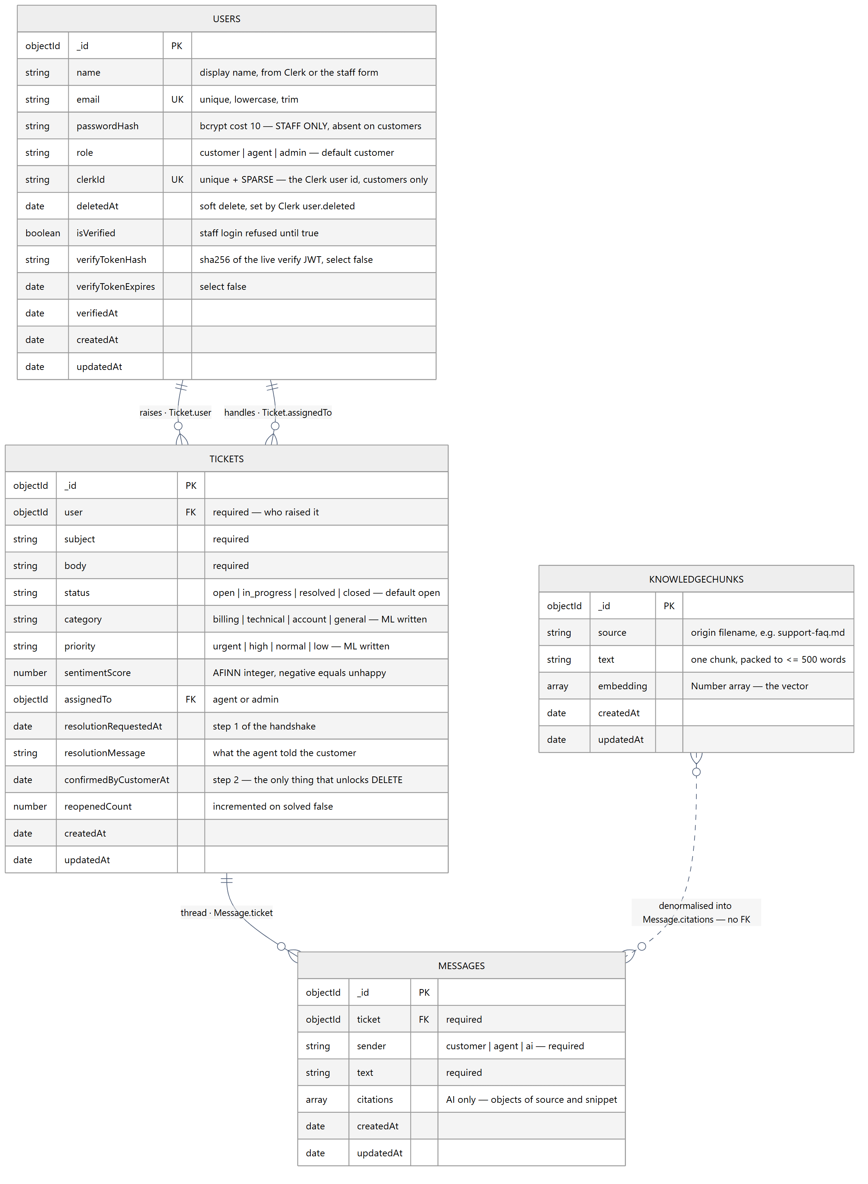
Diagram 4 — 3. Database Schema

3.1 Indexes and schema-level constraints
Collection | Index / constraint | Why it is shaped that way
users | email — unique | one account per address across all three roles; queries are pre-normalised with normEmail() because Mongoose does not apply lowercase/trim setters to query filters, so findOne({email:'Me@x.com'}) would miss the stored me@x.com
users | clerkId — unique + sparse | sparse is what lets one index serve both kinds of account: staff rows have no clerkId at all, and a plain unique index would treat every one of their null values as a duplicate of the first
users | verifyTokenHash, verifyTokenExpires — select: false | never returned by an ordinary query; authController must opt in with .select('+verifyTokenHash')
tickets | user, assignedTo — refs to User | populate('user','name email role') is what turns an id into the board's Customer column
tickets | status, category, priority — enums | an invalid value raises ValidationError ⇒ 400, not a silently corrupt row
messages | ticket — ref, required | deleted en masse before the parent ticket, so no orphan rows survive
knowledgechunks | none — full collection scan by design | cosine ranking happens in Node; USE_ATLAS_VECTOR is the documented switch to an Atlas Vector Search index

3.2 Ticket virtuals — one source of truth for UI and API
Declared with toJSON: { virtuals: true }, so they are serialised into every response and the client never re-derives the rule:
Virtual | Definition | Consumed by
canDelete | Boolean(confirmedByCustomerAt) | admin UI enables/disables Delete; deleteTicket enforces the identical condition server-side
awaitingConfirmation | Boolean(resolutionRequestedAt) && !confirmedByCustomerAt | the customer's "Is your problem solved?" panel and the Action needed banner

3.3 Referential integrity notes
- `knowledgechunks` is standalone. AI citations are denormalised copies ({source, snippet}) written onto the Message document, so a chat thread stays readable and auditable even after the knowledge base is re-ingested and every chunk _id changes.
- Cascade on delete is manual and ordered: Message.deleteMany({ ticket }) runs before ticket.deleteOne(). Mongoose fires no cascade of its own.
- Users are never hard-deleted. deletedAt is a soft flag; listCustomers filters { role:'customer', deletedAt: { $exists: false } }, and resolveCustomer treats a soft-deleted row as absent, then clears deletedAt if that Clerk account returns.
- Aggregation, not N+1: GET /api/admin/customers joins one Ticket.aggregate() grouped by $user — producing total, open and lastTicketAt per customer — onto the user list, instead of a per-customer count query.
- Embedding dimension is model-defined, not schema-constrained: embedding is an unconstrained [Number]. Two in-code comments disagree about the length (KnowledgeChunk.js says 3072 for gemini-embedding-001, gemini.js says 768) — harmless today because cosine is computed in JS, but the true length must be pinned as numDimensions before an Atlas Vector index can be built, and every chunk must be re-ingested with one model: vectors from different embedding models are not comparable.

4. API & Routing Contract
Base URL <API_URL>/api. 25 routes, in real mount order (node scripts/dumpRoutes.js prints exactly this list). "Auth level" is the credential the route requires; ownership checks marked owner are enforced inside the controller, not by the router.
Endpoint | Method | Auth Level (Role) | Action / Purpose
/webhooks/clerk | POST | Svix HMAC (Clerk's servers) | user.created/user.updated ⇒ upsert the local mirror; user.deleted ⇒ soft delete. Raw body, mounted before express.json(). 503 if unconfigured, 400 bad_signature if forged
/health | GET | public | liveness + which auth mode booted: { ok, service, customerAuth: 'clerk' | 'off' }
/auth/register | POST | public + ADMIN_SIGNUP_CODE | create a staff account (role admin only). A role:'customer' body is refused 400 use_customer_signup with the correct URL. Issues + emails the verification link, returns emailSent / mailConfigured
/auth/login | POST | public | bcrypt compare ⇒ 7-day JWT {id, role}. Unverified ⇒ 403 needsVerification. Every 401 carries the same constant hint (never conditional — see §6)
/auth/verify-email | GET | public (signed token) | consume the verify JWT ⇒ isVerified=true. 200 success | already, 400 invalid, 410 expired
/auth/verify | GET | public (signed token) | legacy link shape — 302s to the client page carrying the token
/auth/resend | POST | public | re-issue the link. One identical reply for every outcome (unknown / verified / sent / provider down) so it cannot be used as an account oracle
/auth/me | GET | staff JWT | current staff profile, passwordHash stripped
/admin/tickets | GET | agent | admin | the whole board. Filters: status, priority, category, customer, q (regex-escaped, matches subject or body); newest first; user + assignedTo populated
/admin/tickets/:id | GET | agent | admin | one ticket, both people populated
/admin/tickets/:id | PATCH | agent | admin | set assignedTo, priority, and status — restricted to `open`/`in_progress`; anything else ⇒ 400 naming /resolve. Emits ticket:updated
/admin/tickets/:id/resolve | POST | agent | admin | step 1: propose a fix, status='resolved', write an agent Message, auto-assign the responder. 409 if already confirmed
/admin/tickets/:id | DELETE | admin only | step 3: hard delete + cascade messages. 409 until confirmedByCustomerAt is set
/admin/customers | GET | agent | admin | customer directory + per-customer total / open / lastTicketAt from one aggregation; soft-deleted rows excluded
/admin/agents | GET | agent | admin | staff list for the assignee dropdown (role in ['agent','admin'])
/admin/customers/:id | GET | agent | admin | one customer profile + their full ticket history { user, tickets }
/admin/chat | POST | agent | admin | the same RAG controller as the customer route, under the staff credential
/admin/chat/:ticketId/history | GET | agent | admin | full message thread for any ticket
/me | GET | Clerk session | the customer's local mirror: { _id, id, clerkId, name, email, role, isVerified, createdAt }. Required because ownership is a Mongo _id that the Clerk token does not carry
/tickets | POST | Clerk session (customer) | create ticket ⇒ offline triage ⇒ broadcast `ticket:new` (Pipeline A)
/tickets | GET | Clerk session (customer) | list, hard-scoped to { user: req.user.id } in the controller
/tickets/:id | GET | Clerk session, owner | one ticket; 403 if ticket.user._id !== req.user.id
/tickets/:id/confirm | POST | Clerk session, owner only | step 2: {solved:true} ⇒ closed + unlocks DELETE; {solved:false} ⇒ in_progress, reopenedCount++. Staff get 403 — an admin must not confirm on the customer's behalf
/chat | POST | Clerk session (customer) | RAG answer — embed ⇒ cosine top-4 ⇒ Gemini ⇒ {text, citations}; persists both messages when ticketId is given (Pipeline B)
/chat/:ticketId/history | GET | Clerk session, owner | prior thread, ascending by createdAt, so a page refresh loses nothing

4.1 Error contract
Every failure is JSON with an error string; machine-readable failures add a stable code.
Status | code | Raised by | Meaning
400 | — | errorHandler on CastError | malformed ObjectId in the URL ⇒ Invalid id
400 | — | errorHandler on ValidationError | enum / required-field violation, Mongoose message passed through
400 | use_customer_signup | authController.resolveRole | a customer POSTed to the staff register endpoint
400 | bad_signature | webhookController | wrong CLERK_WEBHOOK_SECRET, replayed timestamp, or a forged call
401 | signed_out | requireCustomer | no userId on the Clerk session
401 | no_mirror | requireCustomer | authenticated, but the local User row could not be loaded
401 | — | middleware/auth.js | missing/expired/tampered staff JWT, or a token carrying a purpose claim
403 | — | requireRole, ownership checks | authenticated but not permitted
403 | needsVerification in body | authController.login | correct password, unproven email address — no token issued
409 | — | deleteTicket, proposeResolution | lifecycle rule violated (see §2.4)
409 | staff_email_conflict | upsertCustomerFromClerk | a Clerk account's email belongs to a staff row — privilege-escalation guard
410 | — | verifyEmail | verification link older than EMAIL_VERIFY_TTL (24 h default)
503 | clerk_not_configured | requireCustomer | server Clerk keys absent — short-circuits before inspecting the token, so the message is actionable
503 | webhook_not_configured | webhookController | CLERK_WEBHOOK_SECRET absent
503 | GEMINI_NOT_CONFIGURED | services/gemini.js | key missing or still a placeholder — "the code is fine, the key isn't"
404 | — | notFound | Not found: <METHOD> <originalUrl> — the signature of calling a route the deployed API doesn't have yet

4.2 Realtime contract — Socket.io
Handshake (io.use) — the client sends whichever token it holds as handshake.auth.token; an unauthenticated socket is refused outright, because CORS alone does not stop a script from opening a socket to the port. Staff is tried first (local jwt.verify, no network); only tokens JWT_SECRET cannot verify fall through to Clerk's verifyToken() against the JWKS, whose sub is then mapped through resolveCustomer() to a Mongo _id — because every room check below compares against Ticket.user.
Direction | Event | Payload | Authorisation
client → server | join:admins | — | staff only; a customer's join is silently ignored
client → server | join:ticket | ticket _id | staff, or String(ticket.user) === socket.user.id
server → client | ticket:new | populated ticket | rooms admins + ticket:<id>
server → client | ticket:updated | populated ticket | rooms admins + ticket:<id>
server → client | ticket:deleted | { _id } | room admins only

Rooms carry whole ticket payloads — subject, body, the customer's name and email, the agent's resolutionMessage — so joining a room is reading customer data, and both joins are therefore authorised exactly the way GET /api/tickets/:id is. CORS origins are the same list app.js exports, so a tunnelled or deployed frontend gets live updates instead of failing silently.
Current client coverage: only AdminDashboard.jsx opens a socket (join:admins, then re-fetches the board on all three events). The server-side ticket:<id> room is authorised and emitted to, but the customer's TicketChat.jsx does not subscribe yet — it re-fetches on navigation instead. Wiring join:ticket into that page is a client-only change; the server side already exists.

5. Codebase Structure
Separation of concerns, one direction of dependency: routes (URL → handler, no logic) → controllers (HTTP + authorisation + orchestration) → services (reusable business/AI logic, no req/res) → models (schemas). middleware is cross-cutting; scripts are one-off operations that never run at request time.
Layer | Knows about | Must never | Files
routes/ | controllers, guards | contain business logic | 5 routers
controllers/ | models, services, req/res | know which auth system authenticated the caller — it reads req.user only | 5 controllers
services/ | models, external SDKs | touch req/res or HTTP status codes (it throws err.status instead) | 5 services
models/ | mongoose only | reach out to services | 4 schemas
middleware/ | models, auth SDKs | own domain rules | 3 files

OptiDesk/
├── ARCHITECTURE.md # this document
├── DEPLOYMENT.md # Atlas + Render + Vercel runbook
│
├── helpdesk-server/ # ── REST API + WebSocket (Render) ──
│ ├── server.js # entry: dotenv → connectDB → http+Socket.io → boot diagnostics
│ ├── app.js # express app: CORS, webhook-before-json, 5 routers, error handlers
│ ├── socket.js # Socket.io init, dual-credential handshake, room authorisation
│ ├── nodemon.json
│ ├── .env / .env.example # .env* is git-ignored except .env.example
│ │
│ ├── config/
│ │ └── db.js # mongoose.connect(MONGO_URI), exit(1) on failure
│ │
│ ├── middleware/
│ │ ├── auth.js # STAFF: jwt.verify + reject `purpose` tokens + requireRole(...)
│ │ ├── clerkAuth.js # CUSTOMER: clerkSession, requireCustomer, resolveCustomer,
│ │ │ # upsertCustomerFromClerk, isClerkConfigured
│ │ └── error.js # notFound + centralised errorHandler
│ │
│ ├── models/ # Mongoose schemas — the only place field shapes are defined
│ │ ├── User.js # dual identity: passwordHash (staff) | clerkId (customer)
│ │ ├── Ticket.js # lifecycle + ML fields + canDelete/awaitingConfirmation virtuals
│ │ ├── Message.js # sender: customer | agent | ai, citations[]
│ │ └── KnowledgeChunk.js # source, text, embedding[] ← the vector store
│ │
│ ├── routes/ # thin URL → controller mapping only
│ │ ├── authRoutes.js # STAFF sign-in (custom JWT + Resend)
│ │ ├── adminRoutes.js # router.use(auth, requireRole('agent','admin')) then 10 routes
│ │ ├── ticketRoutes.js # router.use(requireCustomer) then 4 routes
│ │ ├── chatRoutes.js # router.use(requireCustomer) then 2 routes
│ │ └── webhookRoutes.js # express.raw({type:'application/json'}) + clerkWebhook
│ │
│ ├── controllers/ # HTTP handling + authorisation + orchestration
│ │ ├── authController.js # staff register/login/verify/resend/me; SELF_SERVE_ROLES=['admin']
│ │ ├── ticketController.js # create+triage, list, get, update, resolve, confirm, delete, emit()
│ │ ├── chatController.js # RAG endpoint + history, with ticket-ownership checks
│ │ ├── userController.js # myProfile + staff directory (customers/agents/one customer)
│ │ └── webhookController.js # Svix verify → user.created/updated/deleted
│ │
│ ├── services/ # reusable logic — no req/res anywhere in here
│ │ ├── triage.js # PIPELINE A: Bayes x2 + AFINN + escalate(), offline
│ │ ├── rag.js # PIPELINE B: retrieve() cosine top-K, buildPrompt(), answer()
│ │ ├── gemini.js # embed()/generate() + key-shape guard + GeminiNotConfigured(503)
│ │ ├── mailer.js # Resend HTTPS send, HTML template, boot credential check
│ │ └── verifyToken.js # sign/read the verify JWT on a DERIVED secret + purpose + jti
│ │
│ ├── ml/ # trained model artefacts — git-ignored, built by `npm run train`
│ │ ├── train.js # 92 labelled tickets → two BayesClassifiers
│ │ ├── category.json # generated
│ │ └── priority.json # generated
│ │
│ ├── knowledge/ # RAG source documents (.md / .txt / .pdf)
│ │ └── support-faq.md
│ │
│ └── scripts/ # one-off ops, never mounted
│ ├── ingestKnowledge.js # chunk → embed → KnowledgeChunk (npm run ingest)
│ ├── seedAdmin.js # create the first verified admin (npm run seed:admin)
│ ├── verifyExistingUsers.js # backfill isVerified (npm run verify:existing)
│ ├── testMail.js # prove Resend credentials (npm run mail:test)
│ └── dumpRoutes.js # print the live route table in mount order
│
└── helpdesk-client/ # ── React SPA (Vercel) ──
├── vercel.json # SPA rewrite: every path → index.html (deep links)
├── vite.config.js # react() + tailwindcss() plugins, dev port 5173
├── .env.development # VITE_API_URL=http://localhost:5000
├── .env.production # VITE_API_URL=<render url>
├── .env.example # documents both, and which file wins per mode
├── index.html
└── src/
├── main.jsx # BrowserRouter → ClerkGate → AuthProvider → CustomerProvider → App
├── App.jsx # route table + BARE_PREFIXES (which pages hide the navbar)
├── clerk.js # CLERK_PUBLISHABLE_KEY + clerkEnabled shape check + setup hint
├── index.css # Tailwind v4 @theme block + all component styles (918 lines)
│
├── api/
│ └── axios.js # ONE instance; STAFF_PATH regex picks JWT vs Clerk token
│
├── context/
│ ├── AuthContext.jsx # STAFF session: login/register/logout, localStorage token
│ └── CustomerContext.jsx # CUSTOMER profile from GET /api/me (supplies the Mongo _id)
│
├── components/
│ ├── ClerkGate.jsx # mounts <ClerkProvider> only when clerkEnabled; token bridge
│ ├── CustomerRoute.jsx # Clerk guard → /login; redirects staff to /admin
│ ├── ProtectedRoute.jsx # JWT + role guard → /admin/login, remembers `from`
│ ├── Navbar.jsx # three states: staff badge | customer <UserButton/> | signed out
│ ├── DataTable.jsx # responsive table → cards on mobile, shared by 4 pages
│ ├── AuthLayout.jsx # split-screen branding shell for auth pages
│ ├── CustomerCell.jsx # name + email cell used across the staff board
│ └── PasswordField.jsx # input with show/hide toggle
│
├── pages/
│ ├── CustomerAuth.jsx # <SignIn/> + <SignUp/> + shared Clerk `appearance` + unavailable card
│ ├── AdminLogin.jsx # STAFF form — the original JWT mechanism, preserved verbatim
│ ├── AdminRegister.jsx # STAFF sign-up, requires the admin code
│ ├── VerifyNotice.jsx # "check your inbox" + resend
│ ├── VerifyEmail.jsx # consumes ?token= and reports success/expired/invalid
│ ├── Tickets.jsx # CUSTOMER: create form + own list, "Action needed" banner
│ ├── TicketChat.jsx # CUSTOMER: AI thread + citations + "Is it solved?" buttons
│ ├── AdminDashboard.jsx # STAFF: live board (socket.io), filters, inline triage
│ ├── AdminTicketDetail.jsx # STAFF: assign, re-prioritise, propose resolution, delete
│ ├── AdminCustomers.jsx # STAFF: directory + aggregated stats
│ └── AdminCustomerDetail.jsx # STAFF: one customer + their ticket history
│
└── utils/
└── format.js # fmtDate, statusLabel

5.1 Provider nesting, and why the order is fixed
Diagram 5 — 5.1 Provider nesting, and why the order is fixed
- `ClerkGate` must sit inside `BrowserRouter` — routerPush/routerReplace are what keep Clerk's multi-step flows (SSO callback, 2FA, password reset) navigating through React Router instead of doing a full page reload.
- `ClerkProvider` throws synchronously on a missing or malformed publishableKey. Because it wraps the router, that throw is not "customer sign-in is broken" — it is a blank page for the entire app, staff sign-in included. Hence the clerkEnabled shape check (/^pk_(test|live)_.{8,}$/) and the no-provider fallback path.
- `ClerkTokenBridge` installs the token getter twice, deliberately: once during render (React effects run children-first, so an effect alone would fire after CustomerProvider's /me call and the first customer request would go out unauthenticated) and once in the effect (StrictMode mounts → unmounts → remounts; the cleanup nulls the getter and nothing else would put it back). The assignment is idempotent.
- Every Clerk-hook-calling component is selected at module scope, never conditionally inside a render body — export default clerkEnabled ? ClerkGuard : DisabledGuard, const SignInPage = clerkEnabled ? CustomerSignIn : CustomerAuthUnavailable. Choosing inside a component would change hook order between renders and crash React.

5.2 Why GET /api/me exists at all
A Clerk session token carries a Clerk user id (user_2ab…). Ownership in this database is a Mongo ObjectId (Ticket.user). TicketChat.jsx must know "am I the person who raised this ticket?" to show the confirm buttons, and comparing the Clerk id against ticket.user would never match — hiding the only action on the page from the one person allowed to take it. CustomerContext fetches /api/me once and exposes { profile, loading, ready, error, refresh }; the component gates on ready because until the call returns, profile is null and a bare profile?.id === ownerId reads as "not the owner".

6. Security Model
Authentication
- Customers: delegated entirely to Clerk. Passwords, sign-up, email verification, MFA and session lifetime are not this server's problem, and no customer credential is ever stored locally.
- Staff: bcrypt hashes at cost 10; stateless JWT {id, role} with a 7-day expiry in localStorage. /api/auth/login refuses to issue a token until isVerified is true.
- A staff JWT cannot reach a customer route and vice versa — the URL partition means neither middleware ever runs on the other's path.
Authorisation
- requireRole('agent','admin') gates the entire /api/admin router; DELETE narrows further to requireRole('admin').
- Ownership is re-checked inside controllers, not inferred from the guard: a valid customer token still cannot read, chat about, or confirm somebody else's ticket.
- Role is never read from a token claim on the customer path. requireCustomer sets role:'customer' as a literal, so no Clerk JWT claim — however crafted — can widen permissions.
- The staff_email_conflict 409 closes the escalation path where someone able to receive mail at the admin address signs up through Clerk and inherits that row's admin role.
Token hygiene
- The email-verification JWT is signed with a derived secret (${JWT_SECRET}::verify-email, overridable via EMAIL_VERIFY_SECRET). middleware/auth.js accepts anything JWT_SECRET signs, so a verify link signed with the raw secret would work as a session Bearer token for its whole lifetime.
- Second lock: the token carries purpose: 'verify-email', and both middleware/auth.js and the Socket.io handshake reject any token carrying a purpose claim.
- Only the sha256 fingerprint of the live token is stored (verifyTokenHash, select:false), which makes each link single-use and makes a resend retire the previous one. A leaked database dump cannot be replayed to verify an account.
- A random jti is included because signing is deterministic and iat has only second resolution — without it, a resend inside the same second produces a byte-identical token and the fingerprint that is supposed to retire the old link would not change.
Enumeration and oracle resistance
- POST /api/auth/resend returns one identical response for unknown address, already-verified, sent, and provider failure. The real reason goes to the API console. mailConfigured is a property of the server, not of the address, so the UI stays actionable without identifying anybody.
- POST /api/auth/login attaches the "this is the staff sign-in" hint to every 401, never conditionally — a conditional hint would answer "does this address exist, and is it a customer?" for anyone who asked.
- !user.passwordHash is checked before bcrypt.compare, because compare(pw, undefined) throws and used to surface as a 500 on the ordinary mistake of a customer using the staff form.
Webhook integrity — the endpoint is public by necessity (Clerk's servers call it, not a signed-in browser). Verification is therefore mandatory, not optional: without it anyone could POST a fabricated user.created and plant rows in users. Svix covers signature and timestamp replay. The raw body is never re-serialised — JSON.stringify would reorder keys and break the HMAC.
Injection and transport
- Search input is regex-escaped (escapeRx) before being compiled into a RegExp, so q cannot become a ReDoS or a wildcard scan.
- Mongoose casting + enums reject malformed ids and out-of-range statuses at the schema boundary (CastError ⇒ 400, not a 500).
- CORS is an explicit allow-list from CLIENT_URL + CORS_ORIGINS, shared verbatim with Socket.io. An empty list means allow-all, which is only sane locally.
- Only `VITE_*` values reach the browser, and every one of them is public by design (API URL, Clerk publishable key). Vite inlines them into the bundle — a secret in a VITE_* variable is a published secret.
- Server .env files are git-ignored by the pattern .env* with !.env.example, so .env.bak, .env.local and .env.production are covered too.
Known residual risks
- Staff JWTs live in localStorage and are readable by any XSS on the origin; there is no refresh/revocation list, so a stolen token is valid for up to 7 days. Moving staff sessions to an httpOnly cookie is the mitigation.
- POST /api/auth/register is public and gated only by a shared static ADMIN_SIGNUP_CODE; if it is unset the endpoint disables itself. Prefer npm run seed:admin and leave the code unset in any public deployment.
- No rate limiting on /api/auth/login or /api/chat — the first invites credential stuffing, the second invites cost. express-rate-limit on both is the smallest useful hardening step.

7. Configuration Reference

7.1 helpdesk-server/.env — all secret, never committed
Variable | Required | Consumed by | Notes
MONGO_URI | yes | config/db.js | Atlas SRV string. Missing ⇒ exit(1)
PORT | no (5000) | server.js | EADDRINUSE prints a diagnostic and exits rather than a bare stack trace
JWT_SECRET | yes | middleware/auth.js, authController, socket.js, verifyToken.js | staff sessions and the base for the derived verify secret
CLIENT_URL | yes in prod | app.js CORS, authController link base | primary browser origin; also the base of the emailed link
CORS_ORIGINS | no | app.js, socket.js | extra origins, comma-separated — needed the moment the SPA has more than one address
CLERK_PUBLISHABLE_KEY | for customers | clerkAuth.isClerkConfigured | pk_test_… / pk_live_…; names the Clerk instance
CLERK_SECRET_KEY | for customers | clerkMiddleware, verifyToken | sk_test_… / sk_live_…. Both Clerk keys must be present or customer routes 503
CLERK_WEBHOOK_SECRET | for sync | webhookController | must start whsec_; absent ⇒ the mirror is created lazily instead
GEMINI_API_KEY | for the AI assistant | services/gemini.js | AI Studio key; accepts both AIza… and AQ.… shapes, rejects placeholders
GEMINI_CHAT_MODEL | no | services/gemini.js | default gemini-3.6-flash; the embedding model is fixed at gemini-embedding-001
RESEND_API_KEY | for staff mail | services/mailer.js | re_…; "Sending access" is enough
MAIL_FROM | no | services/mailer.js | e.g. OptiDesk <no-reply@yourdomain.com>; unset falls back to Resend's sandbox sender, which delivers only to your own Resend account address
MAIL_TIMEOUT_MS | no (10 000) | services/mailer.js | send timeout
EMAIL_VERIFY_TTL | no (24h) | services/verifyToken.js | link lifetime
EMAIL_VERIFY_SECRET | no | services/verifyToken.js | overrides the derived secret; leave unset unless rotating independently
ADMIN_SIGNUP_CODE | no | authController.resolveRole | unset ⇒ public admin sign-up is disabled entirely
ADMIN_EMAIL / ADMIN_NAME / ADMIN_PASSWORD | for seeding | scripts/seedAdmin.js | one-time bootstrap of the first verified admin
USE_ATLAS_VECTOR | no (false) | services/rag.js (documented switch) | flip once an Atlas Vector Search index exists
API_URL | no | diagnostics | the API's own public URL

7.2 helpdesk-client — public by definition
Which file wins: npm run dev loads .env + .env.development (+ .env.local); npm run build loads .env + .env.production (+ .env.local). Mode-specific values therefore belong in the two mode files, not in .env.
Variable | Dev value | Prod value | Effect if empty
VITE_API_URL | http://localhost:5000 | the Render URL | falls back to http://localhost:5000 — pointing dev at the deployed API is what produces Not found: POST /api/tickets/<id>/resolve for routes that work perfectly on your machine
VITE_CLERK_PUBLISHABLE_KEY | pk_test_… (dev instance) | pk_live_… (prod instance — a separate Clerk instance with its own user list) | clerkEnabled=false: /login and /signup explain themselves, /admin/login unaffected

Vite inlines every `VITE_*` value into the JavaScript bundle it ships to the browser. A VITE_* variable is a public constant with extra steps. Publishable keys belong there; sk_…, whsec_…, re_…, JWT_SECRET and MONGO_URI never do — they live only in helpdesk-server/.env and the API host's own environment panel.

7.3 Key-pair discipline
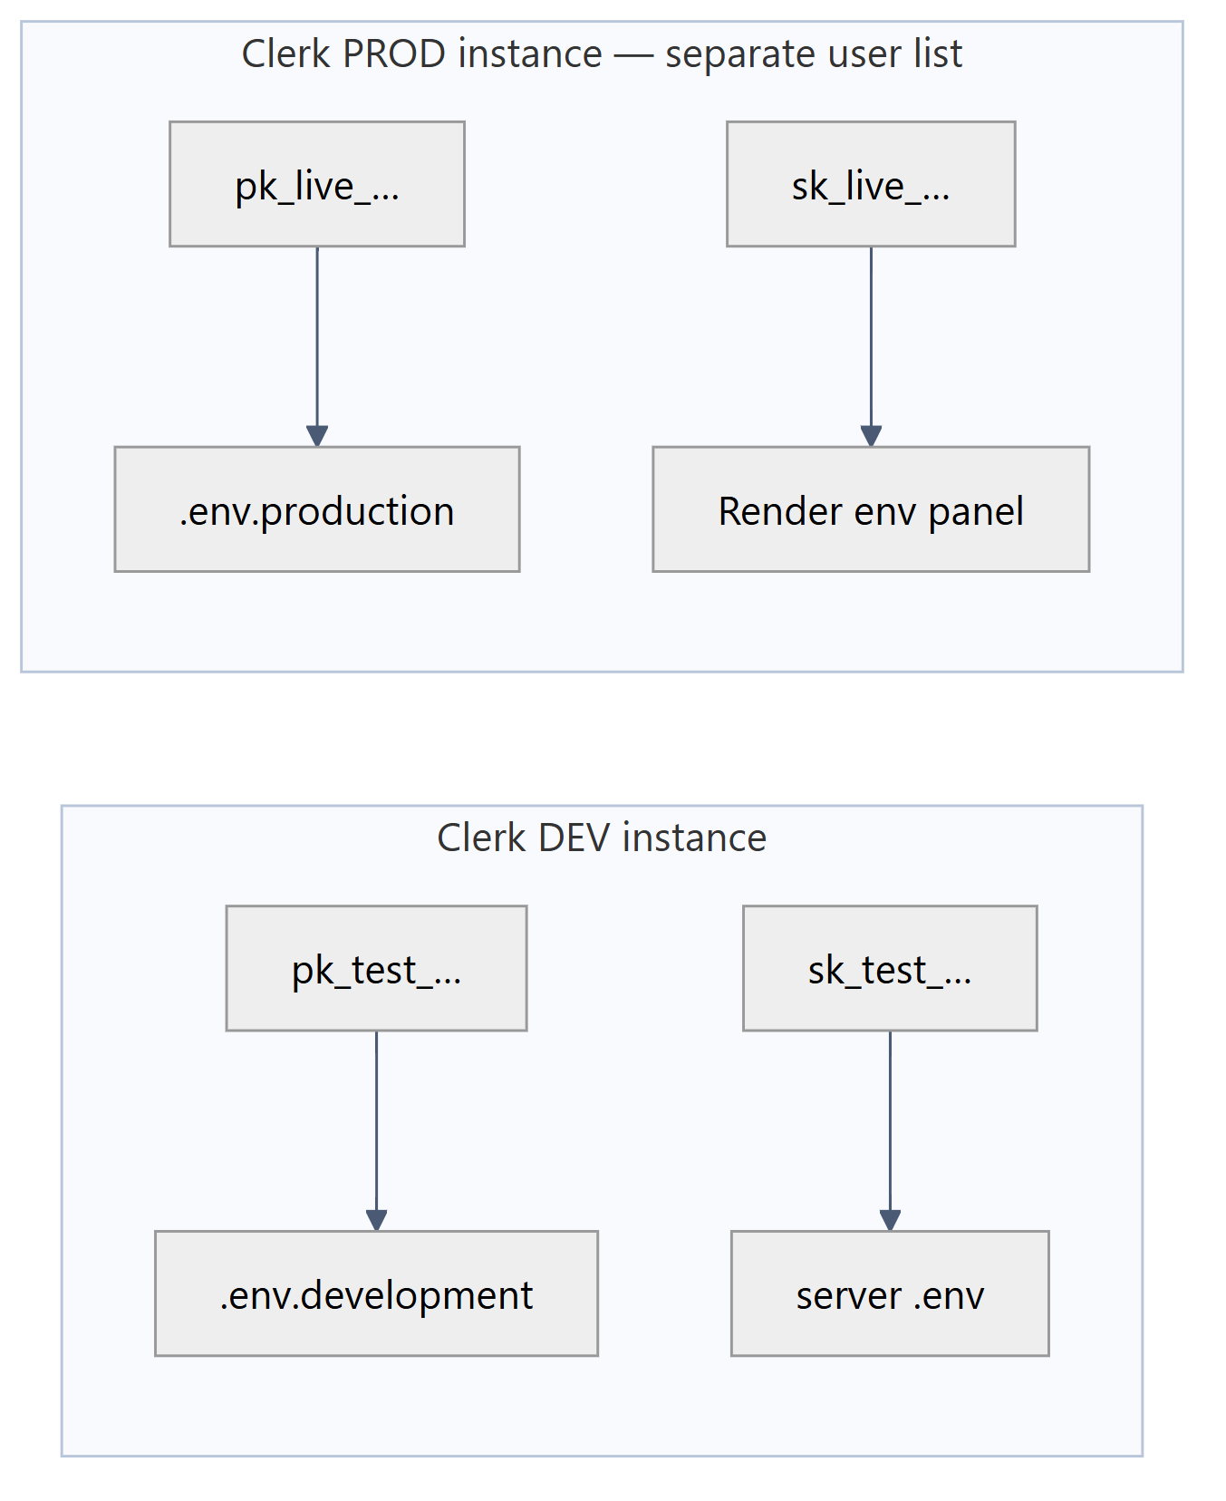
Diagram 6 — 7.3 Key-pair discipline
- A pk_test_ in the browser with an sk_live_ on the server means the two halves talk about different Clerk instances: every session token the client mints fails verification server-side. The instance prefix must match on both sides.
- GET /api/health reports {"customerAuth":"clerk"|"disabled"} — the fastest check that the server half is wired.

8. Operational Runbook

8.1 npm scripts
Script | Command | Purpose | When
dev | nodemon server.js | API with reload | daily
start | node server.js | production entrypoint | Render
train | node ml/train.js | fits both Naive Bayes classifiers, writes ml/category.json + ml/priority.json | first run, every fresh clone, every deploy — the artefacts are git-ignored
ingest | node scripts/ingestKnowledge.js <dir> | wipes knowledgechunks, re-chunks and re-embeds a folder of .txt/.md/.pdf | whenever the knowledge base changes
seed:admin | node scripts/seedAdmin.js | creates/updates the first admin from ADMIN_*, pre-verified | bootstrap
verify:existing | node scripts/verifyExistingUsers.js | back-fills isVerified: true on rows created before verification existed | one-off migration
mail:test | node scripts/testMail.js <to> | proves the Resend key and MAIL_FROM in isolation from the app | when a link never arrives

scripts/dumpRoutes.js is not wired to a script name — run it with node scripts/dumpRoutes.js to print the live Express route table straight off app._router. It is the authoritative answer to "does this deployment actually have that endpoint", which no amount of reading the client can settle.

8.2 First-run order (order matters)
Diagram 7 — 8.2 First-run order (order matters)
Steps 3–5 are each independently skippable and each degrades one feature rather than breaking boot: no ml/*.json ⇒ every ticket lands general/normal; no admin ⇒ no way into /admin/login; no chunks ⇒ the assistant answers honestly that it has no knowledge base.

8.3 Boot banner — the four lines to read
✅ MongoDB connected
🔐 Customer sign-in: ON via Clerk ← both CLERK_* keys present
🪝 Clerk webhook: ON ← CLERK_WEBHOOK_SECRET starts whsec_
✉️ Verification email: ON via Resend ← RESEND_API_KEY validated at boot
🚀 API on :5000

Any of the middle three printing OFF is a configuration fact, not a crash: the corresponding feature self-disables and reports itself (503 clerk_not_configured, lazy mirroring instead of webhook sync, verification links printed to stdout).

8.4 Failure → cause
Symptom | Cause | Fix
503 clerk_not_configured on /api/me | one or both CLERK_* server keys missing | add both, restart
Clerk widget renders, then 401 on every API call | pk_ and sk_ from different Clerk instances | match the instance
Not found: POST /api/tickets/:id/… in the browser only | VITE_API_URL points at the deployed API from a dev build | use .env.development, or redeploy
500 body_not_raw on the webhook | express.json() ran before the webhook router | keep the raw mount first in app.js
Webhook 400 Invalid signature | body re-serialised, or wrong whsec_ | verify the exact bytes; never JSON.stringify before verify()
409 staff_email_conflict at customer sign-in | that email already belongs to an admin/agent row | sign in at /admin/login instead
409 on DELETE /api/admin/tickets/:id | the customer has not confirmed | wait for confirmation — by design
CORS error in console | origin absent from CLIENT_URL/CORS_ORIGINS | add it, restart
503 GEMINI_NOT_CONFIGURED | no/placeholder GEMINI_API_KEY | set a real key; tickets still work

9. Known Gaps & Upgrade Path
Ordered by value per unit of work. Each row states what exists today, so the change is scoped rather than open-ended.
# | Gap | Today | Change required
1 | Vector search is O(n) in Node | rag.js pulls every KnowledgeChunk with .find().lean() and sorts by JS cosine. Fine to a few thousand chunks | Pin one embedding dimension, build an Atlas Vector Search index on embedding, and put a $vectorSearch aggregation behind the already-reserved USE_ATLAS_VECTOR flag. Keep the JS path as the fallback
2 | Embedding dimension is unpinned and self-contradictory | KnowledgeChunk.js comments 3072 dims, gemini.js documents number[768], the schema constrains neither — harmless only because JS cosine tolerates any length | Choose one outputDimensionality, state it in both places, re-run npm run ingest (mixed-dimension chunks silently rank as noise), then #1 becomes possible
3 | No rate limiting | /api/auth/login and /api/chat are both unthrottled; the first invites credential stuffing, the second invites a Gemini bill | express-rate-limit: strict per-IP on login, per-user on chat
4 | Staff JWT in `localStorage` | readable by any XSS on the origin, valid 7 days, no revocation list | httpOnly + SameSite cookie, credentials: 'include', CSRF token on mutating staff routes. Customer sessions already avoid this — Clerk manages them
5 | Customer page does not use its socket authorisation | the server authorises join:ticket and emits to ticket:<id>, but only AdminDashboard.jsx opens a socket; TicketChat.jsx re-fetches on navigation | Client-only: open the socket in TicketChat.jsx, join:ticket, append on message:new. No server change
6 | `POST /api/auth/register` is public | gated only by a shared static ADMIN_SIGNUP_CODE; unset disables it | Leave the code unset in production and provision staff through npm run seed:admin or an authenticated admin-only invite route
7 | No attachments | multer is already a dependency but unused | Multer + object storage, attachments[] on Message, and let ingestKnowledge.js's existing pdf-parse path absorb customer PDFs
8 | Triage never learns | 92 hand-labelled rows in ml/train.js; corrections staff make in the UI are not fed back | Persist staff overrides, retrain periodically from real resolved tickets, version the artefacts
9 | Soft-deleted users are not filtered globally | deletedAt is set by the user.deleted webhook but queries do not exclude it | A pre('find') hook or an explicit filter in resolveCustomer
10 | No test suite | verification is manual + node --check | Jest + mongodb-memory-server on the seams that carry rules: escalate(), resolveRole(), the resolution handshake, the webhook verifier

10. Reusable Project Briefing
Paste this block to give any tool or reviewer the whole architecture in one shot. It is accurate to the current dual-auth codebase.
OptiDesk — MERN AI helpdesk. Two apps in one repo: helpdesk-server (Express 4 +
Mongoose 8 + Socket.io, CommonJS) and helpdesk-client (React 18 + Vite 5 +
Tailwind v4 as a Vite plugin, ESM). MongoDB Atlas is the only datastore and it
doubles as the vector store.
DUAL AUTH over a deliberately disjoint URL space:
- CUSTOMERS: Clerk. @clerk/clerk-react in the SPA, @clerk/express on the API.
Routes /api/me, /api/tickets/*, /api/chat/*. Bearer = Clerk session token.
- STAFF (admin/agent): custom JWT + bcryptjs + email verification via Resend
HTTPS API. Routes /api/auth/* and /api/admin/*. Bearer = own HS256 JWT, 7d.
- Clerk -> Mongo mirror: Svix-verified webhook at /api/webhooks/clerk (raw body,
mounted BEFORE express.json), plus a lazy resolveCustomer() fallback so local
dev works with no tunnel. role is hard-coded 'customer', never read from a
token claim. A Clerk email matching a staff row returns 409.
- The axios interceptor picks the credential from the path alone:
/^\/(admin|auth)(\/|$)/ -> localStorage JWT, everything else -> Clerk getToken().
TWO INDEPENDENT AI SUBSYSTEMS:
A) Triage, offline, zero-cost: two `natural` Naive Bayes classifiers (category,
priority) trained by `npm run train` into git-ignored ml/*.json, plus
`sentiment` AFINN. escalate() bumps priority one step when score <= -3.
Runs synchronously inside createTicket.
B) RAG assistant: Gemini gemini-embedding-001 for embeddings, gemini-3.6-flash
for generation. KnowledgeChunk docs hold the vectors; retrieval is in-memory
cosine, TOP_K=4. Answers cite [1],[2] and are persisted as Message rows with
sender:'ai' and a citations array. Zero chunks retrieved -> the model is not
called; the user gets an honest hand-off message.
The LLM never mutates ticket state. Auto-resolve vs human is a retrieval-
confidence branch plus the customer's explicit confirmation, so a prompt
injection cannot reach the lifecycle.
LIFECYCLE: open -> in_progress -> (staff requests resolution) -> customer
confirms {solved:true|false} -> resolved, or reopened with reopenedCount++.
DELETE refuses 409 until confirmedByCustomerAt is set. Only 'open' and
'in_progress' are settable by hand.
COLLECTIONS: users (dual identity, clerkId unique+sparse), tickets (status,
category, priority, sentimentScore, assignedTo, resolution handshake fields),
messages (ticket ref, sender enum customer|agent|ai, citations[]),
knowledgechunks (source, text, embedding[]).
Every integration degrades instead of crashing: no Clerk keys -> customer routes
503 and staff login is untouched; no Gemini key -> 503 GEMINI_NOT_CONFIGURED;
no ml/*.json -> general/normal defaults; no Resend key -> link to stdout.

