LoRa BASED LANDSLIDE DETECTION SYSTEM

Mrs.M.Preethi

Assistant Professor
Information Technology
Sri Ramakrishna Engineering College
Coimbatore, Tamil Nadu
preethi.muthukumar@srec.ac.in
Kishore R
Information Technology
Sri Ramakrishna Engineering College
Coimbatore, Tamil Nadu
kishore.2305054@srec.ac.in
Nishanth S

Information Technology
Sri Ramakrishna Engineering College Coimbatore, Tamil Nadu nishanth.2305066@srec.ac.in

ABSTRACT -- This project is entitled as “LoRa Based Land Slide Detection & Warning System”, Landslides are a geographical disaster occurs in a short period due to the variations in environmental actions and causes damages in human lives, properties of agriculture. During the rainy season, unlike divisions of India are affected by the landslide natural hazard every year. IOT based technology has the capacity of large scale deployment and real time detecting of landslide losses. IOT based network detect the slightest movements of ground or slope instability due to the several reasons such as dielectric moisture, pore pressure and so on that may occurs during a landslide.
IoT based landslide detection system is used to monitor major landslides that occur mostly in hill station farms and roads. It can be easily monitored and alert the vehicles about the chance of land sliding or landslides before entering or leaving the hill stations in order to avoid accidents and save the lives due to landslides. It can be done by using Transceiver Nodes in which microcontroller is used to measure parameters such as moisture, slide of land, vibration due to earthquake or human activities using mpu6050 gyro sensor, moisture and vibration sensors and alerts transport vehicles in pre-defined distances using LoRa (Long Range) wireless module. And also updates about land sliding node information’s online using IoT, which alerts public service departments to take necessary precautions during land slide or chance of landslides where also having a live monitoring of the sensor fixed area using open cv.

I-INTRODUCTION
Landslides are one of the most dangerous natural disasters, causing serious threats to human lives, agriculture, infrastructure, and transportation. In India, especially during the monsoon season, landslides frequently affect hilly regions, disrupting daily life and endangering communities. Detecting these disasters early and alerting the public in time can significantly reduce the impact.
Traditionally, landslide detection systems rely on various physical sensors such as tilt meters, moisture sensors, and geophones to monitor ground movement, soil moisture, and vibrations. These IoT-based systems use transceiver nodes equipped with microcontrollers and sensors like the MPU6050 gyro sensor, soil moisture sensors, and vibration sensors. Data from these sensors are transmitted wirelessly using LoRa (Long Range) communication modules, allowing real-time alerts and status updates over a wide area. These systems are particularly useful for monitoring roads, farmlands, and hill stations, where timely alerts can warn vehicles and public safety departments before a landslide occurs, potentially saving lives.

However, deploying large-scale physical sensor networks can be costly and logistically complex in rough terrains. To overcome this, our project introduces an alternative and cost-effective software-based landslide detection system using computer vision.
This system leverages image processing techniques to analyze live video feeds or uploaded terrain images. Using OpenCV, the system extracts key visual features that indicate early signs of a landslide, such as:
- Exposed soil and loose earth
- Cracks and surface fissures
- Vegetation loss or shifting
- Changes in terrain texture or tilt
- Visual signs of moisture buildup
These features are then processed by an Isolation Forest anomaly detection model, which has been trained to detect unusual patterns associated with landslide risks.
By eliminating the need for physical sensors, this visual detection approach is not only more affordable but also easier to deploy in remote or inaccessible areas. It is particularly suited for integration with surveillance cameras, drones, and smart monitoring systems used by local authorities. In summary, our project blends the strengths of traditional IoT-based detection with innovative image-based monitoring to create a flexible, scalable, and efficient Landslide Detection System—capable of providing real-time warnings and saving lives.

METHODOLGY
The LoRa-Based Landslide Detection System is implemented using a dual-approach methodology, combining a sensor-based hardware setup with an AI-driven image processing module. This methodology ensures early detection, timely alerts, and efficient monitoring of landslide-prone areas.

1. Transceiver Node Design
The transceiver node is installed at the landslide-prone location. It is equipped with multiple sensors, including an MPU6050 Gyro Sensor (to detect slope or tilt changes), a Soil Moisture Sensor (to monitor ground saturation), a DHT11 Sensor (for temperature and humidity), and a Vibration Sensor (to detect seismic or artificial tremors). These sensors are connected to an ESP32 microcontroller, which processes the readings and decides whether to trigger an alert.
A LoRa module is used for long-range wireless communication, transmitting sensor data to the remote monitoring station. Local alerts are issued using a buzzer and warning LEDs, while an LCD display shows real-time sensor values on site. The node is powered through a regulated DC power supply, enabling consistent outdoor operation.

2. Receiver/Monitoring Node Design
The receiver or monitoring node is placed in a control room or highway checkpoint. It also uses an ESP32, which receives data from the transceiver node via the LoRa module. This node is connected to Wi-Fi, allowing the data to be sent to a web application built specifically for landslide monitoring.
This web interface displays current sensor values, triggers alerts in case of danger, and logs past incidents for analysis. The receiver node also has an LCD and warning LEDs to provide visual indications of risk levels, ensuring real-time awareness for monitoring personnel.

3. Image-Based Landslide Monitoring
In addition to the hardware setup, a vision-based detection system is implemented to visually monitor terrain changes. A live webcam feed captures real-time images of the environment. These images are processed using OpenCV, a powerful computer vision library, to detect early signs of landslides.
The system looks for visual indicators such as cracks or fissures in the soil, tilting land masses, vegetation shifts, soil texture variations, and moisture-related surface changes. These features are then passed into an Isolation Forest anomaly detection model, which identifies unusual patterns and flags them as potential landslide threats.

4. Data Integration and Workflow
Both sensor-based and image-based systems work in parallel. The transceiver node collects environmental data and sends it to the receiver node. Simultaneously, the vision system analyzes camera feeds. If either system detects danger, alerts are triggered, and data is pushed to the web dashboard, allowing authorities or drivers to take timely action.
This hybrid setup ensures redundancy—if one method fails or misses an event, the other still provides a backup alert mechanism, increasing overall system reliability.

5. Testing, Optimization, and Deployment
The system is tested in a simulated environment resembling a hilly region. Threshold calibration is performed to minimize false alarms. The LoRa range is validated in open terrain, and the web dashboard is tested for live updates. To ensure performance, model optimization techniques such as filtering noisy sensor data and simplifying image features are applied.
Finally, the complete solution is deployed with both hardware and software components running concurrently. The design allows scalable deployment, making it suitable for farms, highways, and hill stations.

STUDY LITERATURE

1. Improving Road Safety in Landslide Prone Areas: Real-time LoRa-Based Landslide Detection and Warning System

OBJECTIVE: To design and develop a real-time landslide detection system using LoRa communication and the MPU6050 sensor, aimed at enhancing road safety in hilly regions by detecting slope movement and providing visual warnings to road users via rotator lights.
METHODOLOGY:The system was developed using a prototype equipped with an MPU6050 sensor connected to a microcontroller to monitor ground movements in real time. The sensor was mounted perpendicular to the ground to capture accurate tilt measurements along the X, Y, and Z axes. Threshold values were set as -0.07 (X), 0.16 (Y), and 4.30 (Z) based on stable ground conditions. LoRa (Long Range) wireless modules were used to transmit data between the sensor (transmitter) and a central unit (receiver). When any movement exceeded these threshold values, the system triggered an alert by activating a rotator light, providing a visual warning of potential landslides.
FINDINGS : Testing showed that the system effectively detected abnormal ground movements. When the MPU6050 sensor detected changes beyond the threshold levels, the LoRa-based communication reliably transmitted the warning signals to the receiver, which successfully triggered the rotator light. The prototype responded accurately during various simulated transmitter position tests, proving that it can be used as a reliable early warning system. This makes it especially suitable for landslide-prone areas, such as hilly roads, offering a low-cost, real-time solution for improving road safety.
2. A technological framework for data-driven IoT systems: Application on landslide monitoring

OBJECTIVE: The primary objective of this work is to design and present a comprehensive end-to-end technological framework for data-driven IoT systems specifically targeted at landslide monitoring. The framework aims to enhance traditional monitoring methods by leveraging the Internet of Things, Big Data, and Machine Learning technologies to offer a more accurate, scalable, and timely solution for detecting and responding to landslide events.

METHODOLOGY: The proposed system is structured into three distinct tiers: data acquisition, data curation, and data presentation. The data acquisition tier involves the deployment of IoT hardware at landslide-prone areas to collect dense spatial and temporal data using various sensors. This data is then transmitted through wireless communication technologies. In the data curation tier, Big Data infrastructure is used to store, manage, and process the collected data efficiently. Finally, the data presentation tier incorporates Machine Learning models to analyze the data and deliver meaningful insights to end-users through intuitive visual interfaces. The framework was validated and improved through pilot implementations at two real-world locations with differing landslide characteristics.

FINDINGS : The implementation of the framework demonstrated that data-driven IoT systems offer significant qualitative improvements over traditional landslide monitoring techniques. The pilot studies confirmed the system's effectiveness in detecting early signs of landslides and communicating alerts in real-time. Moreover, the integration of Big Data and Machine Learning enhanced the system’s ability to deliver precise and actionable insights. This study proves the potential of such systems to contribute to interdisciplinary research and bring substantial benefits to society by improving environmental monitoring and disaster preparedness.
3.Assessing Metrics using LoRa Technology for Real-Time Landslide Monitoring within an IoT Framework
OBJECTIVE: The objective of this research is to develop an innovative and cost-effective landslide monitoring system that leverages low-power sensors integrated with the Arduino NANO platform and LoRa-based IoT technology. The system aims to provide real-time environmental data analysis to enable early detection of soil instability and issue timely alerts to mitigate the impact of landslides.
METHODOLOGY: The system architecture includes low-power sensors for monitoring key parameters such as water levels, soil movement, and humidity, all interfaced with the Arduino NANO. These components are connected via LoRa communication to ensure long-range data transmission with minimal power consumption. Collected sensor data is analyzed in real-time, and the system automatically sends email alerts to relevant authorities and communities when critical thresholds are breached. This end-to-end setup supports early intervention through reliable and continuous monitoring.
FINDINGS : The implementation demonstrated that the integrated system is highly effective in providing real-time alerts for potential landslides, improving disaster preparedness and response. The use of LoRa technology ensures wide area coverage and affordability, making it a practical alternative to conventional, expensive monitoring systems. Additionally, the system’s adaptability allows for future expansion into other environmental hazard monitoring applications, enhancing community resilience and risk management capabilities.
4. IoT-Based Landslide Detection System

OBJECTIVE: The primary objective of this research is to develop an early warning system that can detect landslide-prone conditions in real time and alert the authorities and nearby residents, thereby helping to prevent loss of life and infrastructure. The system aims to identify key environmental parameters, such as soil moisture and terrain deformation, that contribute to landslide occurrences, and transmit this data swiftly to a control center for rapid action.

METHODOLOGY: The system utilizes a moisture sensor to monitor soil water content and a piezoelectric sensor mounted on a cantilever-net mechanism to detect terrain shifts. When the sensor readings exceed predefined thresholds, alerts are triggered. These sensor readings are sent via the MQTT protocol to a Raspberry Pi, which categorizes the danger level into SAFE, MIDDLE, or DANGER zones and displays it on a laptop. The data is also uploaded to the ThingSpeak cloud platform for remote monitoring, analysis, and possible emergency response coordination.

FINDINGS : The proposed system demonstrated effective real-time monitoring with high-speed data handling. Sensor data was collected and sent to the Raspberry Pi in less than 10 milliseconds, while cloud transmission to ThingSpeak took about 20 milliseconds. The system proved capable of rapidly detecting landslide risk conditions and sending timely alerts, making it suitable for practical deployment in landslide-prone areas.

5. A real time IoT based System Prediction and Monitoring of Landslides

OBJECTIVE: The primary objective of this research is to develop an advanced IoT-based system for real-time landslide prediction and monitoring. The system is designed to overcome the limitations of traditional methods by delivering accurate, timely, and comprehensive data for early warning and proactive disaster management..

METHODOLOGY: The system architecture consists of a distributed network of sensors—such as geophones, inclinometers, rain gauges, and soil moisture sensors—deployed across landslide-prone regions. These sensors collect real-time data on environmental conditions including soil displacement, rainfall, and groundwater levels. Edge devices located at sensor nodes process and filter this data locally to reduce transmission delays and bandwidth usage. The processed data is then transmitted to the cloud, where machine learning algorithms analyze it to identify patterns signaling potential landslides. The integration of GIS allows dynamic mapping and visualization, supporting situational awareness and facilitating risk analysis
.

FINDINGS : The research demonstrates that the proposed IoT-based system significantly enhances the accuracy and timeliness of landslide detection. Local processing at edge devices improves response time, while cloud analytics and machine learning provide robust predictive capabilities. The system’s ability to integrate GIS enables real-time visualization and better decision-making for emergency response teams. Overall, the solution offers a scalable and efficient approach to landslide monitoring, improving early warning capabilities and community resilience.

ARCHITECTURE DESIGN
The architecture of the LoRa-Based Landslide Detection System is built around a modular and scalable design that enables effective real-time monitoring of landslide-prone areas. The system consists of two primary components: the Transceiver Node and the Receiver or Monitoring Node. The Transceiver Node is deployed in high-risk zones and is responsible for sensing environmental changes. At the heart of this node lies the ESP32 microcontroller, which is selected for its efficient processing capabilities and built-in communication features. It is integrated with multiple sensors including the MPU6050 to detect tilt and acceleration, a soil moisture sensor to assess water saturation in the ground, a DHT11 sensor to measure temperature and humidity, and a vibration sensor to capture seismic activities or ground tremors. These sensors work together to detect signs of land instability. The collected data is displayed on an LCD screen for local inspection and simultaneously transmitted through the LoRa SX1278 module to the receiver node. The node also includes a buzzer and warning LEDs that are triggered when threshold values indicating potential landslides are exceeded, providing immediate on-site alerts. A stable power supply supports continuous operation, and the system is designed to accommodate solar power integration in future enhancements.
The Receiver or Monitoring Node, typically placed at a highway checkpoint or control room, also uses an ESP32 microcontroller. It receives long-range transmissions from the Transceiver Node via a LoRa module and processes the data for real-time monitoring. This node connects to the internet through Wi-Fi, allowing seamless communication with a custom-built web application. The application presents live sensor values, visual alerts, and a historical log of detected anomalies. The monitoring node also features an LCD display and warning LEDs for instant visual notification of potential landslides. This setup ensures that both on-field and centralized monitoring are synchronized for timely action.
Additionally, the system includes an AI-powered image processing module that enhances terrain surveillance using a live webcam feed or drone-based imaging. The video frames are processed using OpenCV to extract key visual features such as soil cracks, ground deformation, vegetation changes, and moisture indicators. After preprocessing, these features are passed into an Isolation Forest anomaly detection model trained to recognize early signs of a landslide. This module eliminates the need for physical sensors in certain areas by providing an efficient, software-driven solution. A lightweight Flask server may be used to handle image analysis and deliver alert messages in real time.
Communication within the system is efficient and robust. Data from the Transceiver Node is transmitted via LoRa to the Monitoring Node, which then updates the web dashboard through Wi-Fi. Meanwhile, the image processing module runs in parallel, providing visual confirmation and contributing to decision-making. All alerts, whether from sensors or AI-based image analysis, are logged and displayed on the centralized web interface, allowing authorities to assess situations quickly and dispatch warnings or emergency support if needed.

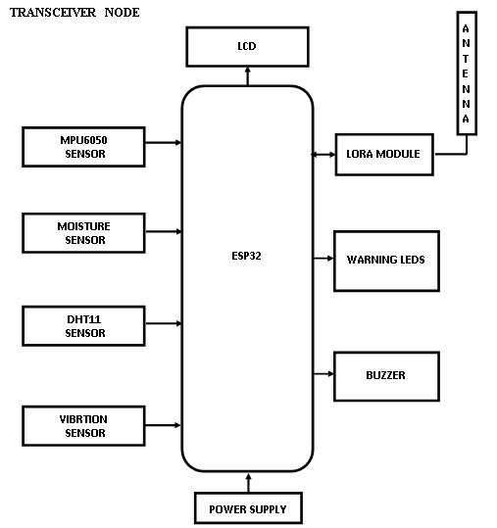

Figure 1.Transceiver Node

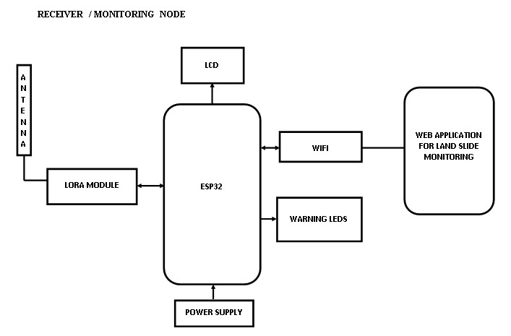

Figure 2.Receiver node

This integrated architecture—combining physical sensors, long-range wireless communication, and intelligent image processing—ensures a cost-effective, deployable, and reliable system for predicting and preventing landslides in vulnerable regions.
V.RESULT AND DISCUSSION
The LoRa-Based Landslide Detection System was successfully implemented and tested under various environmental conditions to evaluate its reliability, accuracy, and responsiveness. The results demonstrated that the integration of sensor-based hardware and AI-driven visual monitoring can significantly enhance early detection and improve safety in landslide-prone areas.
During testing, the sensor node accurately captured real-time environmental parameters such as soil moisture, temperature, humidity, ground tilt, and vibrations. For instance, under simulated heavy rainfall conditions, the soil moisture sensor recorded elevated values, while the MPU6050 gyroscope sensor detected subtle ground movements that could indicate slope instability. These sensor readings were reliably transmitted over LoRa communication to the receiver node, which showed the data on an LCD screen while simultaneously pushing updates to the cloud dashboard. This confirmed that the system could function in low-infrastructure regions without the need for mobile or internet connectivity between nodes, making it highly suitable for remote hill stations and rural roads.
The system's alert mechanisms, including the buzzer and LED indicators, responded promptly when thresholds were breached, demonstrating its effectiveness in providing local real-time warnings. This feature would be crucial in warning travelers or workers on-site before a potential landslide.
In parallel, the AI-based visual detection module analyzed live camera footage to assess the landscape. It could successfully identify visual indicators of landslides, such as cracks in the soil, exposed earth, and changes in terrain texture or vegetation. The use of OpenCV for image feature extraction, combined with the Isolation Forest algorithm for anomaly detection, proved to be a lightweight yet powerful approach. The AI module performed well in daylight and clear weather conditions, and although its performance reduced slightly under poor visibility, it still offered valuable insights when paired with sensor data.
The most notable strength of the system lies in its hybrid architecture, where the hardware sensors and AI module complement each other. The sensor system provides continuous, quantifiable data, while the vision-based model adds an extra layer of intelligence by detecting patterns that might not be captured by physical sensors alone. Together, they create a robust early-warning mechanism.
In conclusion, the results validate the system’s capability to serve as a low-cost, scalable, and efficient landslide monitoring solution. It can be deployed in a wide range of locations with minimal infrastructure requirements and could significantly aid in disaster prevention and response planning. Future improvements could focus on expanding the camera module’s performance in low-light conditions and integrating GPS tracking for precise location alerts.
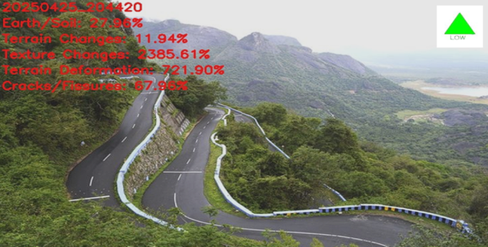

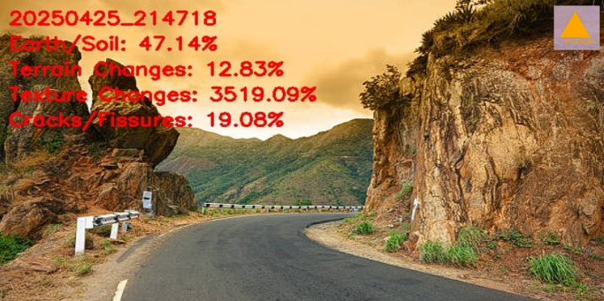

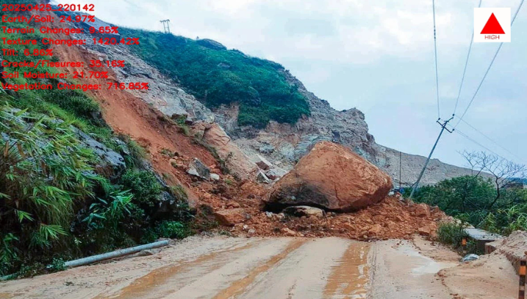

Figure 3.Live monitoring 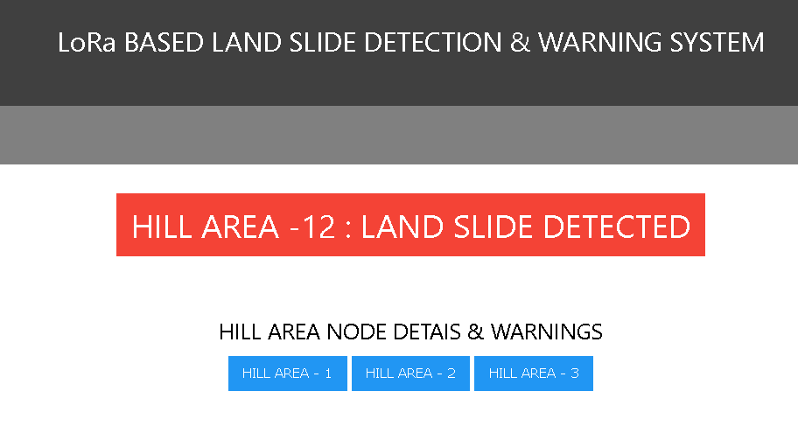

Figure 4.Landslide detected

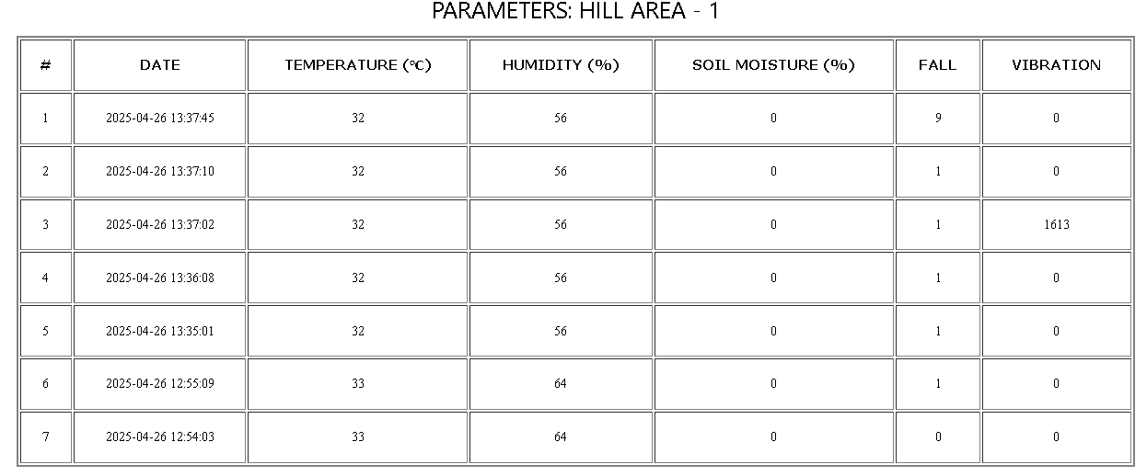

Figure 4.1.Parameters

VI.CONCLUSION
In conclusion, the results validate the system’s capability to serve as a low-cost, scalable, and efficient landslide monitoring solution. It can be deployed in a wide range of locations with minimal infrastructure requirements and could significantly aid in disaster prevention and response planning. Future improvements could focus on expanding the camera module’s performance in low-light conditions and integrating GPS tracking for precise location alerts.
The development of the LoRa-Based Landslide Detection System marks a significant step forward in utilizing modern technology to mitigate natural disasters. By combining sensor-based monitoring with real-time visual analysis through AI and machine learning, this project offers a comprehensive and cost-effective solution for detecting and responding to potential landslides, especially in remote and hilly terrains.
The system successfully integrates long-range LoRa communication for uninterrupted data transfer, ensuring reliable performance even in areas with limited or no internet access. Through continuous monitoring of soil moisture, ground movement, and vibration, along with live terrain analysis via a webcam and OpenCV, the system provides timely alerts that can help prevent accidents and reduce damage to life and infrastructure.
Moreover, the hybrid approach—merging IoT sensors with AI-powered image processing—enables more accurate and intelligent decision-making. This dual-layer detection framework enhances early warning capabilities, giving authorities and travelers enough time to react appropriately.
In summary, this project proves that smart technologies like IoT, LoRa, and computer vision can be effectively combined to create a scalable and impactful solution for landslide monitoring. With further optimization and field deployment, this system has the potential to contribute meaningfully to disaster preparedness and public safety in vulnerable regions.

VII.FUTURE ENHANCEMENTS
While the current system demonstrates strong potential in detecting and alerting about landslides, there are several areas where it can be enhanced for even better performance and broader application. One of the primary improvements could be integrating GSM or satellite communication to ensure alerts are delivered even in areas with no LoRa network coverage. This would make the system more adaptable in extremely remote or mountainous regions.
Another important enhancement involves deploying the system on a larger scale and collecting long-term sensor and image data. This would allow the machine learning models to be trained on more diverse terrain and weather conditions, ultimately improving detection accuracy and reducing false alarms.
Additionally, drone integration could offer aerial monitoring capabilities, enabling a wider field of vision and easier coverage of inaccessible zones. Coupling the system with GPS and geospatial mapping tools would also allow for real-time visualization of high-risk areas on digital maps, helping authorities plan evacuation routes or issue targeted warnings.
Moreover, future versions of the system could include self-powered sensor nodes using solar energy, ensuring continuous operation without the need for frequent maintenance. This would make the entire solution more sustainable and reliable over time.
Ultimately, as technology advances, the system can be made smarter, faster, and more autonomous—contributing significantly to disaster risk reduction and improving public safety in landslide-prone regions.

VII.REFERENCES

[1] M. M. Timbul Sigiro, I. P. Manalu, G. I. Wowiling, S. M. Silalahi, E. S. Sinambela and F. Simatupang, "Improving Road Safety in Landslide Prone Areas: Real-time LoRa-Based Landslide Detection and Warning System," 2023 29th International Conference on Telecommunications (ICT), Toba, Indonesia, 2023,pp.1-5,doi:
10.1109/ICT60153.2023.10374074.

[2]SivanarayaniM. Karunarathne ª, Matthew Dray ª, Lyudmil Popov ª, Matthew Butler ª, Catherine Pennington ^{b}, Constantinos Marios Angelopoulos ª

[3] I. A, P. R and K. M, "Assessing Metrics using LoRa Technology for Real-Time Landslide Monitoring within an IoT Framework," 2024 4th International Conference on Pervasive Computing and Social Networking (ICPCSN), Salem, India, 2024,pp. 656-662, doi: 10.1109/ICPCSN62568.2024.00109.

[4] Sumit Vashista, Deepak Kumar, Ravneet Kaur, Anju Agrawal, Sushil Kumar Singh April 2024 DOI:10.1201/9781003430469-57.

[5] Mr. Rahul S. Pol, Mt. Suyash Dhabare "Automated Face Recognition Based Attendance System using LBP Recognizer", International Journal od Advance Scientific Research and Engineering Trends", Volume 5, Issue 4, | April 2020, ISSN (Online) 2456-0774.

