9/28/2024
Development of AI Algorithms to Detect Explosives in Waste Receptacles Using Vision Transformers and Swin Transformers
MDA522 Artificial Intelligence Assignment 2 - Group 2

Contribution
Student | Contribution
Fathima Shamra (MIT240870) | - Contributed to writing the introduction, literature review and conclusion.  - Finding journals for literature review.  - Creating presentation slides.
Elgiriyage Nisini Nethmila Silva (MIT231399) | - Contributed to writing the sections abstract, research questions, materials and methods, results and discussion, and acknowledgment.  - Finding journals.  - Developing Vision and Swin Transformer models (all binary and multi-classification algorithms).  - Creating presentation slides.

Table of Contents
Title: Development of AI Algorithms to Detect Explosives in Waste Receptables Using Vision Transformers and Swin Transformers 4
Abstract 4
Introduction/ Background 4
Literature Review 5
Materials and Methods 8
a) Data Used for the Model Training 8
b) Method/Algorithms/Models Used (the VIT model/s) 9
Link to Code files 9
Python Libraries 9
Vision Transformer “vit_base_patch16_224” Model 10
Swin Transformer “swin_base_patch4_window7_224” Model 10
c) Experimental Setup 11
Developing classification algorithms using Vision Transformer and Swin Transformer 11
d) Model Training and Experiments 11
Model Architectures of Vision Transformer and Swin Transformer 11
Training Process of Vision Transformer and Swin Transformer 12
Results and discussions 12
Evaluation of Vision Transformer Models 12
Evaluation of Vision Transformer Binary Classification Algorithm 12
Evaluation of Vision Transformer Multi-class Classification Algorithm 13
Evaluation of Swin Transformer Models 14
Evaluation of Swin Transformer Binary Classification Algorithm 14
Evaluation of Swin Transformer Multi-class Classification Algorithm 15
Comparison of the Results 17
Summary of the Comparison of Binary Classification Algorithms 17
Comparison of the Results of Multi-class Classification Algorithms 17
Conclusions 18
Acknowledgment 18
References 18

List of Tables
Table 1: Defined hyperparameters to develop Vision Transformer and Swin Transformer models 11
Table 2: Results of the Vision Transformer Binary Classification Algorithm for each category 13
Table 3: Results of the Vision Transformer Multi-class Classification Algorithm for each category 14
Table 4: Results of the Swin Transformer Binary Classification Algorithm for each category 15
Table 5: Results of the Swin Transformer Multi-class Classification Algorithm for each category 16
Table 6: Comparison of the Results of Binary Classification Algorithms 17
Table 7: Comparison of the Results of Multi-class Classification Algorithms 17

List of Figures
Figure 1: Python libraries used to build the binary classification and multi-class classification - Vision Transformer 9
Figure 2: Confusion matrix for the Vision Transformer binary classification algorithm 13
Figure 3: Confusion matrix for the Vision Transformer multi-class classification algorithm 14
Figure 4: Confusion matrix for the Swin Transformer binary classification algorithm 15
Figure 5: Confusion matrix for the Swin Transformer multi-class classification algorithm 16

Title: Development of AI Algorithms to Detect Explosives in Waste Receptables Using Vision Transformers and Swin Transformers

Abstract
The aim of this research is to develop AI algorithms to detect explosives in waste receptacles using Vision Transformers and Swin Transformers. Therefore, in this study, we proposed Vision Transformer and Swin Transformer binary and multi-class classification algorithms to identify the explosives, while categorizing the waste into different categories. We developed the Vision Transformer and Swin Transformer binary classification to classify the waste into IEDs and real waste. Similarly, we developed Vision Transformer and Swin Transformer multi-class classification algorithms to classify the waste into 7 classes including IED, glass, paper, cardboard, plastic, metal and trash. We used the existing I2Net (Images for IED detection with Neural Networks) and TrashNet databases to develop all the Vision Transformer and Swin Transformer models. We applied a pre-trained “vit_base_patch16_224” model and the 'swin_base_patch4_window7_224' model to develop the Vision Transformer and Swin Transformer classifications respectively. Our Swin Transformer binary classification algorithm classified the IED and real waste into 100% correctly achieving 100% in all precision, recall, and F1 scores. On top of that, the Swin Transformer multi-class classification algorithm also achieved 100% in precision, recall, and F1 Score by classifying the IED 100% correctly among the other 6 classes. Our Vision Transformer binary and multi-class classifiers achieved 100% recall in IED classification. We found that the Swin Transformer models performed better than the Vision Transformer models achieving high accuracy considering all the evaluation metrics. Therefore, the Swin Transformer model is the best model to detect explosives hidden in the waste bin.

Introduction/ Background
Many researchers have developed different AI algorithms for performing image classification tasks in different areas previously. However, there is very little research done in the area of detecting explosives in dustbins using AI algorithms. Explosives hidden in waste bins have become a major threat to public safety at present [1]. There have been many incidents happened before in terms of destroying human lives because of these hidden explosives in waste bins in public places [1]. As a solution, even though they have been removed from public places, it has led to creating new problems for the environment [1]. On the other hand, the resistant explosive bins that can detect explosives are so expensive and huge [1]. So, it is hard to maintain such bins in each and every public area. On top of that, the transparent bins are unpleasant to keep in public places [1]. So, the background of this research is based on the public safety issue, highlighting the threat of explosives in the public waste bins and the adverseness of not having dustbins in public areas to dispose of waste [1]. To address this issue, the paper [1] proposed a multi-classifier algorithm that can classify garbage into different groups using deep transfer learning. The dataset used to develop the classifier contained both improvised explosive device (IED) images and non-IED images [1]. A new database of explosive images was created while non-IED images were taken from TrashNet [1]. However, there is a lack of research done in the area of identifying explosives that are hidden in dustbins [1]. Therefore, in this project, we propose Vision Transformer and Swin Transformer models to classify the waste into two classes and multiple classes including 7 categories using the same data used in the [1] paper.

Literature Review
Applications of Vision Transformers (ViTs) have become more popular in different fields, such as underwater object identification [2] and medical imaging [3]. The previous research has demonstrated how ViTs have evolved and become more versatile, especially compared to Convolutional Neural Networks (CNNs), which have long dominated the image categorization space. Computer vision is the science of teaching computers to understand images in the same way as humans do [4]. This process involves converting images into pixels, which hold values like brightness levels or colour intensities [4]. These pixels are then processed and analysed by computers [4]. Feature detection is the first step in recognizing objects, as it detects key points or patterns in the image. Algorithms are used to understand these patterns, such as edge detection, corner detection, and segmentation [4]. To recognize objects, the computer needs to be trained using machine learning, which uses labelled images to learn patterns associated with specific objects [4]. Deep learning, specifically Convolutional Neural Networks (CNNs), has become a game changer for object recognition, allowing for better accuracy in tasks like face recognition or identifying cars in traffic. Once algorithms are trained, the computer can apply this knowledge to new images, inferring or guessing that the object in the image is a cat. This process is used in various real-world applications, such as facial recognition in security systems, self-driving cars identifying other vehicles, pedestrians, and road signs, and medical imaging to detect diseases. [4].
The [5] book offers a thorough and useful manual for using deep learning methods with visual data, especially pictures. It is perfect for both novices and experts since it simplifies difficult subjects into manageable stages. Here, the author focuses on important ideas such as data augmentation, transfer learning, and convolutional neural networks (CNNs) to enhance model performance on computer vision tasks [5]. The practical approach used by the book is one of its best features. To assist close the knowledge gap between theory and practice, the author presents readers with clear, executable Python code and invites them to experiment with real-world datasets. He describes how CNNs are especially useful for applications like object identification, picture classification, and face recognition because they can automatically learn spatial hierarchies in images [5]. The author also explores transfer learning and the usage of pre-trained models, which let developers make use of pre-existing models that have been trained on huge datasets [5]. This is an effective strategy for increasing performance when there is little data. This book is a helpful tool for anybody working on machine learning projects linked to vision, as it also discusses how to optimize these models [5].
The [3] study evaluates the effectiveness of CNN-based models, namely the Visual Geometric Group Data Spatial Transformer Network (VDSNet), against Vision Transformers (ViTs) in terms of categorizing chest X-ray pictures to diagnose lung illness. Due to their capacity to extract hierarchical information, CNNs have historically performed well in the categorization of medical pictures [3]. However, it states that ViTs' self-attention processes provide them an advantage in processing images more quickly and at a reduced computational cost [3]. Initially effective in Natural Language Processing, ViTs have potential when pretrained on extensive datasets such as ImageNet, surpassing CNNs, particularly with the availability of bigger medical picture datasets [3]. For practitioners with limited computing resources, the requirement for more processing capacity for ViTs is a hurdle [3]. By concentrating on the application of ViTs in biomedical image categorization, the study [6] deepens this comparison. It demonstrates that ViTs achieve higher classification accuracy than CNNs in a number of medical image classification tasks, including pathology and blood microscopy using the MedMNISTv2 dataset [6]. This is because, in contrast to CNNs, which have trouble with long-distance visual correlations, ViTs are able to capture global dependencies via self-attention [6]. Even though ViTs performed well, there are still issues with datasets like RetinaMNIST, where the model's accuracy was just 57% [6].
The paper [7] discusses the problems of overfitting in ViTs, especially with smaller datasets. The AlsmViT model, which the authors suggest, combines data augmentation methods such as LayerScale and Augmentplus to enhance the performance of ViTs in food picture classification [7]. With a 5% increase in accuracy, the enhanced ViT model beats traditional models when used on the Food-101 and Vireo Food-172 datasets [7]. The promise of ViTs in food categorization is demonstrated by this study, particularly when paired with efficient augmentation techniques to reduce overfitting [7].
The potential of ViTs improved with self-supervised learning (SSL) approaches for medical picture categorization is investigated in the [8] study. With the use of SSL, a model called Bootstrap Own Latent of Transformer (BOLT) is put forth that enhances feature extraction from sparse, unannotated medical pictures [8]. In tasks like as diabetic retinopathy grading and skin lesion classification, BOLT outperforms both traditional ImageNet-pretrained ViTs and state-of-the-art SSL techniques by utilizing token-wise perturbations [8]. This study shows how SSL may improve diagnostic accuracy and get around the lack of labeled medical data [8]. The Multiscale Vision Transformer (MViT), designed to overcome the drawbacks of conventional ViTs in high-resolution object detection and video analysis, is presented in the [9] paper. Relative positional embeddings and residual pooling connections are two features added to the upgraded MViTv2 version to improve its performance in object identification and image and video categorization. In several benchmarks, MViTv2 produces state-of-the-art results, such as 88.8% accuracy on ImageNet-1K and higher performance on object detection on COCO and video recognition on Kinetics [9]. According to the study, MViTv2's pooling attention technique makes the model more scalable for a variety of tasks by enabling it to handle high-resolution input more quickly [9].
The [2] study uses a hierarchical ViT called the Swin Transformer for underwater item identification tasks. The research draws attention to the difficulties associated with underwater photography, including low contrast and fuzzy objects, which are made worse by conventional techniques [2]. The suggested model considerably increases detection accuracy on the URPC2018 dataset by combining the Swin Transformer with a Path Aggregation Network (PAN) and Online Hard Example Mining (OHEM) [2]. The Swin Transformer model is well-suited for these tasks because of its hierarchical structure, which allows it to handle multiscale elements in underwater settings [2]. The Swin Transformer, which employs a hierarchical design with shifting windows to remedy the shortcomings of previous Transformers in vision tasks, is the subject of the [10] study. Because of its structure, the model can scale effectively without losing context, which makes it useful for a variety of tasks such semantic segmentation, object identification, and picture classification [10]. The Swin Transformer beats earlier models like as ViT and ResNe(X)t in both object detection (58.7 AP on COCO) and semantic segmentation (53.5 mIoU on ADE20K), achieving a top-1 accuracy of 87.3% on ImageNet-1K. The triumph of the Swin Transformer underscores its capability as an all-encompassing foundation for computer vision assignments, therefore merging the domains of natural language processing and vision [11].
To sum up Vision Transformers (ViTs) have demonstrated considerable promise in picture categorization tasks across several domains. With the ability to overcome overfitting through data augmentation and beat CNNs in medical imaging, ViTs have the potential to completely transform the area of computer vision. But there are still issues like the requirement for bigger datasets and more computing expenditures. Promising answers to these problems may be found in hierarchical models like as the Swin Transformer and multiscale methods like MViTv2. This makes ViTs a flexible and potent tool for further developments in image classification and detection applications. Therefore, in this research, we are developing AI algorithms using Vision and Swin Transformers to identify the IEDs in hidden waste bins using I2Net and TrashNet data. Based on that, we are going to answer the following research questions.
- Can Vision Transformer and Swin Transformer be used to classify the waste into different categories including IEDs?
- Does Vision Transformer outperform CNN or not?
- Which is the best technology among CNNs, Vision Transformers, and Swin Transformers to identify the explosives in hidden waste bins?

Materials and Methods

Data Used for the Model Training
We used the I2Net (Images for IED detection with Neural Networks) and TrashNet database to develop all the Vision Transformer and Swin Transformer models.
We downloaded the I2Net data from GitHub (https://github.com/jessieAmoakoh/I2Net) and used the “split_and_augmented_images.zip” image data to develop the model since it is already augmented and split into train, test, and validation sets. Initially, the IED dataset consisted as follows before the model training.
- IED train set: 1768 images
- IED test set: 26 images
- IED validation set: 24 images
We collected the non-IED data using the existing TrashNet database. It contains six categories including glass, paper, cardboard, plastic, metal and trash. We downloaded them from Kaggle (https://www.kaggle.com/datasets/feyzazkefe/trashnet). At the beginning, the TrashNet database consists of following number of images.
- TrashNet cardboard: 403 images
- TrashNet glass: 501 images
- TrashNet metal: 410 images
- TrashNet paper: 594 images
- TrashNet plastic: 482 images
- TrashNet trash: 137 images

Method/Algorithms/Models Used (the VIT model/s)

Link to Code files
https://drive.google.com/drive/folders/1I06rlFVV5KU0MyuOYI9u2w-g5vadgtZ1?usp=drive_link

Python Libraries
We used the following Python libraries (Figure 1) to develop both the binary classification algorithm and the multi-class classification algorithm using Vision Transformer.
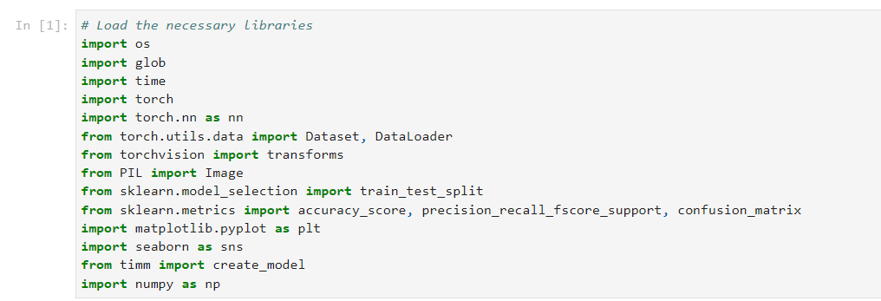
Figure 1: Python libraries used to build the binary classification and multi-class classification - Vision Transformer
We used “os” and “glob” libraries to load image data from different folders. Basically, these libraries are used for file and directory operations. To measure and report training time, we used “time” library. We imported PyTorch libraries such as “torch” and “torch.nn” to build and train neural networks, including the Vision Transformer. The library, “torch.utils.data” is used since it provides Dataset and DataLoader classes for efficient data handling and batching. And, “torchvision.transforms” was used for image preprocessing and augmentation. To open and manipulate image files, we used “PIL” (Python Imaging Library) while the “sklearn.model_selection” was used since it provides train_test_split to divide data into training and testing sets. The “sklearn.metrics” was used for calculating performance metrics like accuracy, precision, recall, and F1-score. To visualize the evaluation metrics using the confusion matrix, we used the libraries, “matplotlib.pyplot” and “seaborn”. We used the library, “timm” (PyTorch Image Models) because it provides pre-trained models, including Vision Transformers. On the other hand, that library makes it easy to use transfer learning. To perform numerical operations and array manipulations, we used “numpy” library.

Vision Transformer “vit_base_patch16_224” Model
In the vision transformation, the image is decomposed into 16x16 pixel patches and then these patches are transformed into patch vectors by a linear transformation. These patch vectors are combined with positional embeddings. They are processed by a transformer in the same way in which the transformer processes word vectors. We applied transfer learning using the “vit_base_patch16_224” pre-trained vision transformer model to develop the binary and multi-class classification algorithms. We selected that model because it has proven a record of providing the best results in image analysis tasks [12]. However, there is a problem with the extraction of patches in the vision transformer for the tasks that require detailed processing of every pixel of the image [10]. This is where the Swin Transformers come into place.

Swin Transformer “swin_base_patch4_window7_224” Model
Swin Transformer is a vision transformer variant but with a hierarchical way of processing the image. Swin stands for Shifted Windows. Swin Transformer still relies on patches but instead of choosing one size and sticking with it, Swin Transformer first starts with small patches for the first Transformer layer and then merges them into bigger ones in the deeper Transformer layers. So, the Swin Transformer takes in the image and splits the image into 4x4 patches and a linear transformation converting each patch into a c-dimensional vector. Transformer blocks process these patch vectors but not with the usual quadratically scaling attention but with the Shifted window-based Self-Attention [10]. The attention span is limited over M patches, which means one patch does not communicate with all other patches but only with M neighbours. In the next layer, the output of a sequence of N patch vectors is merged by the merging layer. In the merging layer, it concatenates the vectors of groups of 2x2 neighbouring patches. So, from 4 of these C-dimensional vectors, now it has one 4xC dimensional vector and it passed through a linear layer, which is basically a linear dimensionality reducer from 4C to 2C dimensions. Then this process repeats again and again. So, we used the “swin_base_patch4_window7_224” pre-trained swin transformer model to develop the binary and multi-class classification algorithms.

Experimental Setup

Developing classification algorithms using Vision Transformer and Swin Transformer
When it comes to developing the Vision and Swin Transformer models, we prepared the dataset by combining the IED (Improvised Explosive Device) and TrashNet data. We set up the binary classification algorithm to classify the garbage into IED and real waste. Similarly, the multi-class classification algorithm was set up to classify garbage into 7 classes including IED, glass, paper, cardboard, plastic, metal and trash. After splitting the combined dataset, we had 3536 training samples, 403 validation samples and 406 test samples. In terms of data preprocessing tasks, we resized the images into 224x224 pixels and applied ToTensor and Normalize transformations for the data augmentation. As the hardware component, we used the CPU for training the model. The hyperparameters that we defined to develop the binary and multi-class classification algorithms are presented in Table 1.
Table 1: Defined hyperparameters to develop Vision Transformer and Swin Transformer models
Hyperparameter | Binary Classification |  | Multi-class Classification
 | Vision Transformer | Swin Transformer | Vision Transformer | Swin  Transformer
Batch size | 16 | 16 | 16 | 16
Learning rate | 1e-4 | 1e-4 | 1e-4 | 1e-4
Number of epochs | 30 | 10 | 10 | 10
Number of classes | 2 | 2 | 7 | 7
Image size | 224x224 | 224x224 | 224x224 | 224x224

Model Training and Experiments

Model Architectures of Vision Transformer and Swin Transformer
In terms of model architectures, we applied a pre-trained Vision Transformer model named “vit_base_patch16_224” model to develop the Vision Transformer models. Similarly, we applied a pre-trained Swin Transformer model named 'swin_base_patch4_window7_224' model to build the Swin Transformer models. By using those models, we performed the binary classification for 2 classes (IED and real waste) and multi-class classification for the 7 classes (IED, glass, paper, cardboard, plastic, metal and trash).

Training Process of Vision Transformer and Swin Transformer
We defined the training process of both Vision Transformer and Swin Transformer with “CrossEntropyLoss” loss function, “AdamW” optimizer and transfer learning approach using pre-trained weights. We iterated the training loop through 30 epochs for Vision Transformer binary classification and 10 epochs for Vision Transformer multi-class classification and Swin Transformer binary and multi-class classification. After that, we performed the validation for each transformer model classification after each epoch. Then we saved the best model for each transformer model classification based on their validation accuracy of each epoch. We were able to complete the model training successfully for all the transformer models while achieving the best validation accuracy for each classification. After that, we evaluated the test sets by calculating the evaluation metrics like Accuracy, Precision, Recall and F1 Score. To understand the evaluation metrics, we visualized the confusion matrix.

Results and discussions
We evaluate all the Vision Transformer and Swin Transformer classification algorithms using evaluation metrics such as model training time, test accuracy, precision, recall, and F1 score. First, we evaluate each model's performance overall, then we estimate each model's performance for each category separately. After evaluating the metrics, we visualized the results using a confusion matrix.

Evaluation of Vision Transformer Models

Evaluation of Vision Transformer Binary Classification Algorithm
The results of the overall model performance are as follows,
- Training time = 115434.20s
- Test Accuracy = 0.9984
- Precision = 0.9986
- Recall = 0.9984
- F1 Score = 0.9985
According to the above results, you can see that, we were able to achieve 99.84% high accuracy for the Vision Transformer binary classification algorithm.
The results of the model performance for each category are as follows. Here, we classify the garbage into IED and real waste.
Table 2: Results of the Vision Transformer Binary Classification Algorithm for each category
Category | Precision | Recall | F1 Score
IED | 0.8667 | 1.0000 | 0.9286
Real Waste | 1.0000 | 0.9984 | 0.9992

The following, Figure 2 displays the confusion matrix for Vision Transformer binary classification.
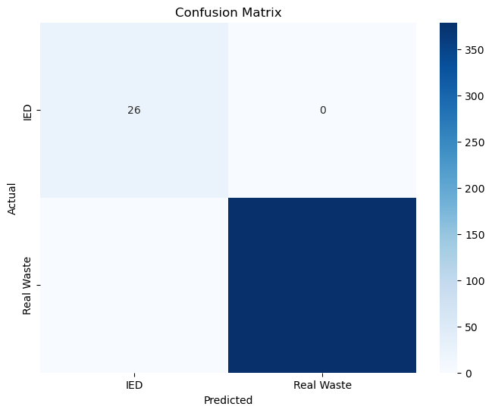
Figure 2: Confusion matrix for the Vision Transformer binary classification algorithm

Evaluation of Vision Transformer Multi-class Classification Algorithm
The overall model performance of the Vision Transformer multi-class classification algorithm is as follows,
- Training time = 37414.46s
- Test Accuracy = 0.9197
- Precision = 0.9263
- Recall = 0.9197
- F1 Score = 0.9209
Here, we were able to achieve 91.97% accuracy for Vision Transformer multi-class classification.
The results of the model performance for each category are as follows in Table 3. Here, we classify the garbage into IED, glass, paper, cardboard, plastic, metal and trash.
Table 3: Results of the Vision Transformer Multi-class Classification Algorithm for each category
Category | Precision | Recall | F1 Score
IED | 0.4815 | 1.0000 | 0.6500
Glass | 0.8780 | 0.9621 | 0.9181
Paper | 0.9580 | 0.9226 | 0.9400
Cardboard | 0.9819 | 0.9429 | 0.9620
Plastic | 0.9457 | 0.9025 | 0.9236
Metal | 0.8931 | 0.9171 | 0.9049
Trash | 0.9182 | 0.7372 | 0.8178

The confusion matrix for the Vision Transformer multi-class classification algorithm is presented in Figure 3 below.
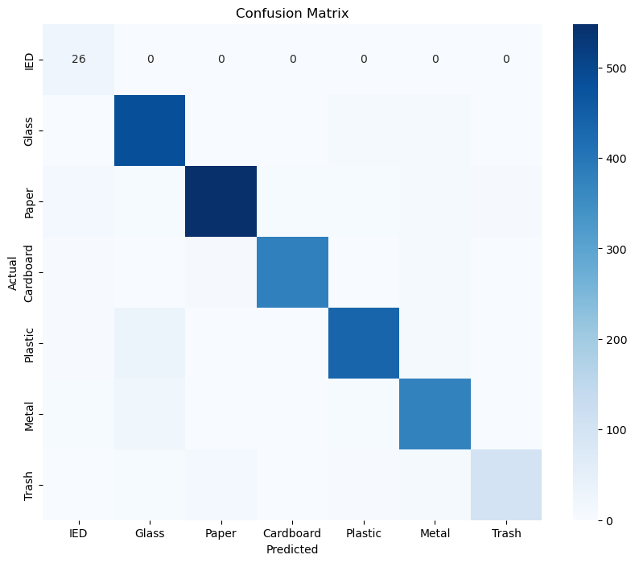
Figure 3: Confusion matrix for the Vision Transformer multi-class classification algorithm

Evaluation of Swin Transformer Models

Evaluation of Swin Transformer Binary Classification Algorithm
The overall model performance of the Swin Transformer binary classification algorithm is as follows,
- Training time = 158347.07s
- Test Accuracy = 1.0000
- Precision = 1.0000
- Recall = 1.0000
- F1 Score = 1.0000
The results of the model performance for each category are as follows in Table 4. Here, we classify the garbage into IED and real waste.
Table 4: Results of the Swin Transformer Binary Classification Algorithm for each category
Category | Precision | Recall | F1 Score
IED | 1.0000 | 1.0000 | 1.0000
Real Waste | 1.0000 | 1.0000 | 1.0000

According to the Table 4, you can see that our Swin Transformer binary classification algorithm classified the IED and real waste into 100% correctly achieving 100% in all precision, recall, and F1 scores for each class. The confusion matrix for the Swin Transformer binary classification algorithm is presented in Figure 4 below.
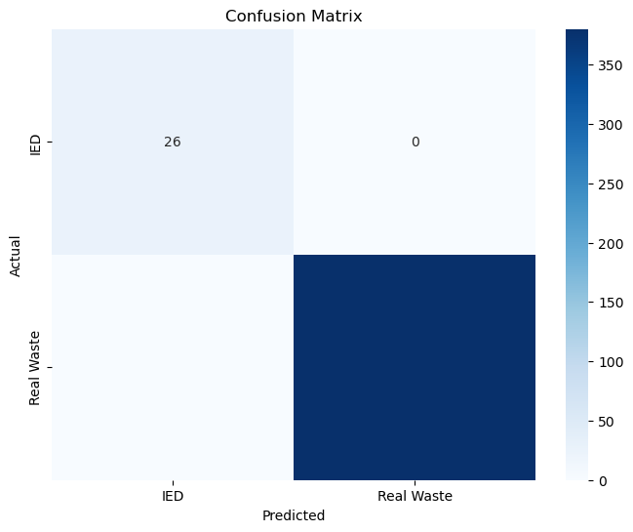
Figure 4: Confusion matrix for the Swin Transformer binary classification algorithm

Evaluation of Swin Transformer Multi-class Classification Algorithm
The overall model performance of the Swin Transformer multi-class classification algorithm is as follows,
- Training time = 112134.69s
- Test Accuracy = 0.9855
- Precision = 0.9856
- Recall = 0.9855
- F1 Score = 0.9855
The results of the model performance for each category are as follows. Here, we classify the garbage into IED, glass, paper, cardboard, plastic, metal, and trash.
Table 5: Results of the Swin Transformer Multi-class Classification Algorithm for each category
Category | Precision | Recall | F1 Score
IED | 1.0000 | 1.0000 | 1.0000
Glass | 0.9784 | 0.9940 | 0.9861
Paper | 0.9833 | 0.9933 | 0.9883
Cardboard | 0.9950 | 0.9926 | 0.9938
Plastic | 0.9936 | 0.9689 | 0.9811
Metal | 0.9878 | 0.9878 | 0.9878
Trash | 0.9559 | 0.9489 | 0.9524

According to the Table 5, you can see that we achieved 100% accuracy for IED classification in terms of precision, recall, and F1 Score. The confusion matrix for the Swin Transformer multi-class classification algorithm is presented in Figure 5 below.
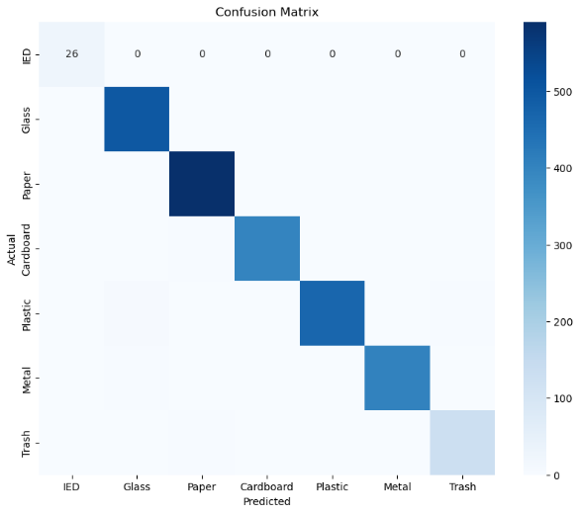
Figure 5: Confusion matrix for the Swin Transformer multi-class classification algorithm

Comparison of the Results
After evaluating the performance for each classification algorithm of both the Vision Transformer and Swin Transformer models, we compared their results to see which model has the best performance in terms of classifying the waste.

Summary of the Comparison of Binary Classification Algorithms
Table 6: Comparison of the Results of Binary Classification Algorithms
Category | Precision |  | Recall |  | F1 Score
 | Vision Transformer | Swin Transformer | Vision Transformer | Swin Transformer | Vision Transformer | Swin Transformer
IED | 0.8667 | 1.0000 | 1.0000 | 1.0000 | 0.9286 | 1.0000
Real Waste | 1.0000 | 1.0000 | 0.9984 | 1.0000 | 0.9992 | 1.0000

Comparison of the Results of Multi-class Classification Algorithms
Based on the results that we achieved; we compared each transformer model performance as presented in Table 6.
Table 7: Comparison of the Results of Multi-class Classification Algorithms
Category | Precision |  | Recall |  | F1 Score
 | Vision Transformer | Swin Transformer | Vision Transformer | Swin Transformer | Vision Transformer | Swin Transformer
IED | 0.4815 | 1.0000 | 1.0000 | 1.0000 | 0.6500 | 1.0000
Glass | 0.8780 | 0.9784 | 0.9621 | 0.9940 | 0.9181 | 0.9861
Paper | 0.9580 | 0.9833 | 0.9226 | 0.9933 | 0.9400 | 0.9883
Cardboard | 0.9819 | 0.9950 | 0.9429 | 0.9926 | 0.9620 | 0.9938
Plastic | 0.9457 | 0.9936 | 0.9025 | 0.9689 | 0.9236 | 0.9811
Metal | 0.8931 | 0.9878 | 0.9171 | 0.9878 | 0.9049 | 0.9878
Trash | 0.9182 | 0.9559 | 0.7372 | 0.9489 | 0.8178 | 0.9524

Conclusions
According to the comparison of the results, which we have done in Table 6 and Table 7, you can see that our Swin Transformer binary and multi-class classification algorithms classified the waste 100% correctly into IED by achieving 100% precision, recall, and FI score. On the other hand, Swin Transformer models have achieved higher evaluation metrics than the Vision Transformer models in both binary and multi-class classification algorithms. According to the results of [1] paper, their trained DenseNet-121 model achieved a Top-1 accuracy of 80%, which is lower than our Vision and Swin Transformer results. Therefore, we can conclude that among the CNN, Vision Transformer, and Swin Transformer algorithms, Swin Transformer is the best cutting-edge technology to identify the explosives in waste bins.

Acknowledgment
We would like to acknowledge our lecturer, Amoakoh Gyasi-Agyei, for letting us conduct new research by developing AI algorithms using the same databases in his previous research area.

References

[1] | A. Gyasi-Agyei, “Detection of explosives in dustbins using deep transfer learning based multiclass classifiers,” Applied Intelligence, vol. 54, pp. 2314-2347, 2024.
[2] | JIA LIU, SHUANG LIU, SHUJUAN XU, CHANGJUN ZHOU, “Two-Stage Underwater Object Detection Network Using Swin Transformer,” IEEE, 2022.
[3] | Om Uparkar, Jyoti Bharti, R. K. Pateriya, Rajeev Kumar Gupta*, Ashutosh Sharma, “Vision Transformer Outperforms Deep Convolutional Neural Network-based Model in Classifying X-ray Images,” Procedia Computer Science 218, 2023.
[4] | Richard Szeliski, in Computer Vision: Algorithms and Applications, Second Edition, Texts In Computer Science, 2022.
[5] | Jason Brownlee, in Deep Learning for Computer Vision: Image Classification, Object Detection, and Face recognition in Python, Machine Learning Mastery, 2020.
[6] | Arindam Halder, Sanghita Gharami, Priyangshu Sadhu, Pawan Kumar Singh, Marcin Woźniak & Muhammad Fazal Ijaz, “Implementing vision transformer for classifying 2D biomedical images,” Scientific Reports, 2024.
[7] | Z. X. a. Z. D. X. Gao, “High accuracy food image classification via vision transformer with data augmentation and feature augmentation,” Journal of Food Engineering, vol. 365, 2024.
[8] | Y. H. N. H. K. M. Y. Z. Yuexiang Li a, “Improving vision transformer for medical image classification via token-wise,” Journal of Visual Communication and Image Representation, Volume 98, 2024.
[9] | Yanghao Li, Chao-Yuan Wu, Haoqi Fan, Karttikeya Mangalam, Bo Xiong, “MViTv2: Improved Multiscale Vision Transformers,” Computer Vision Foundation., 2022.
[10] | Z. Liu, Y. Lin, Y. Cao, H. Hu, Y. Wei, Z. Zhang, S. Lin and B. Guo, “Swin Transformer: Hierarchical Vision Transformer using Shifted Windows,” 2021 IEEE/CVF International Conference on Computer Vision (ICCV), 2021.
[11] | Ze Liu, Yutong Lin, Yue Cao, Han Hu, Yixuan Wei, “Swin Transformer: Hierarchical Vision Transformer using Shifted Windows,” Computer Vision Foundation., 2021.
[12] | A. Halder, S. Gharami, P. Sadhu, P. K. Singh, M. Woźniak and M. F. Ijaz, “Implementing vision transformer for classifying 2D biomedical images,” Scientific Reports, 2024.

