IS BABY’s CRYING ?
PUT BABY ON MOTHER’S CHEST
BABY IS BORN AT ________AM/PM
(BIRTH TIMER STARTS & ALARM AT EVRY MINUTE)

NO
YES ?

NO
Apnea?
START VENTILATION and Apply Pulse Oximeter
YES
VENTILATION STARTED
Measure Heart Rate
HR>100 bpm?
SpO2>90?

VENTILATION STARTED TIMER STARTS & ALARMs AT EVERY 30 Seconds
NO

MEASURE HEART RATE
MEASURE SpO2

YES
HR>100 bpm
SpO2>90

YES
NO
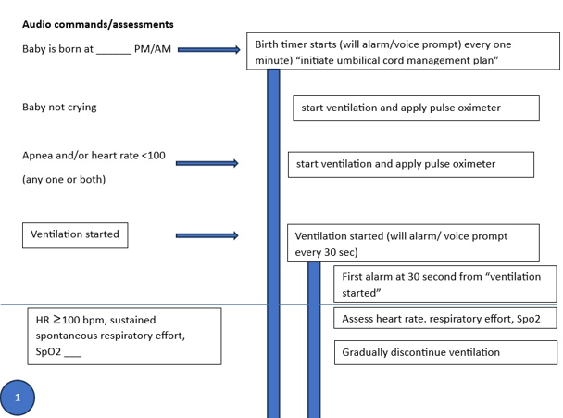

END

