Ex1 :
Q7
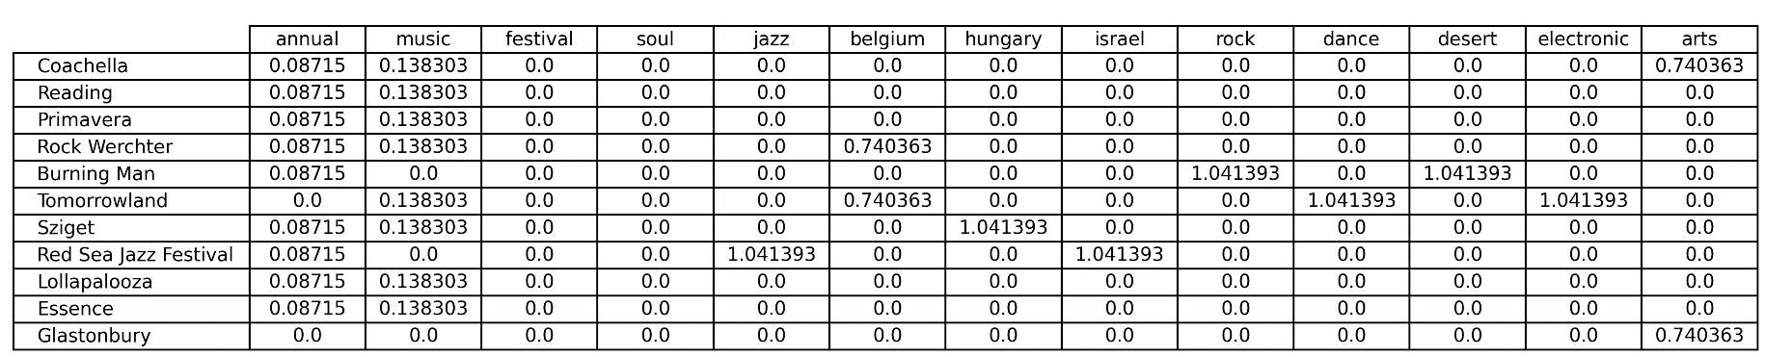
a)1)

Document | tf | Idf | tfidf
Coachella | 0 | 1.04139 | 0
Reading | 0 | 1.04139 | 0
Primavera | 0 | 1.04139 | 0
Rock Werchter | 0 | 1.04139 | 0
Burning Man | 0 | 1.04139 | 0
Tomorrowland | 0 | 1.04139 | 0
Sziget | 0 | 1.04139 | 0
Red Sea Jazz Festival | 0 | 1.04139 | 0
Lollapalooza | 0 | 1.04139 | 0
Essence | 1 | 1.04139 | 1.04139
Glastonbury | 0 | 1.04139 | 0
Soul

$$Festival$$
Document | tf | Idf (Log of 1) | tfidf
Coachella | 1 | 0 | 0
Reading | 1 | 0 | 0
Primavera | 1 | 0 | 0
Rock Werchter | 1 | 0 | 0
Burning Man | 0 | 0 | 0
Tomorrowland | 1 | 0 | 0
Sziget | 1 | 0 | 0
Red Sea Jazz Festival | 1 | 0 | 0
Lollapalooza | 1 | 0 | 0
Essence | 1 | 0 | 0
Glastonbury | 1 | 0 | 0

Tf-idf aims to highlight words that are important to a document, it weights the frequency in specific document vs the frequency across all the documents.
The word 'Festival' is commonly used leading to a very low score (0) as it appears in every single document. Soul is less frequent it has a higher tfidf score not very high as it appears in only one document.
This way we can distinguish words that are redundant for particular languages like 'a' 'an' 'add' etc. words that appear everywhere from important words per context.
B)
Music festival is a name I wouldn’t normalize it at
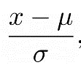
Year - We would normalize via Min-Max as we don’t really care about the specific year number but it's relation to other years .
Number of Participants – we would use standardization
as we did in probability course, in order to achieve expected value of 0 and variance of 1.
Country – is a name no normalization .
Ticket price – same as number of participants we would use standardization.
Number of stages – Min Max Normalization in order to scale the data to a specific range.
C)
We would use L1 (L1 because there is no point in L2 in 1D) in order to measure the distance between the features for numerical data : Year, Number of Participants, Ticket price, Number of stages. For countries we would use categorial numeration.
sanity check: numerical 'Number of Participants'
low - Lollapalooza: 192773 , Essence: 190182 Euclidian distance: 2591
high - Lollapalooza: 192773 , Rock Werchter: 54369 Euclidian distance: 138404
sanity check: categorical:
low - Coachella:USA , Burning Man:USA, will get 0 (same country)
high - Coachella:USA, Red Sea Jazz Festival: Israel will get 1 (different country)
We would use Jaccard's Distance for the text features: Music Festival, Description to measure the dissimilarity between the features.
Sanity check:
More simillar
Coachella – (10 words overall )
Reading – (8 words overall)
The jaccarrd is 5/13
Less similar :
Red Sea Jazz Festival – 8 words overall
Glastonbury – 11 words overall
The jaccard is 3/16
Seems sain

Q8

