INNOVATIVE PRODUCT DEVELOPMENT REPORT - 5

SilentLink: AI-Powered Sign Language Communication and Gesture-Controlled Human–Computer Interaction

Submitted by

T.Nivedita V.Nissy Niveditha V.Nageswari

23RH1A05QA 23RH1A05RG 23RH1A05RQ

Under the Esteemed Guidance of
MR.VIJAY LAKSHETTY
Assistant Professor

In partial fulfilment of the Academic Requirements for the Degree of

BACHELOR OF TECHNOLOGY

Computer Science & Engineering


MALLA REDDY ENGINEERING COLLEGE FOR WOMEN
(Autonomous Institution-UGC, Govt. of India)
Accredited by NBA &NAAC with ‘A+’ Grade UGC, Govt. of India National Ranking
by NIRF Innovation – Rank Band (151-300), MHRD, Govt. of India
Maisammaguda, Dhulapally, Secunderabad-500100

2026-2027

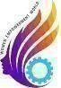
MALLA REDDY ENGINEERING COLLEGE FOR WOMEN
(Autonomous Institution-UGC, Govt. of India)
Accredited by NBA &NAAC with ‘A+’ Grade UGC, Govt. of India
National Ranking by NIRF Innovation – Rank Band (151-300), MHRD, Govt.
of India Maisammaguda, Dhulapally, Secunderabad-500100

DEPARTMENT OF COMPUTER SCIENCE AND ENGINEERING

CERTIFICATE

This is to certify that the work embodies in this dissertation entitled SilentLink: AI-Powered Sign Language Communication and Gesture-Controlled Human–Computer Interaction being submitted by T. NIVEDITA (23RH1A05QA), V.NISSY NIVEDHITHA (23RH1A05RG), V. NAGESWARI (23RH1A05RQ) for partial fulfilment of the requirement for the award BACHELOR OF TECHNOLOGY in Computer Science and Engineering Malla Reddy Engineering Collage For Women (Autonomous), Hyderabad during the academic year 2026-2027.

Guide Signature | Head of the Department
Mr. Vijay Shetty | Dr. V Pradeep
Professor | Associate Professor

EXTERNAL EXAMINER

ACKNOWLEDGEMENT

We feel ourselves honored and privileged to place our warm salutation to our college Malla Reddy Engineering College for Women and Department of Computer Science and Engineering which gave us the opportunity to have expertise in engineering and profound technical knowledge.
We wish to convey gratitude to our Principal Dr. Y. Madhavee Latha, for providing us with the environment and mean to enrich our skills and motivating us in our endeavour and helping us to realize our full potential.
We express my sincere gratitude to Dr. V Pradeep , Head of the Department of Computer Science and Engineering for inspiring us to take up a project to this subject and successfully guiding us towards its completion.
We would like to thank our internal guide Mr. Vijay Shetty, Professor and all the Faculty members for their valuable guidance and encouragement towards the completion of our project work.

With Regards and Gratitude,

T. NIVEDITA (23RH1A05QA)
V. NISSY NIVEDHITHA (23RH1A05RG)
V. NAGESWARI (23RH1A05RQ)

DECLARATION

We hereby declare that our project entitled SilentLink: AI-Powered Sign Language Communication and Gesture-Controlled Human–Computer Interaction submitted to Malla Reddy Engineering College for Women, Hyderabad for the award of the Degree of Bachelor of Technology in Computer Science and Engineering is a result of original research work done by us.
It is declared that the project report or any part thereof has not been previously submitted to any University or Institute for the award of Degree

T. NIVEDITA (23RH1A05QA)
V. NISSY NIVEDHITHA (23RH1A05RG)
V. NAGESWARI (23RH1A05RQ)

ABSTRACT
SilentLink is an AI-powered accessibility platform developed to reduce communication barriers between sign-language users and individuals who may not understand sign language. The system provides a real-time interface that combines sign-language recognition, speech synthesis, gesture-based computer control, and digital communication within a single platform. A webcam captures hand movements, while OpenCV and MediaPipe Hands are used for real-time hand detection, tracking, and landmark extraction. The detected hand region is processed by a deep learning-based classification model to recognize American Sign Language (ASL) alphabet gestures. A prediction-stabilization mechanism is incorporated to reduce inconsistent frame-by-frame predictions and improve the reliability of recognized characters. These characters are sequentially converted into words and sentences, which can be displayed as text and converted into English or Hindi speech using a text-to-speech engine.
Beyond communication, SilentLink introduces a gesture-based human–computer interaction module in which hand movements can control the mouse cursor, perform pinch-based clicking, scroll webpages, and launch applications such as YouTube, WhatsApp Web, and Notepad. Predefined communication gestures can also generate frequently used messages, providing a faster method for everyday interaction. The system is supported by a Flask-based web interface with user authentication and database integration. As part of the project's ongoing enhancement, the architecture is being extended toward word- and phrase-level sign recognition using the WLASL dataset and a reverse communication pipeline in which spoken language can be converted into a sequence of signs and represented through animated sign-language video. Through the integration of computer vision, deep learning, speech processing, and gesture-based human–computer interaction, SilentLink aims to provide a unified and accessible real-time communication platform rather than functioning solely as a sign-language classification system.

INDEX

TITLE | PAGE NO.
1. INTRODUCTION | 1
Introduction about the project | 1
Existing System | 2
Proposed System | 3
Extension | 4
2. SYSTEM STUDY | 5
Feasibility Study | 5
3. REQUIREMENT ANALYSIS | 6
Requirement Specification | 7
Languages Used to Develop | 8
4. SYSTEM ARCHITECTURE | 9
Architecture Diagram | 9
Use case Diagram | 10
Class Diagram | 11
5. MODULES | 12
6. IMPLEMENTATION TOOLS | 13-15
7. TESTING AND VALIDATION | 16-17
8. INPUT AND OUTPUT DESIGN | 18-20
Input and output Design | 21
Output Screens | 22
9. CONCLUSION | 23
10. FUTURE SCOPE | 24
11. REFERENCE | 25

CHAPTER 1

INTRODUCTION ABOUT THE PROJECT

SilentLink is an AI-powered accessibility platform developed to reduce communication barriers faced by sign-language users. The system uses a webcam with OpenCV and MediaPipe Hands to detect and track hand movements in real time. A deep learning-based recognition model processes the detected hand gestures and converts ASL signs into text, which can then be converted into speech for easier communication.
Beyond sign-language recognition, SilentLink provides gesture-based human–computer interaction, allowing users to control the cursor, perform clicks, scroll webpages, and launch applications such as YouTube, WhatsApp Web, and Notepad without conventional input devices. The system also supports predefined messages for common communication needs.
As an ongoing enhancement, the project is being extended toward word- and phrase-level sign recognition using the WLASL dataset and a voice-to-sign animation system. These extensions aim to support more natural two-way communication, making SilentLink a unified platform combining computer vision, deep learning, speech processing, and accessible human–computer interaction.

EXISTING SYSTEM
Existing sign-language communication systems mainly focus on recognizing hand gestures and converting them into text or speech. Most systems use a webcam to capture hand movements and apply computer vision techniques to identify specific signs. Some approaches use machine learning or deep learning models to classify individual alphabets or a limited set of predefined gestures.
Traditional systems generally provide one-way communication, where sign-language gestures are converted into text or speech. They may also require users to interact with separate applications for communication and computer control. In many cases, systems are limited to alphabet-level recognition and may not support continuous sentence formation or real-time interaction with computer applications.
Some existing solutions also provide gesture-based controls for functions such as mouse movement, clicking, or scrolling. However, these features are often implemented separately from sign-language recognition rather than being integrated into a single accessibility platform.
Therefore, existing systems commonly have limitations such as:
- Recognition limited to individual signs or alphabets.
- Limited support for continuous sentence formation.
- Lack of integrated gesture-based computer control.
- Limited two-way communication between sign-language and non-sign-language users.
- Dependence on separate applications for different accessibility functions.
- Difficulty handling real-time, natural communication.
SilentLink addresses these limitations by integrating sign-language recognition, text-to-speech communication, gesture-based computer control, and planned word/phrase-level recognition into a unified platform.

PROPOSED SYSTEM
SilentLink is proposed as an integrated AI-powered accessibility platform that combines sign-language recognition, speech conversion, and gesture-based computer control in a single system. The system uses a webcam to capture the user's hand movements and applies computer vision techniques to detect and track the hand in real time.
The proposed system recognizes ASL alphabet gestures using a deep learning model and converts the recognized signs into text, words, and sentences. The generated text can then be converted into English or Hindi speech, allowing communication with people who may not understand sign language. A prediction-stabilization mechanism is used to reduce incorrect or rapidly changing predictions.
The system also includes a gesture-controlled computer interaction module. Users can move the mouse cursor, perform clicks using a pinch gesture, scroll webpages, and launch applications such as YouTube, WhatsApp Web, and Notepad through predefined hand gestures. This allows users to interact with a computer without depending entirely on a keyboard or mouse.
As an advanced extension, the proposed system incorporates the WLASL dataset for developing word- and phrase-level sign recognition. A voice-to-sign module is also planned, where spoken input can be converted into corresponding sign-language representations through an animated sign system. This provides a pathway toward two-way communication.
The major components of the proposed system are:
- Real-time hand detection and tracking using MediaPipe.
- ASL alphabet recognition using a deep learning model.
- Text and sentence generation from recognized signs.
- English/Hindi text-to-speech conversion.
- Gesture-based mouse and application control.
- WLASL-based word and phrase recognition as an advanced extension.
- Voice-to-sign animation for reverse communication.
- Web-based interface and user authentication using Flask and SQLite.
Overall, the proposed system aims to provide a single, accessible platform for communication and computer interaction, combining computer vision, artificial intelligence, speech processing, and gesture-based human–computer interaction.

EXTENSION OF THE PROJECT
SilentLink focuses on improving the system from basic alphabet-level recognition into a more advanced, natural, and two-way communication platform. The major extensions include:
- Word and Phrase-Level Recognition
The system can be extended using the WLASL dataset to recognize complete signs, words, and phrases instead of only individual alphabets. This can make communication faster and reduce the need to spell every word letter by letter.
- Voice-to-Sign Language Animation
A reverse communication module can be developed in which spoken language is converted into text and then represented through real-time sign-language animation. This would allow non-sign-language users to communicate more effectively with sign-language users.
- Improved AI-Based Recognition
Temporal deep-learning models such as LSTM, GRU, or Transformer-based architectures can be explored to understand the movement and sequence of signs across multiple video frames.
- Multilingual Communication
The system can be expanded to support multiple spoken languages, allowing recognized signs to be converted into different languages through text and speech.
- Mobile and Cloud Support
In the future, SilentLink can be adapted for mobile devices and cloud-based processing, making the system more portable and accessible.

- Personalized Sign Recognition
The model can be further trained or adapted to different users, signing styles, lighting conditions, and camera positions to improve robustness in real-world environments.
- Real-Time Communication Integration
Future versions could integrate sign recognition with video calls and online communication platforms, allowing recognized signs and speech to be exchanged during live conversations.
Overall, these extensions aim to transform SilentLink from an alphabet-based sign recognition system into a complete two-way AI-assisted communication platform.

CHAPTER 2

SYSTEM STUDY

The feasibility study of the SilentLink project is conducted to determine whether the proposed system can be developed and implemented successfully using the available technologies, resources, and infrastructure. The study considers the technical, economic, operational, and schedule feasibility of the system.
1. Technical Feasibility
SilentLink is technically feasible because it can be developed using widely available technologies such as Python, OpenCV, MediaPipe, TensorFlow/Keras, Flask, SQLite, and PyAutoGUI. A standard computer with a webcam is sufficient for the basic real-time sign recognition and gesture-control features. The WLASL dataset can also be used for extending the system toward word- and phrase-level recognition.
The required software libraries are available for development, and the system can operate using a conventional webcam without requiring specialized hardware.
2. Economic Feasibility
The system is economically feasible because it mainly uses open-source software and publicly available datasets. OpenCV, MediaPipe, TensorFlow/Keras, Flask, and SQLite do not require expensive commercial licenses for the intended development. A standard computer and webcam can be used, which reduces hardware costs.
Therefore, the overall development cost can be kept relatively low compared with specialized accessibility hardware.
3. Operational Feasibility
SilentLink is operationally feasible because the system is designed to provide a simple and accessible interface. Users can interact with the system through hand gestures and a webcam rather than relying completely on conventional keyboard and mouse input.
The system supports multiple functions, including sign-to-text conversion, text-to-speech, gesture-based computer control, and application interaction. This makes the proposed system suitable for demonstrating practical accessibility and communication support.
CHAPTER 3

REQUIREMENT ANALYSIS

REQUIREMENT SPECIFICATIONS

The system requirements for SilentLink describe the hardware and software needed to develop and run the proposed accessibility platform.

1. Hardware Requirements
Component | Minimum Requirement
Processor | Intel Core i5 or equivalent
RAM | 8 GB minimum
Storage | 10 GB or more free space
Webcam | Built-in or USB webcam
Display | Standard monitor/laptop display
Internet | Required for web-based services and WhatsApp Web
GPU | Optional; recommended for deep-learning training

2. Software Requirements
Software | Requirement
Operating System | Windows 10/11 or compatible OS
Programming Language | Python 3.x
Computer Vision | OpenCV
Hand Tracking | MediaPipe
Deep Learning | TensorFlow / Keras
Web Framework | Flask
Database | SQLite
Computer Control | PyAutoGUI
Authentication | Flask-SQLAlchemy and Werkzeug
Dataset | WLASL for word/phrase-level extension
Development Environment | VS Code / PyCharm or similar IDE

3. Functional Requirements
The system should be able to:
- Detect a user's hand through a webcam.
- Recognize ASL alphabet gestures.
- Convert recognized gestures into text.
- Form words and sentences from recognized characters.
- Convert generated text into speech.
- Move the computer cursor using hand gestures.
- Perform click and scroll operations through predefined gestures.
- Launch supported applications using gestures.
- Provide user registration and login functionality.
- Support future word- and phrase-level recognition using WLASL.
- Provide a foundation for voice-to-sign animation.
4. Non-Functional Requirements
- Real-time performance: The system should process camera input with minimal delay.
- Accuracy: Gesture recognition should provide stable predictions under suitable lighting and camera conditions.
- Usability: The interface should be simple and accessible.
- Reliability: Repeated gestures should not unnecessarily trigger multiple actions.
- Security: User passwords should be stored using secure password hashing.
- Scalability: The architecture should allow future integration of WLASL-based recognition and sign-language animation.
- Maintainability: The system should use modular components so individual features can be updated independently.

CHAPTER 4

SYSTEM ARCHITECTURE

ARCHITECTURE DIAGRAM
The SilentLink project follows an AI-powered accessibility architecture that processes hand gestures and converts them into communication or computer-control actions. The system consists of interconnected stages from input collection to final output.
1. Input Layer
The system mainly receives input through a webcam, which captures the user's hand gestures in real time. Voice input is also supported as part of the voice-to-sign extension.
2. Data Collection
The captured video is divided into frames and passed for processing. The relevant hand region is identified from these frames.
3. Hand Detection and Tracking
OpenCV and MediaPipe Hands are used to detect and track hand landmarks. The main recognition process is configured to handle one hand at a time.
4. Recognition and Classification
The detected hand information is processed by the deep-learning-based ASL alphabet recognition model. Prediction stabilization is used to improve consistency. The system is also being extended toward word- and phrase-level recognition using WLASL.
5. Text and Sentence Generation
Recognized characters are combined to form words and sentences. The generated text is displayed on the interface and can be passed to the speech module.
6. Gesture Control
A separate gesture-control module interprets predefined gestures for:
- Cursor movement
- Pinch-based clicking
- Scrolling
- Application launching
7. Communication Output
Recognized text can be converted into speech using a text-to-speech engine, enabling sign-to-speech communication.
8. Web and Database Layer
The Flask-based interface provides the application environment and user authentication, while SQLite stores user account information.
9. Advanced Extension
The architecture can be extended with WLASL word/phrase recognition, voice-to-text processing, and voice-to-sign animation to support more natural two-way communication.

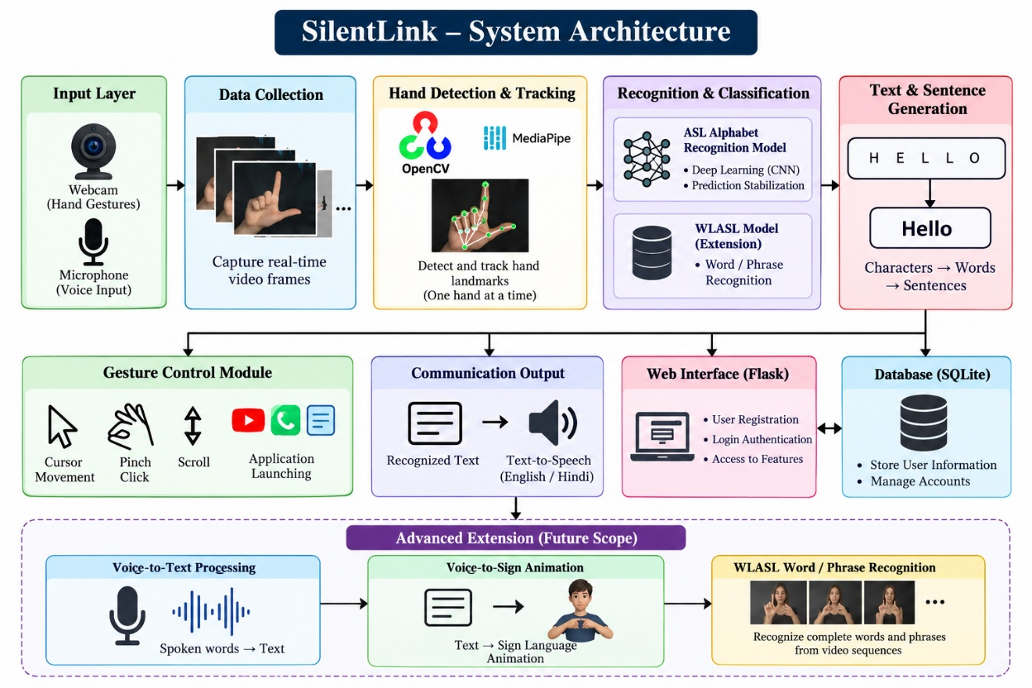

5.2 UML DIAGRAMS
The Use Case Diagram of the SilentLink system represents the interaction between the user and the AI-powered accessibility platform. The main user can interact with the system through hand gestures and voice input to perform different operations. The user can start the camera, detect hand gestures, recognize ASL alphabet signs, generate words and sentences, and convert the recognized text into speech. The user can also control the computer through gestures, including cursor movement, clicking, scrolling, and launching applications such as YouTube, WhatsApp Web, and Notepad. As an extension, the user can provide voice input, convert speech into text, and generate a sign-language animation. The system processes these inputs using computer vision, deep learning, and speech-processing techniques and provides the results through text, speech, or computer actions.

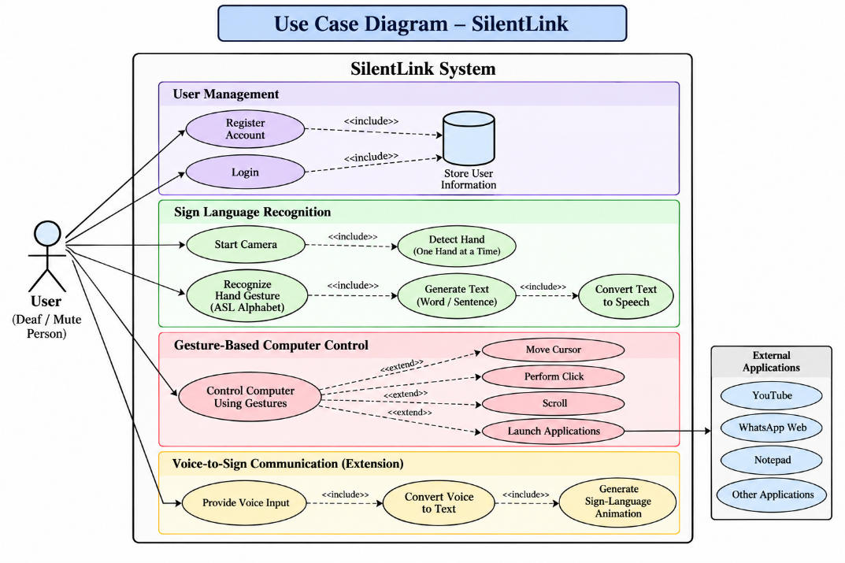
CLASS DIAGRAM

The Class Diagram of the SilentLink system shows the main classes and their relationships within the AI-powered accessibility platform. It includes User, CameraManager, HandDetector, AlphabetRecognizer, PredictionStabilizer, SentenceBuilder, GestureController, TTSEngine, VoiceProcessor, and DatabaseManager. These classes handle user authentication, camera input, hand detection, sign recognition, prediction stabilization, sentence generation, gesture-based computer control, text-to-speech conversion, voice processing, and database operations. The diagram also includes the advanced WLASLRecognizer and SignAnimator components for word/phrase recognition and voice-to-sign animation. The relationships between these classes show how data flows from user input and hand detection to recognition, text generation, speech output, and computer-control actions.

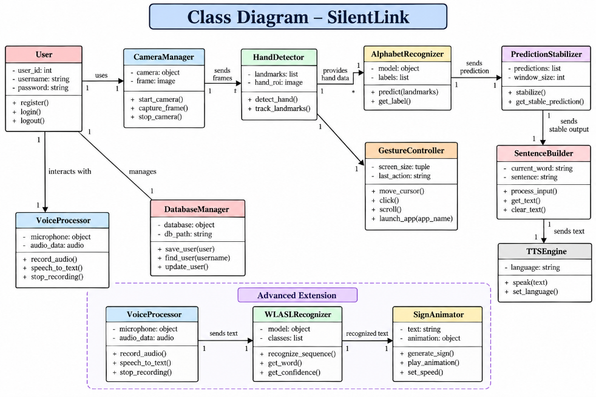

CHAPTER 5
WORKING MODULES AND WORK FLOW

Working Modules
1. User Module
- Handles user registration and login.
- Provides access to the SilentLink system.
2. Sign Recognition Module
- Captures hand gestures using the webcam.
- Detects the hand using MediaPipe.
- Recognizes ASL alphabet signs.
3. Text and Speech Module
- Converts recognized signs into text.
- Forms words and sentences.
- Converts text into speech.
4. Gesture Control Module
- Controls the computer using hand gestures.
- Supports cursor movement, clicking, scrolling, and application launching.
5. WLASL Extension Module
- Supports future word and phrase-level sign recognition.
- Provides a foundation for voice-to-sign animation.
WORKFLOW
- Input – User provides hand gestures or voice.
- Detection – System detects and processes the hand.
- Recognition – The sign is recognized.
- Text Generation – Recognized signs are converted into words and sentences.
- Output – Text is displayed or converted into speech.
- Computer Control – Gestures can also perform computer actions.

CHAPTER 6

IMPLEMENTATION TOOLS
TECHNOLOGIES USED
1. Python
- Python is the main programming language used to develop SilentLink.
- It is used for AI processing, webcam handling, gesture recognition, and backend logic.
2. OpenCV
- OpenCV is used to capture and process real-time webcam frames.
- It helps in image processing and displaying the camera feed.
3. MediaPipe
- MediaPipe Hands is used to detect and track hand landmarks.
- It provides the hand information required for sign and gesture recognition.
4. TensorFlow / Keras
- TensorFlow/Keras is used for the deep learning-based ASL alphabet recognition model.
- It is used for model training and prediction.
5. NumPy
- NumPy is used for numerical calculations and processing image data.
- It helps prepare input data for the recognition model.
6. Flask
- Flask is used as the web framework for the SilentLink application.
- It connects the user interface with the backend modules.
7. SQLite
- SQLite is used to store user account and authentication information.
- It provides lightweight database support.
8. PyAutoGUI
- PyAutoGUI is used for gesture-based computer control.
- It supports cursor movement, clicking, scrolling, and application interaction.
9. HTML and CSS
- HTML is used to create the structure of the web interface.
- CSS is used to design the layout and appearance of the application.
10. WLASL Dataset
- WLASL is used for the planned extension toward word- and phrase-level sign recognition.
- It provides sign-language video data for developing advanced recognition models.
11. Visual Studio Code
- VS Code is used for writing, testing, and managing the SilentLink source code.
- It also helps organize the different project modules.

IMPLEMENTATION PHASES
1. Setup Development Environment
- Install Python and required libraries such as OpenCV, MediaPipe, TensorFlow, Flask, NumPy, and PyAutoGUI.
- Set up the project structure using VS Code.
2. Webcam and Hand Detection
- Connect the webcam to the application.
- Capture real-time video frames.
- Detect and track one hand using MediaPipe.
3. Sign Recognition
- Load the trained ASL recognition model.
- Process the detected hand region.
- Predict the corresponding alphabet gesture.
4. Text Generation
- Stabilize the predictions to reduce incorrect results.
- Combine recognized characters into words and sentences.
- Display the generated text on the interface.
5. Text-to-Speech
- Convert recognized text into speech.
- Provide spoken output for communication.
6. Gesture-Based Computer Control
- Implement hand gestures for cursor movement, clicking, and scrolling.
- Add gestures for launching applications such as YouTube, WhatsApp Web, and Notepad.
7. Flask and Database Integration
- Connect the recognition modules with the Flask web application.
- Implement user registration and login.
- Store user information using SQLite.
8. WLASL Extension
- Prepare the WLASL dataset for word- and phrase-level recognition.
- Develop the required video-processing and recognition pipeline.
9. Testing
- Test sign recognition under different conditions.
- Test gesture controls and application launching.
- Verify text generation, speech output, login, and database functions.
10. Future Extension
- Extend the system toward voice-to-sign communication.
- Connect the application to the required database and datasets

CHAPTER 7
TESTING AND VALIDATION

TESTING AND VALIDATION
- Testing is performed to check whether the SilentLink system works correctly and produces the expected results.
1. Unit Testing
- Tests each module separately.
- Checks sign recognition, text generation, speech, and gesture control.
2. Integration Testing
- Checks whether all modules work together correctly.
- Verifies the flow from gesture recognition to text and speech.
3. System Testing
- Tests the complete SilentLink application.
- Checks camera, recognition, gesture control, login, and database functions.
4. Input Testing
- Tests different hand gestures and positions.
- Checks whether valid and invalid inputs are handled correctly.
5. Performance Testing
- Checks the system's response time during real-time camera operation.
- Ensures gestures are detected with minimal delay.

TEST CASES
ID | Module | Test | Expected Output | Status
TC_01 | Camera | Start camera | Camera opens | Pass
TC_02 | Hand Detection | Show hand | Hand detected | Pass
TC_03 | Sign Recognition | Show ASL sign | Correct sign displayed | Pass
TC_04 | Text | Give multiple signs | Word generated | Pass
TC_05 | Speech | Convert text | Speech generated | Pass
TC_06 | Gesture Control | Move finger | Cursor moves | Pass
TC_07 | Click | Pinch fingers | Click performed | Pass
TC_08 | Scroll | Scroll gesture | Screen scrolls | Pass

VALIDATION
Validation ensures that the SilentLink system meets its required functions and provides correct outputs.
1. Functional Validation
- Verified that the webcam captures hand gestures correctly.
- Confirmed that ASL signs are recognized and converted into text.
- Checked that text can be converted into speech.
- Verified cursor movement, clicking, scrolling, and application launching.
2. Input Validation
- Tested different hand gestures and positions.
- Checked the system with one-hand input.
- Verified that incorrect or unclear gestures are not unnecessarily processed.
3. User Interface Validation
- Checked that the Flask interface is simple and easy to use.
- Verified that recognized signs and text are displayed properly.
- Tested login and navigation functions.
4. Performance Validation
- Checked the response of the system during real-time camera operation.
- Verified that gesture detection and computer-control actions occur with minimal delay.
5. System Validation
- Verified that the different modules work together correctly.
- Confirmed the complete flow from hand gesture → recognition → text → speech/action.
- Tested the system under different lighting and hand positions.

CHAPTER 8

INPUT AND OUTPUT DESIGN
INPUT AND OUTPUT DESIGN
Input and output design describes how users provide information to the SilentLink system and how the system displays the processed results.
1. Sign Language Input
Input Design:
- User performs hand gestures in front of the webcam.
- The webcam captures the hand movement.
Output Design:
- The system detects the hand.
- The recognized sign is displayed as text.
2. Text Generation
Input Design:
- Multiple recognized signs are provided to the text module.
Output Design:
- Characters are combined to form words and sentences.
- The generated text is displayed on the screen.
3. Text-to-Speech
Input Design:
- Recognized text or sentence is given as input.
Output Design:
- The text is converted into speech.
- The generated speech can be heard by the user.
4. Gesture Control
Input Design:
- User performs predefined hand gestures.
Output Design:
- Cursor movement, clicking, and scrolling are performed.
- Specific gestures can launch applications.

5. User Authentication
Input Design:
- User enters username and password.
Output Design:
- Valid details provide access to the system.
- Invalid details display an error message.
6. Advanced Extension
Input Design:
- WLASL video data or voice input is provided.
Output Design:
- Words and phrases can be recognized.
- Voice input can be converted into a sign-language animation in the advanced version.

OUTPUT SCREENS

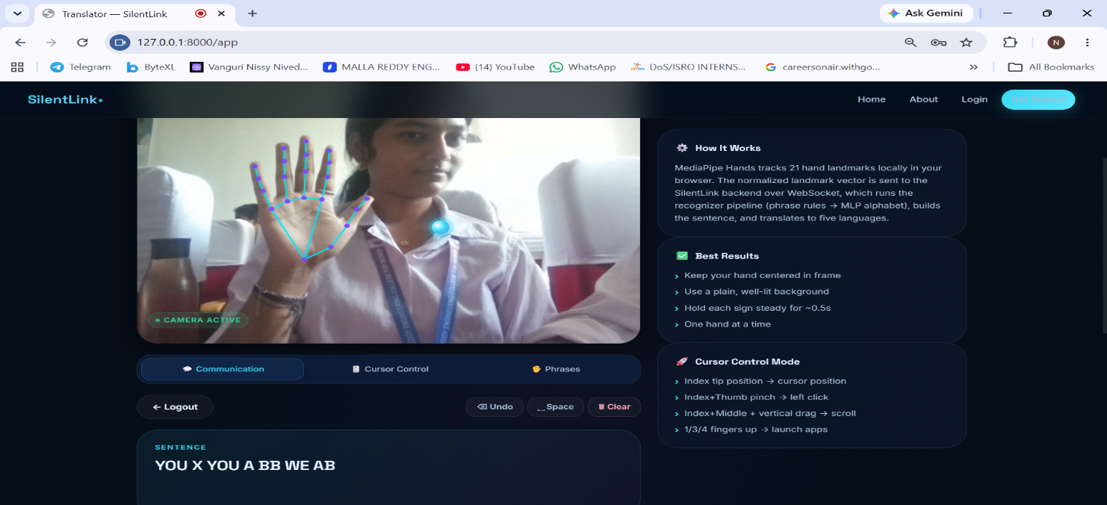

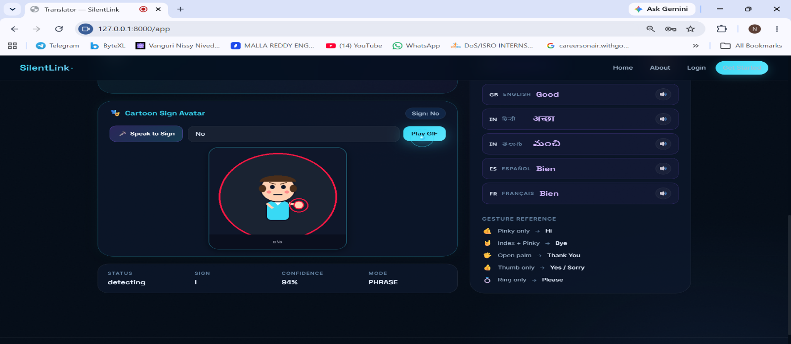

CHAPTER 9

CONCLUSION

SilentLink successfully presents an AI-powered approach to improving communication and computer accessibility for sign-language users. The system combines computer vision, deep learning, speech processing, and gesture-based human–computer interaction into a single platform.
The system uses a webcam to capture hand gestures and MediaPipe to detect hand landmarks. The recognized ASL alphabet gestures are processed by the recognition model and converted into characters, words, and sentences. These results can be displayed as text and converted into speech, helping users communicate with people who may not understand sign language.
In addition to communication, SilentLink provides a gesture-based computer control module. Users can perform actions such as cursor movement, pinch-based clicking, scrolling, and application launching using predefined hand gestures. This provides an alternative method of interacting with a computer and reduces dependence on traditional input devices.
The project also includes a Flask-based web interface with user authentication and SQLite database support, providing a structured environment for accessing the system's features. The modular architecture makes it easier to maintain the system and add new functionality.
As an extension, the project is being developed toward word- and phrase-level sign recognition using the WLASL dataset. A further planned feature is voice-to-sign communication, where spoken input can be converted into text and represented through sign-language animation. These extensions can help move the system beyond alphabet-level recognition toward more natural communication.
Overall, SilentLink demonstrates the potential of AI and computer vision in developing accessible communication and human–computer interaction systems. The project provides a foundation that can be further improved in terms of recognition accuracy, real-time performance, multilingual support, word-level recognition, and two-way communication.

CHAPTER 10

FUTURE SCOPE
The future scope of SilentLink focuses on improving the system's accuracy, usability, and communication capabilities.
- Word and Phrase Recognition
The system can be extended from alphabet recognition to complete words and phrases using the WLASL dataset.
- Voice-to-Sign Animation
Voice input can be converted into text and represented through real-time sign-language animation, supporting two-way communication.
- Improved Recognition Accuracy
Advanced deep-learning and temporal models can be used to improve recognition of continuous hand movements.
- Multilingual Support
The system can be extended to support multiple spoken languages for text-to-speech communication.
- Mobile Application
SilentLink can be developed as a mobile application so that users can access sign recognition and communication features on smartphones.
- Real-Time Communication
The system can be integrated with video-calling and messaging platforms to provide sign-language support during online communication.
- Personalized Recognition
The model can be improved to handle different users, signing styles, backgrounds, and lighting conditions.
- Advanced Sign-Language Avatar
A realistic 3D avatar can be developed to represent signs more naturally and provide a better voice-to-sign experience.
Overall, these future developments can transform SilentLink into a more complete two-way AI-based sign-language communication platform.

CHAPTER 11

REFERENCES

REFERENCES
- Python Software Foundation. Python Documentation.
- OpenCV. OpenCV Documentation – Open Source Computer Vision Library.
- Google. MediaPipe Documentation – Hand Landmarker and Hand Tracking.
- TensorFlow. TensorFlow Documentation – Machine Learning and Deep Learning Framework.
- Keras. Keras Documentation – Deep Learning API.
- Pallets Projects. Flask Documentation – Python Web Framework.
- SQLite. SQLite Documentation – Lightweight Database Engine.
- PyAutoGUI. PyAutoGUI Documentation – Cross-Platform GUI Automation.
- NumPy Developers. NumPy Documentation – Numerical Computing in Python.
- WLASL. Word-Level American Sign Language Dataset.
- Li, D., Rodriguez, C., Yu, X., & Li, H. Word-level Deep Sign Language Recognition from Video: A New Large-scale Dataset and Methods.
- Zhang, J., et al. MediaPipe Hands: On-device Real-time Hand Tracking.
- Bradski, G. The OpenCV Library. Dr. Dobb's Journal of Software Tools.
- Abadi, M., et al. TensorFlow: Large-Scale Machine Learning on Heterogeneous Systems.
- McKinney, W. Python for Data Analysis. O'Reilly Media.
- Géron, A. Hands-On Machine Learning with Scikit-Learn, Keras, and TensorFlow. O'Reilly Media.
- Goodfellow, I., Bengio, Y., & Courville, A. Deep Learning. MIT Press.
- Szeliski, R. Computer Vision: Algorithms and Applications. Springer.
- Jurafsky, D., & Martin, J. H. Speech and Language Processing.
- Flask Documentation. Web Application Development with Flask.

