## Executive Summary

This report provides an in-depth analysis of the factors contributing to the success and challenges faced by restaurants, focusing on the top 5 most popular and highest-revenue restaurants and comparing them with the 5 least popular and lowest-revenue establishments. The aim is to identify key insights and recommend strategies to improve restaurant performance.

#### Key Insights

1. **Top-Performing Restaurants:**
   * Most popular restaurants are franchise-based with high brand visibility and multiple locations.
   * High-revenue restaurants cater to universal preferences, offering affordable, shareable, and fan-favorite foods like pizza, desserts, and burgers.
   * A balance between popularity (ratings and reviews) and broad demographic appeal drives long-term success.
2. **Challenges for Underperforming Restaurants:**
   * Lack of brand recognition due to unique names and absence of franchise backing.
   * Minimal customer engagement and low review counts, leading to limited visibility.
   * Narrow menu offerings that fail to attract diverse customer groups.
3. **Critical Success Factors:**
   * Brand recognition and visibility through marketing and strategic placement.
   * Menu diversity, including vegan-friendly options, to appeal to a wider audience.
   * Customer engagement strategies, such as encouraging online reviews and utilizing social media.

## Restaurant Analysis Report

When comparing the top 5 most popular restaurants with the top 5 most sales amount I found key insights on why these restaurants are doing so well. I also compared the bottom 5 popular and the 5 least sales amounts to find the main differences and how to improve restaurants that aren’t doing so well. By the end of this report, I will provide my recommendations for having a successful restaurant, and answer questions like, what restaurants are popular? What restaurants generate the highest revenue? Why do they generate more revenue? And What similarities do restaurants with the highest revenue have?  
  
 To begin let’s look at the top 5 most popular restaurants. Right off the bat we can see that they have something in common, they are well known franchise restaurants with multiple locations. Most people just by hearing their names would recognize these restaurants. This is because you can find these places most anywhere. The more often a restaurant is seen the more likely people are to want to try it out. Not just that but it is more likely to get multiple reviews raising their popularity. This however does not necessarily mean that they will provide the most sales.

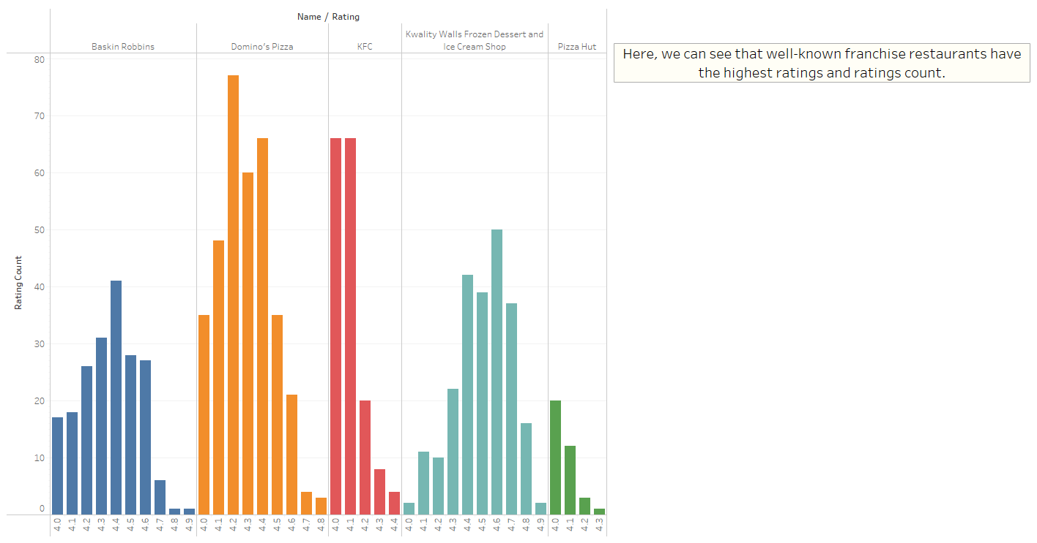

Now let’s take a look at the top 5 restaurants with the highest sales amount. A couple of them might not be so surprising. Dominos and Pizza Hut, these 2-franchise restaurants provide fast, affordable, vegetarian friendly, and shareable food. These things serve not only a variety of different people but also a large some of people. How many of us haven’t gotten together with friends and/or family to watch a game, hang out, meet at the park, have a party, etc... Pizza is one of the best options because it is not only good but also a fan favorite. Food like pizza that is affordable to buy in bulk gives it an advantage and helps with sales! What can be said about the other 3? Well, we can see another pattern immerge with 2 other top selling restaurants. Both Sweet Tooth – Cake and Desserts and Huber & Holly serve another fan favorite food... Desserts! Who doesn’t love a good cup of coffee on a cold day accompanied by a cookie or brownie or even a piece of cake. Or a cold refreshing and creamy ice cream cone on a hot day. Either go great to end a meal on as well hot or cold weather! Last, we have Kouzina Kafe, this restaurant provides ... you guessed it another fan favorite go to type of food burgers. Not only do they provide a fan favorite but they have vegan friendly burgers which provides to a wider demographic of people. The reasons stated although true aren’t the only things needed for a successful restaurant.

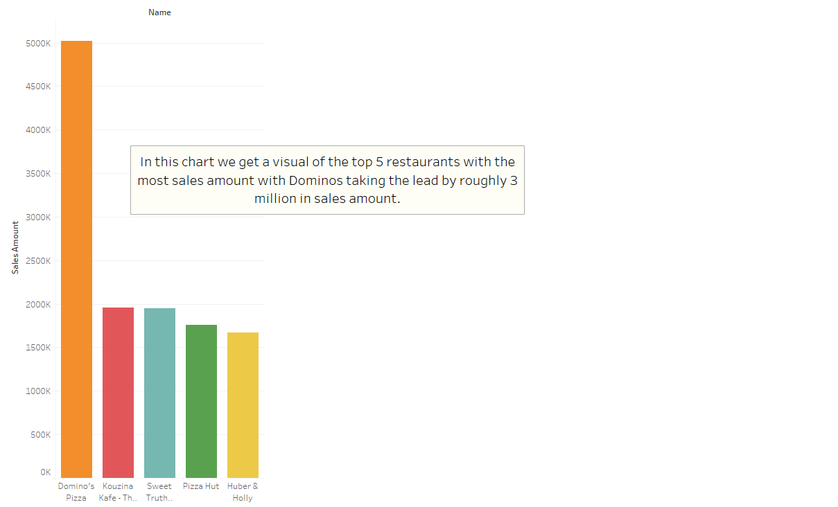

When we compare the 2 top 5’s we see that what helps make a restaurant successful is having a combination of both popularity and catering to a high demographic of people. We can see that Dominos, Sweet Tooth, Pizza Hut, and kouzina kafe. In the case of Huber & Holly they might not have much high-end ratings but are still well known. If we focused on having a stable balance between both, we could have even higher results.

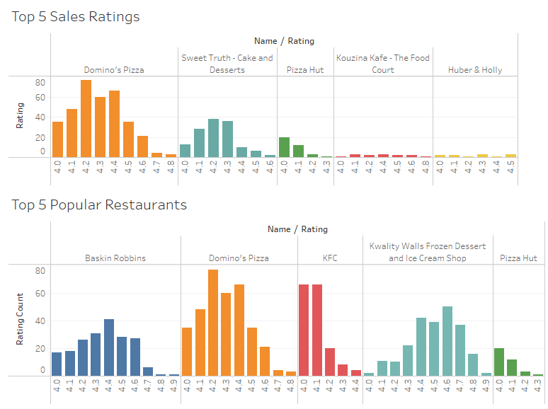

Finally, when we look at the 5 least popular and least number of sales restaurants a couple things stand out to me. The first issue is these restaurants have unique names which tells me they aren’t part of a franchise and most likely not well known by people. The problem this causes is the few people that do go might enjoy the food, but not be enough to draw any real attention. The second issue is they have a very low rating count with each one consisting of just 1 rating. Having people leave good reviews of the place could get it much needed attention.

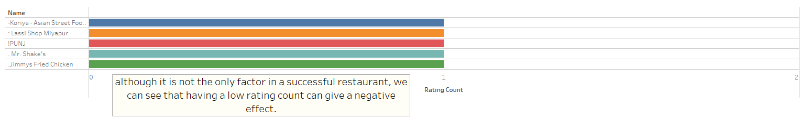

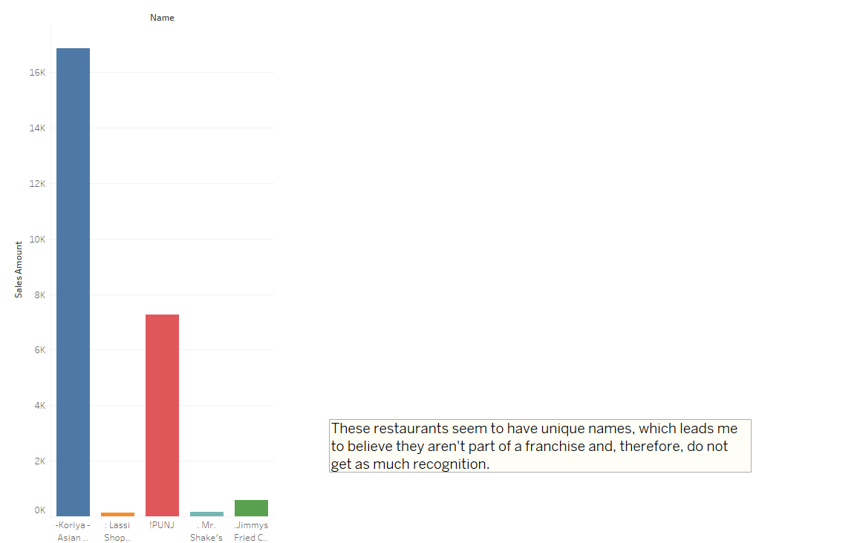

# Conclusion

My analysis highlights that successful restaurants thrive on brand recognition, universal appeal, and catering to diverse demographics. Visibility and customer engagement, such as encouraging reviews, play a critical role in boosting both popularity and revenue. Struggling restaurants often lack these factors, facing challenges in recognition and customer feedback. To improve, they should focus on strategic marketing, broadening their menu options, and fostering strong customer experiences. These steps can help create a balance between popularity and sales, ensuring long-term success.   
  
  
 Recommendations

#### Enhance Visibility

* Invest in eye-catching signage and unique decor to attract walk-in customers.
* Leverage social media platforms to increase online presence.

#### Engage Customers

* Implement rewards systems for leaving reviews to boost engagement and credibility.

#### Offer Deals and Promotions

* Introduce offers like “buy one, get one 20% off” to attract first-time customers.

#### Expand Menu Options

* Add vegan and health-conscious dishes to appeal to broader demographics.

#### Leverage Digital Marketing

* Maintain an active presence on Instagram and Facebook, showcasing promotions and customer engagement campaigns.

## Data Overview and Methodology

#### Data Source

The data was sourced from Zomato’s platform, including metrics such as restaurant names, ratings, revenue, and popularity scores.

#### Data Cleaning

Steps were taken to ensure accuracy, including removing duplicates, addressing missing values, and excluding irrelevant records.

#### Metrics Defined

* **Popularity:** Measured by the number of reviews and average ratings.
* **Earnings:** Based on reported revenue.
* **Ratings:** Derived from customer feedback scores.

#### Assumptions

* Popularity correlates strongly with the number of reviews.
* Revenue figures represent gross income and are consistent across data points.
* Data completeness was assumed for restaurants included in the analysis.