INTERNSHIP TECHNICAL WORK REPORT

Project: Twitter Profile Analyzer
Submitted by: Nistha Srivastava
Organization: Innefu Labs
University: KIIT University
Programme: B.Tech — Computer Science and Engineering
Internship Role: Data Scientist Intern
Internship Duration: 2 months
Mentor / Manager: Ashutosh Khanna
Submission Date: 10 July 2026

Declaration / Report Note
This report documents the technical work completed during my internship at Innefu Labs. All descriptions, commands, and architectural details are based on inspection of the actual project repository as of the submission date. Where information could not be verified from code or configuration files, it is clearly marked for manual confirmation before final submission.

Table of Contents
1. Introduction
2. Project Overview
3. Problem Statement
4. Project Objectives
5. My Role and Work Completed
6. Technologies Used
7. System Architecture
8. Complete Project Workflow
9. Twitter/X Data Collection
10. Probing Agent
11. Profile Discovery
12. Tweet Collection
13. Text Preprocessing
14. N-Gram Dictionary and Matching
15. User Flagging / Classification Logic
16. Browser Automation
17. Session and Authentication Handling
18. Backend Implementation
19. Frontend Application
20. Data Storage and Result Management
21. Important Project Files
22. API Endpoints
23. Challenges I Faced and How I Worked on Them
24. Commands to Install the Project
25. Commands to Run the Project
26. Commands / Steps to Test the Project
27. Testing Performed
28. Performance Observations
29. Screenshots of Working Application
30. Current Limitations
31. Future Improvements
32. Security, Privacy, and Responsible Use
33. What I Learned During This Project
34. Conclusion
Appendix A — Complete Installation Commands
Appendix B — Complete Run Commands
Appendix C — Complete Test Steps
Appendix D — API Endpoint Summary
Appendix E — Important Files and Functions
Appendix F — Screenshot Checklist
Appendix G — Final Submission Checklist

1. Introduction
During my internship at Innefu Labs, I worked on the Twitter Profile Analyzer project — a Python-based social media intelligence tool that collects public tweet text from Twitter/X profiles and analyzes it using machine learning and rule-based NLP techniques.
The project addresses a practical need in social media monitoring: given a public profile URL, how can tweet content be collected reliably, stored, classified, and summarized for review? The repository implements multiple analysis paths: a Streamlit web application and CLI tools for product taxonomy classification (FastText), semantic metadata extraction (BitNetClient module), and hate/offensive content detection using TF-IDF n-gram features with a Random Forest classifier (twitter_ngram_analyzer.py).
This report explains the verified implementation as found in the repository, including installation and run commands, data flow, limitations, and testing procedures suitable for internship evaluation.

2. Project Overview
Twitter Profile Analyzer is a Python application for analyzing public Twitter/X profile timelines. It does not use the official X API; instead, it uses Playwright browser automation to load profile pages and extract tweet text from the DOM.

Problem Solved
The system helps analysts and researchers quickly profile a Twitter/X account by collecting recent tweets and applying automated text analysis — product category labeling, sentiment/topic metadata, and optional hate/offensive speech flagging.

Primary Inputs and Outputs
Input | Output
Public Twitter/X profile URL (x.com or twitter.com) | Scraped tweet text stored in SQLite
Tweet text (from scrape or fallback dataset) | FastText predicted product taxonomy category
Tweet text | BitNetClient sentiment, topic, and entity labels (rule-based)
Tweet text (n-gram analyzer path) | HOF/NOT classification per tweet with flagged count
Analyzed tweet categories | Matplotlib pie chart saved to outputs/category_distribution.png

3. Problem Statement
- Collecting tweet text without official API access requires browser automation, which is sensitive to login walls and DOM changes.
- Platform layout changes can block scraping, requiring fallback data paths (verified in app.py and web_app.py).
- Text must be cleaned differently for FastText taxonomy vs. TF-IDF n-gram classification.
- Persistent browser sessions are needed so users can log in manually when required.
- Multiple analysis modes exist (taxonomy vs. hate/offensive detection) with different tweet limits and models.

4. Project Objectives
- Accept a public Twitter/X profile URL and validate its format.
- Launch a headed Chromium browser with a persistent user profile for session reuse.
- Scrape tweet text from profile timeline DOM elements.
- Store profiles and tweets in a local SQLite database.
- Classify tweets into Google Product Taxonomy categories using FastText.
- Extract sentiment, topic, and named-entity metadata via the BitNetClient module.
- Detect hate/offensive themes using TF-IDF n-grams (1–3) and Random Forest on HASOC2021 labels.
- Visualize category distribution with a matplotlib pie chart.
- Provide both CLI (app.py, twitter_ngram_analyzer.py) and Streamlit (web_app.py) interfaces.

5. My Role and Work Completed
Contribution details should be reviewed by the student before submission. Based on repository evidence, the project includes the following work areas:
Area | Evidence in Repository
Profile URL input and validation | app.py, web_app.py, tweet_scraper.py validate_url()
Browser automation (Playwright) | fetcher/browser_launcher.py, fetcher/tweet_scraper.py
Tweet scraping from profile pages | TweetScraper.fetch_profile_tweets()
SQLite data persistence | database/database.py — profiles and tweets tables
FastText taxonomy classification | classifier/fasttext_classifier.py
N-gram ML flagging pipeline | twitter_ngram_analyzer.py, classifier/ngram_trainer.py
Rule-based semantic analysis | llm/bitnet_client.py
Visualization | visualization/charts.py
Streamlit web UI | web_app.py
CLI analysis entry points | app.py, twitter_ngram_analyzer.py

6. Technologies Used
Technology | Purpose | Where Used (Verified)
Python 3 | Core language | All .py files
Playwright 1.42.0 | Browser automation, DOM scraping | fetcher/browser_launcher.py, tweet_scraper.py
Chromium (via Playwright) | Persistent headed browser context | BrowserLauncher.get_context()
Streamlit | Web UI framework | web_app.py (not in requirements.txt — see limitations)
FastText (fasttext-wheel 0.9.2) | Supervised text classification | classifier/fasttext_classifier.py
scikit-learn | TF-IDF vectorizer, RandomForest, GridSearchCV | twitter_ngram_analyzer.py, ngram_trainer.py
pandas | HASOC2021 CSV loading | twitter_ngram_analyzer.py, ngram_trainer.py
joblib | Model persistence (.pkl) | twitter_ngram_analyzer.py
SQLite3 | Local relational storage | database/database.py
matplotlib 3.8.3 | Pie chart generation | visualization/charts.py
numpy 1.26.4 | Numerical dependency | requirements.txt
regex (re) | URL validation, text cleaning | tweet_scraper.py, fasttext_classifier.py

7. System Architecture
The repository implements a modular Python architecture with three entry points sharing common fetcher, database, classifier, and visualization modules.
┌─────────────────────────────────────────────────────────────────┐
│ ENTRY POINTS │
│ app.py (CLI) │ web_app.py (Streamlit) │ twitter_ngram_analyzer.py │
└────────┬────────────────┬──────────────────────────┬────────────┘
│ │ │
▼ ▼ ▼
┌────────────────┐ ┌──────────────┐ ┌──────────────────────────┐
│ BrowserLauncher│ │ TweetScraper │ │ TfidfVectorizer + │
│ (Playwright) │ │ (DOM extract)│ │ RandomForest (HASOC2021) │
└────────┬───────┘ └──────┬───────┘ └──────────────────────────┘
│ │
▼ ▼
┌────────────────────────────────────────┐
│ DatabaseManager (SQLite) │
│ profiles table │ tweets table │
└────────────────────┬───────────────────┘
│
┌───────────┼───────────┐
▼ ▼ ▼
┌─────────────┐ ┌──────────┐ ┌─────────────┐
│ FastText │ │ BitNet │ │ ChartGen │
│ Classifier │ │ Client │ │ (matplotlib)│
└─────────────┘ └──────────┘ └─────────────┘
Note: No probing agent, home-feed crawler, FastAPI backend, or React frontend was found in the repository.

8. Complete Project Workflow

Path A — Streamlit / app.py (Taxonomy + Semantic Analysis)
1. User provides profile URL.
2. TweetScraper.validate_url() checks URL pattern against x.com or twitter.com.
3. BrowserLauncher launches Chromium persistent context (headed, user_data_dir=browser_profile).
4. page.goto(profile_url) with wait_until=domcontentloaded, then 20-second timeout.
5. Locator article[data-testid='tweet'] collects up to max_tweets elements.
6. Tweet text extracted from div[data-testid='tweetText'].
7. If no tweets scraped, fallback simulation tweets are used (profile-specific in web_app.py).
8. Profile and raw tweets inserted into SQLite.
9. Each unprocessed tweet: FastTextClassifier.clean_text() then predict_category().
10. BitNetClient.process_all_semantic_tasks() adds sentiment, topic, entities.
11. Results updated in database; ChartGenerator produces pie chart.

Path B — twitter_ngram_analyzer.py (Hate/Offensive Detection)
1. User provides profile URL; scraper fetches up to 25 tweets (default in this file).
2. Load models/heavy_ngram_model.pkl if exists; otherwise train via GridSearchCV on en_Hasoc2021_train.csv.
3. For each tweet: RandomForest predicts task_1 label (HOF or NOT).
4. HOF prediction prints FLAGGED status; displays matched bigrams/trigrams from TF-IDF features.
5. Summary prints total flagged tweet count.

9. Twitter/X Data Collection
Aspect | Verified Implementation
Method | Playwright DOM scraping — no Tweepy, snscrape, or official API
Authentication | Manual login via persistent browser profile (browser_profile/)
Browser mode | Headed (headless=False)
Navigation | page.goto(profile_url, wait_until='domcontentloaded')
Wait time | page.wait_for_timeout(20000) — 20 seconds fixed
Tweet selector | article[data-testid='tweet']
Text selector | div[data-testid='tweetText']
Retries | None explicit; bare except continues/skips failed elements
Rate limiting | Not implemented
Fallback | Hardcoded simulation tweets when scrape returns empty

10. Probing Agent
No probing agent, home-feed crawler, or automated profile-discovery module was found in the repository. Profiles are provided manually by the user via URL input. A design involving home-feed crawling and automatic user discovery was discussed in planning but is not implemented in the current codebase.

11. Profile Discovery
Profile discovery is manual only. The user enters a full profile URL in the CLI prompt or Streamlit text input. No duplicate-profile queue, verified-account handling, private-account detection, or feed-based discovery is implemented.

12. Tweet Collection
Parameter | web_app.py | app.py | twitter_ngram_analyzer.py
max_tweets default | 5 (comment: quick testing) | 100 | 25
Replies included | Not filtered — first N DOM tweets | Same | Same
Retweets filtered | No | No | No
Pinned tweets | Not specifically handled | Same | Same
Timestamp captured | Empty string '' | Same | Same
Duplicate removal | No | No | No

13. Text Preprocessing

FastText path (fasttext_classifier.py — clean_text)
1. Remove URLs (http, www, https patterns)
2. Remove @mentions and #hashtags
3. Collapse whitespace and lowercase

N-gram ML path
Raw tweet text is passed directly to TfidfVectorizer without additional cleaning in twitter_ngram_analyzer.py. The vectorizer uses ngram_range=(1,3) with default sklearn tokenization.

14. N-Gram Dictionary and Matching
Important clarification: The hate/offensive detection path does NOT use a static n-gram dictionary file. It uses machine-learned TF-IDF n-gram features trained on en_Hasoc2021_train.csv (HASOC 2021 dataset). Labels: task_1 column — HOF (Hate/Offensive) and NOT (Not offensive).

N-gram Types
Unigrams, bigrams, and trigrams: ngram_range=(1,3) in twitter_ngram_analyzer.py
ngram_trainer.py uses ngram_range=(2,3) only (bigrams and trigrams)

Example (Based on Implementation Logic)
Tweet: "The weather is absolutely amazing and clear today."
The TfidfVectorizer tokenizes and generates features such as unigrams (weather, amazing), bigrams (absolutely amazing), and trigrams from the training vocabulary.
The trained RandomForest predicts NOT → SAFE.
Tweet: "Anti national elements are spreading fake news everywhere."
Model may predict HOF → FLAGGED (Hate/Offensive Theme). Matching n-gram features are printed from the sparse vector (up to 4 bigrams and 4 trigrams shown).
FastText path (separate from flagging): Uses wordNgrams=1 during training on models/taxonomy_train.txt (Google Product Taxonomy-style multi-label lines). Predicts product categories, not HOF/NOT.

15. User Flagging / Classification Logic
Flagging exists only in twitter_ngram_analyzer.py and classifier/ngram_trainer.py.
Rule | Implementation
Flag condition | RandomForest prediction == 'HOF'
Per-tweet decision | Yes — each tweet classified independently
User-level aggregation | No — only summary count of flagged tweets printed
Threshold | None — hard class label from classifier
Confidence score | Not output in terminal analysis
FastText flagging | No — FastText assigns taxonomy categories only

16. Browser Automation
Setting | Value (from browser_launcher.py)
Framework | Playwright sync_api
Launch method | chromium.launch_persistent_context
User data directory | browser_profile (default)
Headless | False (visible browser window)
Extra args | --disable-blink-features=AutomationControlled
Context cleanup | context.close() in finally block

17. Session and Authentication Handling
Authentication relies on a persistent Chromium user data directory (browser_profile/). When the user runs the scraper, a visible browser opens. If a login page appears, the user must log in manually. web_app.py provides a configurable wait slider (0–120 seconds, default 90) to allow time for login and tweet loading before scraping proceeds.
No cookies, tokens, or credentials are stored in source code. Session state lives in the browser profile directory and must not be included in submission ZIP files.

18. Backend Implementation
There is no separate FastAPI, Flask, or Django backend. The Streamlit application (web_app.py) runs analysis logic directly in the Streamlit process. Database access is via SQLite through DatabaseManager. No REST API routes or WebSocket endpoints exist.

19. Frontend Application
Framework: Streamlit (web_app.py)
UI Element | Function
Page title | Twitter Profile Analyzer
Sidebar | Setup instructions, tweet fetching steps, BitNet note
Profile URL input | st.text_input with x.com/twitter.com placeholder
Wait time slider | 0–120 seconds for login/load wait
Button 1 | Fetch Tweets — launches scraper, stores in DB
Button 2 | Analyze & Chart — runs FastText + BitNetClient, shows chart and dataframe
Session state | current_profile_id stored between button clicks
Error states | Invalid URL, fetch-before-analyze warning, scrape fallback warning

20. Data Storage and Result Management
Storage | Location | Format | Contents
SQLite DB | database/twitter_analyzer.db | Relational | profiles, tweets with analysis fields
FastText model | models/google_taxonomy_model.bin | Binary | Generated on first run if missing
N-gram ML model | models/heavy_ngram_model.pkl | joblib pickle | Generated after GridSearchCV training
Training data | models/taxonomy_train.txt | FastText format | Google taxonomy labels + text
HASOC dataset | en_Hasoc2021_train.csv | CSV | text, task_1 (HOF/NOT), task_2
Chart output | outputs/category_distribution.png | PNG | Category pie chart
Browser session | browser_profile/ | Chromium profile | Cookies, local storage — SENSITIVE

21. Important Project Files
File | Purpose | Key Functions/Classes | Role
app.py | CLI main pipeline | main() | Entry: scrape 100 tweets, analyze, chart
web_app.py | Streamlit UI | main() | Entry: web-based fetch and analyze
twitter_ngram_analyzer.py | N-gram flagging CLI | main() | Entry: scrape 25, train/load ML, flag
fetcher/browser_launcher.py | Browser setup | BrowserLauncher.get_context() | Playwright context
fetcher/tweet_scraper.py | Tweet extraction | TweetScraper.fetch_profile_tweets() | DOM scraping
database/database.py | Persistence | DatabaseManager | SQLite CRUD
classifier/fasttext_classifier.py | Taxonomy ML | FastTextClassifier | Train/load/predict
classifier/ngram_trainer.py | N-gram trainer | HeavyNgramTrainer | GridSearch training
llm/bitnet_client.py | Semantic metadata | BitNetClient | Rule-based sentiment/topic/entities
visualization/charts.py | Charts | ChartGenerator | Pie chart generation

22. API Endpoints
No HTTP API endpoints are implemented. The application uses direct Python function calls and Streamlit UI events.
Method | Endpoint | Purpose | Input | Output | Source
N/A | N/A | No REST API | N/A | N/A | Verified: no FastAPI/Flask routes

23. Challenges I Faced and How I Worked on Them
Challenge | What I Observed | Likely/Verified Cause | What I Tried or Changed | Current Status
Empty scrape results | No tweets returned from profile page | Login wall or DOM timing (20s may be insufficient) | Added fallback simulation datasets; web_app wait slider (0–120s) | Fallback active; live scrape unreliable without login
Platform layout wall | Warning logged in app.py | X/Twitter UI changes or auth requirement | Profile-specific and generic mock tweet data | Documented in code comments
Incomplete requirements.txt | Import errors for streamlit, sklearn, pandas | requirements.txt lists only 4 packages | Manual pip install of missing packages needed | Requires manual verification before submission
Missing setup scripts | web_app sidebar references scripts/setup_bitnet.ps1 | Scripts folder not present in repository | Manual install/run commands documented in this report | Scripts not found — use commands in Section 24–25
BitNet naming vs. implementation | Module named BitNetClient | Actual implementation is keyword-based heuristics | Used as lightweight semantic placeholder | Not a real BitNet LLM integration
Long model training | GridSearchCV 405 fits mentioned | Heavy hyperparameter grid on HASOC2021 | Model saved to heavy_ngram_model.pkl for reuse | First run slow; subsequent runs load pickle
Browser profile sensitivity | browser_profile/ contains session data | Persistent context stores cookies | Exclude from ZIP submission | Ongoing — review before submission

24. Commands to Install the Project
Environment: Windows PowerShell. Project root: C:\twitter_profile_analyzer (1)
Step | Terminal | Working Directory | Command | Purpose | Expected Result
1 | 1 | C:\ | cd "C:\twitter_profile_analyzer (1)" | Navigate to project root | Current directory set to project
2 | 1 | C:\twitter_profile_analyzer (1) | python -m venv venv | Create virtual environment | venv folder created
3 | 1 | C:\twitter_profile_analyzer (1) | .\venv\Scripts\Activate.ps1 | Activate virtual environment | Prompt shows (venv)
4 | 1 | C:\twitter_profile_analyzer (1) | python -m pip install --upgrade pip | Upgrade pip | pip upgraded
5 | 1 | C:\twitter_profile_analyzer (1) | pip install -r requirements.txt | Install listed dependencies | playwright, fasttext-wheel, matplotlib, numpy installed
6 | 1 | C:\twitter_profile_analyzer (1) | pip install streamlit pandas scikit-learn joblib | Install additional runtime dependencies | All imports resolve
7 | 1 | C:\twitter_profile_analyzer (1) | playwright install chromium | Install Playwright Chromium browser | Chromium browser binaries downloaded

25. Commands to Run the Project

Option A — Streamlit Web Application (Recommended UI)
Step | Terminal | Working Directory | Command | Purpose | Expected Result
1 | 1 | C:\twitter_profile_analyzer (1) | .\venv\Scripts\Activate.ps1 | Activate venv | (venv) active
2 | 1 | C:\twitter_profile_analyzer (1) | streamlit run web_app.py | Start Streamlit app | Local URL http://localhost:8501 displayed
3 | Browser | N/A | Open http://localhost:8501 | Access application | Twitter Profile Analyzer UI loads
4 | Browser | N/A | Enter profile URL, click Fetch Tweets | Scrape tweets | Browser opens; tweets stored or fallback used
5 | Browser | N/A | Click Analyze & Chart | Run analysis | Pie chart and dataframe displayed

Option B — CLI Full Pipeline (app.py)
cd "C:\twitter_profile_analyzer (1)"
.\venv\Scripts\Activate.ps1
python app.py
Enter profile URL when prompted. Fetches up to 100 tweets, runs FastText + BitNetClient, prints summary and generates chart.

Option C — N-Gram Hate/Offensive Analyzer
cd "C:\twitter_profile_analyzer (1)"
.\venv\Scripts\Activate.ps1
python twitter_ngram_analyzer.py
Enter profile URL. Fetches up to 25 tweets. Trains or loads heavy_ngram_model.pkl. Prints per-tweet FLAGGED/SAFE status.

26. Commands / Steps to Test the Project
Test ID | Objective | Steps | Expected Result | Actual Result
TEST 1 | Virtual environment | Run .\venv\Scripts\Activate.ps1 | Prompt shows (venv) | [STUDENT TO FILL AFTER FINAL TEST]
TEST 2 | Dependency import | python -c "import streamlit, playwright, fasttext, sklearn" | No ImportError | [STUDENT TO FILL AFTER FINAL TEST]
TEST 3 | Playwright browser | playwright install chromium | Chromium installed | [STUDENT TO FILL AFTER FINAL TEST]
TEST 4 | Streamlit startup | streamlit run web_app.py | App at localhost:8501 | [STUDENT TO FILL AFTER FINAL TEST]
TEST 5 | URL validation | Enter invalid URL in UI | Error: valid Twitter/X URL required | [STUDENT TO FILL AFTER FINAL TEST]
TEST 6 | Tweet fetch | Enter https://x.com/nasa, Fetch Tweets | Tweets stored or fallback warning shown | [STUDENT TO FILL AFTER FINAL TEST]
TEST 7 | Analysis pipeline | Click Analyze & Chart after fetch | Pie chart and dataframe appear | [STUDENT TO FILL AFTER FINAL TEST]
TEST 8 | FastText model | First analysis run | models/google_taxonomy_model.bin created | [STUDENT TO FILL AFTER FINAL TEST]
TEST 9 | N-gram analyzer | python twitter_ngram_analyzer.py | Per-tweet HOF/NOT output | [STUDENT TO FILL AFTER FINAL TEST]
TEST 10 | SQLite persistence | Check database/twitter_analyzer.db after fetch | profiles and tweets rows exist | [STUDENT TO FILL AFTER FINAL TEST]
TEST 11 | CLI app.py | python app.py with valid URL | Console summary and chart path logged | [STUDENT TO FILL AFTER FINAL TEST]
TEST 12 | Missing profile | Fetch without prior analyze | Warning: click Fetch Tweets first | [STUDENT TO FILL AFTER FINAL TEST]

27. Testing Performed
Actual results must be filled by the student after running tests on their machine.
Test ID | Feature | Input | Expected Result | Observed Result | Status
TEST 1 | Virtual environment | Run .\venv\Scripts\Activate.ps1 | Prompt shows (venv) | [STUDENT TO FILL AFTER FINAL TEST] | Pending
TEST 2 | Dependency import | python -c "import streamlit, playwright, fasttext, sklearn" | No ImportError | [STUDENT TO FILL AFTER FINAL TEST] | Pending
TEST 3 | Playwright browser | playwright install chromium | Chromium installed | [STUDENT TO FILL AFTER FINAL TEST] | Pending
TEST 4 | Streamlit startup | streamlit run web_app.py | App at localhost:8501 | [STUDENT TO FILL AFTER FINAL TEST] | Pending
TEST 5 | URL validation | Enter invalid URL in UI | Error: valid Twitter/X URL required | [STUDENT TO FILL AFTER FINAL TEST] | Pending
TEST 6 | Tweet fetch | Enter https://x.com/nasa, Fetch Tweets | Tweets stored or fallback warning shown | [STUDENT TO FILL AFTER FINAL TEST] | Pending
TEST 7 | Analysis pipeline | Click Analyze & Chart after fetch | Pie chart and dataframe appear | [STUDENT TO FILL AFTER FINAL TEST] | Pending
TEST 8 | FastText model | First analysis run | models/google_taxonomy_model.bin created | [STUDENT TO FILL AFTER FINAL TEST] | Pending
TEST 9 | N-gram analyzer | python twitter_ngram_analyzer.py | Per-tweet HOF/NOT output | [STUDENT TO FILL AFTER FINAL TEST] | Pending
TEST 10 | SQLite persistence | Check database/twitter_analyzer.db after fetch | profiles and tweets rows exist | [STUDENT TO FILL AFTER FINAL TEST] | Pending
TEST 11 | CLI app.py | python app.py with valid URL | Console summary and chart path logged | [STUDENT TO FILL AFTER FINAL TEST] | Pending
TEST 12 | Missing profile | Fetch without prior analyze | Warning: click Fetch Tweets first | [STUDENT TO FILL AFTER FINAL TEST] | Pending

28. Performance Observations
No formal benchmark was verified in the repository.
Informal timing references found in code:
- twitter_ngram_analyzer.py: GridSearchCV training reported in minutes (time.perf_counter equivalent via time.time()).
- tweet_scraper.py: Fixed 20-second page wait per scrape.
- fasttext_classifier.py: Training configured with epoch=5, wordNgrams=1 for faster training.
- ngram_trainer.py comments: 10–20 minute training estimate for GridSearchCV.

29. Screenshots of Working Application
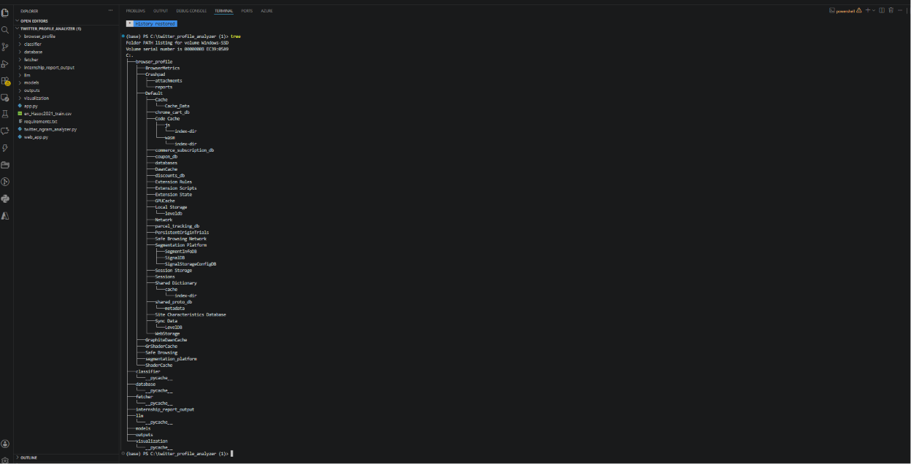
Figure 1: Project repository structure in development environment

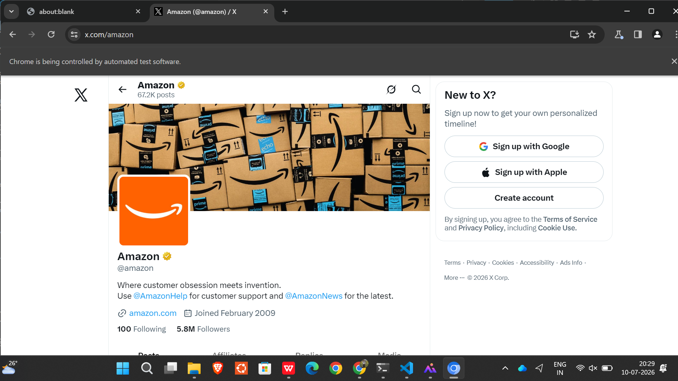
Figure 2: Playwright browser during tweet collection

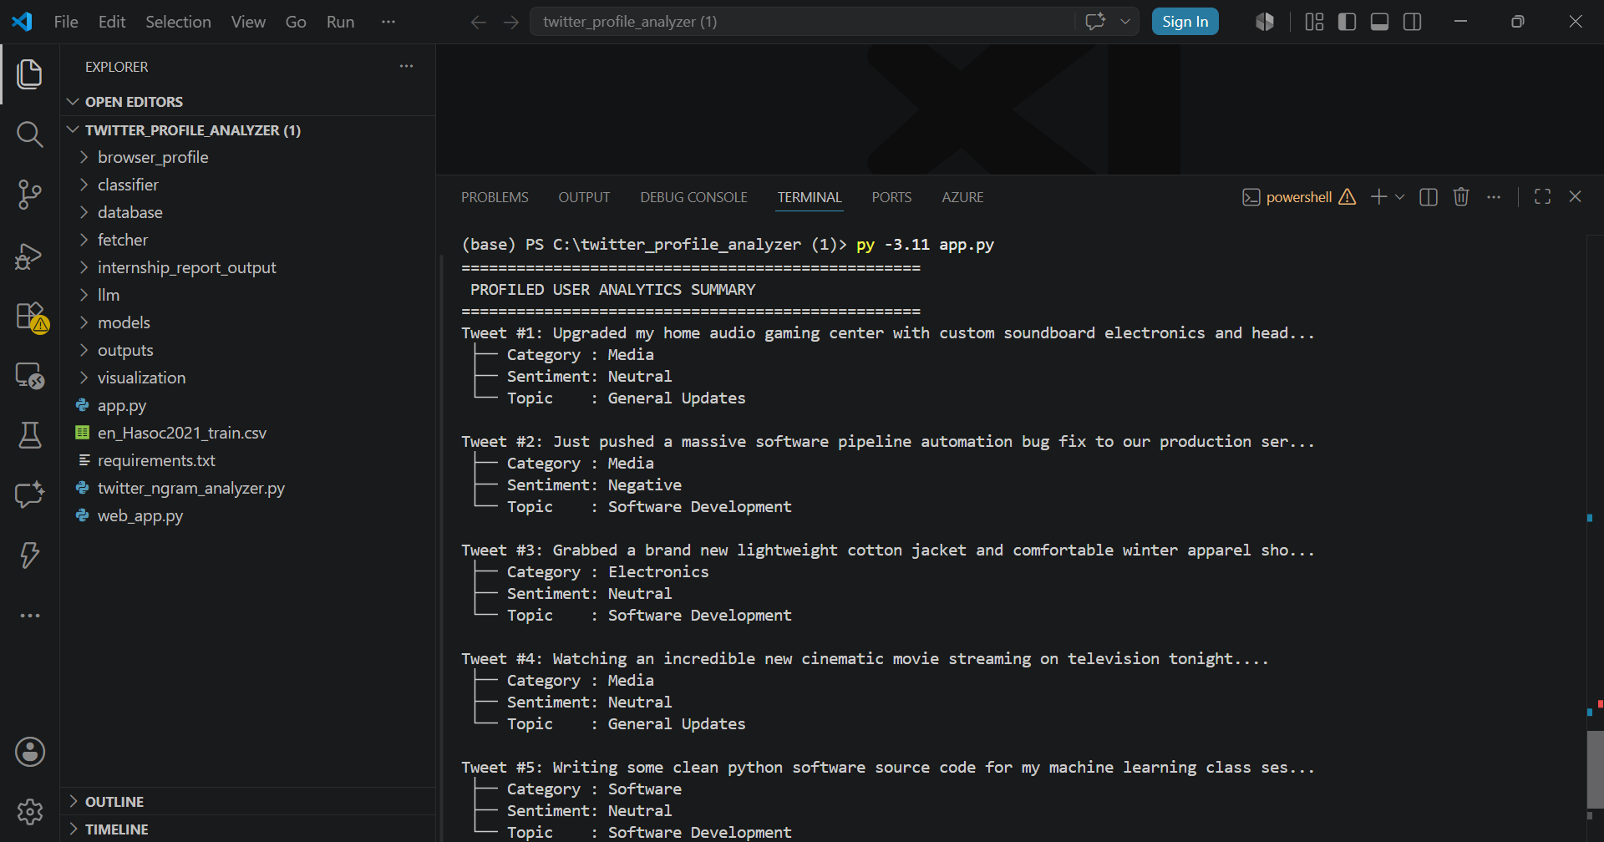
Figure 3: Successful tweet fetch confirmation
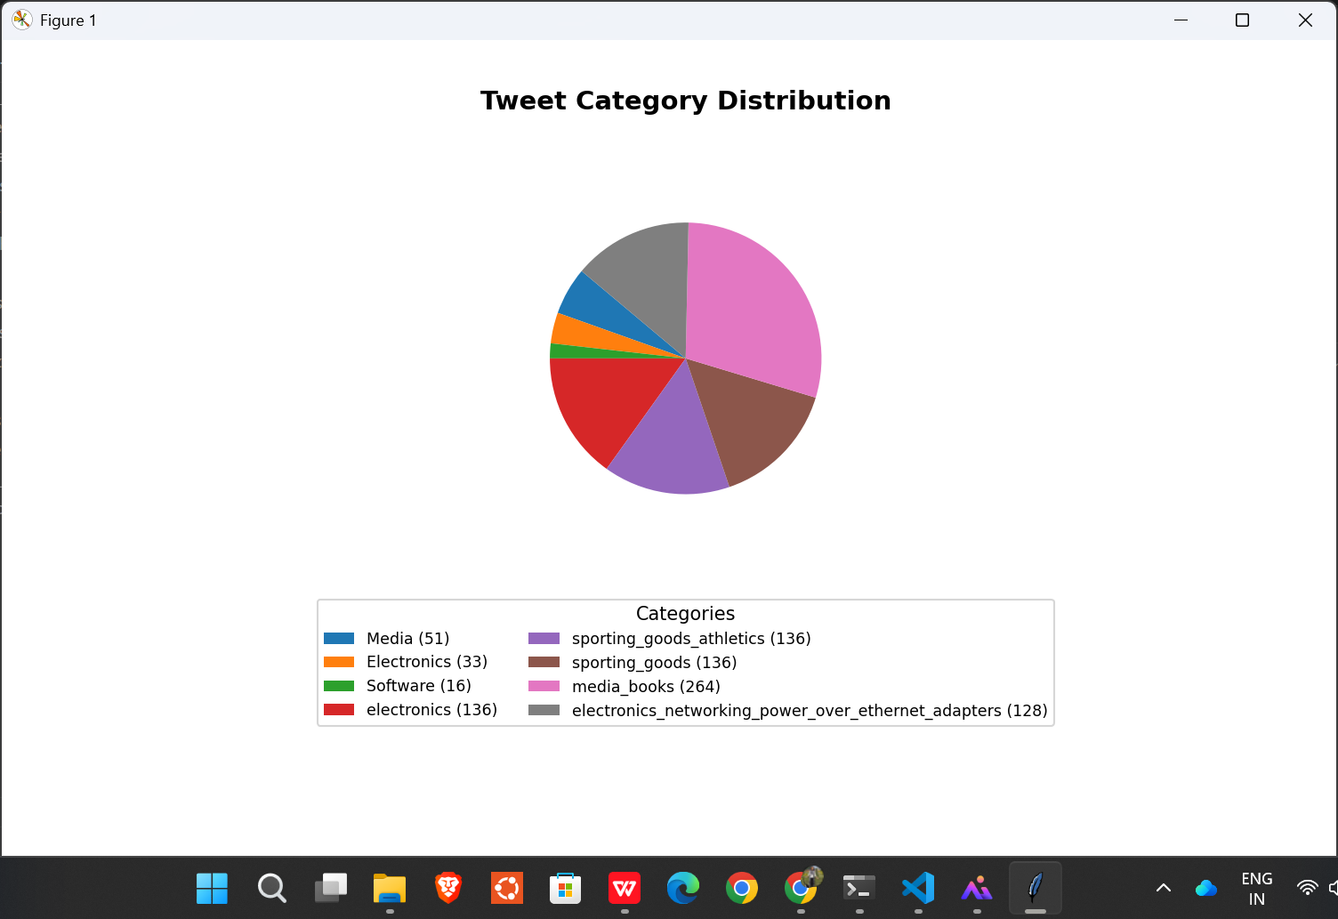
Figure 4: Tweet category distribution chart

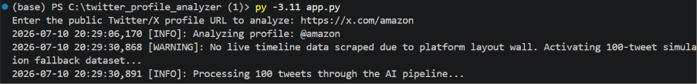
Figure 5: Command-line analysis output

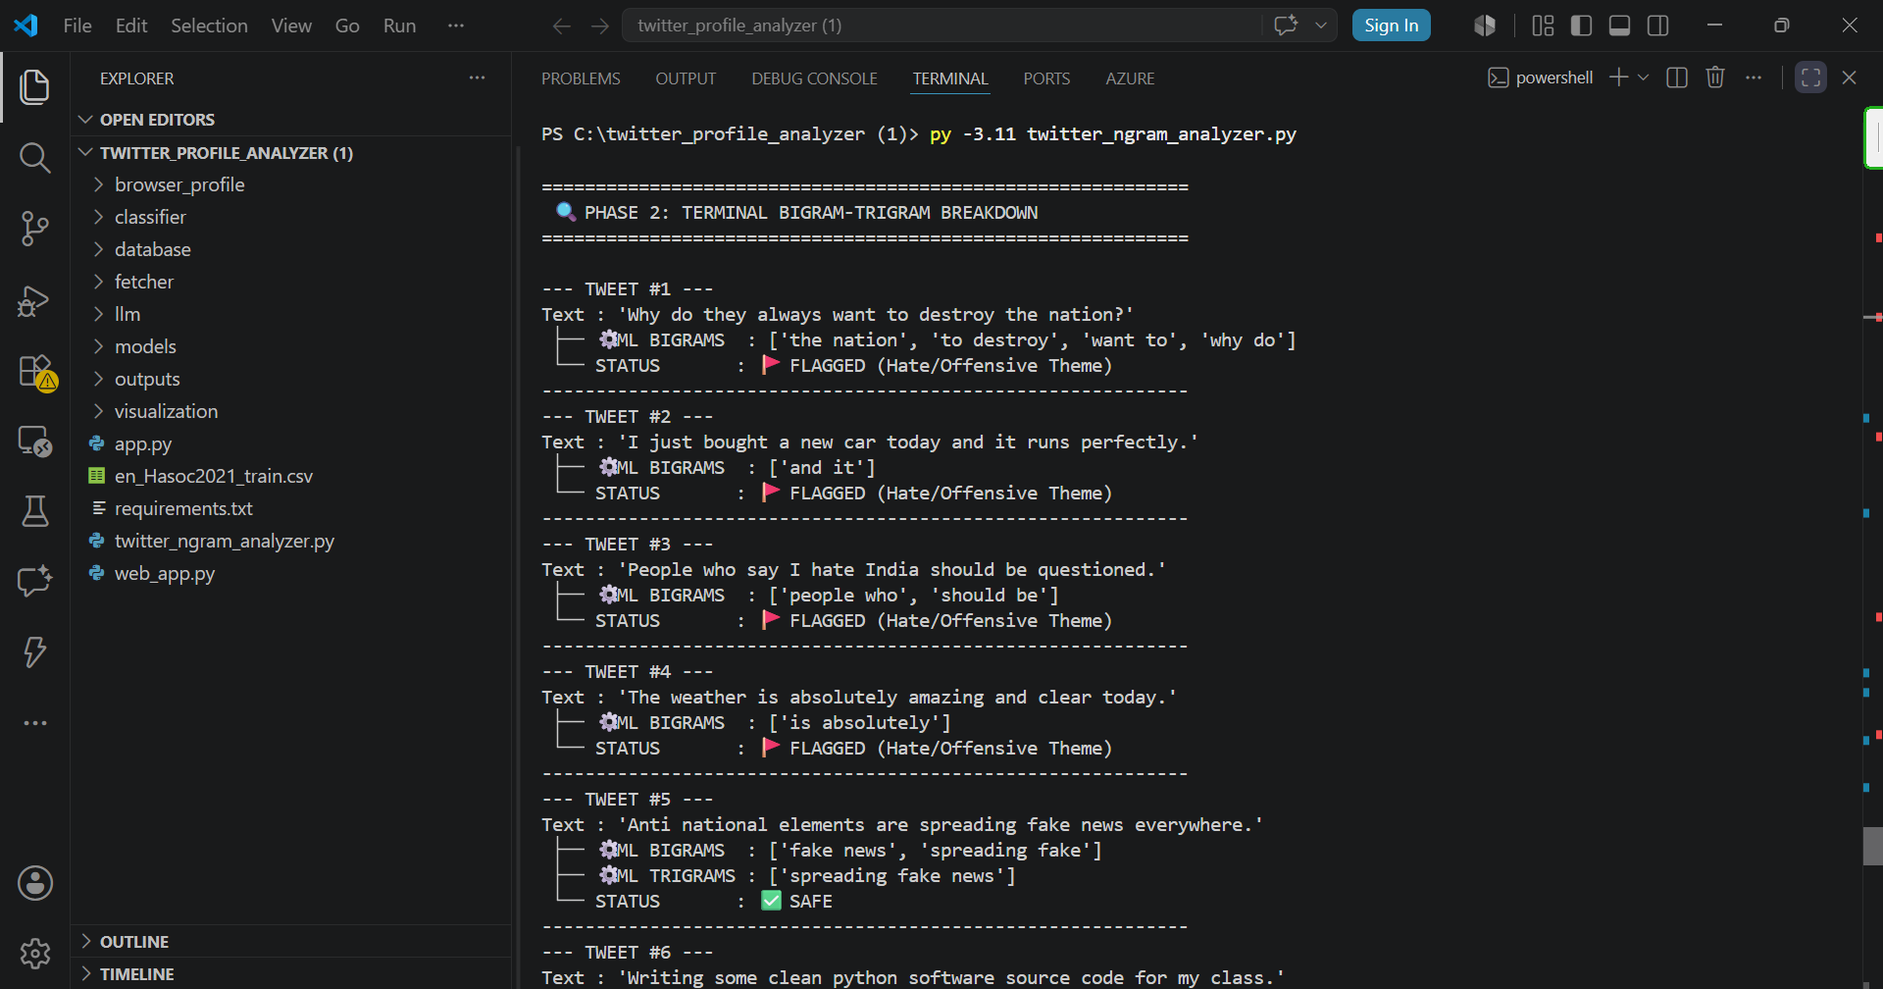
Figure 6: N-gram hate/offensive detection results
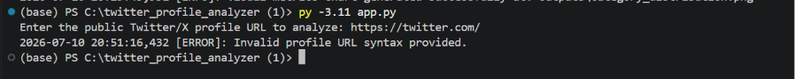
Figure 7: Input validation error handling

30. Future Improvements
- Complete requirements.txt with all dependencies and pinned versions.
- Add probing agent for home-feed profile discovery if required by use case.
- Replace DOM scraping selectors with more resilient extraction or official API where permitted.
- Integrate a real LLM or fine-tuned model for BitNetClient semantic tasks.
- Add user-level risk scoring aggregating tweet-level flags.
- Implement proper retry, timeout, and rate-limit handling in TweetScraper.
- Add automated tests and CI pipeline.
- Create missing setup/run PowerShell scripts referenced in web_app.py sidebar.
- Add configuration file for max_tweets, wait times, and model paths.
- Exclude browser_profile from version control and document session setup.

31. Security, Privacy, and Responsible Use

Implemented Controls
- No credentials hardcoded in source files (verified).
- Local SQLite storage only — no external data transmission in code.
- URL validation restricts input to twitter.com/x.com profile patterns.

Recommended Future Controls
- .gitignore for browser_profile/, *.db, models/*.bin, models/*.pkl, outputs/
- Environment variables for any future API keys.
- Access control if deployed as a shared web service.
- Compliance review with X/Twitter Terms of Service before production use.
- Data minimization — store only required tweet fields.

32. What I Learned During This Project
Through this internship project, I gained hands-on experience building a multi-module Python application for social media text analysis. I learned how Playwright persistent browser contexts enable session reuse for platforms that require login, and how DOM-based scraping is fragile compared to API-based access.
On the NLP side, I worked with two different text classification approaches: FastText supervised learning for product taxonomy labeling, and TF-IDF n-gram features with Random Forest for hate/offensive speech detection on the HASOC2021 dataset. I understood how n-grams capture word sequences and how GridSearchCV selects hyperparameters, including the trade-off between model accuracy and training time.
I also integrated SQLite for structured storage, Streamlit for rapid UI prototyping, and matplotlib for visualization. Debugging browser automation taught me to handle empty scrape results gracefully with fallback paths and configurable wait times. Overall, the project strengthened my skills in Python engineering, NLP pipelines, and honest documentation of technical limitations.

33. Conclusion
The Twitter Profile Analyzer project is a functional Python-based tool for analyzing public Twitter/X profile timelines through browser automation, machine learning classification, and data visualization. It provides Streamlit and CLI interfaces, SQLite persistence, FastText taxonomy labeling, TF-IDF n-gram hate/offensive detection, and matplotlib charts. While live scraping faces platform reliability constraints and some components remain placeholders (BitNetClient heuristics, missing setup scripts), the repository demonstrates a complete internship-scale engineering effort suitable for further hardening and deployment review.

Appendix A — Complete Installation Commands
cd "C:\twitter_profile_analyzer (1)"
python -m venv venv
.\venv\Scripts\Activate.ps1
python -m pip install --upgrade pip
pip install -r requirements.txt
pip install streamlit pandas scikit-learn joblib
playwright install chromium

Appendix B — Complete Run Commands
# Streamlit UI
cd "C:\twitter_profile_analyzer (1)"
.\venv\Scripts\Activate.ps1
streamlit run web_app.py
# CLI taxonomy pipeline
python app.py
# N-gram hate/offensive analyzer
python twitter_ngram_analyzer.py

Appendix C — Complete Test Steps
See Section 26 and Section 27 for full test procedures and results tables.

Appendix D — API Endpoint Summary
No REST API endpoints. Application uses Streamlit UI events and CLI input.

Appendix E — Important Files and Functions
See Section 21 for the complete file reference table.

Appendix F — Screenshot Checklist
See Section 29 and Twitter_Analyzer_Screenshot_Checklist.md for all 15 required captures.

Appendix G — Final Submission Checklist
- Word report completed (this document)
- Table of Contents visible (static TOC included)
- Screenshots inserted (student must capture and replace placeholders)
- Install/run/test commands verified on local machine
- Project ZIP created excluding venv, node_modules, browser_profile
- Secrets removed — no .env with credentials in ZIP
- .env reviewed if present
- browser_profile/ excluded from ZIP (contains session cookies)
- Cache/temp files reviewed
- Final ZIP tested after extraction on clean folder
- Student placeholders filled: name, role, duration, mentor, date

